Ant Colony Optimization for a Five City Tour

1 Problem and Algorithm
Experiment Number: 09
Aim: Implement Ant Colony Optimization and evaluate how its parameters affect a symmetric five-city tour.
Problem Statement: Find a short closed tour through cities A to E, verify the optimum by enumeration, and compare ACO parameter settings across 30 reproducible seeds.
Algorithm:
• Initialize pheromone equally on every valid edge.
• Combine pheromone and inverse-distance desirability to form transition probabilities.
• Sample tours without revisiting cities.
• Compute tour lengths and deposit Q divided by tour length.
• Evaporate old pheromone and add all ant deposits.
• Repeat for the stated iteration budget and retain the best tour.

2 Program
The notebook contains the complete executable program. The essential implementation is summarized below.
weights = pheromone[current, unvisited]**alpha * eta[current, unvisited]**beta
probabilities = weights / weights.sum()
pheromone = (1 - rho) * pheromone + deposits
best_tour = min(sampled_tours, key=tour_length)

Key Parameter Settings
Parameter | Value
alpha | 1
beta | 2
rho | 0.5
Q | 100
Ants | 3
Iterations | 20
Random seeds | 30

Executable notebook: notebooks/ACO_Step_by_Step.ipynb

3 Output and Analysis
Execution Status: Successfully executed with 25 of 25 code cells complete and no errors.
Best Tour: A to B to E to D to C to A
Best Tour Length: 27
Independent Verification: Enumeration confirms the exact shortest length is 27.
Result | Value | Analysis
Baseline mean length | 27.000 | Matched the exact optimum in all 30 runs
Baseline success | 100% | The optimum was found reliably
First-hit iteration | 2.10 | The small problem was normally solved early
Single-iteration worked tours | 27, 28, 28 | The best supplied tour is globally optimal

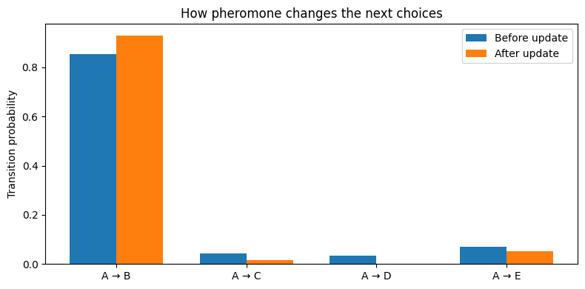
Figure 1 Transition probabilities before and after pheromone updating
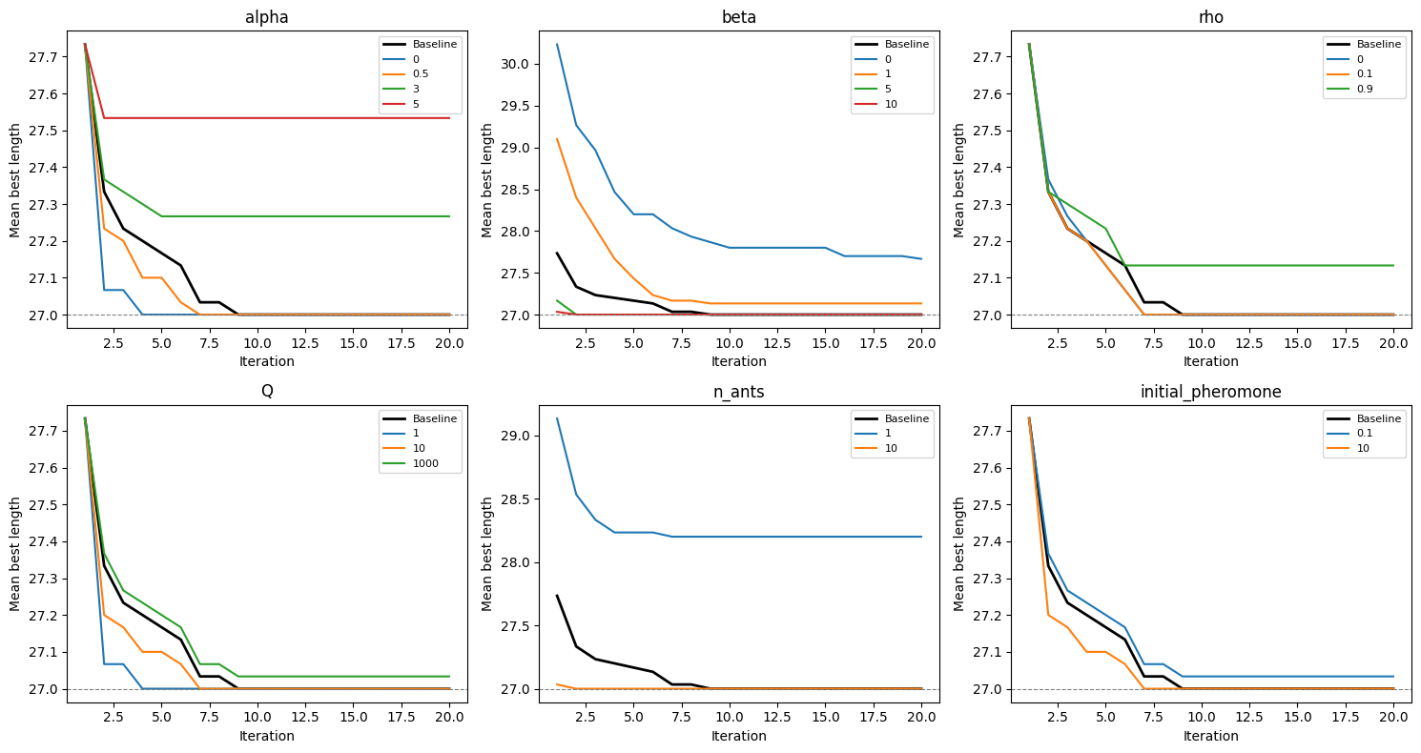
Figure 2 Mean best tour length under parameter changes

4 Parameter Modification
Setting | Mean Length | Success | Observation
Baseline | 27.000 | 100.0% | Reference configuration
alpha = 5 | 27.533 | 70.0% | Excessive pheromone feedback reduced reliability
beta = 0 | 27.667 | 80.0% | Removing distance guidance weakened search
rho = 0.9 | 27.133 | 90.0% | Fast evaporation slightly reduced reliability
ants = 1 | 28.200 | 56.7% | Too little exploration produced the worst mean result
ants = 10 | 27.000 | 100.0% | More candidates recovered baseline reliability at higher cost
iterations = 1 | 27.733 | 60.0% | The short budget often ended before the optimum was sampled

5 Conclusion
The baseline ACO found the exact length-27 tour in every seeded run. Parameter changes show that strong feedback, missing distance guidance, too few ants, or too few iterations can reduce reliability even on this small problem.

