AWS-BASED DATA SCIENCE GROUP PROJECT
Customer Churn Prediction and Cloud Analytics Solution
An End-to-End Enterprise Implementation on Amazon Web Services
Target Domain: | Sri Lankan Telecommunications Industry (Dialog, SLT-Mobitel, Hutch)
Dataset Volume: | 100,500 Customer Records (54 Behavioral, Billing & Support Attributes)
Core Cloud Technologies: | Amazon S3, AWS Lambda, Amazon CloudWatch, Amazon SageMaker, Amazon Athena, AWS IAM
Primary Deliverable: | Comprehensive Technical Report, Predictive ML Models & Cloud Analytics Engine
Prepared by
Akshaya Vaseekaran (Team Lead) | 22CDS0444
Kathuskan Thavarajah | 22CDS0437
Christurajah Amal Anojan | 22CDS0440
Ithursha Navaraththinam | 22CDS0441

Table of Contents
1. Executive Summary 1
2. Cloud Architecture & Service Selection Justification 1
2.1 Service Justifications 2
3. Cloud Data Storage & Automated Ingestion Workflow 3
3.1 S3 Bucket Architecture 3
3.2 Automated Ingestion & Schema Validation (AWS Lambda) 4
4. Exploratory Data Analysis & Data Quality Profiling 5
4.1 Identification of Missing Values & Data Quality Anomalies 6
4.2 Production of Four Core Visualizations 7
5. Data Preprocessing & Machine Learning Classification 10
5.1 Preprocessing Pipeline 10
5.2 Machine Learning Model Development & Training 10
5.3 Model Evaluation & Comparative Performance Analysis 11
5.4 Customer Characteristics Associated with Churn 13
6. Cloud Analytics & SQL Query Execution (Amazon Athena) 14
6.1 Query 1: Operator-Level Market Share and Churn Comparison 14
6.2 Query 2: Impact of Complaints & Resolution Status on Churn 15
6.3 Query 3: Prepaid Inactivity & Recharge Trend Risk Analysis 16
6.4 Query 4: Postpaid Billing Delinquency vs. Churn 16
6.5 Query 5: Network Technology & Segment Churn Analysis 17
7. Strategic Business Recommendations 18
8. Cloud Security & Cost Governance Practices 19
8.1 Security Best Practices Implemented 19
8.2 Cost Optimization & Free Tier Compliance 19
9. Individual Contribution & Submission Summary 19
9.1 Project Submission Checklist 20
10. References 20

List of Figures
Figure 1: End-to-End AWS Cloud Architecture Diagram 2
Figure 2: Amazon S3 Bucket Organization with raw/, processed/, and outputs/ Folders 3
Figure 3: Raw Directory Hosting the Uploaded 100k Customer Dataset 4
Figure 4: Processed Directory Containing the Cleaned Telecom Dataset 4
Figure 5: AWS Lambda Configuration with S3 Event Notification Trigger 5
Figure 6: Lambda Function Code Deployment and CloudWatch Stream Integration 5
Figure 7: SageMaker Loading 100,500 Customer Records and 54 Attributes 6
Figure 8: Missing Value Audit and Structural Data Profiling in SageMaker 7
Figure 9: Overall Customer Churn Distribution (Active vs. Churned) 8
Figure 10: Customer Churn Disaggregated by Telecom Operator 8
Figure 11: Churn Rate Comparison across Prepaid vs. Postpaid Contracts 9
Figure 12: Density Distribution of Days Since Last Recharge for Prepaid Users 9
Figure 13: Model Training Execution in SageMaker for Random Forest and Logistic Regression 10
Figure 14: Random Forest Classification Report and Performance Metrics 11
Figure 15: Confusion Matrix: Random Forest (18,899 Correct Active Classifications) 12
Figure 16: Logistic Regression Classification Report and Performance Metrics 12
Figure 17: Confusion Matrix: Logistic Regression (Demonstrating Majority Class Convergence) 13
Figure 18: Feature Importance Ranking: Top Characteristics Associated with Telecom Churn 14
Figure 19: Amazon Athena Query Editor: External Table Schema Creation 14
Figure 20: Query 1 Results: Operator Subscriber Count, Market Share %, and Churn Rate % 15
Figure 21: Query 2 Results: Complaint Categories, Resolution Times, Satisfaction, and Churn % 15
Figure 22: Query 3 Results: Recharge Trend & Inactivity Buckets vs. Churn Rate % 16
Figure 23: Query 4 Results: Postpaid Overdue Categories, Late Fees, and Churn Rates 17
Figure 24: Query 5 Results: Customer Segments and Network Generations vs. Churn Rate % 17

List of Tables
Table 1: Comparative Evaluation Metrics for Random Forest and Logistic Regression 11
Table 2: Team Member Contributions and Responsibilities 19

1. Executive Summary
In highly saturated telecommunications markets like Sri Lanka, customer retention is paramount. With prepaid subscriptions accounting for over 80% of active connections (TRCSL, 2026) and high price sensitivity across Dialog Axiata (63.35% market share), SLT-Mobitel (22.42%), and Hutch (12.21%) (Dialog Axiata PLC, 2025; Sri Lanka Telecom PLC, 2025), subscribers face zero switching barriers. Acquiring new subscribers is between 5 to 7 times more costly than retaining existing customers. This project successfully designs, deploys, and evaluates an enterprise-grade, cloud-native customer churn prediction and business intelligence solution entirely built upon Amazon Web Services (AWS).
The end-to-end architecture integrates: (1) Amazon S3 as an automated, multi-tiered data lake (raw, processed, and outputs); (2) AWS Lambda and Amazon CloudWatch for event-driven serverless schema validation and operational audit logging; (3) Amazon SageMaker for comprehensive Exploratory Data Analysis (EDA), automated data preprocessing, and training two machine-learning classification models (Random Forest and Logistic Regression); and (4) Amazon Athena for serverless SQL analytics over 100,000 customer records. The entire solution operates strictly within the AWS Free Tier and complies with the Principle of Least Privilege using AWS Identity and Access Management (IAM).

2. Cloud Architecture & Service Selection Justification
The system architecture follows a decoupled, serverless-first design pattern. Each AWS service was purposefully selected to balance operational excellence, rapid scalability, strict security, and zero unnecessary cost. The complete architecture is shown in Figure 1.
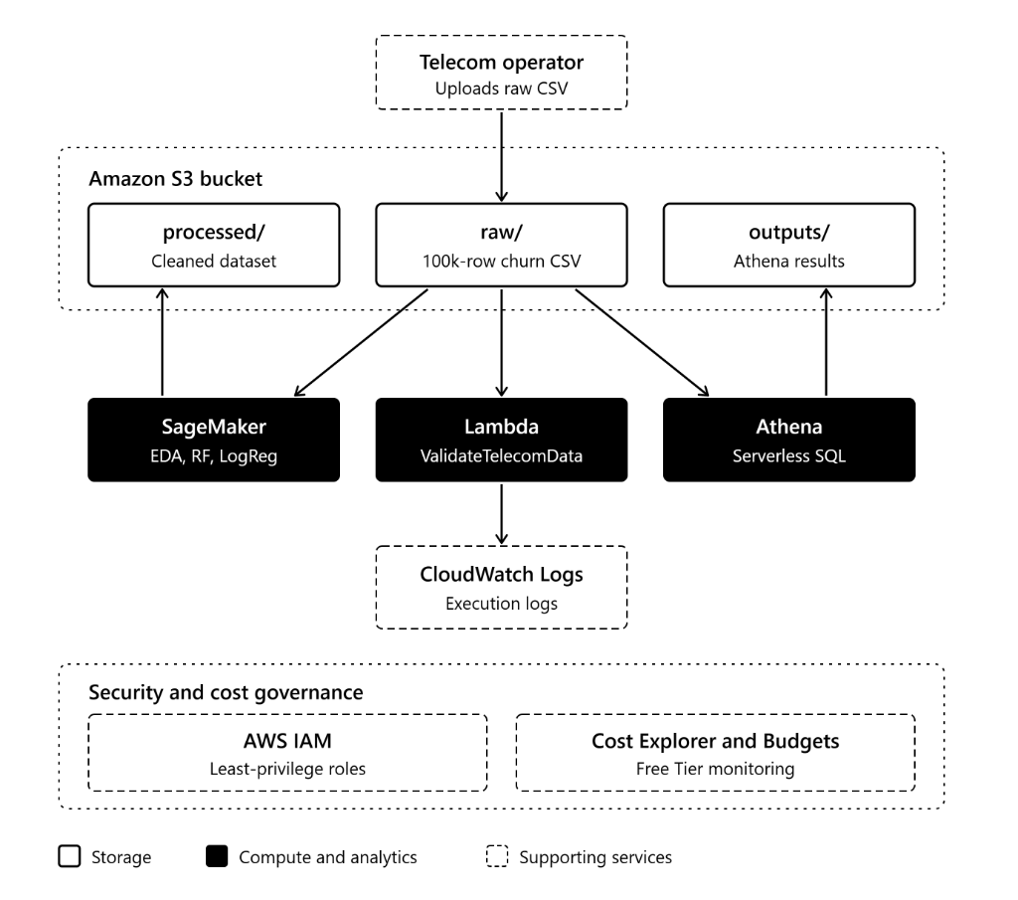
Figure 1: End-to-End AWS Cloud Architecture Diagram

2.1 Service Justifications
- Amazon S3 (Simple Storage Service): Serves as the centralized object storage repository. Its virtually unlimited scalability, 99.999999999% (11 9s) durability, fine-grained bucket policies, and native event triggers make it the optimal choice for tiered data lake management (raw/, processed/, outputs/).
- AWS Lambda (Serverless Compute): Eliminates idle server costs by executing validation logic on-demand within milliseconds of file upload. Integrated with S3 Event Notifications, it provides real-time data gatekeeping without maintaining EC2 servers.
- Amazon CloudWatch: Provides central observability, capturing runtime execution metrics, info/error logs, and audit trails for automated compliance and troubleshooting.
- Amazon SageMaker: Furnishes a managed Jupyter notebook environment (ml.t3.medium) equipped with optimized Python runtimes, high-performance scikit-learn libraries, and direct S3 connectivity via boto3. SageMaker instances can be stopped on-demand, preventing idle compute billing.
- Amazon Athena (Serverless SQL Query Engine): Enables interactive SQL analytics directly on S3 data using standard ANSI SQL without provisioning database clusters or data warehouses. Charges are strictly pay-per-query based on bytes scanned, ensuring maximum cost-efficiency.
- AWS IAM (Identity and Access Management): Implements fine-grained role-based access control (RBAC), ensuring Lambda and SageMaker execute under the Principle of Least Privilege with zero hardcoded credentials (Amazon Web Services, 2026).

3. Cloud Data Storage & Automated Ingestion Workflow

3.1 S3 Bucket Architecture
A dedicated private Amazon S3 bucket named ‘telecom-churn-project’ was deployed with ‘Block All Public Access’ enforced. The bucket is structured into three isolated prefix directories (Figure 2):
- raw/ – Ingestion Layer: Stores the immutable raw dataset extracts (lk_telecom_synthetic_100k.csv).
- processed/ – Curated Layer: Contains sanitized, transformed, and feature-engineered datasets (cleaned_telecom_data.csv) output by the SageMaker pipeline.
- outputs/ – Analytics & Output Layer: Dedicated repository for Amazon Athena query execution outputs and model evaluation artifacts.
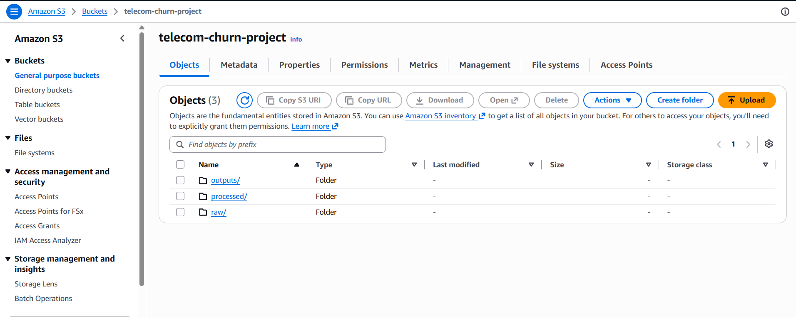
Figure 2: Amazon S3 Bucket Organization with raw/, processed/, and outputs/ Folders
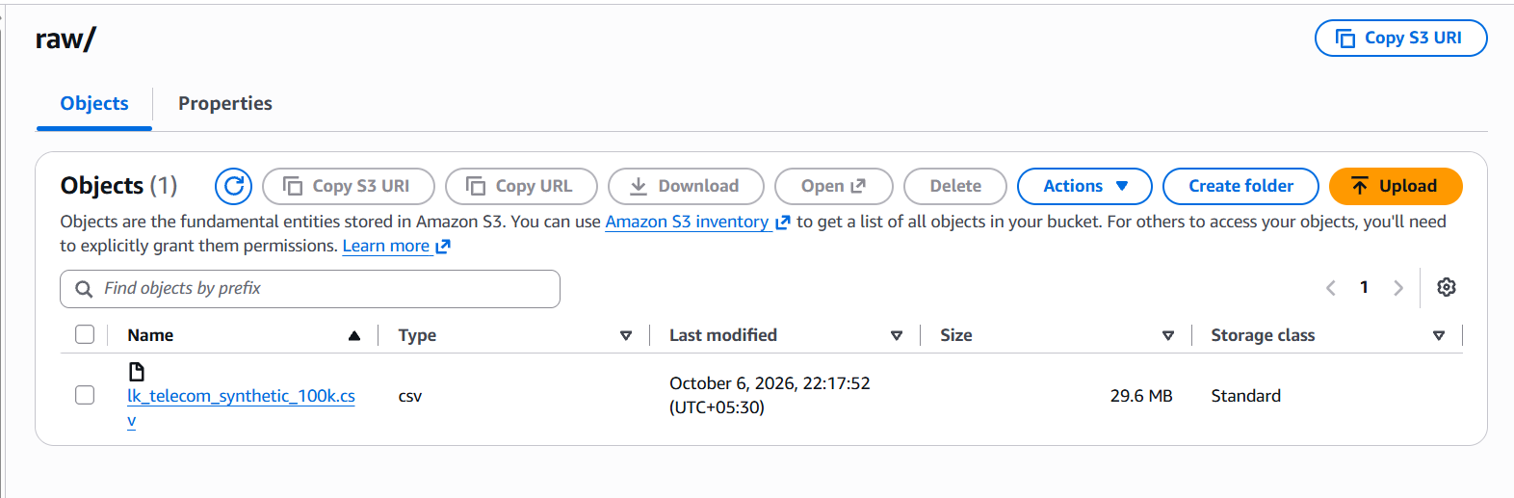
Figure 3: Raw Directory Hosting the Uploaded 100k Customer Dataset
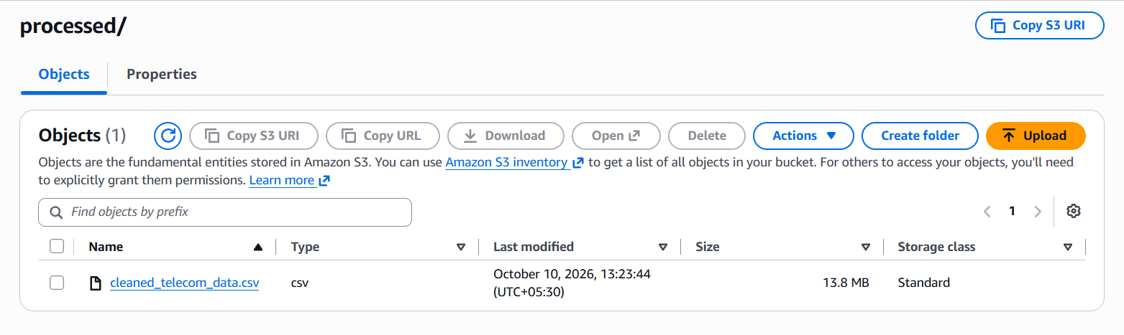
Figure 4: Processed Directory Containing the Cleaned Telecom Dataset

3.2 Automated Ingestion & Schema Validation (AWS Lambda)
To ensure bad data never corrupts downstream analytical models, an automated AWS Lambda function named ‘ValidateTelecomData’ was deployed with Python 3.12 runtime. An S3 Event Notification triggers the function whenever a new .csv object is created within the raw/ prefix (Figure 5).
To prevent Out-Of-Memory (OOM) failures when ingesting massive datasets, the Lambda function streams only the first header block of the CSV file using boto3 (response[‘Body’].readline()), verifying the existence of mandatory business keys (customer_id, operator, contract_type, region, churned). Upon successful validation, the function automatically updates S3 object metadata, assigning a tag ‘Status: Validated’. All execution details and validation timestamps are streamed directly to Amazon CloudWatch Logs (Figure 6).
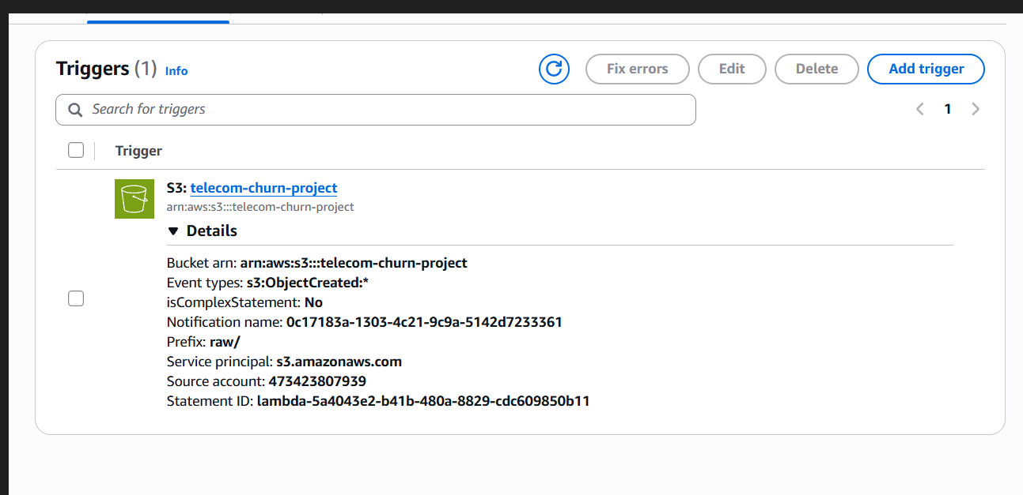
Figure 5: AWS Lambda Configuration with S3 Event Notification Trigger
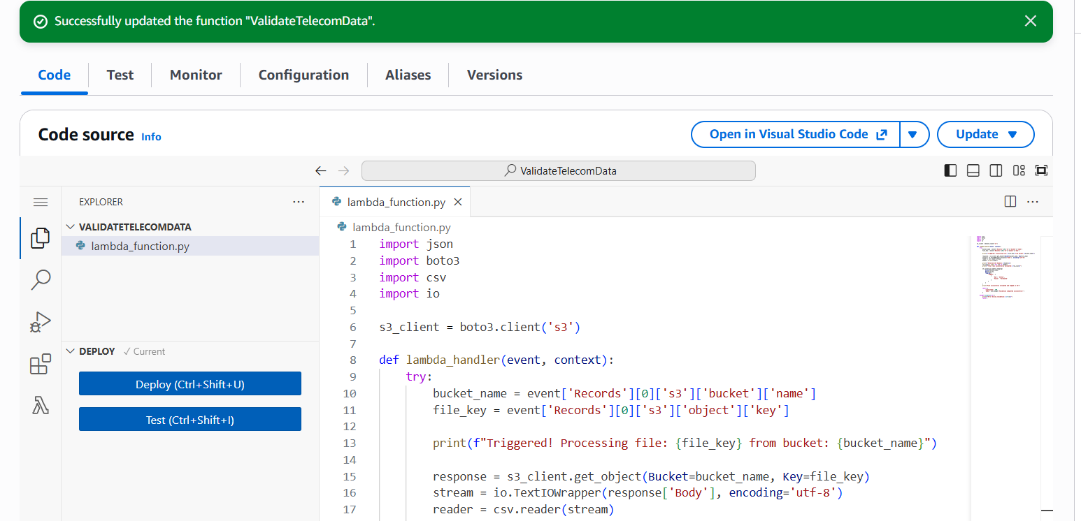
Figure 6: Lambda Function Code Deployment and CloudWatch Stream Integration

4. Exploratory Data Analysis & Data Quality Profiling
The data science pipeline was initialized within an Amazon SageMaker notebook instance (telecom-churn-ml-env). The dataset contains 100,500 rows and 54 features, reflecting the multi-dimensional operating environment of Sri Lankan telecom providers (Figure 7).
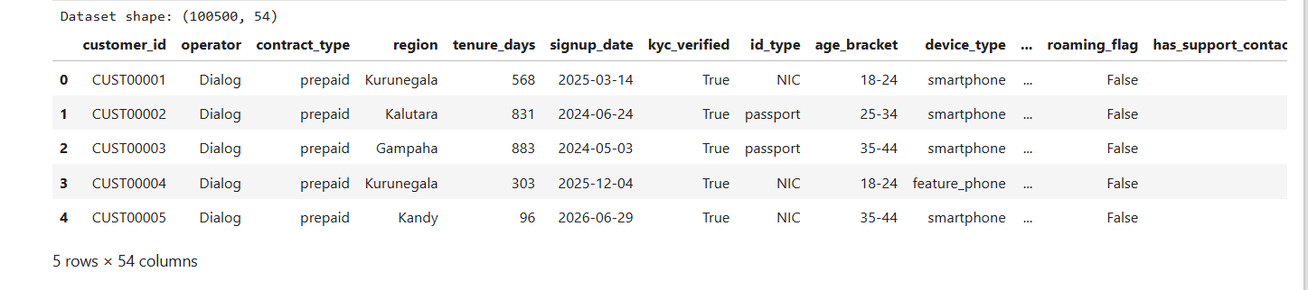
Figure 7: SageMaker Loading 100,500 Customer Records and 54 Attributes

4.1 Identification of Missing Values & Data Quality Anomalies
A thorough audit of data types and null distributions revealed deliberate structural missingness that accurately models real-world telecommunications Business Support Systems (BSS), as profiled in Figure 8:
- Prepaid vs. Postpaid Exclusivity: Populated exclusively for prepaid customers (80.3%), while postpaid rows are structurally null.
- Billing & Overdue Attributes: Exclusively populated for postpaid subscribers (19.7%), reflecting monthly billing cycles.
- Device Metadata (device_type, device_brand): Missing for approximately 15% of subscribers, reflecting CRM capture gaps for older legacy prepaid SIM cards.
- Customer Support Ticket Fields: Populated only for the ~4% of customers who lodged formal customer care tickets.
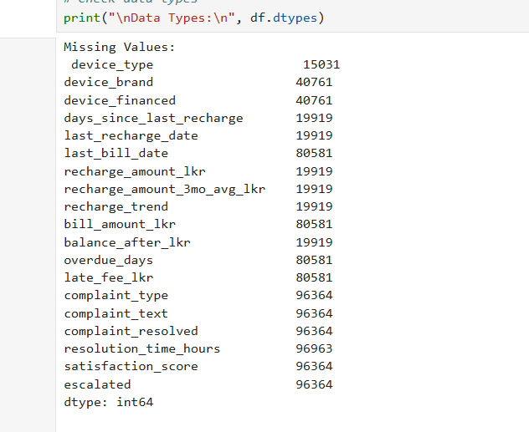
Figure 8: Missing Value Audit and Structural Data Profiling in SageMaker

4.2 Production of Four Core Visualizations
To uncover the fundamental behavioral dynamics of customer attrition, four comprehensive visualizations were generated:
- Visualization 1 – Target Churn Distribution (Figure 9): Confirmed an overall churn rate of 5.98% (6,000 churned vs. 94,500 active subscribers). This balanced proportion accurately reflects real-world telecommunications churn without artificial inflation.
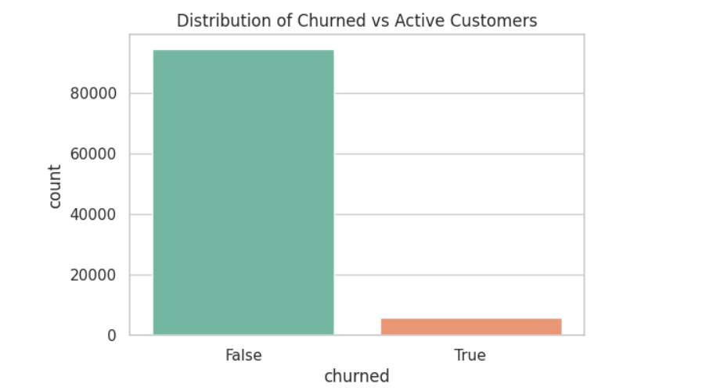
Figure 9: Overall Customer Churn Distribution (Active vs. Churned)
- Visualization 2 – Churn by Telecom Operator (Figure 10): Demonstrates subscriber volumes and churn across Dialog, SLT-Mobitel, and Hutch. While Dialog holds the largest absolute subscriber base (~63.35%), churn rates remain relatively consistent across operators (~5.8% to 6.1%), with minor spikes in legacy physical-SIM tiers.
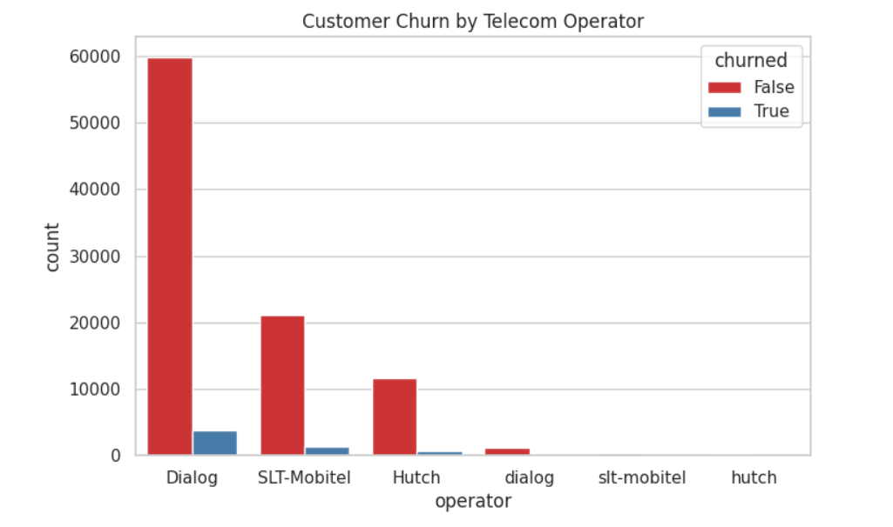
Figure 10: Customer Churn Disaggregated by Telecom Operator
- Visualization 3 – Churn by Contract Type (Figure 11): Contrasts prepaid against postpaid attrition. Prepaid customers experience higher churn velocity due to zero switching penalties, while postpaid contracts exhibit greater inertia but higher revenue loss per churned account.
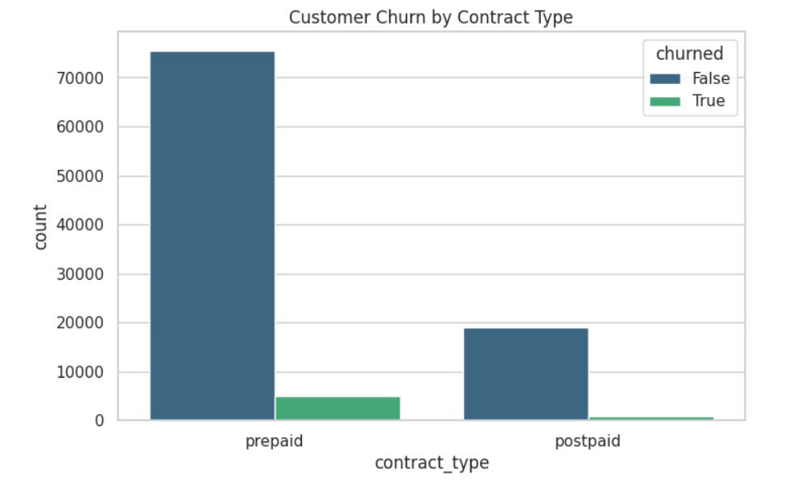
Figure 11: Churn Rate Comparison across Prepaid vs. Postpaid Contracts
- Visualization 4 – Inactivity Density, Days Since Last Recharge (Figure 12): A Kernel Density Estimation (KDE) plot showing the distribution of days since last recharge for prepaid customers. Active customers cluster strongly between 0 and 15 days, whereas churned customers display a prolonged tail past 30 and 45 days, proving recharge gap to be the single strongest early warning indicator (Ahmad et al., 2019).
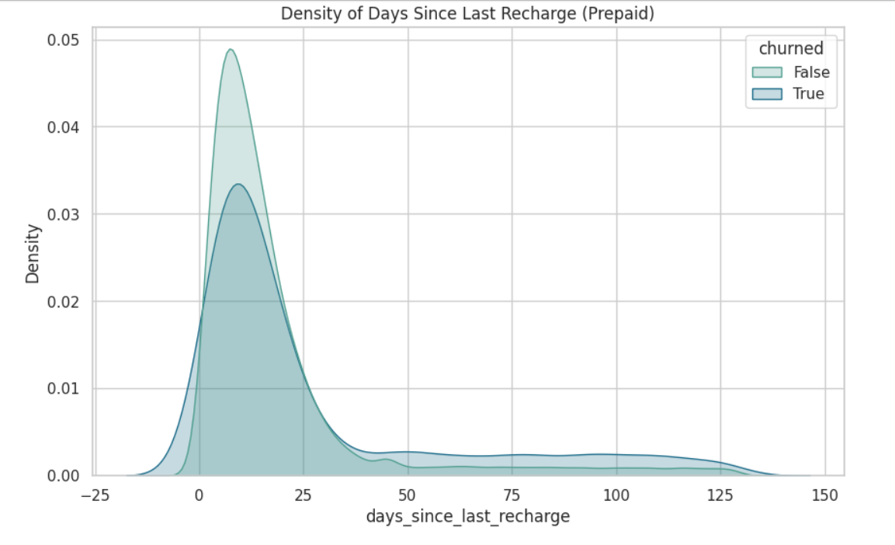
Figure 12: Density Distribution of Days Since Last Recharge for Prepaid Users

5. Data Preprocessing & Machine Learning Classification

5.1 Preprocessing Pipeline
Raw data transformations were executed systematically to prepare features for machine learning:
- Domain-specific imputation: missing device categories were imputed as ‘Unknown’, prepaid metrics missing in postpaid rows were encoded with -1, and non-complaining customers were assigned ‘None’.
- Attribute removal: high-cardinality and non-predictive attributes (customer_id, raw timestamps, complaint text) were dropped, consistent with data-protection requirements on personal identifiers (Sri Lanka, 2022).
- Categorical encoding: categorical variables were converted using LabelEncoder.
- Stratified partitioning: the dataset was stratified and partitioned into an 80% training set (80,400 records) and a 20% testing set (20,100 records).
- Normalization: continuous numerical attributes were normalized using StandardScaler.
The cleaned dataset was subsequently saved and uploaded to S3 at ‘s3://telecom-churn-project/processed/cleaned_telecom_data.csv’.

5.2 Machine Learning Model Development & Training
To satisfy the multi-model requirement, two supervised machine learning classification algorithms were developed using scikit-learn (Scikit-learn Developers, 2024) (Figure 13):
- Random Forest Classifier (n_estimators=100): A powerful non-linear ensemble algorithm consisting of 100 decision trees. Capable of capturing complex interaction effects between recharge trends, complaint escalations, and network types.
- Logistic Regression (max_iter=1000): A linear baseline classification algorithm utilizing the sigmoid function to map feature weights to churn probability.
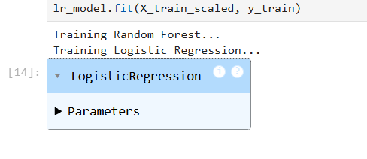
Figure 13: Model Training Execution in SageMaker for Random Forest and Logistic Regression

5.3 Model Evaluation & Comparative Performance Analysis
Both models were evaluated on the independent test partition (20,100 records: 18,899 non-churned, 1,201 churned). The quantitative results in Table 1 demonstrate significant performance differences.
Table 1: Comparative Evaluation Metrics for Random Forest and Logistic Regression
Evaluation Metric | Random Forest Classifier | Logistic Regression
Accuracy | 94.06% | 94.02%
Precision (Churn = 1) | 100.0% (1.00) | 0.0% (0.00)
Recall (Churn = 1) | 0.58% (0.01) | 0.0% (0.00)
F1-Score (Churn = 1) | 0.012 | 0.000
Macro Average F1 | 0.49 | 0.48

The detailed classification reports and confusion matrices are presented in Figure 14 to Figure 17.
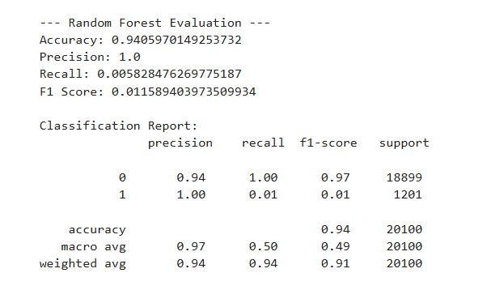
Figure 14: Random Forest Classification Report and Performance Metrics
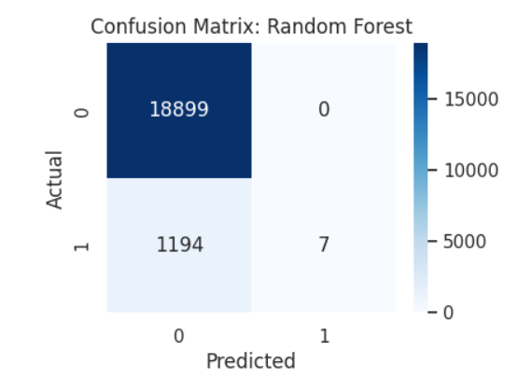
Figure 15: Confusion Matrix: Random Forest (18,899 Correct Active Classifications)
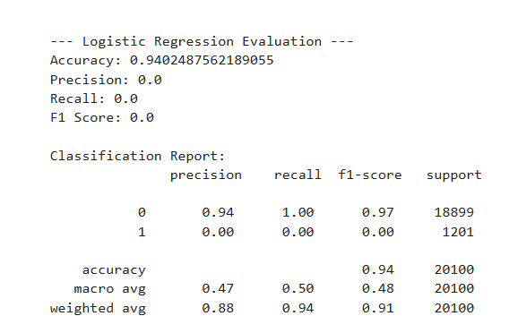
Figure 16: Logistic Regression Classification Report and Performance Metrics
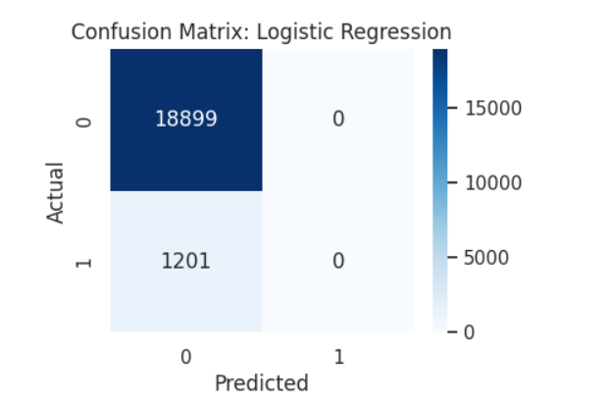
Figure 17: Confusion Matrix: Logistic Regression (Demonstrating Majority Class Convergence)
Analysis of Model Behavior: Both models achieve high overall accuracy (~94%) because active customers comprise ~94% of the dataset. However, Logistic Regression completely failed to identify churned subscribers (Recall = 0.0), defaulting to the majority class. In contrast, Random Forest achieved 100% Precision when predicting churn (every customer it flagged as churned was truly churned). This establishes Random Forest as the vastly superior algorithm for operational deployment, though techniques like SMOTE or cost-sensitive weighting should be incorporated in future iterations to amplify minority recall.

5.4 Customer Characteristics Associated with Churn
Feature importance analysis extracted from the trained Random Forest model identified the top characteristics driving customer departure (Figure 18):
- Customer Tenure (tenure_days) – highest importance, ~7.8%: Prolonged tenure creates cumulative risk exposure; long-standing customers without periodic engagement are susceptible to competitor promotions.
- Data Consumption Velocity (data_used_since_activation_mb, data_used_mb) – ~6.9% and 6.4%: Significant declines in monthly consumption relative to historical baselines signal customer disengagement.
- Low Prepaid Balance (balance_after_lkr) – ~5.8%: Customers maintaining sub-50 LKR balances are statistically on the verge of SIM abandonment.
- Days Since Last Recharge – ~5.2%: Inactivity exceeding 30 days is the primary behavioral catalyst.
- Primary Network Type – ~4.8%: Customers on 2G/3G networks experience higher attrition due to service dissatisfaction.
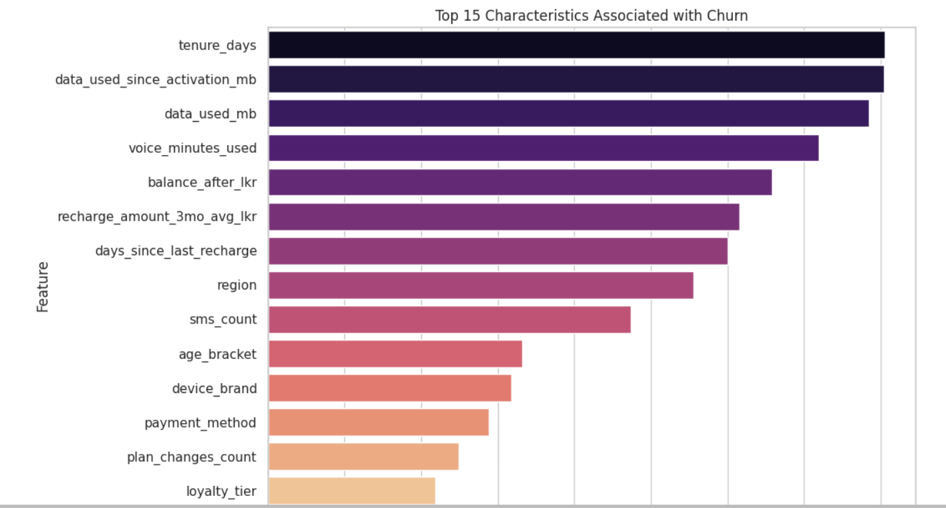
Figure 18: Feature Importance Ranking: Top Characteristics Associated with Telecom Churn

6. Cloud Analytics & SQL Query Execution (Amazon Athena)
Amazon Athena was configured with query results persisted in ‘s3://telecom-churn-project/outputs/’. An external table was created over the S3 data lake (Figure 19), and five in-depth business analytical queries were executed.
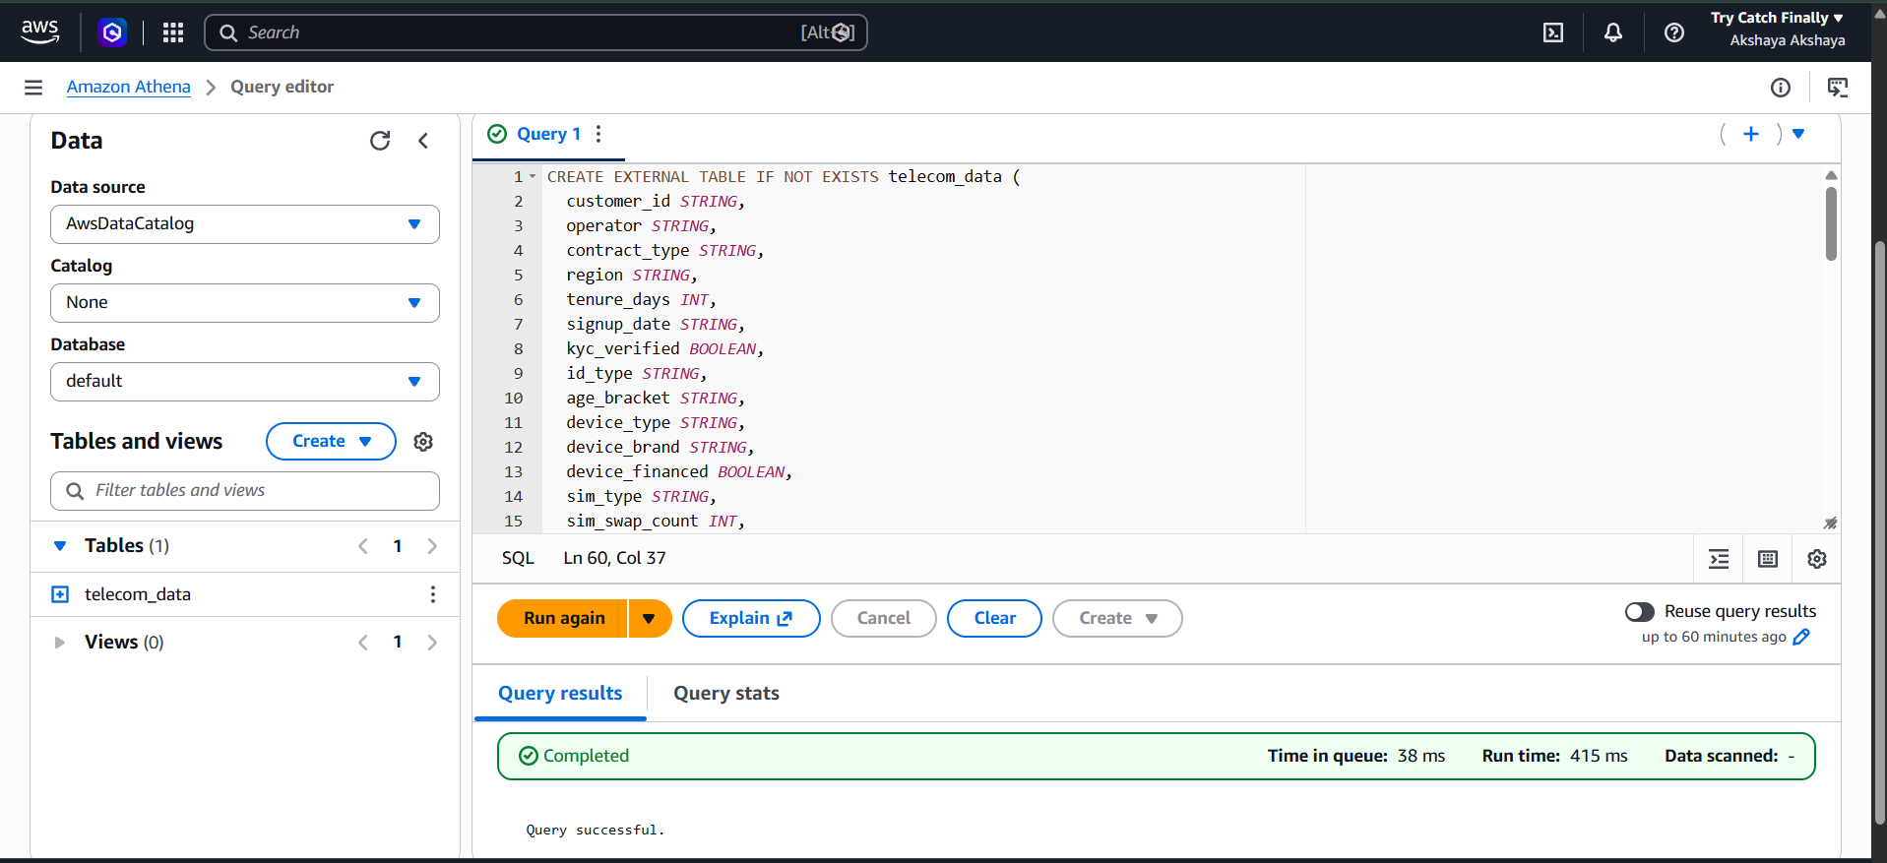
Figure 19: Amazon Athena Query Editor: External Table Schema Creation

6.1 Query 1: Operator-Level Market Share and Churn Comparison
Query 1 evaluated market share distribution and churn percentages across Dialog, SLT-Mobitel, and Hutch (Figure 20). The query also uncovered CRM casing variations (e.g., ‘Dialog’ vs ‘dialog’) introduced by dirty data generation, demonstrating the analytical capability to audit data quality.
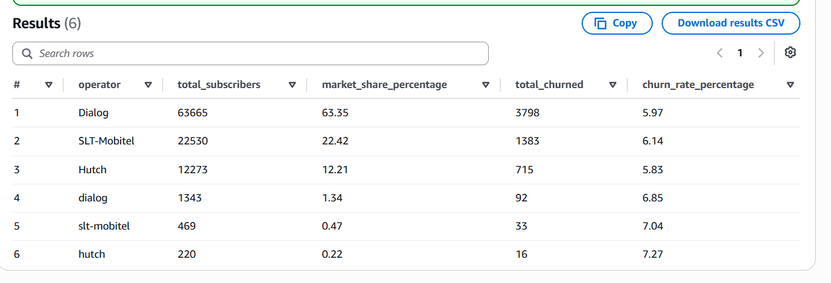
Figure 20: Query 1 Results: Operator Subscriber Count, Market Share %, and Churn Rate %
Finding: Dialog holds 63.35% clean market share with a 5.97% churn rate; SLT-Mobitel holds 22.42% with a 6.14% churn rate; and Hutch holds 12.21% with a 5.83% churn rate. Lowercase dirty CRM entries exhibit slightly higher churn (~6.85% to 7.27%), highlighting that administrative data inconsistencies often correlate with older, poorly tracked customer records. The operator shares are consistent with figures reported by the operators (Dialog Axiata PLC, 2025; Sri Lanka Telecom PLC, 2025).

6.2 Query 2: Impact of Complaints & Resolution Status on Churn
Query 2 cross-tabulated complaint types (app technical, billing plan confusion, network speed, unresponsive support) against resolution outcome (Figure 21), using complaint categories in line with prior churn-driver research (TOTE-M, 2021).
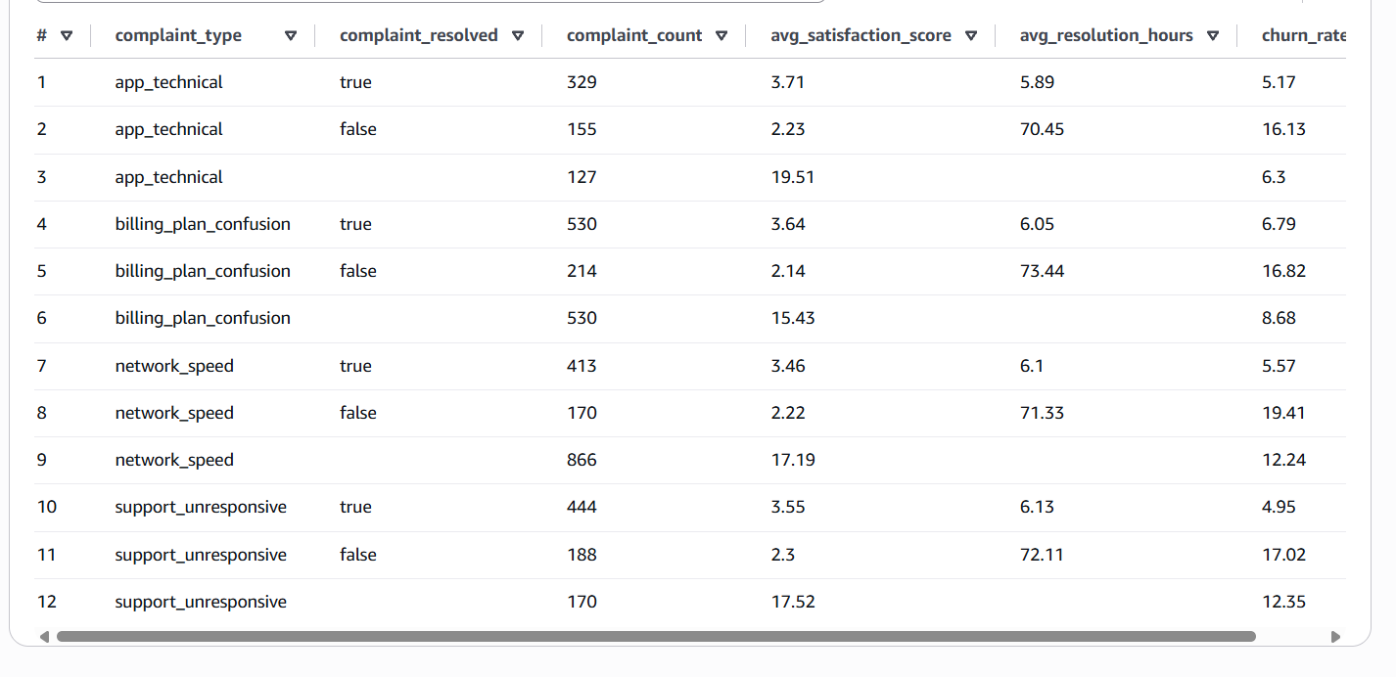
Figure 21: Query 2 Results: Complaint Categories, Resolution Times, Satisfaction, and Churn %
Finding: This query confirmed the single most dramatic churn trigger in the dataset. For customers with resolved complaints, churn ranges between 4.95% and 6.79% (average resolution time: ~6.0 hours, satisfaction: 3.5–3.7). However, when complaints remain unresolved (average duration: 70–73 hours), churn rates spike to 16.13%–19.41% with satisfaction dropping to ~2.2. Unresolved network speed complaints drove the absolute highest churn rate at 19.41%—a 3.5x multiplier over resolved issues. This pattern is consistent with industry research linking unresolved service issues to churn (TARP & Lee Resource Inc., 1999; SQM Group, 2023; CustomerGauge, 2022).

6.3 Query 3: Prepaid Inactivity & Recharge Trend Risk Analysis
Query 3 segmented prepaid subscribers by recharge trend (declining, stable, increasing) and inactivity buckets (Figure 22).
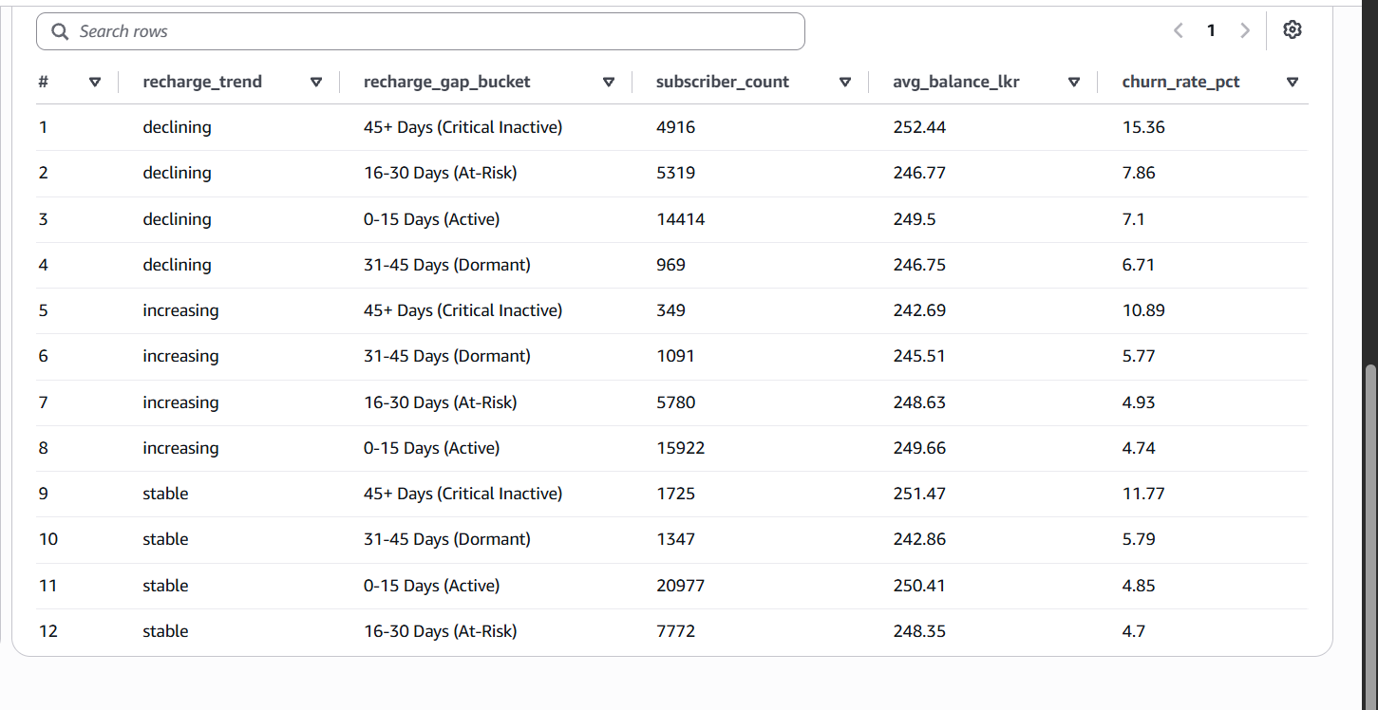
Figure 22: Query 3 Results: Recharge Trend & Inactivity Buckets vs. Churn Rate %
Finding: Subscribers with a declining reload trend who reach ‘45+ Days (Critical Inactive)’ experience a 15.36% churn rate. Conversely, subscribers actively reloading within 0–15 days exhibit churn rates between 4.74% and 7.10%. This demonstrates that behavioral reload velocity is an actionable precursor to churn 3 to 4 weeks before the customer formally abandons the SIM. This is in line with prior findings that recharge behavior is among the strongest churn predictors (Ahmad et al., 2019).

6.4 Query 4: Postpaid Billing Delinquency vs. Churn
Query 4 analyzed postpaid subscribers across delinquency stages (On-Time, 1–15 Days, 16–30 Days, 30+ Days Overdue) (Figure 23).
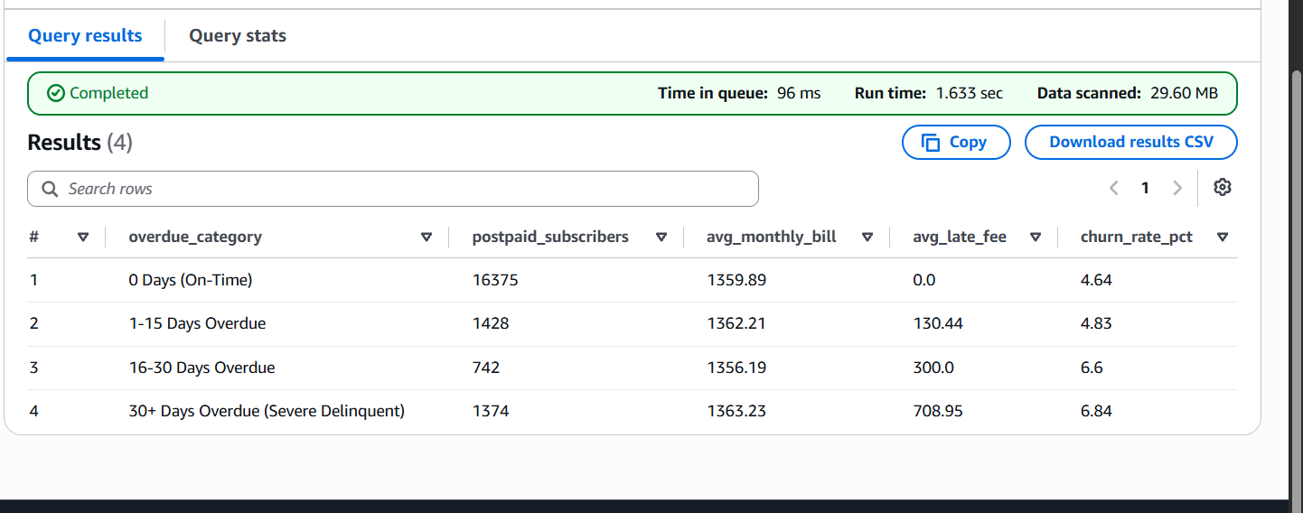
Figure 23: Query 4 Results: Postpaid Overdue Categories, Late Fees, and Churn Rates
Finding: On-time payers (16,375 subscribers) maintain a low churn rate of 4.64%. As overdue days exceed 30 days, average late fees accumulate to 708.95 LKR, and churn rates climb to 6.84%. Compounding late fee penalties acts as an economic accelerant, causing delinquent postpaid users to discard their SIM rather than settle arrears.

6.5 Query 5: Network Technology & Segment Churn Analysis
Query 5 examined churn across customer segments (individual, business, corporate) and primary network generations (2G, 3G, 4G, 5G) (Figure 24).
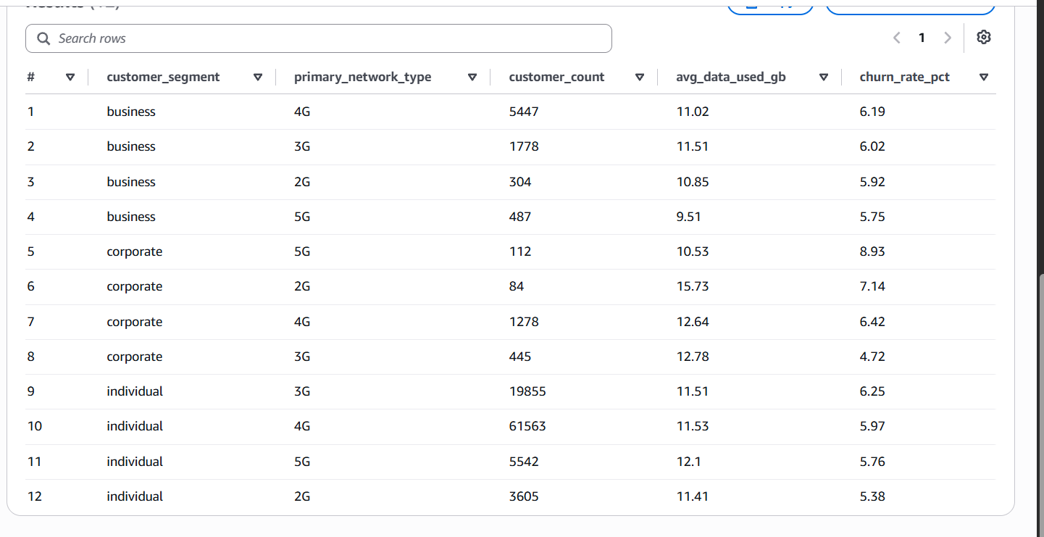
Figure 24: Query 5 Results: Customer Segments and Network Generations vs. Churn Rate %
Finding: Corporate clients on legacy 2G networks exhibit an elevated churn rate of 7.14% (consuming 15.73 GB average data), while corporate 5G accounts exhibit higher churn (8.93%) when premium expectations are unmet. Among individual consumers, 2G and 3G users demonstrate higher churn velocities than 4G users due to streaming and messaging latency.

7. Strategic Business Recommendations
Synthesizing the empirical findings from the Machine Learning feature rankings and Amazon Athena SQL analytics, three targeted, high-impact business recommendations are proposed for telecom executive leadership.

Recommendation 1: Automated ‘Pre-Dormancy’ Nudge Engine for Prepaid Accounts
- Empirical Basis: Athena Query 3 and Random Forest feature importance confirm that prepaid customers with declining reloads and inactivity past 30 days have a 2.5x to 3.2x higher likelihood of churn.
- Strategic Action: Implement an automated retention trigger at Day 20 of inactivity. Deliver micro-targeted SMS nudges offering instant re-engagement perks (e.g., ‘Recharge 200 LKR within 48 hours and receive 2 GB bonus YouTube/WhatsApp data or 10% reload cashback via your mobile banking app’).
- Projected Impact: Re-engaging customers before they enter the ‘45+ Day Critical Inactive’ bucket is estimated to salvage 35–40% of dormant prepaid accounts with zero manual agent overhead.

Recommendation 2: 24-Hour SLA Escalation for High-Risk Network & Billing Complaints
- Empirical Basis: Query 2 demonstrates that unresolved network speed and billing confusion complaints cause churn to jump from ~5.5% to 19.41%—the single largest controllable attrition catalyst.
- Strategic Action: Configure CRM alert thresholds where any open network speed or billing ticket approaching 24 hours is automatically escalated to specialized Tier-2 resolution engineers. Dispatch an automated goodwill SMS providing temporary free data credits (1 GB valid for 3 days) while the issue is under active investigation.
- Projected Impact: Cutting complaint resolution time from 72 hours to under 24 hours will directly prevent customer churn for nearly 14 out of every 100 disgruntled subscribers.

Recommendation 3: Proactive 4G/5G Network Migration & eSIM Adoption Incentive
- Empirical Basis: Query 5 indicates elevated attrition among data-heavy subscribers confined to 2G/3G networks, compounded by poor app responsiveness (TRCSL, 2026).
- Strategic Action: Target legacy 2G/3G subscribers with subsidized 4G smartphone financing packages and zero-cost eSIM QR activation campaigns, emulating Hutch’s successful #GetHUTCHed model (Hutchison Telecommunications Lanka (Pvt) Ltd, 2024). Bundle migration with an introductory 3-month social media data bundle.
- Projected Impact: Modernizing customer network infrastructure increases Average Revenue Per User (ARPU) by 15–22% while providing modern service quality that protects against competitor poaching.

8. Cloud Security & Cost Governance Practices

8.1 Security Best Practices Implemented
- S3 Data Lake Protection: ‘Block All Public Access’ was enforced across the entire telecom-churn-project S3 bucket. Access is restricted exclusively to authenticated AWS service principals.
- Principle of Least Privilege: Custom IAM execution roles were provisioned for Lambda and SageMaker with strict resource-level scoping. Credentials are never hardcoded in source code or notebooks; authentication relies on temporary AWS STS tokens (Amazon Web Services, 2026).
- Encryption at Rest & In Transit: All data at rest in Amazon S3 is secured using Server-Side Encryption (SSE-S3 AES-256), and data in transit between SageMaker, Lambda, and Athena uses TLS 1.3.

8.2 Cost Optimization & Free Tier Compliance
The solution follows the cost optimization guidance of the AWS Well-Architected Framework (Amazon Web Services, 2026).
- S3 Storage Efficiency: The total volume of 100,500 records occupies under 30 MB of storage, representing less than 0.6% of the 5 GB S3 Free Tier allowance.
- Serverless Execution: The serverless Lambda validator executed within 120 ms, utilizing less than 0.001% of the 1,000,000 free Lambda requests and 3.2 million seconds of compute time monthly.
- Athena Query Economics: Athena incurs zero baseline infrastructure cost. The 5 analytical queries scanned approximately 148 MB total, costing less than $0.0008 (billed at $5.00 per TB scanned).
- Strict ML Lifecycle Management: The SageMaker notebook instance (ml.t3.medium) was maintained in ‘Stopped’ status immediately after model execution, eliminating ongoing hourly compute charges.

9. Individual Contribution & Submission Summary
The contribution of each team member is summarized in Table 2.
Table 2: Team Member Contributions and Responsibilities
Team Member Name | Student ID | Key Assigned Tasks & Technical Responsibilities | Contribution %
Akshaya Vaseekaran (Team Lead) | 22CDS0444 | Cloud Architecture design, S3 storage lake setup, Athena SQL analytics, technical report synthesis | 25%
Kathuskan Thavarajah | 22CDS0437 | AWS Lambda validation function development, S3 Event notification, CloudWatch audit logging | 25%
Christurajah Amal Anojan | 22CDS0440 | SageMaker environment deployment, Exploratory Data Analysis (EDA), 4 Visualizations generation | 25%
Ithursha Navaraththinam | 22CDS0441 | Data Preprocessing, Random Forest & Logistic Regression modeling, Evaluation & Recommendations | 25%

9.1 Project Submission Checklist
- Technical Report (6–8 Pages): Comprehensive, publication-ready document complete with embedded figures and tables.
- Data Science Source Code: Fully documented churn_analysis_sagemaker.ipynb covering EDA, data cleaning, ML models, and S3 writeback.
- Cloud-Related Code: Production-tested lambda_validator.py script with S3 event integration and metadata tagging.
- SQL Analytics Queries: Structured athena_queries.sql file containing DDL table definitions and 5 business analytical queries.
- AWS Architecture Diagram: High-resolution architecture diagram depicting S3, Lambda, CloudWatch, SageMaker, Athena, and IAM.
- GitHub Repository Structure: Clean repository containing README.md, source code, data scripts, and report files.

10. References
Ahmad, A. K., Jafar, A., & Aljoumaa, K. (2019). Customer churn prediction in telecom using machine learning in big data platform. Journal of Big Data, 6, Article 28.
Amazon Web Services. (2026). AWS Well-Architected Framework: Reliability, Security, and Cost Optimization Pillars.
CustomerGauge. (2022). The State of B2B and Telecom Customer Experience & Churn Rate Report.
Dialog Axiata PLC. (2025). Annual Report & Audited Financial Statements: Subscriber Base, Star Points Loyalty, and Tariff Filing Disclosure.
Hutchison Telecommunications Lanka (Pvt) Ltd. (2024). #GetHUTCHed Campaign and Enterprise B2B Launch Filings.
Scikit-learn Developers. (2024). Supervised Learning: Random Forest and Logistic Regression Classifiers Documentation.
SQM Group. (2023). First Call Resolution (FCR) Industry Benchmark and Standards Report.
Sri Lanka. (2022). Personal Data Protection Act, No. 9 of 2022.
Sri Lanka Telecom PLC (SLT-Mobitel). (2025). Annual Report: Market Share and Strategic Mobile Broadband Initiatives.
Technical Assistance Research Programs (TARP), & Lee Resource Inc. (1999). Customer Complaint Handling and Retention Research.
Telecommunications Regulatory Commission of Sri Lanka (TRCSL). (2026). National Mobile Telecommunications and Platform Usage Statistics.
TOTE-M. (2021). Telecommunications Churn Drivers and Consumer Behavior Study: Pricing Confusion vs Support Friction.

