
V SEMESTER B.TECH. IT & CCE
End-Semester Examination, November 2022
SUBJECT: Network Programming and Simulation [ICT 3165]
REVISED CREDIT SYSTEM
(8/11/2022)
Time: 2:00 Hour MAX. MARKS: 40
0
Instructions to Candidates:
- Answer ALL the questions.
- Missing data, if any may be suitably assumed.

1. | Configure the network with required commands as shown in Figure 1. (5)  - Configure the yellow region with OSPF protocol, white region with RIP protocol and show the routing table of router 2. (8)  - Test the connectivity between Laptop 0 and Server0 by using command line. (3)  - Configure the VoIP for the below given topology and call IP Phone1 from IP Phone0. (3)  - Changes the Hello Interval timer to 20 seconds of router 2. (1)  Note:  - While configuring the network use same IP address as shown in figure 1.  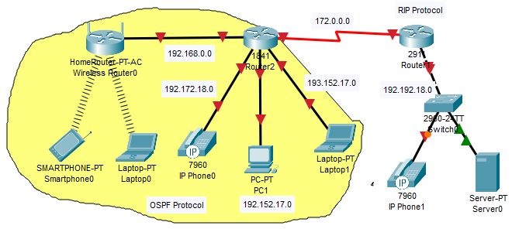  Figure 1: Network Configuration | 20
2 | Write two separate C programs (one for server and the other for client) using socket APIs, to implement the following connection-oriented client-server model to create a book database at the server side (structure) and store the following information: Book_ID,Book_Name, Title, Publisher_Name, Genre. Save the information for minimum 3 books. Note that the results must be displayed at the client side. (5)  The client program should display a menu for the following operations.  - Insert (5)  - Update (5)  - Search (4)  - Exit (1)  Client and Server will perform following operations as per menu options:  - Insert the information of each book and Display.  - Update the Genre of the book titled “Harry Potter” from Comic to Fantasy.  - Search and display the name of the author with maximum number of publications.  - Exit the application with “Bye” message. | 20

Q. No |  | Comments (Full / Partial (Min/Max) / No output) | Allotted  Marks | Obtained  Marks
1. |  |  | 5
1. | a. |  | 8
1. | b. |  | 3
1. | c. |  | 3
1. | d. |  | 1
2. |  |  | 5
2. | a. |  | 5
2. | b. |  | 5
2. | c. |  | 4
2. | d. |  | 1

