**Layout**

As a Web Developer, Building beautiful & Self explanatory website is really necessary. Specially designing a perfect blueprint is really necessary for organizing web page in well-defined manner. For the same we use "HTML Layout".

In this note you will be going to learn "What is HTML Layout?" & "Types of HTML Layout element".

What is HTML Layout?

HTML layout is used to design the structural appearance of the webpage. It is a method of designing the website using simple HTML elements.

Unable to understand yet?

Lets understand it using example of simple newspaper. Generally a Newspaper has big head, small sub-headings & smaller content in multiple rows consisting different news. The whole design is known as Layout of Newspaper.

Similarly, we design any website based on the content we want to display. We design our webpage using different HTML tags & attributes, This is known as layout (HTML layout).

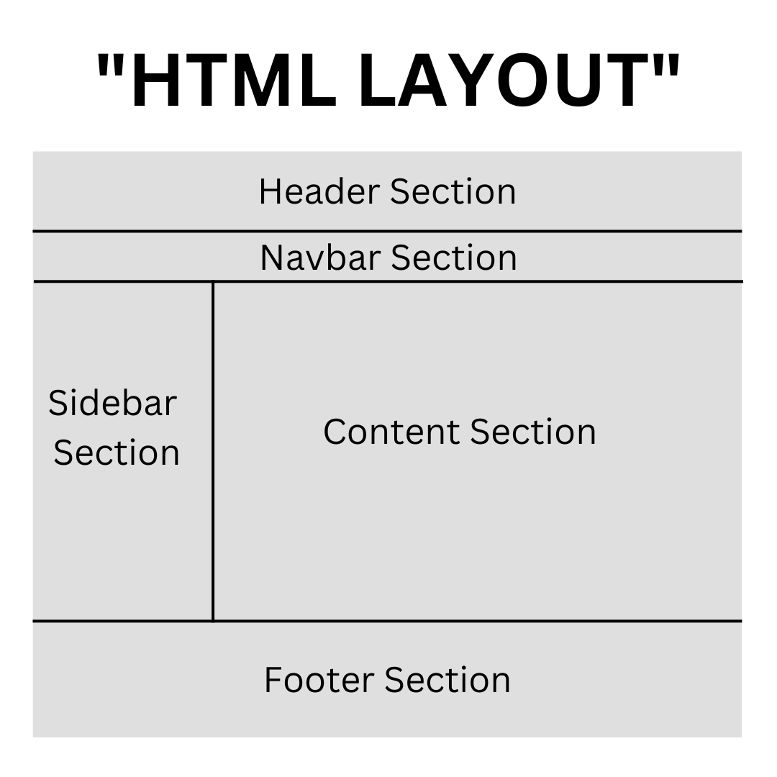

Types of HTML layout element

👉 <header> tag: It is used to define header part of Website.

👉 <section> tag: It is used to define a section in web page.

👉 <aside> tag: It is generally used for sidebar.

👉 <footer> tag: It is used to define footer part of Website.

We will be discussing about all the types of HTML layout in further articles.

Index of upcoming topic of Layout:

1. Header

2. Nav

3. Section

4. Aside

5.Footer

1. Header

What is Header section in HTML Layout?

The Header section is defined using <header> tag. It is used to represent introductory content of the page/document. <header> tag consists of heading elements like a navigation link, logo, page name etc.

Example:-

<header>

<div>hello i am header</div>

<div>i am execution of header</div>

</header>

2. Nav

What is Nav section in HTML Layout?

The Nav section is defined using <nav> tag. The <nav> tag is used to define the navigation section of a website. It's purpose is to provide navigation links to the other parts of website or to any external website.

The navigation sections usually contains a list or a nested list of navigation links for the website.

Example:-

<nav>

<a href="#home">Home</a>

<a href="#about">about</a>

<a href="#contact">contact</a>

</nav>

Above we have seen the implementation of <nav> tag inside webpage .

Section:-What is Section tag in HTML Layout?

The <section> tag is used to define the generalised section of a page if the page doesn't have a more specific semantic element to represent it.

Example:-

<main>

<section>

<h3>Content Section</h3>

</section>

</main>

Aside:-

What is Aside tag in HTML Layout?

The <aside> tag is used to define a portion of a document whose content is only indirectly related to the document's main content. In terms of working, <aside> tag is very similar to <div> tag but has different meaning.

But why should we use <aside> tag?

The <aside> tag makes it easy to design the page and it enhances the clarity of HTML document. We mainly use it as a highlight block in our website to showcase the highlighted or important content. In simple terms it provides information about the main content.

Ex: Sidebar on your web page can be put inside <aside> tag as it is related & provides information of main content of page but it's not the main content.

Example:-

<!DOCTYPE html>

<html lang="en">

<head>

<meta charset="UTF-8" />

<meta name="viewport" content="width=device-width, initial-scale=1.0" />

<title>Document</title>

</head>

<body>

<html>

<head>

<style>

article {

width: 50%;

padding: 10px;

float: left;

}

aside {

width: 40%;

float: right;

background-color: blue;

color: white;

padding: 5px;

margin: 22px;

height: 100px;

}

</style>

</head>

<body>

<!-- We are dividing HTML body in two segments (Article Segment & Index Segment)-->

<h1>In this example we are using aside tag for displaying index:</h1>

<article>

<!-- article tag consist the article... (Yes I know that tag name itself defines itself!!) -->

<h3>Why we use Aside tag?</h3>

<p>

Aside tag simply creates section or division & it only contains the

content that is related to the main web page. We mainly use it as a

highlight block in our website to showcase the highlighted or

important content.

</p>

</article>

<aside>

<!--We are using aside tag for highlighting the index cont

the article -->

<h1>Index:</h1>

<p>Why we use Aside tag?</p>

</aside>

</body>

</html>

</body>

</html>

In the above implementation we have created a highlighted block for index using HT <aside> tag inside HTML document. We can also do this <div> tag, but mainly we use <aside> tag for better SEO & readability of our HTML document.

Footer:-

What is Footer tag in HTML Layout?

The <footer> tag is use to defined the footer area or a section of the website. It mainly contains the navigation links, contact details, contact forms & copyright claim by the owner.

Example:-

</html>

<!DOCTYPE html>

<html>

<head>

<style>

footer {

width: 100%;

bottom: 0px;

background-color: #000;

color: #fff;

position: absolute;

padding-top: 20px;

padding-bottom: 50px;

text-align: center;

font-size: 30px;

}

</style>

</head>

<body>

<!-- Footer Section -->

<footer>Footer Section</footer>

</body>

</html>

Above we have seen the implementation of <footer> tag inside webpage.