**53900 - Analytics for Social Media Marketing**

Findings of Amazon Web data scraping

**Intro:**

Note: The data was directly from Amazon.com

I scraped sales data for 5 different brands of gaming laptops on Amazon. The data include product name, product price, and product rating. I chose Amazon because it not only sells its own products but also cooperates with third-party sellers. So the final result came from not only from 1 retailer, but several different retailers.

* The 5 brands(retailers) are: Asus, MSI, Acer, HP, and Lenovo
* 25 different laptops’ data every day, 175 laptops’ data in total(7-days scraping).
* Data is from 2 time slots: (a). 11/24/2023 - 11/27/2023, and (b). 12/05/2023 - 12/07/2023. The 1st time slot displays product price during Thanksgiving & Cyber Monday, and the 2nd time slot shows price for normal non-festival days.

**Comparison:**

Amazon is a dynamic shopping website, it has promotions, discounts, and all kinds of activity, so it changes its html contents very frequently. Sometimes the 5 products captured today and the next day might not be totally the same. But I was also able to capture the data of some popular products for 7 days. For better comparison, I re-organize the data structure into the following:

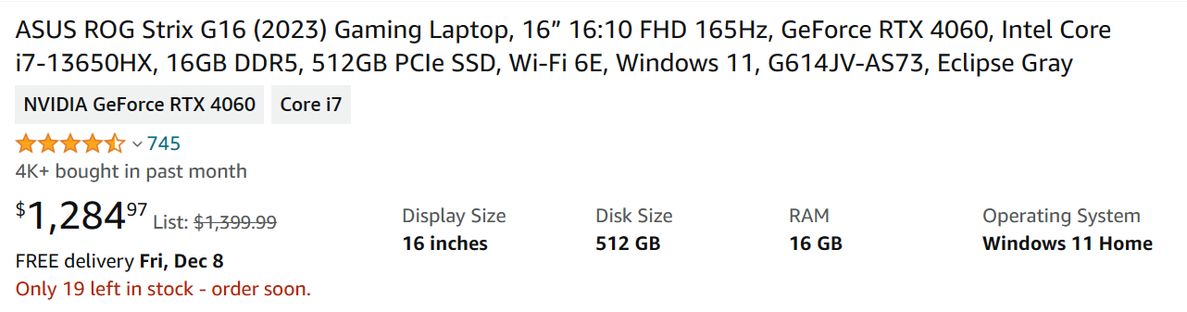2023-11-24 14:50:24 - 1,099 - 4.4 out of 5 stars

2023-11-25 14:50:43 - 1,099 - 4.4 out of 5 stars

2023-11-26 14:50:39 - 1,099 - 4.4 out of 5 stars

2023-11-27 14:50:45 - 1,099 - 4.4 out of 5 stars

2023-12-05 16:36:11 - 1,284 - 4.4 out of 5 stars

2023-12-06 00:01:27 - 1,284 - 4.4 out of 5 stars

2023-12-07 02:10:52 - 1,282 - 4.4 out of 5 stars

This is one of the newest version of Asus gaming laptop, my data indicates a clear pattern of price reduction during the Thanksgiving and Cyber Monday period, followed by a return to normal pricing. Manufacturers and retailers should capitalize on this trend by planning strategic discounts during these peak shopping times. This approach not only boosts sales but also attracts price-sensitive consumers who are waiting for such occasions. Furthermore, the consistent consumer ratings across different time periods suggest a stable quality perception among consumers. Manufacturers should maintain this consistency in product quality, as it reinforces brand reliability and trust. Retailers can leverage this consistency in their marketing campaigns, emphasizing the sustained high ratings as a testament to quality. This approach can maximize ROI on marketing spend. Also, Amazon collaborates with various third-party sellers, manufacturers should leverage this multi-retailer platform to expand their reach. They can provide exclusive deals or bundles to different retailers, creating a sense of uniqueness and attracting diverse customer segments.

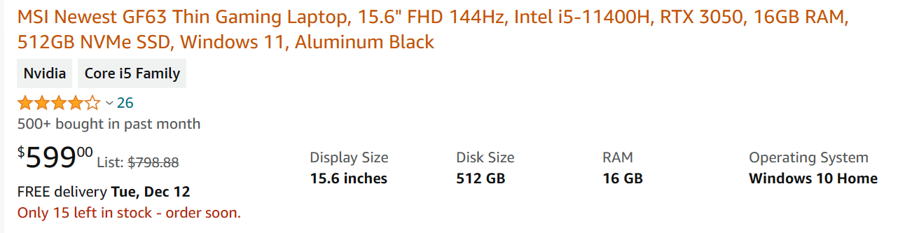

2023-11-24 14:50:38 - 849 - 4.4 out of 5 stars

2023-11-25 14:50:57 - 849 - 4.4 out of 5 stars

2023-11-26 14:50:51 - 899 - 4.4 out of 5 stars

2023-11-27 14:50:58 - 602 - 4.4 out of 5 stars

2023-12-05 16:36:27 - 599 - 4.2 out of 5 stars

2023-12-06 00:01:40 - 599 - 4.2 out of 5 stars

2023-12-07 02:11:05 - 599 - 4.2 out of 5 stars

I also see some products with pretty serious price fluctuation: For this particular MSI product, there was a notable drop to $602 on November 27 and $599 on December 5. Retailers should highlight these price drops in their marketing campaigns to attract budget-conscious consumers. Flash sales or limited-time offers can be particularly effective in driving quick sales. Also notably, the drop in consumer rating from 4.4 to 4.2 stars suggests some level of customer dissatisfaction or changing perceptions. Manufacturers should investigate the reasons behind this rating change. If it's due to product issues, they should address these in future iterations. Retailers can also use this information to adjust their sales strategies or provide additional information to potential buyers to manage expectations. The significant price drop on November 27 could be due to Cyber Monday sales. But because the overall sale has been not very ideal, I also have a sense that the price drop is possibly because of inventory clearance. Besides, retailers should plan similar strategic discounting events, not just during traditional sale periods but also at other times to capture market attention. This could include back-to-school sales, new semester promotions, or gaming tournaments etc..