Note:The compared items selected are highlighted in yellow

**2023/11/24**

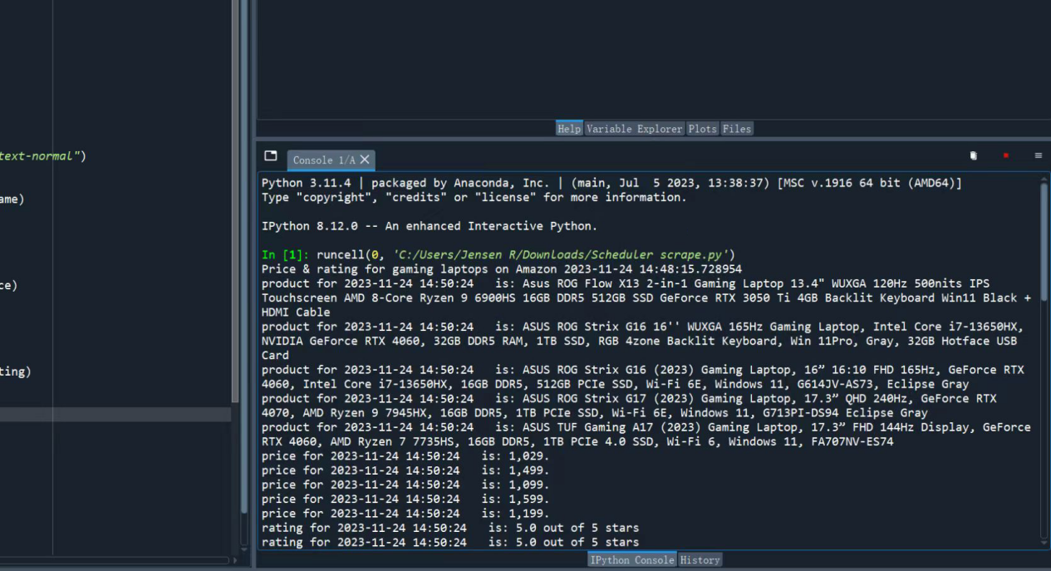

Price & rating for gaming laptops on Amazon 2023-11-24 14:48:15.728954

product for 2023-11-24 14:50:24 is: Asus ROG Flow X13 2-in-1 Gaming Laptop 13.4" WUXGA 120Hz 500nits IPS Touchscreen AMD 8-Core Ryzen 9 6900HS 16GB DDR5 512GB SSD GeForce RTX 3050 Ti 4GB Backlit Keyboard Win11 Black + HDMI Cable

product for 2023-11-24 14:50:24 is: ASUS ROG Strix G16 16'' WUXGA 165Hz Gaming Laptop, Intel Core i7-13650HX, NVIDIA GeForce RTX 4060, 32GB DDR5 RAM, 1TB SSD, RGB 4zone Backlit Keyboard, Win 11Pro, Gray, 32GB Hotface USB Card

product for 2023-11-24 14:50:24 is: ASUS ROG Strix G16 (2023) Gaming Laptop, 16” 16:10 FHD 165Hz, GeForce RTX 4060, Intel Core i7-13650HX, 16GB DDR5, 512GB PCIe SSD, Wi-Fi 6E, Windows 11, G614JV-AS73, Eclipse Gray

product for 2023-11-24 14:50:24 is: ASUS ROG Strix G17 (2023) Gaming Laptop, 17.3” QHD 240Hz, GeForce RTX 4070, AMD Ryzen 9 7945HX, 16GB DDR5, 1TB PCIe SSD, Wi-Fi 6E, Windows 11, G713PI-DS94 Eclipse Gray

product for 2023-11-24 14:50:24 is: ASUS TUF Gaming A17 (2023) Gaming Laptop, 17.3” FHD 144Hz Display, GeForce RTX 4060, AMD Ryzen 7 7735HS, 16GB DDR5, 1TB PCIe 4.0 SSD, Wi-Fi 6, Windows 11, FA707NV-ES74

price for 2023-11-24 14:50:24 is: 1,029.

price for 2023-11-24 14:50:24 is: 1,499.

price for 2023-11-24 14:50:24 is: 1,099.

price for 2023-11-24 14:50:24 is: 1,599.

price for 2023-11-24 14:50:24 is: 1,199.

rating for 2023-11-24 14:50:24 is: 5.0 out of 5 stars

rating for 2023-11-24 14:50:24 is: 5.0 out of 5 stars

rating for 2023-11-24 14:50:24 is: 4.4 out of 5 stars

rating for 2023-11-24 14:50:24 is: 4.0 out of 5 stars

rating for 2023-11-24 14:50:24 is: 4.5 out of 5 stars

product for 2023-11-24 14:50:38 is: MSI Cyborg 15 Gaming Laptop 15.6" FHD IPS 144Hz Display 12th Gen Intel 10-core i7-12650H Processor 16GB RAM 1TB SSD GeForce RTX 4060 8GB Graphics Backlit Keyboard USB-C Win11 Black + HDMI Cable

product for 2023-11-24 14:50:38 is: MSI Thin GF63 15.6” FHD 144Hz Gaming Laptop, Intel Core i5-12450H Processor, NVIDIA GeForce RTX 2050, 32GB RAM, 1TB PCIe SSD, Backlit Keyboard, WiFi 6, Black, Win 11 Pro, 32GB Snowbell USB Card

product for 2023-11-24 14:50:38 is: MSI Thin GF63 15.6" 144Hz Gaming Laptop: 12th Gen Intel Core i7, NVIDIA GeForce RTX 4050, 16GB DDR4, 512GB NVMe SSD, Type-C, Cooler Boost 5, Win11 Home: Black 12VE-066US

product for 2023-11-24 14:50:38 is: MSI Katana 17 Gaming Laptop: 13th Gen Intel Core i7, GeForce RTX 4060, 17.3" 144Hz FHD Display, 32GB DDR5, 1TB NVMe SSD, USB-Type C, Cooler Boost 5, Win11 Home: Black B13VFK-835US

product for 2023-11-24 14:50:38 is: MSI Newest GF63 Thin Gaming Laptop, 15.6" FHD 144Hz, Intel i5-11400H, RTX 3050, 16GB RAM, 512GB NVMe SSD, Windows 11, Aluminum Black

price for 2023-11-24 14:50:38 is: 1,199.

price for 2023-11-24 14:50:38 is: 799.

price for 2023-11-24 14:50:38 is: 2,399.

price for 2023-11-24 14:50:38 is: 1,169.

price for 2023-11-24 14:50:38 is: 849.

rating for 2023-11-24 14:50:38 is: 5.0 out of 5 stars

rating for 2023-11-24 14:50:38 is: 4.4 out of 5 stars

rating for 2023-11-24 14:50:38 is: 4.5 out of 5 stars

rating for 2023-11-24 14:50:38 is: 4.3 out of 5 stars

rating for 2023-11-24 14:50:38 is: 4.4 out of 5 stars

product for 2023-11-24 14:50:51 is: Acer Swift Go Intel Evo Thin & Light Premium Laptop 14" 1920x1200 100% sRGB Touch Screen Display Intel Core i7-1355U Intel Iris Xe 16GB LPDDR5 512GB Gen 4 SSD SFG14-71T-72QV

product for 2023-11-24 14:50:51 is: Acer Predator Helios 300 15 Gaming Laptop | 15.6'' FHD 165Hz | 12th Gen Intel 14-Core i7-12700H | 32GB DDR5 1TB SSD + 1TB SSD | GeForce RTX 3060 6GB | Backlit Thunderbolt Win11 + 32GB MicroSD Card

product for 2023-11-24 14:50:51 is: Acer Nitro 5 AN515-58-525P Gaming Laptop |Core i5-12500H | NVIDIA GeForce RTX 3050 Laptop GPU | 15.6" FHD 144Hz IPS Display | 8GB DDR4 | 512GB PCIe Gen 4 SSD | Killer Wi-Fi 6 | Backlit Keyboard, Black

product for 2023-11-24 14:50:51 is: Acer Nitro 17 Gaming Laptop | AMD Ryzen 7 7840HS Octa-Core CPU | NVIDIA GeForce RTX 4060 Laptop GPU | 17.3" QHD 165Hz IPS Display | 1TB Gen 4 SSD | Wi-Fi 6E | RGB Backlit KB | AN17-41-R7G3, Black

product for 2023-11-24 14:50:51 is: Acer Nitro 17 Gaming Laptop | AMD Ryzen 7 7735HS Octa-Core CPU | NVIDIA GeForce RTX 4050 GPU | 17.3" FHD 165Hz IPS Display | 16GB DDR5 | 1TB Gen 4 SSD | Wi-Fi 6E | RGB Backlit KB | AN17-41-R8N5, Black

price for 2023-11-24 14:50:51 is: 649.

price for 2023-11-24 14:50:51 is: 1,599.

price for 2023-11-24 14:50:51 is: 599.

price for 2023-11-24 14:50:51 is: 999.

price for 2023-11-24 14:50:51 is: 969.

rating for 2023-11-24 14:50:51 is: 4.2 out of 5 stars

rating for 2023-11-24 14:50:51 is: 4.6 out of 5 stars

rating for 2023-11-24 14:50:51 is: 4.4 out of 5 stars

rating for 2023-11-24 14:50:51 is: 4.3 out of 5 stars

rating for 2023-11-24 14:50:51 is: 4.3 out of 5 stars

product for 2023-11-24 14:51:05 is: HP Essential 14 Laptop, 14" HD Touchscreen, AMD Ryzen 3 5300U, 32GB RAM, 1TB SSD, Webcam, HDMI, Wi-Fi, Windows 11 Home, Black

product for 2023-11-24 14:51:05 is: HP Newest 17t Laptop, 17.3" HD+ Touchscreen, Intel Core i5-1135G7, 32GB RAM, 1TB SSD, Webcam, HDMI, Backlit KB, Wi-Fi 6, Windows 11 Home, Silver

product for 2023-11-24 14:51:05 is: HP Victus 15 Gaming Laptop, 15.6" FHD 144Hz Display, AMD Ryzen 5 7535HS, 16GB DDR5 RAM, 512GB PCIe M.2 SSD, NVIDIA GeForce RTX 2050, HDMI, Webcam, Backlit Keyboard, Wi-Fi 6, Windows 11 Home, Silver

product for 2023-11-24 14:51:05 is: HP Victus 15.6" Full HD 144Hz Gaming Laptop | AMD Ryzen 5 7535HS | NVIDIA GeForce RTX 2050 | 8GB RAM DDR5| 512GB SSD | Backlit | Windows 11 Home | Bundle with 64GB USB Flash Drive, Mica Silver

product for 2023-11-24 14:51:05 is: HP - Victus 15.6" Gaming Laptop - Intel Core i5-12450H - 8GB Memory - NVIDIA GeForce GTX 1650-512GB SSD - Mica Silver - Model 15-fa0031dx

price for 2023-11-24 14:51:05 is: 482.

price for 2023-11-24 14:51:05 is: 719.

price for 2023-11-24 14:51:05 is: 565.

price for 2023-11-24 14:51:05 is: 548.

price for 2023-11-24 14:51:05 is: 585.

rating for 2023-11-24 14:51:05 is: 4.4 out of 5 stars

rating for 2023-11-24 14:51:05 is: 4.4 out of 5 stars

rating for 2023-11-24 14:51:05 is: 4.2 out of 5 stars

rating for 2023-11-24 14:51:05 is: 4.5 out of 5 stars

rating for 2023-11-24 14:51:05 is: 4.4 out of 5 stars

product for 2023-11-24 14:51:20 is: Lenovo LOQ Gaming Laptop, NVIDIA GeForce RTX 4060, Intel 13th Gen i7-13700H, 15.6" FHD 144Hz Display, 32GB DDR5 RAM, 2TB PCIe SSD, Webcam, HDMI, RJ45, Backlit KB, Wi-Fi 6, Windows 11 Home, Grey

product for 2023-11-24 14:51:20 is: Lenovo LOQ Gaming Laptop, 15.6" FHD 144Hz Display, NVIDIA GeForce RTX 4060, Intel 13th Gen i7-13700H, 16GB DDR5 RAM, 1TB PCIe SSD, Webcam, RJ45, Backlit KB, HDMI, Wi-Fi 6, Windows 11 Home

product for 2023-11-24 14:51:20 is: Lenovo IdeaPad Gaming 3 15 Laptop, 15.6" FHD Display, AMD Ryzen 5 5600H, NVIDIA GeForce GTX 1650, 8GB RAM, 256GB Storage, Windows 10H

product for 2023-11-24 14:51:20 is: Lenovo IdeaPad Gaming 3 - (2022) - Essential Gaming Laptop Computer - 15.6" FHD - 120Hz - AMD Ryzen 5 6600H - NVIDIA GeForce RTX 3050 - 8GB DDR5 RAM - 256GB NVMe Storage - Windows 11 Home

product for 2023-11-24 14:51:20 is: Lenovo Legion Pro 5i - (2023) - Gaming Laptop Computer - NVIDIA GeForce RTX 4060-16" WQXGA - 165Hz - Intel Core i7-13700HX - 16GB RAM - 1TB SSD - Windows 11-3-Month Xbox GamePass Included

price for 2023-11-24 14:51:20 is: 1,349.

price for 2023-11-24 14:51:20 is: 1,449.

price for 2023-11-24 14:51:20 is: 609.

price for 2023-11-24 14:51:20 is: 673.

price for 2023-11-24 14:51:20 is: 1,249.

rating for 2023-11-24 14:51:20 is: 4.4 out of 5 stars

rating for 2023-11-24 14:51:20 is: 5.0 out of 5 stars

rating for 2023-11-24 14:51:20 is: 4.6 out of 5 stars

rating for 2023-11-24 14:51:20 is: 4.3 out of 5 stars

rating for 2023-11-24 14:51:20 is: 4.3 out of 5 stars

**2023/11/25**

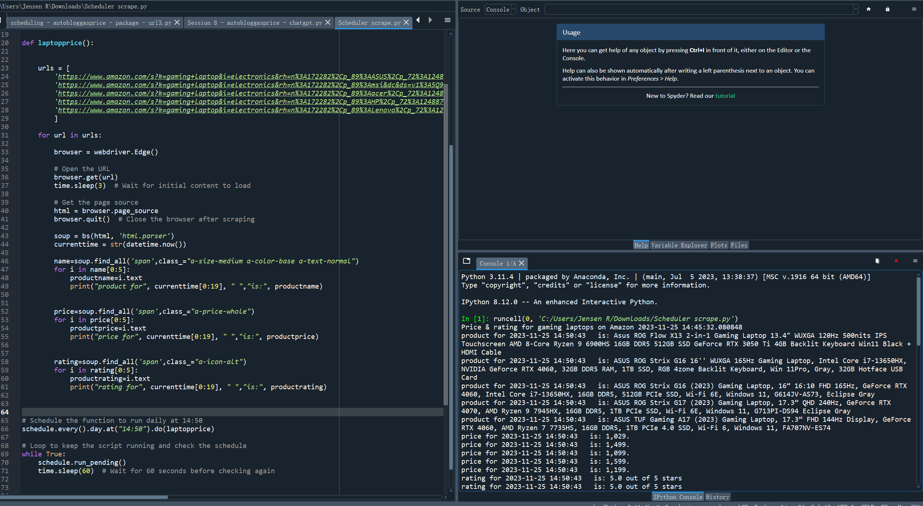

Price & rating for gaming laptops on Amazon 2023-11-25 14:45:32.080848

product for 2023-11-25 14:50:43 is: Asus ROG Flow X13 2-in-1 Gaming Laptop 13.4" WUXGA 120Hz 500nits IPS Touchscreen AMD 8-Core Ryzen 9 6900HS 16GB DDR5 512GB SSD GeForce RTX 3050 Ti 4GB Backlit Keyboard Win11 Black + HDMI Cable

product for 2023-11-25 14:50:43 is: ASUS ROG Strix G16 16'' WUXGA 165Hz Gaming Laptop, Intel Core i7-13650HX, NVIDIA GeForce RTX 4060, 32GB DDR5 RAM, 1TB SSD, RGB 4zone Backlit Keyboard, Win 11Pro, Gray, 32GB Hotface USB Card

product for 2023-11-25 14:50:43 is: ASUS ROG Strix G16 (2023) Gaming Laptop, 16” 16:10 FHD 165Hz, GeForce RTX 4060, Intel Core i7-13650HX, 16GB DDR5, 512GB PCIe SSD, Wi-Fi 6E, Windows 11, G614JV-AS73, Eclipse Gray

product for 2023-11-25 14:50:43 is: ASUS ROG Strix G17 (2023) Gaming Laptop, 17.3” QHD 240Hz, GeForce RTX 4070, AMD Ryzen 9 7945HX, 16GB DDR5, 1TB PCIe SSD, Wi-Fi 6E, Windows 11, G713PI-DS94 Eclipse Gray

product for 2023-11-25 14:50:43 is: ASUS TUF Gaming A17 (2023) Gaming Laptop, 17.3” FHD 144Hz Display, GeForce RTX 4060, AMD Ryzen 7 7735HS, 16GB DDR5, 1TB PCIe 4.0 SSD, Wi-Fi 6, Windows 11, FA707NV-ES74

price for 2023-11-25 14:50:43 is: 1,029.

price for 2023-11-25 14:50:43 is: 1,499.

price for 2023-11-25 14:50:43 is: 1,099.

price for 2023-11-25 14:50:43 is: 1,599.

price for 2023-11-25 14:50:43 is: 1,199.

rating for 2023-11-25 14:50:43 is: 5.0 out of 5 stars

rating for 2023-11-25 14:50:43 is: 5.0 out of 5 stars

rating for 2023-11-25 14:50:43 is: 4.4 out of 5 stars

rating for 2023-11-25 14:50:43 is: 4.0 out of 5 stars

rating for 2023-11-25 14:50:43 is: 4.5 out of 5 stars

product for 2023-11-25 14:50:57 is: MSI Cyborg 15 Gaming Laptop 15.6" FHD IPS 144Hz Display 12th Gen Intel 10-core i7-12650H Processor 16GB RAM 1TB SSD GeForce RTX 4060 8GB Graphics Backlit Keyboard USB-C Win11 Black + HDMI Cable

product for 2023-11-25 14:50:57 is: MSI Thin GF63 15.6” FHD 144Hz Gaming Laptop, Intel Core i5-12450H Processor, NVIDIA GeForce RTX 2050, 32GB RAM, 1TB PCIe SSD, Backlit Keyboard, WiFi 6, Black, Win 11 Pro, 32GB Snowbell USB Card

product for 2023-11-25 14:50:57 is: MSI Thin GF63 15.6" 144Hz Gaming Laptop: 12th Gen Intel Core i7, NVIDIA GeForce RTX 4050, 16GB DDR4, 512GB NVMe SSD, Type-C, Cooler Boost 5, Win11 Home: Black 12VE-066US

product for 2023-11-25 14:50:57 is: MSI Katana 17 Gaming Laptop: 13th Gen Intel Core i7, GeForce RTX 4060, 17.3" 144Hz FHD Display, 32GB DDR5, 1TB NVMe SSD, USB-Type C, Cooler Boost 5, Win11 Home: Black B13VFK-835US

product for 2023-11-25 14:50:57 is: MSI Newest GF63 Thin Gaming Laptop, 15.6" FHD 144Hz, Intel i5-11400H, RTX 3050, 16GB RAM, 512GB NVMe SSD, Windows 11, Aluminum Black

price for 2023-11-25 14:50:57 is: 1,199.

price for 2023-11-25 14:50:57 is: 799.

price for 2023-11-25 14:50:57 is: 2,399.

price for 2023-11-25 14:50:57 is: 1,169.

price for 2023-11-25 14:50:57 is: 849.

rating for 2023-11-25 14:50:57 is: 5.0 out of 5 stars

rating for 2023-11-25 14:50:57 is: 4.4 out of 5 stars

rating for 2023-11-25 14:50:57 is: 4.5 out of 5 stars

rating for 2023-11-25 14:50:57 is: 4.3 out of 5 stars

rating for 2023-11-25 14:50:57 is: 4.4 out of 5 stars

product for 2023-11-25 14:51:10 is: Acer Swift Go Intel Evo Thin & Light Premium Laptop 14" 1920x1200 100% sRGB Touch Screen Display Intel Core i7-1355U Intel Iris Xe 16GB LPDDR5 512GB Gen 4 SSD SFG14-71T-72QV

product for 2023-11-25 14:51:10 is: Acer Predator Helios 300 15 Gaming Laptop | 15.6'' FHD 165Hz | 12th Gen Intel 14-Core i7-12700H | 32GB DDR5 1TB SSD + 1TB SSD | GeForce RTX 3060 6GB | Backlit Thunderbolt Win11 + 32GB MicroSD Card

product for 2023-11-25 14:51:10 is: Acer Nitro 5 AN515-58-525P Gaming Laptop |Core i5-12500H | NVIDIA GeForce RTX 3050 Laptop GPU | 15.6" FHD 144Hz IPS Display | 8GB DDR4 | 512GB PCIe Gen 4 SSD | Killer Wi-Fi 6 | Backlit Keyboard, Black

product for 2023-11-25 14:51:10 is: Acer Nitro 17 Gaming Laptop | AMD Ryzen 7 7840HS Octa-Core CPU | NVIDIA GeForce RTX 4060 Laptop GPU | 17.3" QHD 165Hz IPS Display | 1TB Gen 4 SSD | Wi-Fi 6E | RGB Backlit KB | AN17-41-R7G3, Black

product for 2023-11-25 14:51:10 is: Acer Nitro 17 Gaming Laptop | AMD Ryzen 7 7735HS Octa-Core CPU | NVIDIA GeForce RTX 4050 GPU | 17.3" FHD 165Hz IPS Display | 16GB DDR5 | 1TB Gen 4 SSD | Wi-Fi 6E | RGB Backlit KB | AN17-41-R8N5, Black

price for 2023-11-25 14:51:10 is: 649.

price for 2023-11-25 14:51:10 is: 1,599.

price for 2023-11-25 14:51:10 is: 599.

price for 2023-11-25 14:51:10 is: 999.

price for 2023-11-25 14:51:10 is: 969.

rating for 2023-11-25 14:51:10 is: 4.2 out of 5 stars

rating for 2023-11-25 14:51:10 is: 4.6 out of 5 stars

rating for 2023-11-25 14:51:10 is: 4.4 out of 5 stars

rating for 2023-11-25 14:51:10 is: 4.3 out of 5 stars

rating for 2023-11-25 14:51:10 is: 4.3 out of 5 stars

product for 2023-11-25 14:51:26 is: HP Essential 14 Laptop, 14" HD Touchscreen, AMD Ryzen 3 5300U, 32GB RAM, 1TB SSD, Webcam, HDMI, Wi-Fi, Windows 11 Home, Black

product for 2023-11-25 14:51:26 is: HP Newest 17t Laptop, 17.3" HD+ Touchscreen, Intel Core i5-1135G7, 32GB RAM, 1TB SSD, Webcam, HDMI, Backlit KB, Wi-Fi 6, Windows 11 Home, Silver

product for 2023-11-25 14:51:26 is: HP Victus 15 Gaming Laptop, 15.6" FHD 144Hz Display, AMD Ryzen 5 7535HS, 16GB DDR5 RAM, 512GB PCIe M.2 SSD, NVIDIA GeForce RTX 2050, HDMI, Webcam, Backlit Keyboard, Wi-Fi 6, Windows 11 Home, Silver

product for 2023-11-25 14:51:26 is: HP Victus 15.6" Full HD 144Hz Gaming Laptop | AMD Ryzen 5 7535HS | NVIDIA GeForce RTX 2050 | 8GB RAM DDR5| 512GB SSD | Backlit | Windows 11 Home | Bundle with 64GB USB Flash Drive, Mica Silver

product for 2023-11-25 14:51:26 is: HP - Victus 15.6" Gaming Laptop - Intel Core i5-12450H - 8GB Memory - NVIDIA GeForce GTX 1650-512GB SSD - Mica Silver - Model 15-fa0031dx

price for 2023-11-25 14:51:26 is: 482.

price for 2023-11-25 14:51:26 is: 719.

price for 2023-11-25 14:51:26 is: 565.

price for 2023-11-25 14:51:26 is: 548.

price for 2023-11-25 14:51:26 is: 585.

rating for 2023-11-25 14:51:26 is: 4.4 out of 5 stars

rating for 2023-11-25 14:51:26 is: 4.4 out of 5 stars

rating for 2023-11-25 14:51:26 is: 4.2 out of 5 stars

rating for 2023-11-25 14:51:26 is: 4.5 out of 5 stars

rating for 2023-11-25 14:51:26 is: 4.4 out of 5 stars

product for 2023-11-25 14:51:42 is: Lenovo LOQ Gaming Laptop, NVIDIA GeForce RTX 4060, Intel 13th Gen i7-13700H, 15.6" FHD 144Hz Display, 32GB DDR5 RAM, 2TB PCIe SSD, Webcam, HDMI, RJ45, Backlit KB, Wi-Fi 6, Windows 11 Home, Grey

product for 2023-11-25 14:51:42 is: Lenovo LOQ Gaming Laptop, 15.6" FHD 144Hz Display, NVIDIA GeForce RTX 4060, Intel 13th Gen i7-13700H, 16GB DDR5 RAM, 1TB PCIe SSD, Webcam, RJ45, Backlit KB, HDMI, Wi-Fi 6, Windows 11 Home

product for 2023-11-25 14:51:42 is: Lenovo IdeaPad Gaming 3 15 Laptop, 15.6" FHD Display, AMD Ryzen 5 5600H, NVIDIA GeForce GTX 1650, 8GB RAM, 256GB Storage, Windows 10H

product for 2023-11-25 14:51:42 is: Lenovo IdeaPad Gaming 3 - (2022) - Essential Gaming Laptop Computer - 15.6" FHD - 120Hz - AMD Ryzen 5 6600H - NVIDIA GeForce RTX 3050 - 8GB DDR5 RAM - 256GB NVMe Storage - Windows 11 Home

product for 2023-11-25 14:51:42 is: Lenovo Legion Pro 5i - (2023) - Gaming Laptop Computer - NVIDIA GeForce RTX 4060-16" WQXGA - 165Hz - Intel Core i7-13700HX - 16GB RAM - 1TB SSD - Windows 11-3-Month Xbox GamePass Included

price for 2023-11-25 14:51:42 is: 1,349.

price for 2023-11-25 14:51:42 is: 1,449.

price for 2023-11-25 14:51:42 is: 609.

price for 2023-11-25 14:51:42 is: 673.

price for 2023-11-25 14:51:42 is: 1,249.

rating for 2023-11-25 14:51:42 is: 4.4 out of 5 stars

rating for 2023-11-25 14:51:42 is: 5.0 out of 5 stars

rating for 2023-11-25 14:51:42 is: 4.6 out of 5 stars

rating for 2023-11-25 14:51:42 is: 4.3 out of 5 stars

rating for 2023-11-25 14:51:42 is: 4.3 out of 5 stars

**2023/11/26**

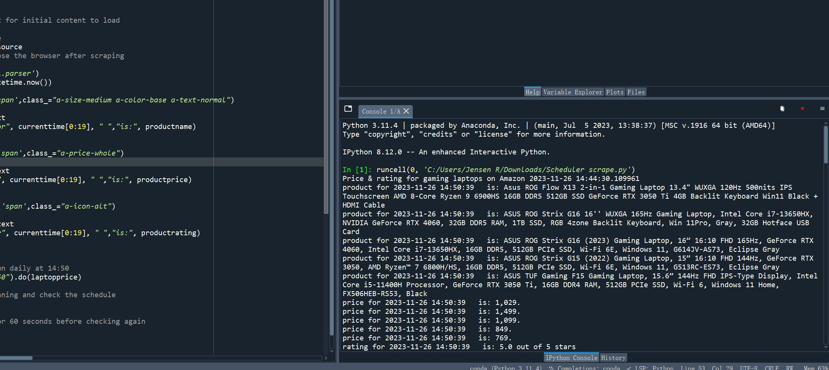

Price & rating for gaming laptops on Amazon 2023-11-26 14:44:30.109961

product for 2023-11-26 14:50:39 is: Asus ROG Flow X13 2-in-1 Gaming Laptop 13.4" WUXGA 120Hz 500nits IPS Touchscreen AMD 8-Core Ryzen 9 6900HS 16GB DDR5 512GB SSD GeForce RTX 3050 Ti 4GB Backlit Keyboard Win11 Black + HDMI Cable

product for 2023-11-26 14:50:39 is: ASUS ROG Strix G16 16'' WUXGA 165Hz Gaming Laptop, Intel Core i7-13650HX, NVIDIA GeForce RTX 4060, 32GB DDR5 RAM, 1TB SSD, RGB 4zone Backlit Keyboard, Win 11Pro, Gray, 32GB Hotface USB Card

product for 2023-11-26 14:50:39 is: ASUS ROG Strix G16 (2023) Gaming Laptop, 16” 16:10 FHD 165Hz, GeForce RTX 4060, Intel Core i7-13650HX, 16GB DDR5, 512GB PCIe SSD, Wi-Fi 6E, Windows 11, G614JV-AS73, Eclipse Gray

product for 2023-11-26 14:50:39 is: ASUS ROG Strix G15 (2022) Gaming Laptop, 15” 16:10 FHD 144Hz, GeForce RTX 3050, AMD Ryzen™ 7 6800H/HS, 16GB DDR5, 512GB PCIe SSD, Wi-Fi 6E, Windows 11, G513RC-ES73, Eclipse Gray

product for 2023-11-26 14:50:39 is: ASUS TUF Gaming F15 Gaming Laptop, 15.6” 144Hz FHD IPS-Type Display, Intel Core i5-11400H Processor, GeForce RTX 3050 Ti, 16GB DDR4 RAM, 512GB PCIe SSD, Wi-Fi 6, Windows 11 Home, FX506HEB-RS53, Black

price for 2023-11-26 14:50:39 is: 1,029.

price for 2023-11-26 14:50:39 is: 1,499.

price for 2023-11-26 14:50:39 is: 1,099.

price for 2023-11-26 14:50:39 is: 849.

price for 2023-11-26 14:50:39 is: 769.

rating for 2023-11-26 14:50:39 is: 5.0 out of 5 stars

rating for 2023-11-26 14:50:39 is: 5.0 out of 5 stars

rating for 2023-11-26 14:50:39 is: 4.4 out of 5 stars

rating for 2023-11-26 14:50:39 is: 4.6 out of 5 stars

rating for 2023-11-26 14:50:39 is: 4.5 out of 5 stars

product for 2023-11-26 14:50:51 is: MSI Cyborg 15 Gaming Laptop 15.6" FHD IPS 144Hz Display 12th Gen Intel 10-core i7-12650H Processor 16GB RAM 1TB SSD GeForce RTX 4060 8GB Graphics Backlit Keyboard USB-C Win11 Black + HDMI Cable

product for 2023-11-26 14:50:51 is: MSI Thin GF63 15.6” FHD 144Hz Gaming Laptop, Intel Core i5-12450H Processor, NVIDIA GeForce RTX 2050, 32GB RAM, 2TB PCIe SSD, Backlit Keyboard, WiFi 6, Black, Win 11 Pro, 32GB Snowbell USB Card

product for 2023-11-26 14:50:51 is: MSI Thin GF63 15.6" 144Hz Gaming Laptop: 12th Gen Intel Core i7, NVIDIA GeForce RTX 4050, 16GB DDR4, 512GB NVMe SSD, Type-C, Cooler Boost 5, Win11 Home: Black 12VE-066US

product for 2023-11-26 14:50:51 is: MSI Katana 17 Gaming Laptop: 13th Gen Intel Core i7, GeForce RTX 4060, 17.3" 144Hz FHD Display, 32GB DDR5, 1TB NVMe SSD, USB-Type C, Cooler Boost 5, Win11 Home: Black B13VFK-835US

product for 2023-11-26 14:50:51 is: MSI Newest GF63 Thin Gaming Laptop, 15.6" FHD 144Hz, Intel i5-11400H, RTX 3050, 16GB RAM, 512GB NVMe SSD, Windows 11, Aluminum Black

price for 2023-11-26 14:50:51 is: 1,199.

price for 2023-11-26 14:50:51 is: 799.

price for 2023-11-26 14:50:51 is: 2,399.

price for 2023-11-26 14:50:51 is: 1,169.

price for 2023-11-26 14:50:51 is: 899.

rating for 2023-11-26 14:50:51 is: 5.0 out of 5 stars

rating for 2023-11-26 14:50:51 is: 4.4 out of 5 stars

rating for 2023-11-26 14:50:51 is: 4.5 out of 5 stars

rating for 2023-11-26 14:50:51 is: 4.3 out of 5 stars

rating for 2023-11-26 14:50:51 is: 4.4 out of 5 stars

product for 2023-11-26 14:51:05 is: Acer Swift Go Intel Evo Thin & Light Premium Laptop 14" 1920x1200 100% sRGB Touch Screen Display Intel Core i7-1355U Intel Iris Xe 16GB LPDDR5 512GB Gen 4 SSD SFG14-71T-72QV

product for 2023-11-26 14:51:05 is: Acer Nitro 17 Gaming Laptop | AMD Ryzen 7 7735HS Octa-Core CPU | NVIDIA GeForce RTX 4050 GPU | 17.3" FHD 165Hz IPS Display | 16GB DDR5 | 1TB Gen 4 SSD | Wi-Fi 6E | RGB Backlit KB | AN17-41-R8N5, Black

product for 2023-11-26 14:51:05 is: Acer Nitro 5 AN515-58-525P Gaming Laptop |Core i5-12500H | NVIDIA GeForce RTX 3050 Laptop GPU | 15.6" FHD 144Hz IPS Display | 8GB DDR4 | 512GB PCIe Gen 4 SSD | Killer Wi-Fi 6 | Backlit Keyboard, Black

product for 2023-11-26 14:51:05 is: Acer Nitro 17 Gaming Laptop | AMD Ryzen 7 7840HS Octa-Core CPU | NVIDIA GeForce RTX 4060 Laptop GPU | 17.3" QHD 165Hz IPS Display | 1TB Gen 4 SSD | Wi-Fi 6E | RGB Backlit KB | AN17-41-R7G3, Black

product for 2023-11-26 14:51:05 is: Acer Nitro 17 Gaming Laptop | AMD Ryzen 7 7735HS Octa-Core CPU | NVIDIA GeForce RTX 4050 GPU | 17.3" FHD 165Hz IPS Display | 16GB DDR5 | 1TB Gen 4 SSD | Wi-Fi 6E | RGB Backlit KB | AN17-41-R8N5, Black

price for 2023-11-26 14:51:05 is: 649.

price for 2023-11-26 14:51:05 is: 969.

price for 2023-11-26 14:51:05 is: 599.

price for 2023-11-26 14:51:05 is: 999.

price for 2023-11-26 14:51:05 is: 969.

rating for 2023-11-26 14:51:05 is: 4.2 out of 5 stars

rating for 2023-11-26 14:51:05 is: 4.3 out of 5 stars

rating for 2023-11-26 14:51:05 is: 4.4 out of 5 stars

rating for 2023-11-26 14:51:05 is: 4.3 out of 5 stars

rating for 2023-11-26 14:51:05 is: 4.3 out of 5 stars

product for 2023-11-26 14:51:18 is: HP Essential 14 Laptop, 14" HD Touchscreen, AMD Ryzen 3 5300U, 32GB RAM, 1TB SSD, Webcam, HDMI, Wi-Fi, Windows 11 Home, Black

product for 2023-11-26 14:51:18 is: HP 17 Laptop, 17.3" HD+ Touchscreen, Intel Core i7-1255U Processor, 32GB RAM, 2TB SSD, Webcam, HDMI, Backlit Keyboard, Wi-Fi, Windows 11 Home, Silver

product for 2023-11-26 14:51:18 is: HP Victus 15 Gaming Laptop, 15.6" FHD 144Hz Display, AMD Ryzen 5 7535HS, 16GB DDR5 RAM, 512GB PCIe M.2 SSD, NVIDIA GeForce RTX 2050, HDMI, Webcam, Backlit Keyboard, Wi-Fi 6, Windows 11 Home, Silver

product for 2023-11-26 14:51:18 is: HP Victus 15.6" Full HD 144Hz Gaming Laptop | AMD Ryzen 5 7535HS | NVIDIA GeForce RTX 2050 | 8GB RAM DDR5| 512GB SSD | Backlit | Windows 11 Home | Bundle with 64GB USB Flash Drive, Mica Silver

product for 2023-11-26 14:51:18 is: HP Victus Gaming Laptop | 15.6" FHD 144Hz | 13th Gen Intel 8 Cores i5-13420H Up to 4.60 GHz | NVIDIA GeForce RTX 3050 6GB | 32GB RAM | 1TB PCIe SSD | Backlit | Wi-Fi 6 |Webcam |Type-C |Windows 11 Home

price for 2023-11-26 14:51:18 is: 482.

price for 2023-11-26 14:51:18 is: 889.

price for 2023-11-26 14:51:18 is: 565.

price for 2023-11-26 14:51:18 is: 548.

price for 2023-11-26 14:51:18 is: 809.

rating for 2023-11-26 14:51:18 is: 4.4 out of 5 stars

rating for 2023-11-26 14:51:18 is: 4.4 out of 5 stars

rating for 2023-11-26 14:51:18 is: 4.3 out of 5 stars

rating for 2023-11-26 14:51:18 is: 4.5 out of 5 stars

rating for 2023-11-26 14:51:18 is: 5.0 out of 5 stars

product for 2023-11-26 14:51:31 is: Lenovo LOQ 15.6" FHD 144Hz Gaming Laptop, 13th Gen 8-Core Intel Core i5-13420H (Beats Intel i7-1260P), 32GB DDR5 5600MHz RAM, 1TB SSD, NVIDIA GeForce RTX 3050 6GB, Backlit KB, Win11 PRO

product for 2023-11-26 14:51:31 is: Lenovo LOQ 16" 144Hz WUXGA Gaming Laptop, GeForce RTX 4050, AMD Ryzen 7 7840HS (> i7-12700H), 64GB DDR5 RAM, 2TB PCIe SSD, RJ-45, Wi-Fi 6, Webcam, Backlit Keyboard, Windows 11 Home, Grey

product for 2023-11-26 14:51:31 is: Lenovo IdeaPad Gaming 3 15 Laptop, 15.6" FHD Display, AMD Ryzen 5 5600H, NVIDIA GeForce GTX 1650, 8GB RAM, 256GB Storage, Windows 10H

product for 2023-11-26 14:51:31 is: Lenovo IdeaPad Gaming 3 - (2022) - Essential Gaming Laptop Computer - 15.6" FHD - 120Hz - AMD Ryzen 5 6600H - NVIDIA GeForce RTX 3050 - 8GB DDR5 RAM - 256GB NVMe Storage - Windows 11 Home

product for 2023-11-26 14:51:31 is: Lenovo LOQ Gaming Laptop, NVIDIA GeForce RTX 4060, Intel 13th Gen i7-13700H, 15.6" FHD 144Hz Display, 64GB DDR5 RAM, 2TB PCIe SSD, Webcam, HDMI, RJ45, Backlit KB, Wi-Fi 6, Windows 11 Home, Grey

price for 2023-11-26 14:51:31 is: 940.

price for 2023-11-26 14:51:31 is: 1,199.

price for 2023-11-26 14:51:31 is: 597.

price for 2023-11-26 14:51:31 is: 699.

price for 2023-11-26 14:51:31 is: 1,369.

rating for 2023-11-26 14:51:31 is: 4.2 out of 5 stars

rating for 2023-11-26 14:51:31 is: 5.0 out of 5 stars

rating for 2023-11-26 14:51:31 is: 4.6 out of 5 stars

rating for 2023-11-26 14:51:31 is: 4.3 out of 5 stars

rating for 2023-11-26 14:51:31 is: 4.4 out of 5 stars

**2023/11/27**

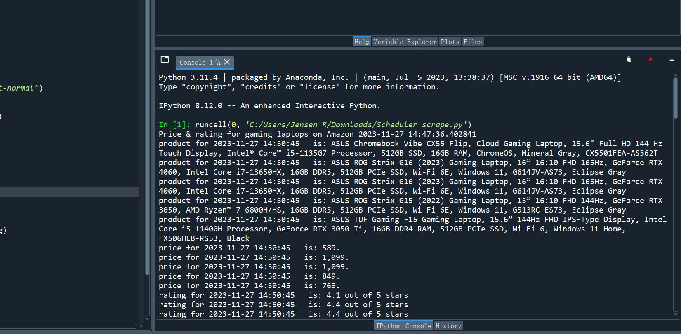

Price & rating for gaming laptops on Amazon 2023-11-27 14:47:36.402841

product for 2023-11-27 14:50:45 is: ASUS Chromebook Vibe CX55 Flip, Cloud Gaming Laptop, 15.6" Full HD 144 Hz Touch Display, Intel® Core™ i5-1135G7 Processor, 512GB SSD, 16GB RAM, ChromeOS, Mineral Gray, CX5501FEA-AS562T

product for 2023-11-27 14:50:45 is: ASUS ROG Strix G16 (2023) Gaming Laptop, 16” 16:10 FHD 165Hz, GeForce RTX 4060, Intel Core i7-13650HX, 16GB DDR5, 512GB PCIe SSD, Wi-Fi 6E, Windows 11, G614JV-AS73, Eclipse Gray

product for 2023-11-27 14:50:45 is: ASUS ROG Strix G16 (2023) Gaming Laptop, 16” 16:10 FHD 165Hz, GeForce RTX 4060, Intel Core i7-13650HX, 16GB DDR5, 512GB PCIe SSD, Wi-Fi 6E, Windows 11, G614JV-AS73, Eclipse Gray

product for 2023-11-27 14:50:45 is: ASUS ROG Strix G15 (2022) Gaming Laptop, 15” 16:10 FHD 144Hz, GeForce RTX 3050, AMD Ryzen™ 7 6800H/HS, 16GB DDR5, 512GB PCIe SSD, Wi-Fi 6E, Windows 11, G513RC-ES73, Eclipse Gray

product for 2023-11-27 14:50:45 is: ASUS TUF Gaming F15 Gaming Laptop, 15.6” 144Hz FHD IPS-Type Display, Intel Core i5-11400H Processor, GeForce RTX 3050 Ti, 16GB DDR4 RAM, 512GB PCIe SSD, Wi-Fi 6, Windows 11 Home, FX506HEB-RS53, Black

price for 2023-11-27 14:50:45 is: 589.

price for 2023-11-27 14:50:45 is: 1,099.

price for 2023-11-27 14:50:45 is: 1,099.

price for 2023-11-27 14:50:45 is: 849.

price for 2023-11-27 14:50:45 is: 769.

rating for 2023-11-27 14:50:45 is: 4.1 out of 5 stars

rating for 2023-11-27 14:50:45 is: 4.4 out of 5 stars

rating for 2023-11-27 14:50:45 is: 4.4 out of 5 stars

rating for 2023-11-27 14:50:45 is: 4.6 out of 5 stars

rating for 2023-11-27 14:50:45 is: 4.5 out of 5 stars

product for 2023-11-27 14:50:58 is: MSI Thin GF63 15.6" 144Hz Gaming Laptop: 12th Gen Intel Core i7, NVIDIA GeForce RTX 4050, 16GB DDR4, 512GB NVMe SSD, Type-C, Cooler Boost 5, Win11 Home: Black 12VE-066US

product for 2023-11-27 14:50:58 is: MSI Cyborg 15 Gaming Laptop 15.6" FHD IPS 144Hz Display 12th Gen Intel 10-core i7-12650H Processor 16GB RAM 1TB SSD GeForce RTX 4060 8GB Graphics Backlit Keyboard USB-C Win11 Black + HDMI Cable

product for 2023-11-27 14:50:58 is: MSI GF63 15.6" 144 Hz Gaming Laptop Intel Core i5-11400H RTX 3050 16GB 512GB NVMe SSD Win11 (11UC-263)

product for 2023-11-27 14:50:58 is: MSI Katana 17 Gaming Laptop: 13th Gen Intel Core i7, GeForce RTX 4060, 17.3" 144Hz FHD Display, 32GB DDR5, 1TB NVMe SSD, USB-Type C, Cooler Boost 5, Win11 Home: Black B13VFK-835US

product for 2023-11-27 14:50:58 is: MSI Newest GF63 Thin Gaming Laptop, 15.6" FHD 144Hz, Intel i5-11400H, RTX 3050, 16GB RAM, 512GB NVMe SSD, Windows 11, Aluminum Black

price for 2023-11-27 14:50:58 is: 799.

price for 2023-11-27 14:50:58 is: 1,169.

price for 2023-11-27 14:50:58 is: 615.

price for 2023-11-27 14:50:58 is: 1,199.

price for 2023-11-27 14:50:58 is: 602.

rating for 2023-11-27 14:50:58 is: 4.5 out of 5 stars

rating for 2023-11-27 14:50:58 is: 5.0 out of 5 stars

rating for 2023-11-27 14:50:58 is: 4.5 out of 5 stars

rating for 2023-11-27 14:50:58 is: 4.3 out of 5 stars

rating for 2023-11-27 14:50:58 is: 4.4 out of 5 stars

product for 2023-11-27 14:51:11 is: Acer Nitro 17 Gaming Laptop | AMD Ryzen 7 7840HS Octa-Core CPU | NVIDIA GeForce RTX 4060 Laptop GPU | 17.3" QHD 165Hz IPS Display | 1TB Gen 4 SSD | Wi-Fi 6E | RGB Backlit KB | AN17-41-R7G3, Black

product for 2023-11-27 14:51:11 is: Acer Nitro 5 AN515-58-525P Gaming Laptop |Core i5-12500H | NVIDIA GeForce RTX 3050 Laptop GPU | 15.6" FHD 144Hz IPS Display | 8GB DDR4 | 512GB PCIe Gen 4 SSD | Killer Wi-Fi 6 | Backlit Keyboard, Black

product for 2023-11-27 14:51:11 is: Acer Nitro 5 AN515-58-525P Gaming Laptop |Core i5-12500H | NVIDIA GeForce RTX 3050 Laptop GPU | 15.6" FHD 144Hz IPS Display | 8GB DDR4 | 512GB PCIe Gen 4 SSD | Killer Wi-Fi 6 | Backlit Keyboard, Black

product for 2023-11-27 14:51:11 is: Acer Nitro 17 Gaming Laptop | AMD Ryzen 7 7840HS Octa-Core CPU | NVIDIA GeForce RTX 4060 Laptop GPU | 17.3" QHD 165Hz IPS Display | 1TB Gen 4 SSD | Wi-Fi 6E | RGB Backlit KB | AN17-41-R7G3, Black

product for 2023-11-27 14:51:11 is: Acer Nitro 17 Gaming Laptop | AMD Ryzen 7 7735HS Octa-Core CPU | NVIDIA GeForce RTX 4050 GPU | 17.3" FHD 165Hz IPS Display | 16GB DDR5 | 1TB Gen 4 SSD | Wi-Fi 6E | RGB Backlit KB | AN17-41-R8N5, Black

price for 2023-11-27 14:51:11 is: 999.

price for 2023-11-27 14:51:11 is: 599.

price for 2023-11-27 14:51:11 is: 599.

price for 2023-11-27 14:51:11 is: 999.

price for 2023-11-27 14:51:11 is: 969.

rating for 2023-11-27 14:51:11 is: 4.3 out of 5 stars

rating for 2023-11-27 14:51:11 is: 4.4 out of 5 stars

rating for 2023-11-27 14:51:11 is: 4.4 out of 5 stars

rating for 2023-11-27 14:51:11 is: 4.3 out of 5 stars

rating for 2023-11-27 14:51:11 is: 4.3 out of 5 stars

product for 2023-11-27 14:51:24 is: HP Essential 14 Laptop, 14" HD Touchscreen, AMD Ryzen 3 5300U, 32GB RAM, 1TB SSD, Webcam, HDMI, Wi-Fi, Windows 11 Home, Black

product for 2023-11-27 14:51:24 is: HP Victus 15.6" 144Hz FHD Gaming Laptop Computer, Hexa-Core AMD Ryzen 5 7535HS (Beat i5-13420H), 16GB DDR5 RAM, 1TB PCIe SSD, GeForce RTX 2050, WiFi 6, BT5.3, Backlit Keyboard, Windows 11 Pro, BROAG

product for 2023-11-27 14:51:24 is: HP Victus 15 Gaming Laptop, 15.6" FHD 144Hz Display, AMD Ryzen 5 7535HS, 16GB DDR5 RAM, 512GB PCIe M.2 SSD, NVIDIA GeForce RTX 2050, HDMI, Webcam, Backlit Keyboard, Wi-Fi 6, Windows 11 Home, Silver

product for 2023-11-27 14:51:24 is: HP 15 Laptop, AMD Ryzen 3 Processor, 8 GB RAM, 256 GB SSD, 15.6” Full HD Windows 10 Home in S Mode, Lightweight Computer With Webcam and Dual Mics, Work, Study, & Gaming (15-ef1050nr, 2021)

product for 2023-11-27 14:51:24 is: HP Victus 15.6" Full HD 144Hz Gaming Laptop | AMD Ryzen 5 7535HS | NVIDIA GeForce RTX 2050 | 8GB RAM DDR5| 512GB SSD | Backlit | Windows 11 Home | Bundle with 64GB USB Flash Drive, Mica Silver

price for 2023-11-27 14:51:24 is: 482.

price for 2023-11-27 14:51:24 is: 609.

price for 2023-11-27 14:51:24 is: 565.

price for 2023-11-27 14:51:24 is: 379.

price for 2023-11-27 14:51:24 is: 545.

rating for 2023-11-27 14:51:24 is: 4.4 out of 5 stars

rating for 2023-11-27 14:51:24 is: 5.0 out of 5 stars

rating for 2023-11-27 14:51:24 is: 4.3 out of 5 stars

rating for 2023-11-27 14:51:24 is: 4.6 out of 5 stars

rating for 2023-11-27 14:51:24 is: 4.5 out of 5 stars

product for 2023-11-27 14:51:38 is: Lenovo LOQ Gaming Laptop GeForce RTX 4060, Intel Core i7-13700H, 16" WUXGA, 32GB DDR5 RAM, 2TB SSD, Webcam, HDMI, RJ45, Backlit KB, Wi-Fi 6, Windows 11 Home, Grey

product for 2023-11-27 14:51:38 is: Lenovo LOQ Gaming Laptop, NVIDIA GeForce RTX 4060, Intel 13th Gen i7-13700H, 15.6" FHD 144Hz Display, 32GB DDR5 RAM, 2TB PCIe SSD, Webcam, HDMI, RJ45, Backlit KB, Wi-Fi 6, Windows 11 Home, Grey

product for 2023-11-27 14:51:38 is: Lenovo IdeaPad Gaming 3 - (2022) - Essential Gaming Laptop Computer - 15.6" FHD - 120Hz - AMD Ryzen 5 6600H - NVIDIA GeForce RTX 3050 - 8GB DDR5 RAM - 256GB NVMe Storage - Windows 11 Home

product for 2023-11-27 14:51:38 is: Lenovo LOQ Gaming Laptop - 15.6" FHD 144Hz - Intel Core i5-13420H - 16GB DDR5 RAM - 1TB SSD - NVIDIA GeForce RTX 2050 Graphics - Windows 11 Home - Storm Grey

product for 2023-11-27 14:51:38 is: Lenovo Legion Pro 5i - (2023) - Gaming Laptop Computer - NVIDIA GeForce RTX 4060-16" WQXGA - 165Hz - Intel Core i7-13700HX - 16GB RAM - 1TB SSD - Windows 11-3-Month Xbox GamePass Included

price for 2023-11-27 14:51:38 is: 1,599.

price for 2023-11-27 14:51:38 is: 1,379.

price for 2023-11-27 14:51:38 is: 729.

price for 2023-11-27 14:51:38 is: 689.

price for 2023-11-27 14:51:38 is: 1,249.

rating for 2023-11-27 14:51:38 is: 4.3 out of 5 stars.

rating for 2023-11-27 14:51:38 is: 4.2 out of 5 stars.

rating for 2023-11-27 14:51:38 is: 4.5 out of 5 stars.

rating for 2023-11-27 14:51:38 is: 4.7 out of 5 stars

rating for 2023-11-27 14:51:38 is: 4.4 out of 5 stars

**2023/12/05**

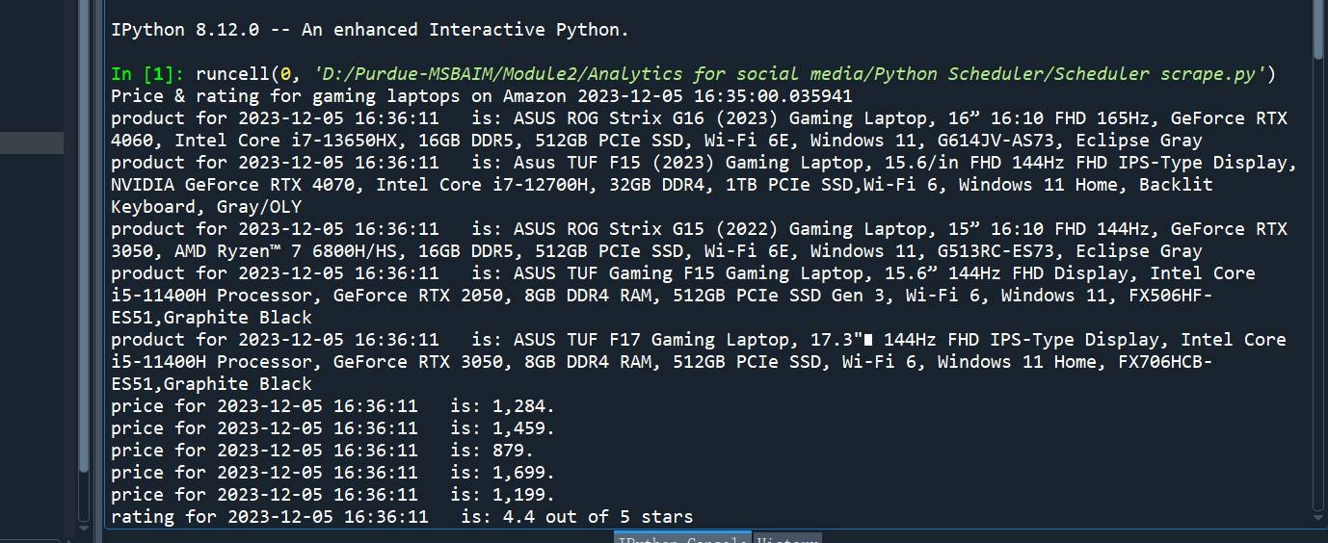

Price & rating for gaming laptops on Amazon 2023-12-05 16:35:00.035941

product for 2023-12-05 16:36:11 is: ASUS ROG Strix G16 (2023) Gaming Laptop, 16” 16:10 FHD 165Hz, GeForce RTX 4060, Intel Core i7-13650HX, 16GB DDR5, 512GB PCIe SSD, Wi-Fi 6E, Windows 11, G614JV-AS73, Eclipse Gray

product for 2023-12-05 16:36:11 is: Asus TUF F15 (2023) Gaming Laptop, 15.6/in FHD 144Hz FHD IPS-Type Display, NVIDIA GeForce RTX 4070, Intel Core i7-12700H, 32GB DDR4, 1TB PCIe SSD,Wi-Fi 6, Windows 11 Home, Backlit Keyboard, Gray/OLY

product for 2023-12-05 16:36:11 is: ASUS ROG Strix G15 (2022) Gaming Laptop, 15” 16:10 FHD 144Hz, GeForce RTX 3050, AMD Ryzen™ 7 6800H/HS, 16GB DDR5, 512GB PCIe SSD, Wi-Fi 6E, Windows 11, G513RC-ES73, Eclipse Gray

product for 2023-12-05 16:36:11 is: ASUS TUF Gaming F15 Gaming Laptop, 15.6” 144Hz FHD Display, Intel Core i5-11400H Processor, GeForce RTX 2050, 8GB DDR4 RAM, 512GB PCIe SSD Gen 3, Wi-Fi 6, Windows 11, FX506HF-ES51,Graphite Black

product for 2023-12-05 16:36:11 is: ASUS TUF F17 Gaming Laptop, 17.3" 144Hz FHD IPS-Type Display, Intel Core i5-11400H Processor, GeForce RTX 3050, 8GB DDR4 RAM, 512GB PCIe SSD, Wi-Fi 6, Windows 11 Home, FX706HCB-ES51,Graphite Black

price for 2023-12-05 16:36:11 is: 1,284.

price for 2023-12-05 16:36:11 is: 1,459.

price for 2023-12-05 16:36:11 is: 879.

price for 2023-12-05 16:36:11 is: 1,699.

price for 2023-12-05 16:36:11 is: 1,199.

rating for 2023-12-05 16:36:11 is: 4.4 out of 5 stars

rating for 2023-12-05 16:36:11 is: 4.8 out of 5 stars

rating for 2023-12-05 16:36:11 is: 4.6 out of 5 stars

rating for 2023-12-05 16:36:11 is: 4.4 out of 5 stars

rating for 2023-12-05 16:36:11 is: 4.1 out of 5 stars

product for 2023-12-05 16:36:27 is: MSI Katana 15 Gaming Laptop 15.6" FHD IPS 144Hz Intel 10-Core i7-12650H Processor 16GB RAM 1TB SSD GeForce RTX 4060 8GB Graphic Backlit USB-C Nahimic Win11 Black + HDMI Cable

product for 2023-12-05 16:36:27 is: MSI Katana 15 Gaming Laptop 15.6" FHD IPS 144Hz Intel 10-Core i7-12650H Processor 16GB RAM 2TB SSD GeForce RTX 4060 8GB Graphic Backlit USB-C Nahimic Win11 Black + HDMI Cable

product for 2023-12-05 16:36:27 is: MSI GF63 15.6" 144 Hz Gaming Laptop Intel Core i5-11400H RTX 3050 16GB 512GB NVMe SSD Win11 (11UC-263)

product for 2023-12-05 16:36:27 is: MSI Newest GF63 Thin Gaming Laptop, 15.6" FHD 144Hz, Intel i5-11400H, RTX 3050, 16GB RAM, 512GB NVMe SSD, Windows 11, Aluminum Black

product for 2023-12-05 16:36:27 is: MSI Raider GE77HX Gaming & Entertainment Laptop (Intel i7-12800HX 16-Core, 64GB DDR5 4000MHz RAM, 2x8TB PCIe SSD RAID 1 (8TB), GeForce RTX 3080 Ti, Win 11 Pro) with MS 365 Personal, Hub

price for 2023-12-05 16:36:27 is: 1,099.

price for 2023-12-05 16:36:27 is: 1,199.

price for 2023-12-05 16:36:27 is: 608.

price for 2023-12-05 16:36:27 is: 599.

price for 2023-12-05 16:36:27 is: 9,404.

rating for 2023-12-05 16:36:27 is: 4.4 out of 5 stars

rating for 2023-12-05 16:36:27 is: 4.1 out of 5 stars

rating for 2023-12-05 16:36:27 is: 4.3 out of 5 stars

rating for 2023-12-05 16:36:27 is: 4.2 out of 5 stars

rating for 2023-12-05 16:36:27 is: 4.6 out of 5 stars

product for 2023-12-05 16:36:41 is: Acer Predator Helios 16 Gaming Laptop | 13th Gen Intel Core i7-13700HX | NVIDIA GeForce RTX 4060 | 16" 2560 x 1600 165Hz G-SYNC Display | 16GB DDR5 | 1TB Gen 4 SSD | Killer Wi-Fi 6E | PH16-71-74UU

product for 2023-12-05 16:36:41 is: Acer Nitro 5 Gaming Laptop | Intel 12th Gen i7-12650H | NVIDIA GeForce RTX 4060 Laptop GPU | 15.6” FHD 144Hz IPS Display | 16GB DDR5 | 1TB Gen 4 SSD | Killer Wi-Fi 6 | RGB Backlit KB | AN515-58-781P

product for 2023-12-05 16:36:41 is: Acer Nitro 5 AN515-58-525P Gaming Laptop |Core i5-12500H | NVIDIA GeForce RTX 3050 Laptop GPU | 15.6" FHD 144Hz IPS Display | 8GB DDR4 | 512GB PCIe Gen 4 SSD | Killer Wi-Fi 6 | Backlit Keyboard, Black

product for 2023-12-05 16:36:41 is: Acer Nitro 17 Gaming Laptop | AMD Ryzen 7 7840HS Octa-Core CPU | NVIDIA GeForce RTX 4060 Laptop GPU | 17.3" QHD 165Hz IPS Display | 1TB Gen 4 SSD | Wi-Fi 6E | RGB Backlit KB | AN17-41-R7G3, Black

product for 2023-12-05 16:36:41 is: Acer Nitro 17 Gaming Laptop | AMD Ryzen 7 7735HS Octa-Core CPU | NVIDIA GeForce RTX 4050 GPU | 17.3" FHD 165Hz IPS Display | 16GB DDR5 | 1TB Gen 4 SSD | Wi-Fi 6E | RGB Backlit KB | AN17-41-R8N5, Black

price for 2023-12-05 16:36:41 is: 1,199.

price for 2023-12-05 16:36:41 is: 1,186.

price for 2023-12-05 16:36:41 is: 689.

price for 2023-12-05 16:36:41 is: 1,173.

price for 2023-12-05 16:36:41 is: 1,119.

rating for 2023-12-05 16:36:41 is: 4.5 out of 5 stars

rating for 2023-12-05 16:36:41 is: 4.4 out of 5 stars

rating for 2023-12-05 16:36:41 is: 4.4 out of 5 stars

rating for 2023-12-05 16:36:41 is: 4.3 out of 5 stars

rating for 2023-12-05 16:36:41 is: 4.3 out of 5 stars

product for 2023-12-05 16:36:54 is: HP Envy 16" Touchscreen WQXGA (2560x1600) Gaming Laptop Premium Creator Workstation Computer, 13th Gen Intel 14-Core i9-13900H, GeForce RTX 4060 8G, 32GB DDR5 RAM, 1TB PCIe SSD, Windows 11 Pro, BROAG

product for 2023-12-05 16:36:54 is: HP Pavilion 15t Laptop, 15.6" FHD Touchscreen, Intel Core i7-1355U Processor, 64GB RAM, 2TB SSD, Webcam, Backlit Keyboard, FP Reader, HDMI, Wi-Fi 6, Windows 11 Pro, Warm Gold

product for 2023-12-05 16:36:54 is: HP Victus 15 Gaming Laptop, 15.6" FHD 144Hz Display, AMD Ryzen 5 7535HS, 16GB DDR5 RAM, 1TB PCIe M.2 SSD, NVIDIA GeForce RTX 2050, HDMI, Webcam, Backlit Keyboard, Wi-Fi 6, Windows 11 Home, Silver

product for 2023-12-05 16:36:54 is: HP - Pavilion 15.6inch Gaming Laptop - AMD Ryzen 5 - 8GB Memory - NVIDIA GeForce GTX 1650 - 256GB SSD - Shadow Black, 15-ec1073d

product for 2023-12-05 16:36:54 is: HP Victus 15.6" Full HD 144Hz Gaming Laptop | AMD Ryzen 5 7535HS | NVIDIA GeForce RTX 2050 | 8GB RAM DDR5| 512GB SSD | Backlit | Windows 11 Home | Bundle with 64GB USB Flash Drive, Mica Silver

price for 2023-12-05 16:36:54 is: 1,519.

price for 2023-12-05 16:36:54 is: 979.

price for 2023-12-05 16:36:54 is: 595.

price for 2023-12-05 16:36:54 is: 879.

price for 2023-12-05 16:36:54 is: 549.

rating for 2023-12-05 16:36:54 is: 5.0 out of 5 stars

rating for 2023-12-05 16:36:54 is: 5.0 out of 5 stars

rating for 2023-12-05 16:36:54 is: 4.3 out of 5 stars

rating for 2023-12-05 16:36:54 is: 4.6 out of 5 stars

rating for 2023-12-05 16:36:54 is: 4.4 out of 5 stars

product for 2023-12-05 16:37:07 is: Lenovo LOQ Gaming Laptop, NVIDIA GeForce RTX 4060, Intel 13th Gen i7-13700H, 15.6" FHD 144Hz Display, 64GB DDR5 RAM, 2TB PCIe SSD, Webcam, HDMI, RJ45, Backlit KB, Wi-Fi 6, Windows 11 Home, Grey

product for 2023-12-05 16:37:07 is: Lenovo LOQ Gaming Laptop, 15.6" FHD 144Hz Display, NVIDIA GeForce RTX 4060, Intel 13th Gen i7-13700H, 32GB DDR5 RAM, 2TB PCIe SSD, Webcam, RJ45, Backlit KB, HDMI, Wi-Fi 6, Windows 11 Home

product for 2023-12-05 16:37:07 is: Lenovo IdeaPad Gaming 3 - (2022) - Essential Gaming Laptop Computer - 15.6" FHD - 120Hz - AMD Ryzen 5 6600H - NVIDIA GeForce RTX 3050 - 8GB DDR5 RAM - 256GB NVMe Storage - Windows 11 Home

product for 2023-12-05 16:37:07 is: Lenovo LOQ 16" 144Hz WUXGA Gaming Laptop, GeForce RTX 4050, AMD Ryzen 7 7840HS (> i7-12700H), 64GB DDR5 RAM, 2TB PCIe SSD, RJ-45, Wi-Fi 6, Webcam, Backlit Keyboard, Windows 11 Home, Grey

product for 2023-12-05 16:37:07 is: Lenovo - 2021 - IdeaPad Gaming 3 - Laptop Computer - 15.6" FHD Display -120Hz - AMD Ryzen 5 5600H - 8GB RAM - 256GB Storage - NVIDIA GeForce GTX 1650 - Windows 11 Home

price for 2023-12-05 16:37:07 is: 1,449.

price for 2023-12-05 16:37:07 is: 1,529.

price for 2023-12-05 16:37:07 is: 685.

price for 2023-12-05 16:37:07 is: 1,249.

price for 2023-12-05 16:37:07 is: 594.

rating for 2023-12-05 16:37:07 is: 4.4 out of 5 stars

rating for 2023-12-05 16:37:07 is: 5.0 out of 5 stars

rating for 2023-12-05 16:37:07 is: 4.3 out of 5 stars

rating for 2023-12-05 16:37:07 is: 4.0 out of 5 stars

rating for 2023-12-05 16:37:07 is: 4.5 out of 5 stars

**2023/12/06**

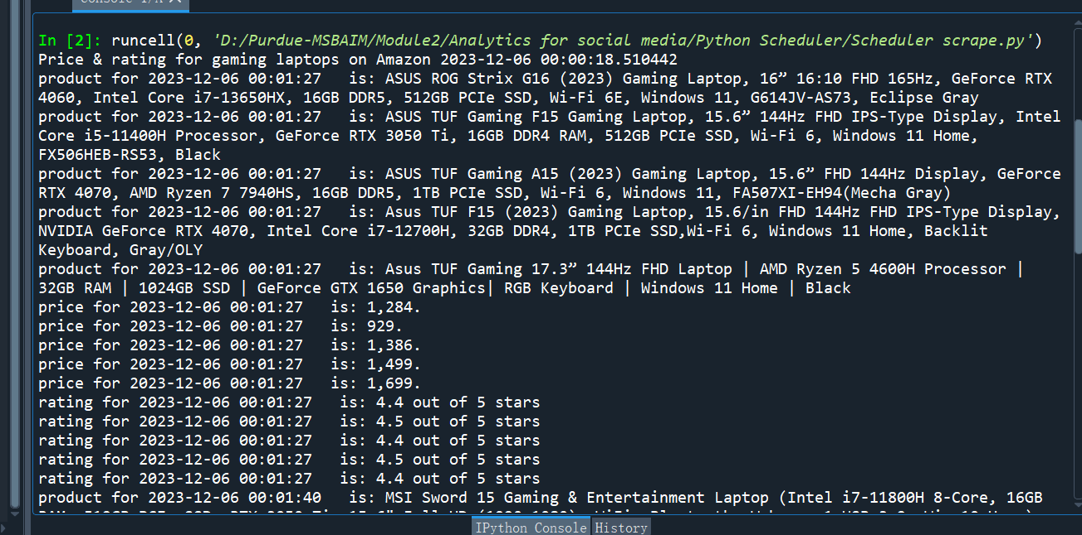

Price & rating for gaming laptops on Amazon 2023-12-06 00:00:18.510442

product for 2023-12-06 00:01:27 is: ASUS ROG Strix G16 (2023) Gaming Laptop, 16” 16:10 FHD 165Hz, GeForce RTX 4060, Intel Core i7-13650HX, 16GB DDR5, 512GB PCIe SSD, Wi-Fi 6E, Windows 11, G614JV-AS73, Eclipse Gray

product for 2023-12-06 00:01:27 is: ASUS TUF Gaming F15 Gaming Laptop, 15.6” 144Hz FHD IPS-Type Display, Intel Core i5-11400H Processor, GeForce RTX 3050 Ti, 16GB DDR4 RAM, 512GB PCIe SSD, Wi-Fi 6, Windows 11 Home, FX506HEB-RS53, Black

product for 2023-12-06 00:01:27 is: ASUS TUF Gaming A15 (2023) Gaming Laptop, 15.6” FHD 144Hz Display, GeForce RTX 4070, AMD Ryzen 7 7940HS, 16GB DDR5, 1TB PCIe SSD, Wi-Fi 6, Windows 11, FA507XI-EH94(Mecha Gray)

product for 2023-12-06 00:01:27 is: Asus TUF F15 (2023) Gaming Laptop, 15.6/in FHD 144Hz FHD IPS-Type Display, NVIDIA GeForce RTX 4070, Intel Core i7-12700H, 32GB DDR4, 1TB PCIe SSD,Wi-Fi 6, Windows 11 Home, Backlit Keyboard, Gray/OLY

product for 2023-12-06 00:01:27 is: Asus TUF Gaming 17.3” 144Hz FHD Laptop | AMD Ryzen 5 4600H Processor | 32GB RAM | 1024GB SSD | GeForce GTX 1650 Graphics| RGB Keyboard | Windows 11 Home | Black

price for 2023-12-06 00:01:27 is: 1,284.

price for 2023-12-06 00:01:27 is: 929.

price for 2023-12-06 00:01:27 is: 1,386.

price for 2023-12-06 00:01:27 is: 1,499.

price for 2023-12-06 00:01:27 is: 1,699.

rating for 2023-12-06 00:01:27 is: 4.4 out of 5 stars

rating for 2023-12-06 00:01:27 is: 4.5 out of 5 stars

rating for 2023-12-06 00:01:27 is: 4.4 out of 5 stars

rating for 2023-12-06 00:01:27 is: 4.5 out of 5 stars

rating for 2023-12-06 00:01:27 is: 4.4 out of 5 stars

product for 2023-12-06 00:01:40 is: MSI Sword 15 Gaming & Entertainment Laptop (Intel i7-11800H 8-Core, 16GB RAM, 512GB PCIe SSD, RTX 3050 Ti, 15.6" Full HD (1920x1080), WiFi, Bluetooth, Webcam, 1xUSB 3.2, Win 10 Home)

product for 2023-12-06 00:01:40 is: MSI Katana 15 Gaming Laptop 15.6" FHD IPS 144Hz Intel 10-Core i7-12650H Processor 16GB RAM 1TB SSD GeForce RTX 4060 8GB Graphic Backlit USB-C Nahimic Win11 Black + HDMI Cable

product for 2023-12-06 00:01:40 is: MSI GF63 15.6" 144 Hz Gaming Laptop Intel Core i5-11400H RTX 3050 16GB 512GB NVMe SSD Win11 (11UC-263)

product for 2023-12-06 00:01:40 is: MSI Newest GF63 Thin Gaming Laptop, 15.6" FHD 144Hz, Intel i5-11400H, RTX 3050, 16GB RAM, 512GB NVMe SSD, Windows 11, Aluminum Black

product for 2023-12-06 00:01:40 is: MSI 2023 Cyborg Gaming Laptop, 15.6" FHD 144Hz FHD IPS-Type Display, NVIDIA GeForce RTX 4060,Intel Core i7-12650H, 64GB DDR5, 2TB PCIe SSD, Wi-Fi 6, Windows 11 Home, Backlit Keyboard, Black/OLY

price for 2023-12-06 00:01:40 is: 979.

price for 2023-12-06 00:01:40 is: 1,099.

price for 2023-12-06 00:01:40 is: 608.

price for 2023-12-06 00:01:40 is: 599.

price for 2023-12-06 00:01:40 is: 1,399.

rating for 2023-12-06 00:01:40 is: 3.9 out of 5 stars

rating for 2023-12-06 00:01:40 is: 4.4 out of 5 stars

rating for 2023-12-06 00:01:40 is: 4.3 out of 5 stars

rating for 2023-12-06 00:01:40 is: 4.2 out of 5 stars

rating for 2023-12-06 00:01:40 is: 4.6 out of 5 stars

product for 2023-12-06 00:01:53 is: Predator Helios Gaming Laptop 2023 Newest, 16" WQXGA 165Hz Display, Intel Core i7-13700HX, NVIDIA GeForce RTX 4060, 32GB DDR5 RAM, 1TB SSD, Backlit Keyboard, Windows 11 Home, with Cleaning Brush

product for 2023-12-06 00:01:53 is: acer Nitro 5 Gaming Laptop,15.6" FHD IPS 165Hz, 12th gen 10-Core Intel Core i7-12650H, GeForce RTX 4060 Graphic, WiFi6, Backlit KB, RJ-45, Win11 Home (16GB DDR5|1TB SSD)

product for 2023-12-06 00:01:53 is: Acer Nitro 5 AN515-58-525P Gaming Laptop |Core i5-12500H | NVIDIA GeForce RTX 3050 Laptop GPU | 15.6" FHD 144Hz IPS Display | 8GB DDR4 | 512GB PCIe Gen 4 SSD | Killer Wi-Fi 6 | Backlit Keyboard, Black

product for 2023-12-06 00:01:53 is: Acer Nitro 17 Gaming Laptop | AMD Ryzen 7 7840HS Octa-Core CPU | NVIDIA GeForce RTX 4060 Laptop GPU | 17.3" QHD 165Hz IPS Display | 1TB Gen 4 SSD | Wi-Fi 6E | RGB Backlit KB | AN17-41-R7G3, Black

product for 2023-12-06 00:01:53 is: Acer Nitro 17 Gaming Laptop | AMD Ryzen 7 7735HS Octa-Core CPU | NVIDIA GeForce RTX 4050 GPU | 17.3" FHD 165Hz IPS Display | 16GB DDR5 | 1TB Gen 4 SSD | Wi-Fi 6E | RGB Backlit KB | AN17-41-R8N5, Black

price for 2023-12-06 00:01:53 is: 1,559.

price for 2023-12-06 00:01:53 is: 1,110.

price for 2023-12-06 00:01:53 is: 695.

price for 2023-12-06 00:01:53 is: 1,169.

price for 2023-12-06 00:01:53 is: 1,119.

rating for 2023-12-06 00:01:53 is: 4.4 out of 5 stars

rating for 2023-12-06 00:01:53 is: 4.8 out of 5 stars

rating for 2023-12-06 00:01:53 is: 4.4 out of 5 stars

rating for 2023-12-06 00:01:53 is: 4.3 out of 5 stars

rating for 2023-12-06 00:01:53 is: 4.3 out of 5 stars

product for 2023-12-06 00:02:06 is: HP Envy 16" Touchscreen WQXGA (2560x1600) Gaming Laptop Premium Creator Workstation Computer, 13th Gen Intel 14-Core i9-13900H, GeForce RTX 4060 8G, 32GB DDR5 RAM, 1TB PCIe SSD, Windows 11 Pro, BROAG

product for 2023-12-06 00:02:06 is: HP 470 G9 Business Laptop, 17.3" FHD Display, Intel Core i5-1235U(> i7-1165G7) Processor, NVIDIA GeForce MX550, 16GB RAM, 1TB PCIe SSD, Webcam, Backlit KB, Wi-Fi 6, Windows 11 Pro, Silver

product for 2023-12-06 00:02:06 is: HP Victus 15 Gaming Laptop, 15.6" FHD 144Hz Display, AMD Ryzen 5 7535HS, 16GB DDR5 RAM, 1TB PCIe M.2 SSD, NVIDIA GeForce RTX 2050, HDMI, Webcam, Backlit Keyboard, Wi-Fi 6, Windows 11 Home, Silver

product for 2023-12-06 00:02:06 is: HP Victus 15.6" Full HD 144Hz Gaming Laptop | AMD Ryzen 5 7535HS | NVIDIA GeForce RTX 2050 | 8GB RAM DDR5| 512GB SSD | Backlit | Windows 11 Home | Bundle with 64GB USB Flash Drive, Mica Silver

product for 2023-12-06 00:02:06 is: HP Victus 15 Gaming Laptop 15.6" FHD IPS 144Hz AMD Hexa-Core Ryzen 5 7535HS Processor (Beats i7-11800H) 16GB RAM 512GB SSD GeForce RTX 2050 4GB Graphic Backlit USB-C B&O Win11 + HDMI Cable

price for 2023-12-06 00:02:06 is: 1,519.

price for 2023-12-06 00:02:06 is: 859.

price for 2023-12-06 00:02:06 is: 595.

price for 2023-12-06 00:02:06 is: 558.

price for 2023-12-06 00:02:06 is: 575.

rating for 2023-12-06 00:02:06 is: 5.0 out of 5 stars

rating for 2023-12-06 00:02:06 is: 5.0 out of 5 stars

rating for 2023-12-06 00:02:06 is: 4.3 out of 5 stars

rating for 2023-12-06 00:02:06 is: 4.4 out of 5 stars

rating for 2023-12-06 00:02:06 is: 4.7 out of 5 stars

product for 2023-12-06 00:02:20 is: Lenovo LOQ Gaming Laptop, NVIDIA GeForce RTX 4060, Intel 13th Gen i7-13700H, 15.6" FHD 144Hz Display, 64GB DDR5 RAM, 2TB PCIe SSD, Webcam, HDMI, RJ45, Backlit KB, Wi-Fi 6, Windows 11 Home, Grey

product for 2023-12-06 00:02:20 is: Lenovo LOQ Gaming Laptop, 15.6" FHD 144Hz Display, NVIDIA GeForce RTX 4060, Intel 13th Gen i7-13700H, 32GB DDR5 RAM, 2TB PCIe SSD, Webcam, RJ45, Backlit KB, HDMI, Wi-Fi 6, Windows 11 Home

product for 2023-12-06 00:02:20 is: Lenovo IdeaPad Gaming 3 - (2022) - Essential Gaming Laptop Computer - 15.6" FHD - 120Hz - AMD Ryzen 5 6600H - NVIDIA GeForce RTX 3050 - 8GB DDR5 RAM - 256GB NVMe Storage - Windows 11 Home

product for 2023-12-06 00:02:20 is: Lenovo LOQ Gaming - 2023 - Everyday Gaming Laptop - NVIDIA GeForce RTX 3050 Graphics - 15.6" FHD Display - 16GB Memory - 1TB Storage - Intel i5-13420H 13th Gen - Grey

product for 2023-12-06 00:02:20 is: Lenovo LOQ Gaming Laptop, NVIDIA GeForce RTX 4060, Intel 13th Gen i7-13700H, 15.6" FHD 144Hz Display, 32GB DDR5 RAM, 2TB PCIe SSD, Webcam, HDMI, RJ45, Backlit KB, Wi-Fi 6, Windows 11 Home, Grey

price for 2023-12-06 00:02:20 is: 1,449.

price for 2023-12-06 00:02:20 is: 1,529.

price for 2023-12-06 00:02:20 is: 685.

price for 2023-12-06 00:02:20 is: 863.

price for 2023-12-06 00:02:20 is: 1,387.

rating for 2023-12-06 00:02:20 is: 4.4 out of 5 stars

rating for 2023-12-06 00:02:20 is: 5.0 out of 5 stars

rating for 2023-12-06 00:02:20 is: 4.3 out of 5 stars

rating for 2023-12-06 00:02:20 is: 4.3 out of 5 stars

rating for 2023-12-06 00:02:20 is: 4.4 out of 5 stars

**2023/12/07**

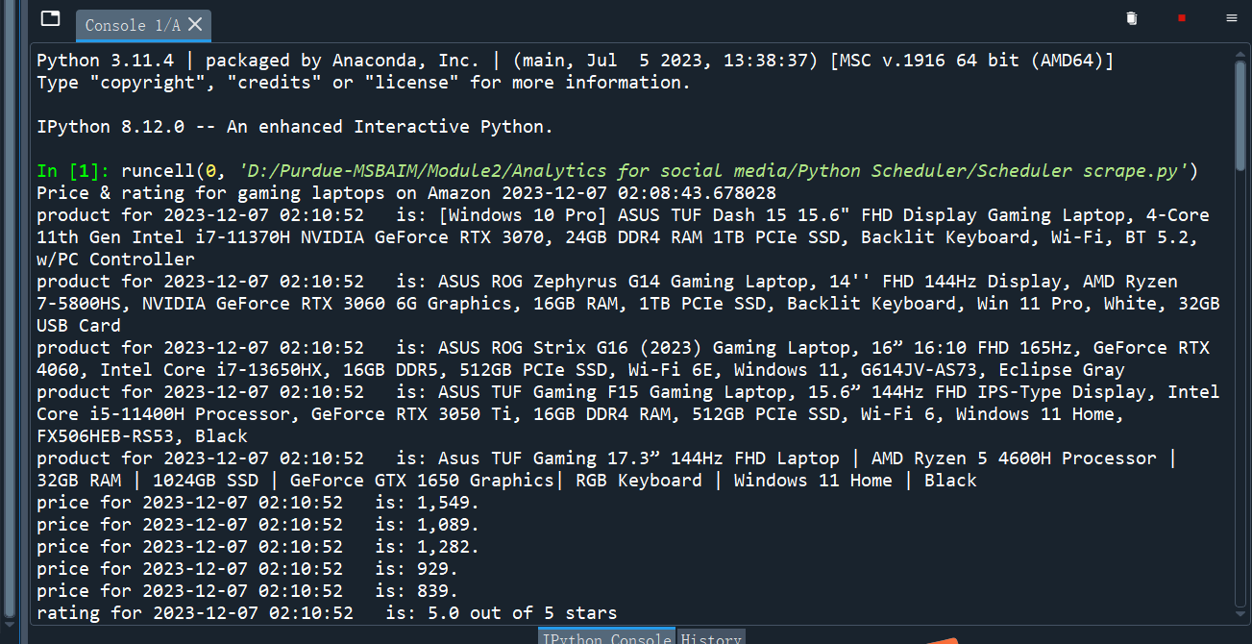

Price & rating for gaming laptops on Amazon 2023-12-07 02:08:43.678028

product for 2023-12-07 02:10:52 is: [Windows 10 Pro] ASUS TUF Dash 15 15.6" FHD Display Gaming Laptop, 4-Core 11th Gen Intel i7-11370H NVIDIA GeForce RTX 3070, 24GB DDR4 RAM 1TB PCIe SSD, Backlit Keyboard, Wi-Fi, BT 5.2, w/PC Controller

product for 2023-12-07 02:10:52 is: ASUS ROG Zephyrus G14 Gaming Laptop, 14'' FHD 144Hz Display, AMD Ryzen 7-5800HS, NVIDIA GeForce RTX 3060 6G Graphics, 16GB RAM, 1TB PCIe SSD, Backlit Keyboard, Win 11 Pro, White, 32GB USB Card

product for 2023-12-07 02:10:52 is: ASUS ROG Strix G16 (2023) Gaming Laptop, 16” 16:10 FHD 165Hz, GeForce RTX 4060, Intel Core i7-13650HX, 16GB DDR5, 512GB PCIe SSD, Wi-Fi 6E, Windows 11, G614JV-AS73, Eclipse Gray

product for 2023-12-07 02:10:52 is: ASUS TUF Gaming F15 Gaming Laptop, 15.6” 144Hz FHD IPS-Type Display, Intel Core i5-11400H Processor, GeForce RTX 3050 Ti, 16GB DDR4 RAM, 512GB PCIe SSD, Wi-Fi 6, Windows 11 Home, FX506HEB-RS53, Black

product for 2023-12-07 02:10:52 is: Asus TUF Gaming 17.3” 144Hz FHD Laptop | AMD Ryzen 5 4600H Processor | 32GB RAM | 1024GB SSD | GeForce GTX 1650 Graphics| RGB Keyboard | Windows 11 Home | Black

price for 2023-12-07 02:10:52 is: 1,549.

price for 2023-12-07 02:10:52 is: 1,089.

price for 2023-12-07 02:10:52 is: 1,282.

price for 2023-12-07 02:10:52 is: 929.

price for 2023-12-07 02:10:52 is: 839.

rating for 2023-12-07 02:10:52 is: 5.0 out of 5 stars

rating for 2023-12-07 02:10:52 is: 4.5 out of 5 stars

rating for 2023-12-07 02:10:52 is: 4.4 out of 5 stars

rating for 2023-12-07 02:10:52 is: 4.5 out of 5 stars

rating for 2023-12-07 02:10:52 is: 4.6 out of 5 stars

product for 2023-12-07 02:11:05 is: MSI Thin GF63 Gaming Laptop, 15.6" 144Hz FHD Display, 12th Gen Intel Core i5-12450H, NVIDIA GeForce RTX 4050, 32GB RAM, 2TB PCIe SSD, Webcam, Backlit KB, Wi-Fi 6, Windows 11 Home

product for 2023-12-07 02:11:05 is: MSI Sword 15 Gaming Laptop, 15.6" FHD 144Hz Display, Intel Core i7-12650H, NVIDIA GeForce RTX 4050, 16GB DDR5 RAM, 1TB SSD, Webcam, Backlit KB, HDMI, RJ-45, Wi-Fi 6, Windows 11 Home, White

product for 2023-12-07 02:11:05 is: MSI GF63 15.6" 144 Hz Gaming Laptop Intel Core i5-11400H RTX 3050 16GB 512GB NVMe SSD Win11 (11UC-263)

product for 2023-12-07 02:11:05 is: MSI Newest GF63 Thin Gaming Laptop, 15.6" FHD 144Hz, Intel i5-11400H, RTX 3050, 16GB RAM, 512GB NVMe SSD, Windows 11, Aluminum Black

product for 2023-12-07 02:11:05 is: MSI 2023 Cyborg Gaming Laptop, 15.6" FHD 144Hz FHD IPS-Type Display, NVIDIA GeForce RTX 4060,Intel Core i7-12650H, 64GB DDR5, 2TB PCIe SSD, Wi-Fi 6, Windows 11 Home, Backlit Keyboard, Black/OLY

price for 2023-12-07 02:11:05 is: 1,079.

price for 2023-12-07 02:11:05 is: 1,169.

price for 2023-12-07 02:11:05 is: 608.

price for 2023-12-07 02:11:05 is: 599.

price for 2023-12-07 02:11:05 is: 1,399.

rating for 2023-12-07 02:11:05 is: 4.6 out of 5 stars

rating for 2023-12-07 02:11:05 is: 5.0 out of 5 stars

rating for 2023-12-07 02:11:05 is: 4.4 out of 5 stars

rating for 2023-12-07 02:11:05 is: 4.2 out of 5 stars

rating for 2023-12-07 02:11:05 is: 4.6 out of 5 stars

product for 2023-12-07 02:11:18 is: acer Nitro 5 Gaming Laptop 165Hz 15.6" QHD, AMD Ryzen 7 6800H 8-Core, GeForce RTX 3070 Ti 8GB, 32GB DDR5 RAM 1TB SSD, 4-Zone RGB Backlit Keyboard, WiFi 6E, RJ45, Windows 11+GM Mousepad

product for 2023-12-07 02:11:18 is: acer 2023 Predator Helios 300 Gaming Laptop, 15.6" 2K QHD 240Hz Display, Intel Core i7-12700H 14-Core, GeForce RTX 3070 Ti, 64GB DDR5, 2TB PCIe SSD, RGB Keyboard, Thunderbolt 4, RJ-45, GM Accessories

product for 2023-12-07 02:11:18 is: Acer Nitro 5 AN515-58-525P Gaming Laptop |Core i5-12500H | NVIDIA GeForce RTX 3050 Laptop GPU | 15.6" FHD 144Hz IPS Display | 8GB DDR4 | 512GB PCIe Gen 4 SSD | Killer Wi-Fi 6 | Backlit Keyboard, Black

product for 2023-12-07 02:11:18 is: Acer Nitro 17 Gaming Laptop | AMD Ryzen 7 7840HS Octa-Core CPU | NVIDIA GeForce RTX 4060 Laptop GPU | 17.3" QHD 165Hz IPS Display | 1TB Gen 4 SSD | Wi-Fi 6E | RGB Backlit KB | AN17-41-R7G3, Black

product for 2023-12-07 02:11:18 is: Acer Nitro 17 Gaming Laptop | AMD Ryzen 7 7735HS Octa-Core CPU | NVIDIA GeForce RTX 4050 GPU | 17.3" FHD 165Hz IPS Display | 16GB DDR5 | 1TB Gen 4 SSD | Wi-Fi 6E | RGB Backlit KB | AN17-41-R8N5, Black

price for 2023-12-07 02:11:18 is: 1,099.

price for 2023-12-07 02:11:18 is: 1,799.

price for 2023-12-07 02:11:18 is: 703.

price for 2023-12-07 02:11:18 is: 1,169.

price for 2023-12-07 02:11:18 is: 1,119.

rating for 2023-12-07 02:11:18 is: 4.3 out of 5 stars

rating for 2023-12-07 02:11:18 is: 4.2 out of 5 stars

rating for 2023-12-07 02:11:18 is: 4.4 out of 5 stars

rating for 2023-12-07 02:11:18 is: 4.3 out of 5 stars

rating for 2023-12-07 02:11:18 is: 4.3 out of 5 stars

product for 2023-12-07 02:11:31 is: HP Victus Gaming Laptop, 16.1" FHD 144Hz Display, Intel Core i7-13700HX, NVIDIA GeForce RTX 4060, 32GB DDR5 RAM, 1TB SSD, Wi-Fi 6, Webcam, Backlit KB, RJ-45, HDMI, Windows 11 Home, Silver

product for 2023-12-07 02:11:31 is: HP Envy 16" Touchscreen WQXGA (2560x1600) Gaming Laptop Premium Creator Workstation Computer, 13th Gen Intel 14-Core i9-13900H, GeForce RTX 4060 8G, 32GB DDR5 RAM, 2TB PCIe SSD, Windows 11 Pro, BROAG

product for 2023-12-07 02:11:31 is: HP Victus 15 Gaming Laptop, 15.6" FHD 144Hz Display, AMD Ryzen 5 7535HS, 16GB DDR5 RAM, 1TB PCIe M.2 SSD, NVIDIA GeForce RTX 2050, HDMI, Webcam, Backlit Keyboard, Wi-Fi 6, Windows 11 Home, Silver

product for 2023-12-07 02:11:31 is: HP Victus 15.6" Full HD 144Hz Gaming Laptop | AMD Ryzen 5 7535HS | NVIDIA GeForce RTX 2050 | 8GB RAM DDR5| 512GB SSD | Backlit | Windows 11 Home | Bundle with 64GB USB Flash Drive, Mica Silver

product for 2023-12-07 02:11:31 is: HP Victus 15 Gaming Laptop 15.6" FHD IPS 144Hz AMD Hexa-Core Ryzen 5 7535HS Processor (Beats i7-11800H) 16GB RAM 512GB SSD GeForce RTX 2050 4GB Graphic Backlit USB-C B&O Win11 + HDMI Cable

price for 2023-12-07 02:11:31 is: 1,179.

price for 2023-12-07 02:11:31 is: 1,559.

price for 2023-12-07 02:11:31 is: 595.

price for 2023-12-07 02:11:31 is: 549.

price for 2023-12-07 02:11:31 is: 589.

rating for 2023-12-07 02:11:31 is: 5.0 out of 5 stars

rating for 2023-12-07 02:11:31 is: 5.0 out of 5 stars

rating for 2023-12-07 02:11:31 is: 4.3 out of 5 stars

rating for 2023-12-07 02:11:31 is: 4.4 out of 5 stars

rating for 2023-12-07 02:11:31 is: 4.7 out of 5 stars

product for 2023-12-07 02:11:44 is: Lenovo LOQ 16" 144Hz WUXGA Gaming Laptop, GeForce RTX 4050, AMD Ryzen 7 7840HS (> i7-12700H), 32GB DDR5 RAM, 2TB PCIe SSD, RJ-45, Wi-Fi 6, Webcam, Backlit Keyboard, Windows 11 Home, Grey

product for 2023-12-07 02:11:44 is: Lenovo Ideapad Gaming 3 Laptop 15.6 120Hz, AMD Ryzen 7 7735HS up to 4.75 Ghz, NVIDIA GeForce RTX 4050, 32GB DDR5 2TB SSD, Backlit, WiFi 6, USB-C, RJ-45, HDMI, Webcam, Windows 11 +Mousepad, Gray

product for 2023-12-07 02:11:44 is: Lenovo IdeaPad Gaming 3 - (2022) - Essential Gaming Laptop Computer - 15.6" FHD - 120Hz - AMD Ryzen 5 6600H - NVIDIA GeForce RTX 3050 - 8GB DDR5 RAM - 256GB NVMe Storage - Windows 11 Home

product for 2023-12-07 02:11:44 is: Lenovo LOQ 15.6" Gaming Laptop 1920 x 1080(FHD), Intel Core i5-13420H, 8-core, 4.6GHz, 16GB DDR5 Memory 1TB SSD, NVIDIA GeForce RTX 3050, Backlit KB, Windows 11, Storm Grey, W/GaLiMu

product for 2023-12-07 02:11:44 is: Lenovo LOQ Gaming Laptop, NVIDIA GeForce RTX 4060, Intel 13th Gen i7-13700H, 15.6" FHD 144Hz Display, 32GB DDR5 RAM, 2TB PCIe SSD, Webcam, HDMI, RJ45, Backlit KB, Wi-Fi 6, Windows 11 Home, Grey

price for 2023-12-07 02:11:44 is: 1,299.

price for 2023-12-07 02:11:44 is: 1,169.

price for 2023-12-07 02:11:44 is: 683.

price for 2023-12-07 02:11:44 is: 868.

price for 2023-12-07 02:11:44 is: 1,387.

rating for 2023-12-07 02:11:44 is: 4.0 out of 5 stars

rating for 2023-12-07 02:11:44 is: 4.5 out of 5 stars

rating for 2023-12-07 02:11:44 is: 4.3 out of 5 stars

rating for 2023-12-07 02:11:44 is: 4.6 out of 5 stars

rating for 2023-12-07 02:11:44 is: 4.4 out of 5 stars