** Elite coaching**

**Center**

Project Designer &amp; Developer

* Mohibullah Afridi
* Mahad bin asad
* Shayan zuberi
* Islam uddin
* Adnan khan

Project Instructor

SIR MUHAMMAD HASHIR

Submitted To

eprojects@aptech.ac.in

Batch code

Pr-202312

System Requirement

Operating System

* Windows XP to 10

Main Processor

* Minimum 2.45 or better

Ram (Memory)

* Minimum 256 or better

Web Browsers

* Chrome and Microsoft Edge

Software

* Visual Studio Code



**Software Requirement**

**Hardware**

* **Intel Core i3/i5 Processor or higher**
* **8 GB RAM or above**
* **Color SVGA**
* **500 GB Hard Disk space**
* **Mouse**
* **Keyboard**

**Software**

* **Frontend: HTML5, CSS, Bootstrap, JavaScript, jQuery**
* **Data Store: JSON files or TXT files**

**Other Requirements**

* **Operating Portal: Windows**
* **Browsers: Edge, Chrome, Mozilla Firefox, Safari**



**Header & Home Coding**

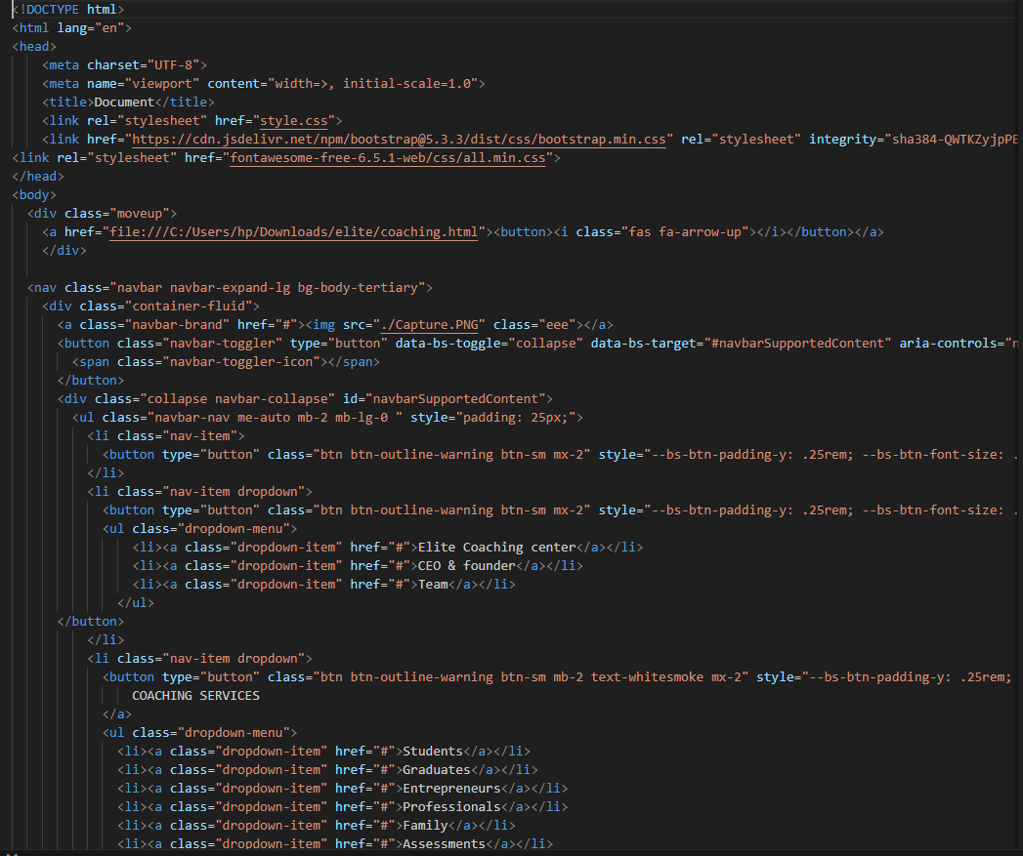

* This HTML code snippet appears to be a partial representation of a web page, likely related to a website for an elite coaching center or a similar educational institution. Let's break down what each part of the code does:

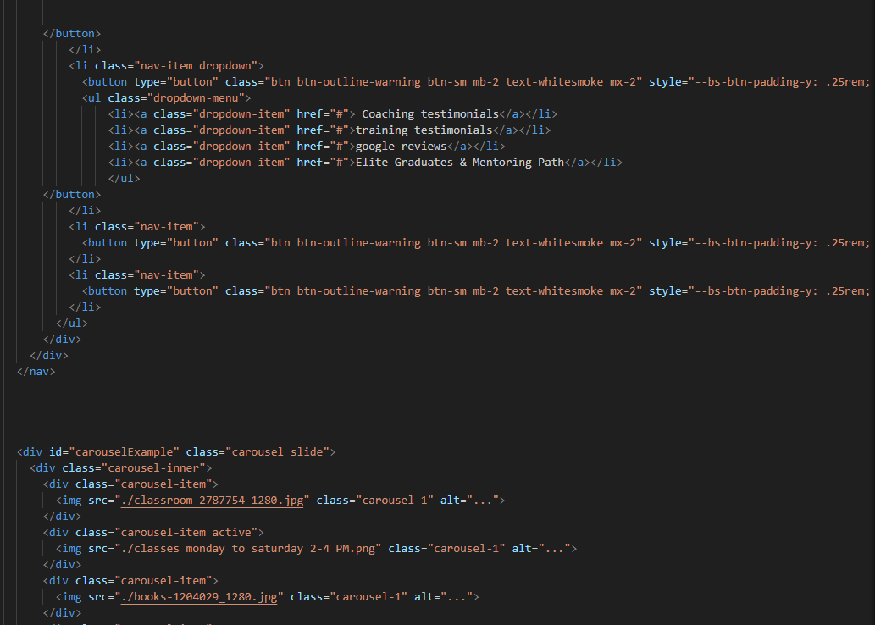

* This section contains a <div> with a class move up.
* Inside the <div>, there is an <a> tag wrapping a <button> element.
* The <a> tag has a href attribute pointing to a local file path which suggests a link to another page or file on the local system.

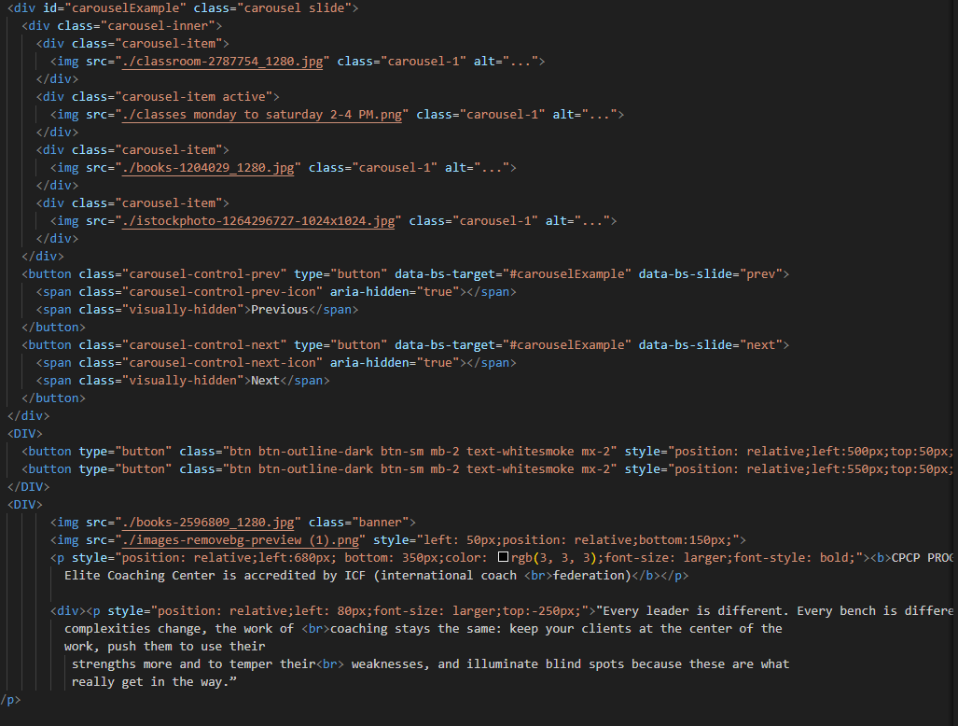

* This section defines a navigation bar (<nav class="navbar navbar-expand-lg bg-body-tertiary">) using Bootstrap classes for styling.
* Inside the navigation bar, there's a logo or brand image (<img src="./Capture.PNG" class="eee">) and various navigation links.
* navigation links are structured as buttons (<button> elements) styled with Bootstrap classes (btn btn-outline-warning btn-sm).

**Home Page CSS**

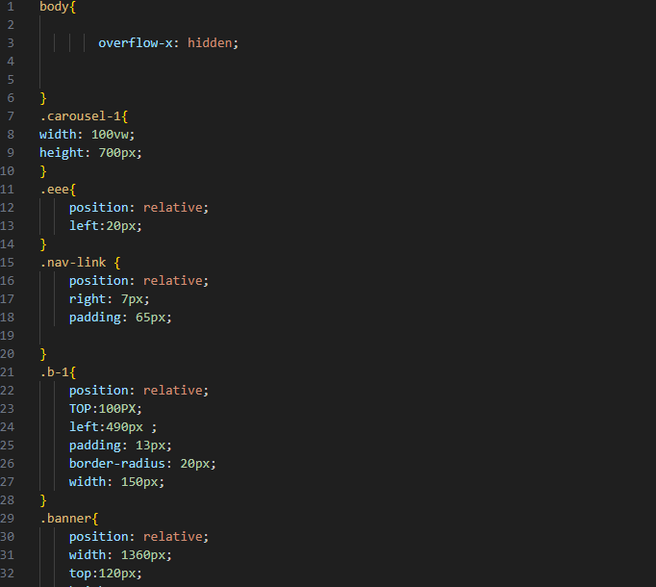

* **Overflow-x**: Hides horizontal overflow, preventing horizontal scrolling.
* **Width and Height**: Sets the width to 100% of the viewport width and the height to 700 pixels for elements with the class carousel-1.
* **Position and Left**: Positions the element relatively, shifting it 20 pixels to the right .
* **Padding**: Adds 65 pixels of padding on all sides.

• **Position**: Positions the element relatively.

• **Top**: Moves the element down 100 pixels.

• **Left**: Moves the element right 490 pixels.

• **Padding**: Adds 13 pixels of padding on all sides.

• **Border-radius**: Rounds the corners of the element

with a 20-pixel radius.

• **Width**: Sets the width to 150 pixels.

• **Body Overflow**: Hides horizontal overflow to

prevent scrolling.

• **Carousel**: Sets the size of a carousel element.

• **Class eee**: Moves an element 20 pixels to the

right.

• **Navigation Link**: Adjusts position and adds

padding to navigation links.

• **Button b-1**: Positions a button element, adds

padding, sets a width, and rounds its corners.

• **Banner**: Sets the size and position of a banner

Element..

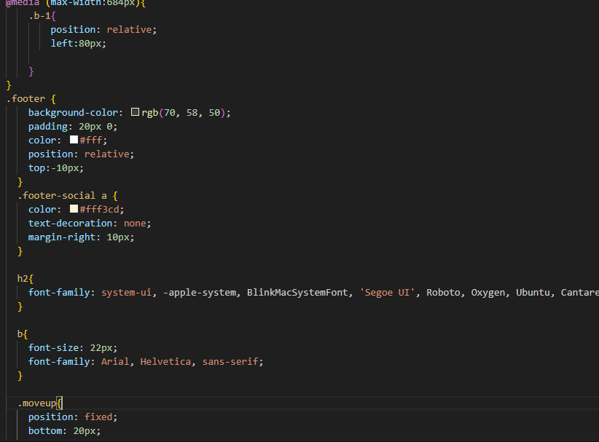

• **Media Query**: Applies the following styles

only when the screen width is 684 pixels or less.

• **Class .b-1**: Positions the element relatively and

shifts it 80 pixels to the right for small screens.

• **Background-color**: Sets the background color to

a dark brown.

• **Padding**: Adds 20 pixels of padding to the top

and bottom.

• **Color**: Sets the text color to white.

• **Position and Top**: Positions the element relatively

and moves it up 10 pixels.

• **Media Query**: Adjusts the position of .b-1 for

small screens.

• **Footer Styling**: Defines the background color,

padding, text color, and position of the footer.

• **Footer Social Links**: Styles the social links in the

footer with specific color, no underline, and right

margin.

• **Heading 2**: Sets the font for <h2> elements.

• **Bold Text**: Sets the font size and font for bold text.

• **Move Up Button**: Fixes the position of an element

at the bottom of the viewport.

* Inside the <button>, there is an <i> ta

Courses

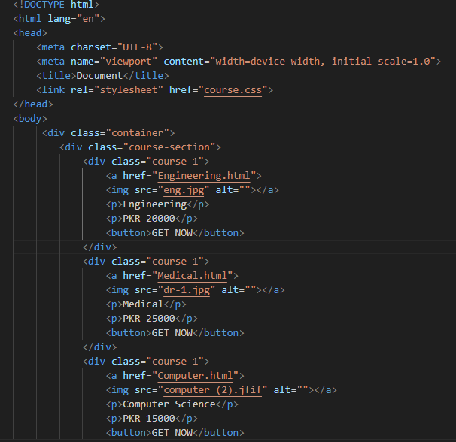

* Explanation:
* **Container (<div class="container">)**: This <div> serves as a wrapper that contains all the content related to courses.
* **Course Section (<div class="course-section">)**: Inside the container, there's a <div> with the class course-section. This section groups all the individual course blocks together.



* **Course Block (<div class="course-1">)**: Each course is represented by a <div> with the class course-1. There are four course blocks within the course-section.
* **Course Link (<a href="...">)**: Each course block includes an <a> tag that wraps around an <img> tag. This <a> tag links to a specific HTML page (Engineering.html, Medical.html, Computer.html, Commerce.html) where more details about the course can be found.



* **Image (<img src="..." alt="">)**: Inside each <a> tag, there's an <img> tag that displays an image related to the course. The src attribute specifies the path to the image (eng.jpg, dr-1.jpg, computer (2)., com.jpg), and the alt attribute provides alternative text for accessibility purposes.
* **Course Title (<p>Engineering</p>, <p>Medical</p>, etc.)**: Below each image, there's a <p> tag that displays the name of the course (Engineering, Medical, Computer Science, Commerce).



* **Course Price (<p>PKR 20000</p>, <p>PKR 25000</p>, etc.)**: Next to the course title, there's another <p> tag that shows the price of the course in Pakistani Rupees (PKR).
* **Button (<button>GET NOW</button>)**: Each course block ends with a <button> labeled "GET NOW". This button likely serves as a call-to-action to prompt users to take action related to the course, such as purchasing or enrolling.



* Purpose:
* This HTML structure is designed to present a catalog of courses in a clear and structured manner. Each course block contains essential information (image, title, price) along with a direct link to more detailed information about the course. The use of semantic HTML elements (<a>, <img>, <p>, <button>) ensures accessibility and proper structuring of content.
* Top of Form
* Bottom of Form

**Coaching Services**

**Overview**

This website offers comprehensive coaching services tailored to different groups. The main page includes a dropdown menu with six distinct pages, each catering to a specific audience. The sections are: Students, Graduates, Entrepreneurs, Professionals, Family, and Assessments.

**Dropdown Menu Pages**

**Students**

**Description:**

* + This section provides coaching services for students, helping them navigate their academic journey, manage time effectively, and develop skills for future success.

**Key Features:**

* + - Academic planning and guidance
    - Study techniques and strategies
    - Career counseling and goal setting
    - Stress and time management tips

**Graduates**

**Description:**

This section is designed for graduates who are transitioning from academic life to professional careers. It offers support in job search strategies, resume building, and interview preparation.

**Key Features:**

* + - Job search techniques
    - Resume and cover letter writing
    - Interview skills and mock interviews
    - Networking tips and career advice

**Entrepreneurs**

**Description:**

This section targets aspiring and established entrepreneurs. It provides coaching on business planning, startup strategies, and growth management.

**Key Features:**

* + - Business plan development
    - Marketing and sales strategies
    - Financial management
    - Leadership and team building

**Professionals**

**Description:**

This section is aimed at professionals looking to advance in their careers. It includes coaching on professional development, leadership skills, and work-life balance.

**Key Features:**

* + - Career advancement strategies
    - Leadership and management training
    - Communication and interpersonal skills
    - Work-life balance techniques

**Family**

**Description:**

This section offers coaching for families, focusing on improving relationships, parenting skills, and family dynamics.

**Key Features:**

* + - Parenting advice and support
    - Relationship counseling
    - Conflict resolution
    - Family communication skills

**Assessments**

**Description:**

* + - This section provides various assessments to help clients understand their strengths, weaknesses, and areas for improvement.

**Key Features:**

* + - Personality assessments
    - Skills and competency evaluations
    - Career aptitude tests
    - Feedback and developmental planning

**Conclusion**

The coaching services website is structured to address the needs of diverse groups through specialized sections. Each page within the dropdown menu offers targeted support and resources to help individuals and families achieve their personal and professional goals.