Faculty Page Explanation & Code

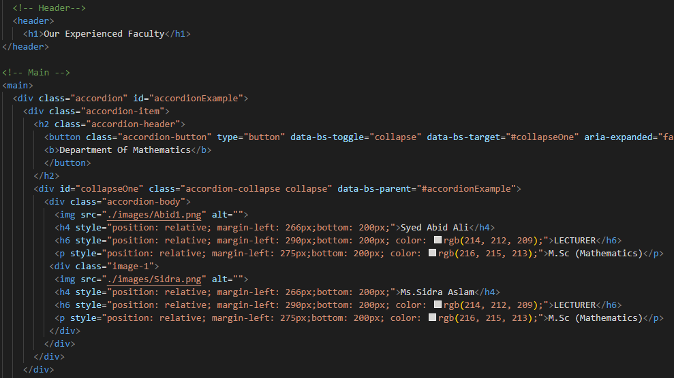

* There is a <h1> tag which define the main header that

Make the text bold and bigger.

* And there is a <div> tag which define class and in this div there is an Accordion which reveal Specific Information About individuals
* for example: like an image and text
* There is bootstrap classes that are added in it like <div class=”accordion ” with id=”accordionExample”>in ID first letter should always be small or it won’t work

****Css Stylesheet

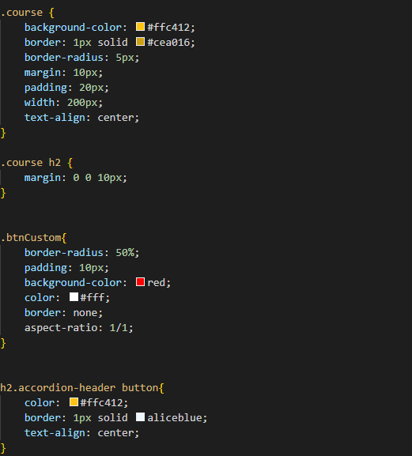

* AS you can see this is called external Css there course class that have been styling with background-color yellow and with width 200px text align center is one of the Css properties that give you the option to manipulate text width and color moreover you can do something interesting too
* The bootstrap that we have problem to solve in internal Css. We have solve it in external Css as you can see the class we have given it