**XPath Axes**

**Ancestor**

Selects all ancestors elements (grandparent, parent, etc) of the current node.

//employee/ancestor::* - select all ancestor node of the employee node.  
 //ancestor::name - select all ancestor of the name node in context node.

**Child**

Select child of the context node.

Child::* - select all child nodes of the context node.  
 child::employee – Select all child elements of employee node.

Note  
 context node is nothing whichever node we are pointing node or we are making as base node.

**Parent**

Select child of the context node.

//name/parent::* - Select parent node of the ‘name’ context node.  
 //email/parent::employee – Return result node if employee node is parent node of the context node, otherwise no node found.

**Preceding**

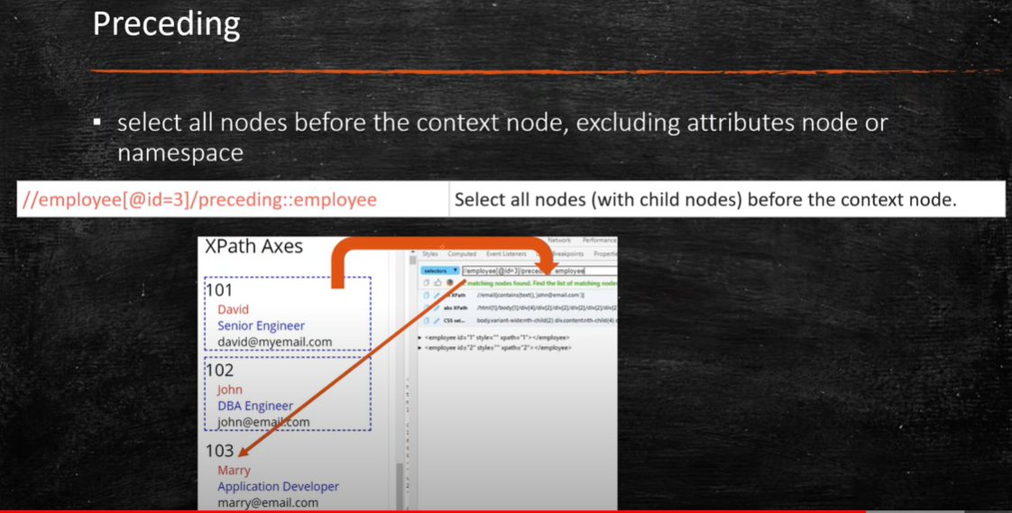

**Following**

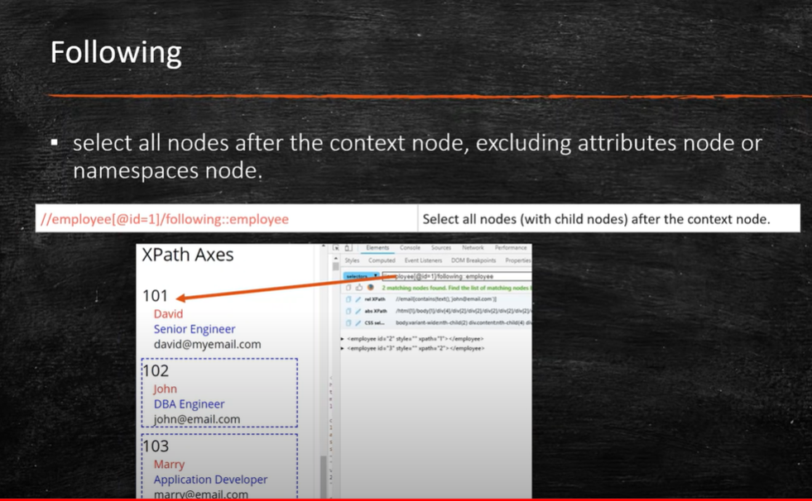

**Self**

Selects the current node ‘name’

//name/self::*

**Descendant**

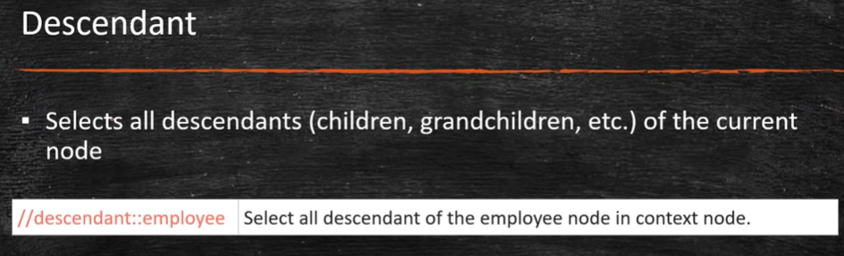

Css Inner Text

Syntax -> css=<HTML tag><:><contains><(text)>

* **:**  the colon is used to symbolize the contains method
* contains – the value of the Class attribute that is being accessed
* text – the text displayed anywhere on the web page, irrespective of its location

**Note:**

If multiple web elements have the same HTML tag and attribute value, it is the first element marked in the page source that will be identified.