**Program Logic and design**

**Von-Neumann Model**

**V**on-Neumann proposed his computer architecture design in 1945 which was later known as Von-Neumann Architecture.  
 It consists of a Control Unit, Arithmetic and Logical Unit (ALU), Memory Unit, Registers and Inputs/Outputs.

A Von Neumann-based computer:

* Uses a single processor
* Uses one memory for both instructions and data.
* Executes programs following the fetch-decode-execute cycle

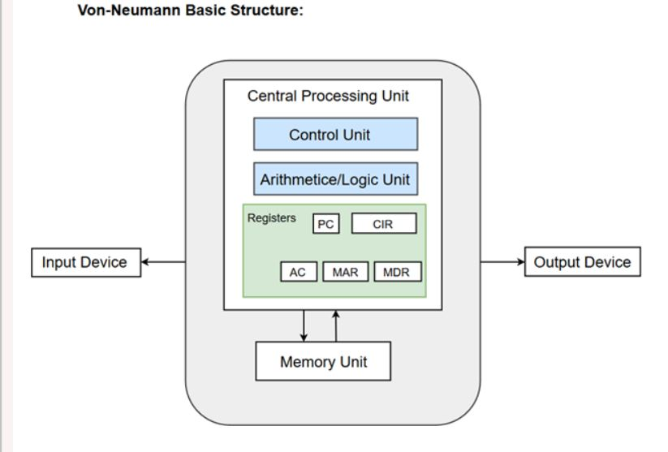

**Components of Von-Neumann Model:**

* Central Processing Unit
* Buses
* Memory Unit

1. Central Processing Unit

The part of the Computer that performs the bulk of data processing operations is called the Central Processing Unit and is referred to as the CPU.  
 The Central Processing Unit can also be defined as an electric circuit responsible for executing the instructions of a computer program.

The major components of CPU are   
 Arithmetic and Logic Unit (ALU)  
 Control Unit (CU)  
 variety of registers.

1. Buses

Data is transmitted from one part of a computer to another, connecting all major internal components to the CPU and memory, by the means of Buses.   
 Von-Neumann Architecture comprised of three major bus systems for data transfer.

* Address Bus
  + It carries data among the memory unit, the I/O devices, and the processor.
* Data Bus
  + It carries the address of data (not the actual data) between memory and processor.
* Control Bus
  + It carries control commands from the CPU in order to control and coordinate all the activities within the computer.

1. Memory Unit

A memory unit is a collection of storage cells together with associated circuits needed to transfer information in and out of the storage.

Two major types of memories are used in computer systems:

RAM (Random Access Memory)  
 ROM (Read-Only Memory)

**Basic Gates**

* The logic gates are the main structural part of a digital system.
* Logic Gates are a block of hardware that produces signals of binary 1 or 0 when input logic requirements are satisfied.

**AND GATE:**

The AND gate is an electronic circuit which gives a high output only if all its inputs are high. The AND operation is represented by a dot (.) sign.

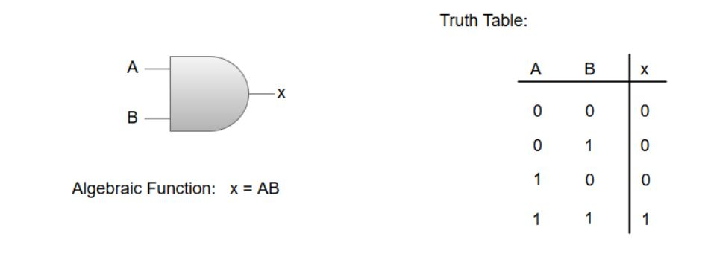

**OR GATE**

The OR gate is an electronic circuit which gives a high output if one or more of its inputs are high. The operation performed by an OR gate is represented by a plus (+) sign.

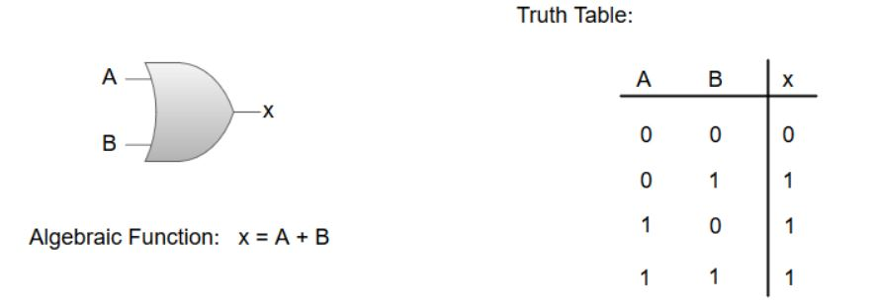

**NOT GATE:**

The NOT gate is an electronic circuit which produces an inverted version of the input at its output. It is also known as an **Inverter**.

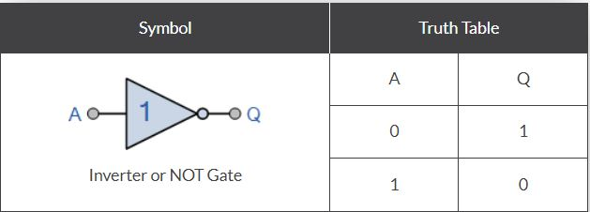

NAND Gate

The NAND gate is a special type of logic gate in the digital logic circuit. The NAND gate is the universal gate.   
 It means all the basic gates such as AND, OR, and NOT gate can be constructed using a NAND gate.  
 The NAND gate is the combination of the NOT-AND gate. The output state of the NAND gate will be low only when all the inputs are high.

