HR Policy Knowledge System
Architecture Overview
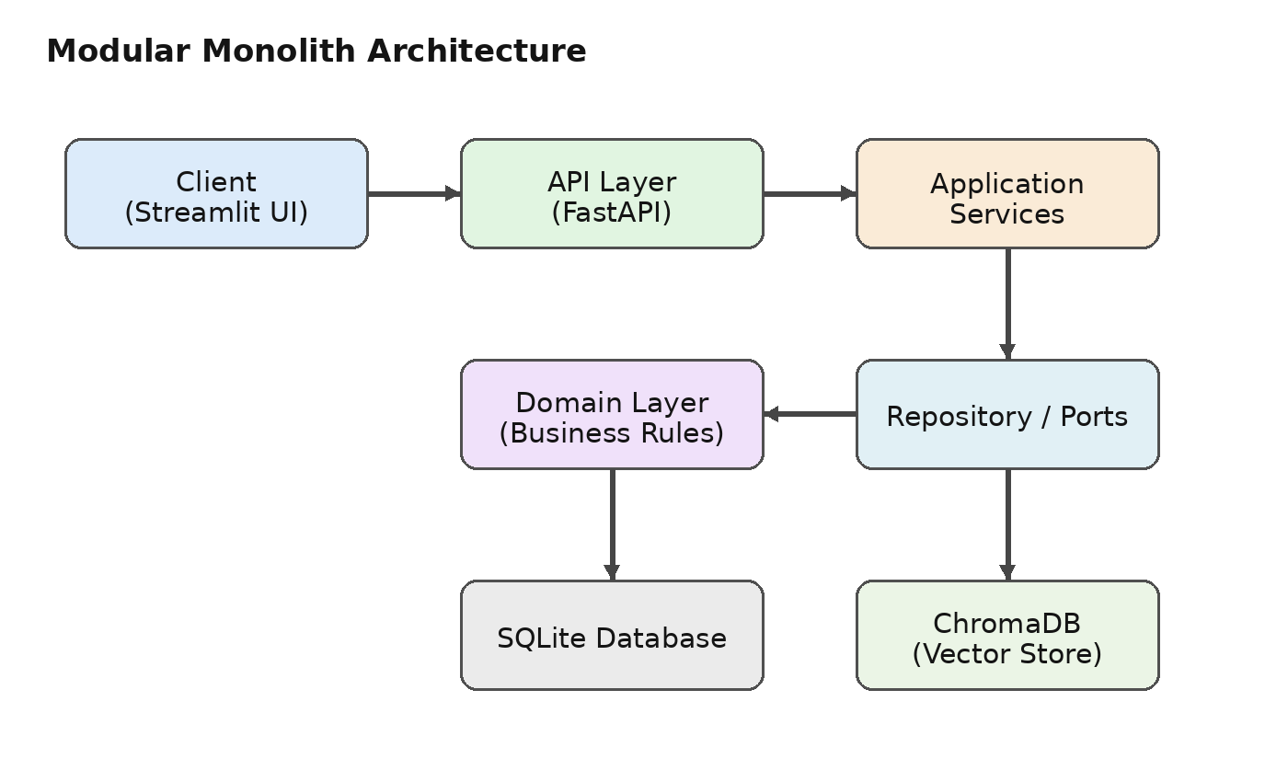

Architecture Description
The system follows a modular-monolith approach. The Streamlit client sends requests to a FastAPI API layer. Application services coordinate authentication, authorization, retrieval, and business workflows. The domain layer contains core business rules, while repositories isolate persistence details. SQLite stores application and access-control data, while ChromaDB stores document embeddings used for semantic retrieval.

Request and Retrieval Flow
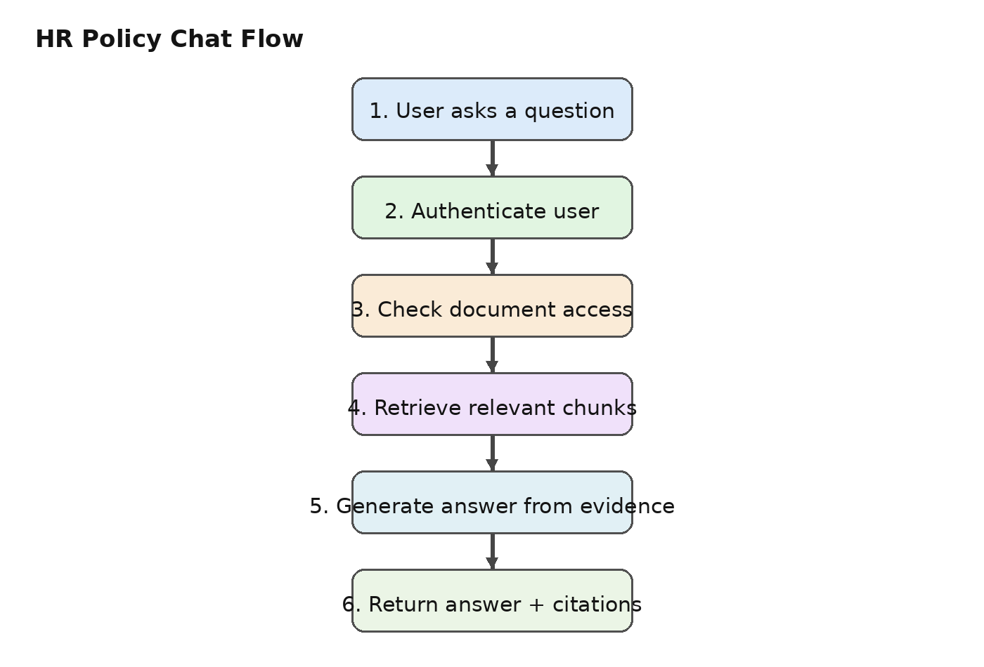

What Happens During a Query?
- The user submits a natural-language question through the chat interface.
- The backend verifies the user's identity and determines which documents the user is allowed to access.
- The retrieval layer searches authorized document chunks and selects relevant evidence.
- The answer-generation step uses the selected evidence and returns citations so the user can trace the response.

Document Ingestion and Data Model
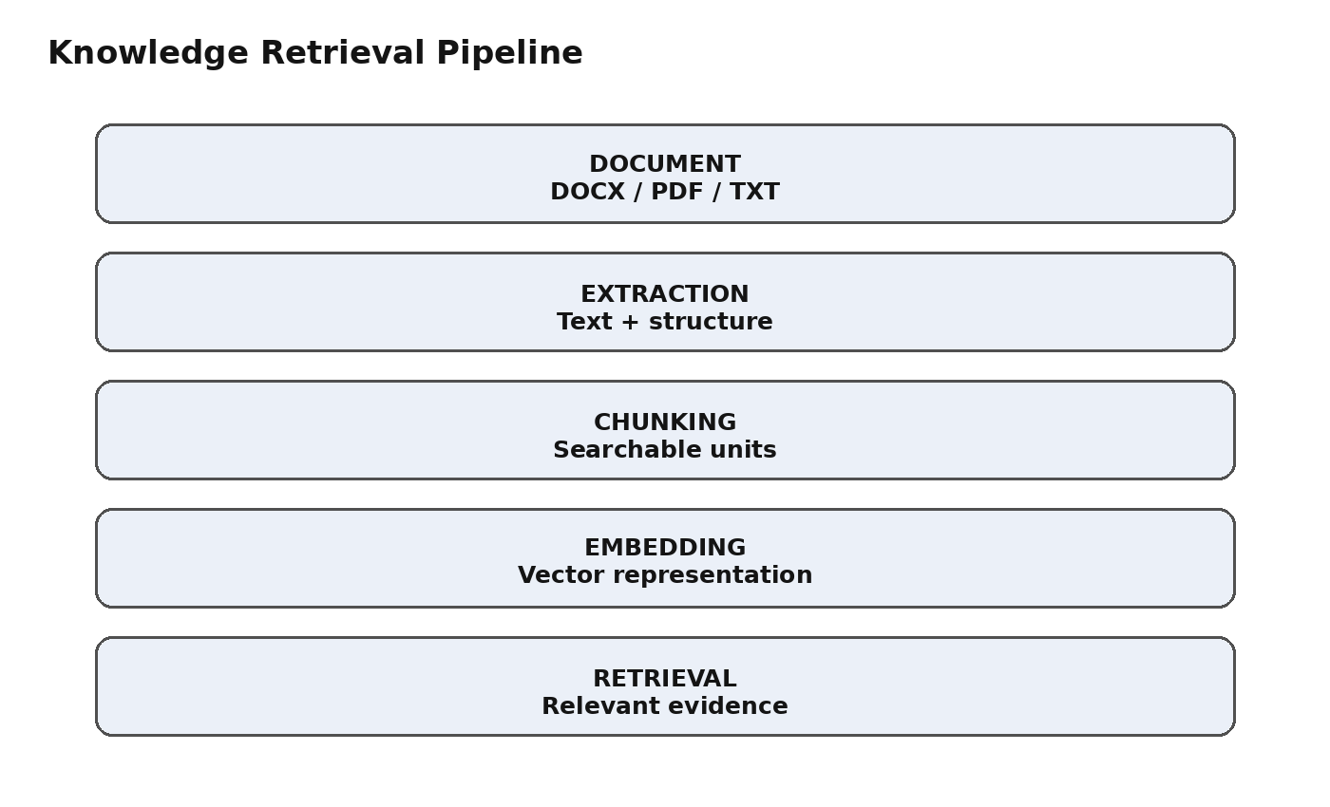

Example System Data
Component | Purpose | Example | Output
User | Identity and access | EMP-1042 | Authorized session
Project | Groups related documents | Onboarding Project | Project access
Document | Stores source metadata | Employee Handbook | Document record
Chunk | Small searchable text unit | Leave policy section | Vector embedding
Permission | Controls resource access | Project = HR | Allow / deny

Key Design Principles
Separation of responsibilities keeps the system easier to test and change. Authentication answers who the user is; authorization answers what the user can access; retrieval finds evidence only from authorized sources; and answer generation produces a response grounded in that evidence.

