Employee Onboarding Guide

1. Overview
This guide describes how a new employee is onboarded, which systems they are granted access to, and who approves each step. It is synthetic test content generated for a document-ingestion experiment.
Every role named in this document is fictional. No real employee, client, or system from any production environment is referenced.

1.1 Purpose
The purpose of this section is to state that onboarding is completed within five working days of the joining date, and that the approving manager is recorded in the access matrix.

2. Onboarding Steps
- HR creates the employee account in the HR portal.
- The manager assigns the employee to a delivery project.
- IT issues the laptop and provisions repository access.
- Payroll adds the employee to the monthly salary cycle.

3. Access Matrix by Department
The table below records the portal role, the approver and the payroll access level granted to each department.
Department | Portal Role | Approver | Payroll Access
Engineering | Employee | Engineering Manager | Read Only
Engineering | Manager | VP Engineering | Read Only
Finance | Employee | Finance Director | Read Write
Human Resources | HR Admin | HR Director | Read Write

4. Employee Record Card
The figure below shows 4. employee record card as it appears in the source document.
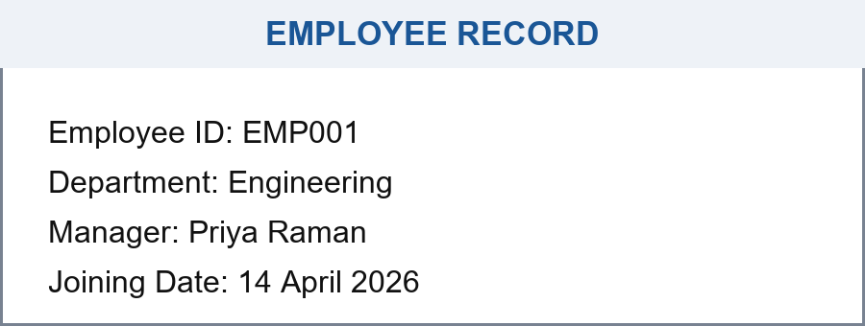

5. HR Portal Screenshot
The figure below shows 5. hr portal screenshot as it appears in the source document.
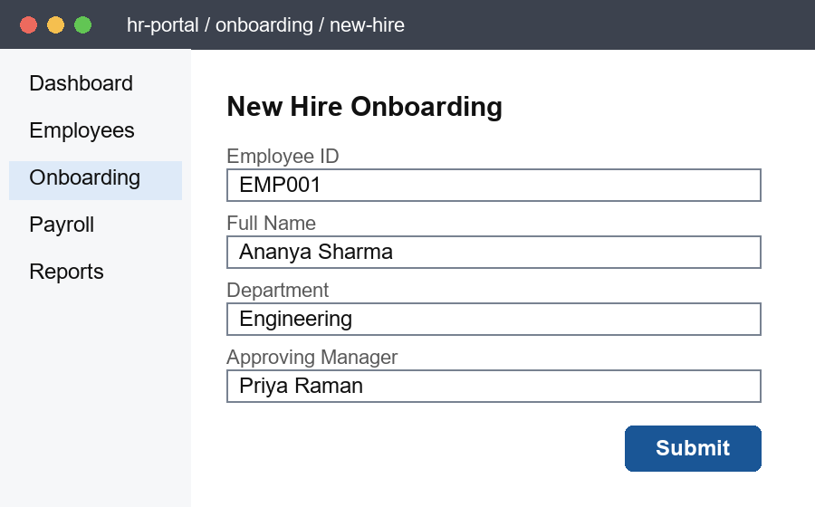

6. Platform Architecture
The figure below shows 6. platform architecture as it appears in the source document.
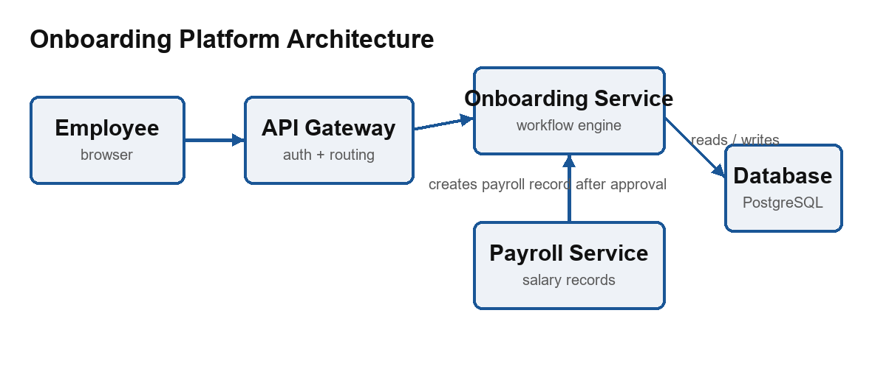

7. Leave Approval Flow
The figure below shows 7. leave approval flow as it appears in the source document.
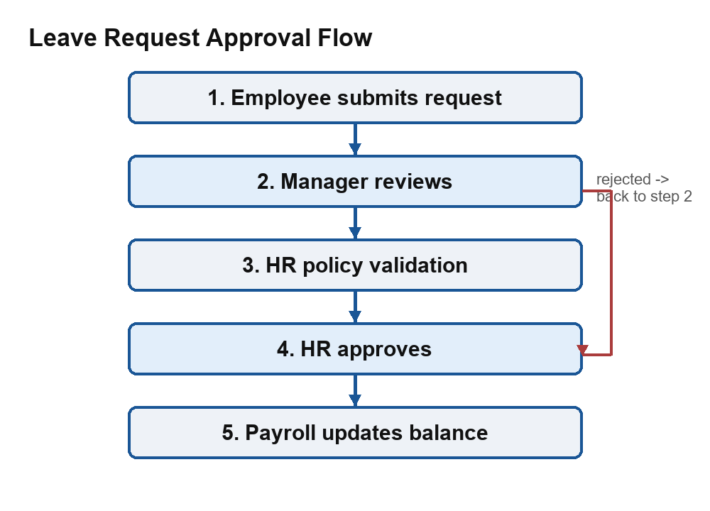

8. Headcount by Quarter
The figure below shows 8. headcount by quarter as it appears in the source document.
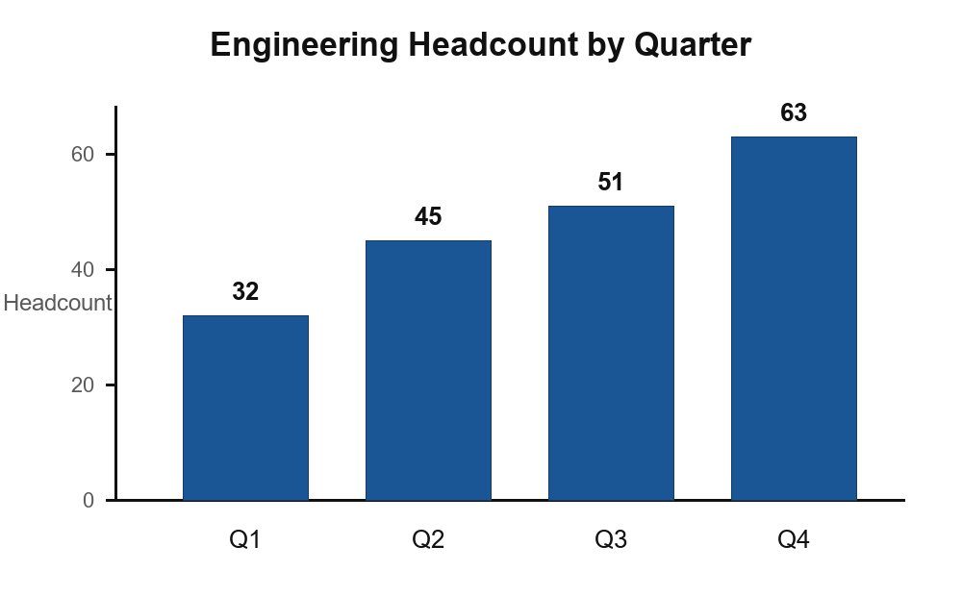

9. Company Identity
The figure below shows 9. company identity as it appears in the source document.


