RML_070.R

darki

2020-04-03

# Rozdział 7 - Metoda wektorów nośnych (SVM)  
  
rm(list=ls())  
  
set.seed(1)  
x=matrix(rnorm(20*2), ncol=2)  
y=c(rep(-1,10), rep(1,10))  
x[y==1,]=x[y==1,] + 1  
plot(x, col=(3-y))

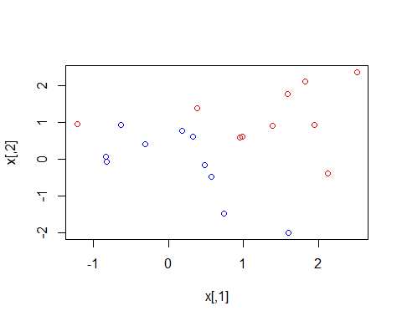

dat=data.frame(x=x, y=as.factor(y))  
  
library(e1071)  
svmfit=svm(y~., data=dat, kernel="linear", cost=10,scale=FALSE)  
plot(svmfit, dat)

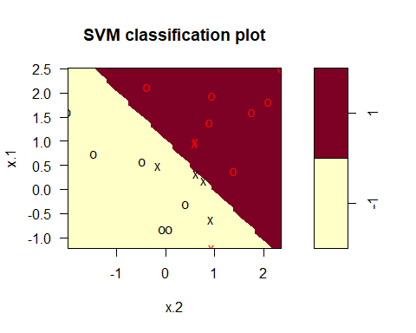

svmfit$index

## [1] 1 2 5 7 14 16 17

summary(svmfit)

##   
 ## Call:  
 ## svm(formula = y ~ ., data = dat, kernel = "linear", cost = 10,   
 ## scale = FALSE)  
 ##   
 ##   
 ## Parameters:  
 ## SVM-Type: C-classification   
 ## SVM-Kernel: linear   
 ## cost: 10   
 ##   
 ## Number of Support Vectors: 7  
 ##   
 ## ( 4 3 )  
 ##   
 ##   
 ## Number of Classes: 2   
 ##   
 ## Levels:   
 ## -1 1

svmfit=svm(y~., data=dat, kernel="linear", cost=0.1,scale=FALSE)  
plot(svmfit, dat)

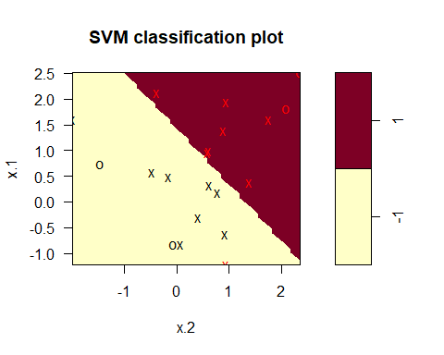

svmfit$index

## [1] 1 2 3 4 5 7 9 10 12 13 14 15 16 17 18 20

set.seed(1)  
tune.out=tune(svm,y~.,data=dat,kernel="linear",ranges=list(cost=c(0.001, 0.01, 0.1, 1,5,10,100)))  
summary(tune.out)

##   
 ## Parameter tuning of 'svm':  
 ##   
 ## - sampling method: 10-fold cross validation   
 ##   
 ## - best parameters:  
 ## cost  
 ## 0.1  
 ##   
 ## - best performance: 0.05   
 ##   
 ## - Detailed performance results:  
 ## cost error dispersion  
 ## 1 1e-03 0.55 0.4377975  
 ## 2 1e-02 0.55 0.4377975  
 ## 3 1e-01 0.05 0.1581139  
 ## 4 1e+00 0.15 0.2415229  
 ## 5 5e+00 0.15 0.2415229  
 ## 6 1e+01 0.15 0.2415229  
 ## 7 1e+02 0.15 0.2415229

bestmod=tune.out$best.model  
summary(bestmod)

##   
 ## Call:  
 ## best.tune(method = svm, train.x = y ~ ., data = dat, ranges = list(cost = c(0.001,   
 ## 0.01, 0.1, 1, 5, 10, 100)), kernel = "linear")  
 ##   
 ##   
 ## Parameters:  
 ## SVM-Type: C-classification   
 ## SVM-Kernel: linear   
 ## cost: 0.1   
 ##   
 ## Number of Support Vectors: 16  
 ##   
 ## ( 8 8 )  
 ##   
 ##   
 ## Number of Classes: 2   
 ##   
 ## Levels:   
 ## -1 1

xtest=matrix(rnorm(20*2), ncol=2)  
ytest=sample(c(-1,1), 20, rep=TRUE)  
xtest[ytest==1,]=xtest[ytest==1,] + 1  
testdat=data.frame(x=xtest, y=as.factor(ytest))  
ypred=predict(bestmod,testdat)  
table(predict=ypred, truth=testdat$y)

## truth  
 ## predict -1 1  
 ## -1 9 1  
 ## 1 2 8

svmfit=svm(y~., data=dat, kernel="linear", cost=.01,scale=FALSE)  
ypred=predict(svmfit,testdat)  
table(predict=ypred, truth=testdat$y)

## truth  
 ## predict -1 1  
 ## -1 11 6  
 ## 1 0 3

x[y==1,]=x[y==1,]+0.5  
plot(x, col=(y+5)/2, pch=19)

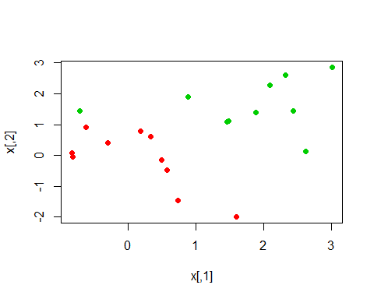

dat=data.frame(x=x,y=as.factor(y))  
svmfit=svm(y~., data=dat, kernel="linear", cost=1e5)  
summary(svmfit)

##   
 ## Call:  
 ## svm(formula = y ~ ., data = dat, kernel = "linear", cost = 1e+05)  
 ##   
 ##   
 ## Parameters:  
 ## SVM-Type: C-classification   
 ## SVM-Kernel: linear   
 ## cost: 1e+05   
 ##   
 ## Number of Support Vectors: 3  
 ##   
 ## ( 1 2 )  
 ##   
 ##   
 ## Number of Classes: 2   
 ##   
 ## Levels:   
 ## -1 1

plot(svmfit, dat)

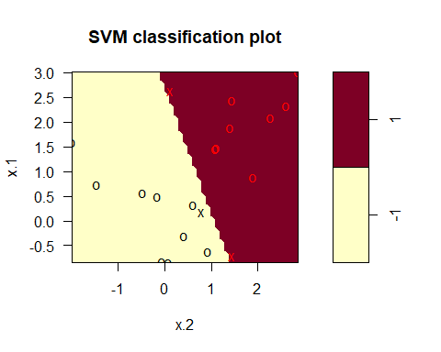

svmfit=svm(y~., data=dat, kernel="linear", cost=1)  
summary(svmfit)

##   
 ## Call:  
 ## svm(formula = y ~ ., data = dat, kernel = "linear", cost = 1)  
 ##   
 ##   
 ## Parameters:  
 ## SVM-Type: C-classification   
 ## SVM-Kernel: linear   
 ## cost: 1   
 ##   
 ## Number of Support Vectors: 7  
 ##   
 ## ( 4 3 )  
 ##   
 ##   
 ## Number of Classes: 2   
 ##   
 ## Levels:   
 ## -1 1

plot(svmfit,dat)

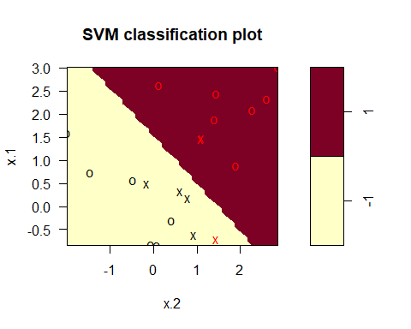

# Support Vector Machine  
  
set.seed(1)  
x=matrix(rnorm(200*2), ncol=2)  
x[1:100,]=x[1:100,]+2  
x[101:150,]=x[101:150,]-2  
y=c(rep(1,150),rep(2,50))  
dat=data.frame(x=x,y=as.factor(y))  
plot(x, col=y)

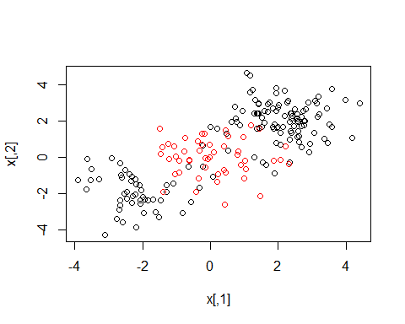

train=sample(200,100)  
svmfit=svm(y~., data=dat[train,], kernel="radial", gamma=1, cost=1)  
plot(svmfit, dat[train,])

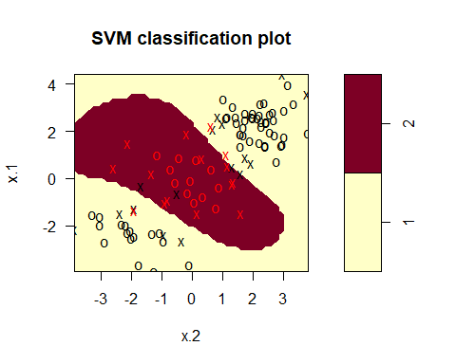

summary(svmfit)

##   
 ## Call:  
 ## svm(formula = y ~ ., data = dat[train, ], kernel = "radial",   
 ## gamma = 1, cost = 1)  
 ##   
 ##   
 ## Parameters:  
 ## SVM-Type: C-classification   
 ## SVM-Kernel: radial   
 ## cost: 1   
 ##   
 ## Number of Support Vectors: 31  
 ##   
 ## ( 16 15 )  
 ##   
 ##   
 ## Number of Classes: 2   
 ##   
 ## Levels:   
 ## 1 2

svmfit=svm(y~., data=dat[train,], kernel="radial",gamma=1,cost=1e5)  
plot(svmfit,dat[train,])

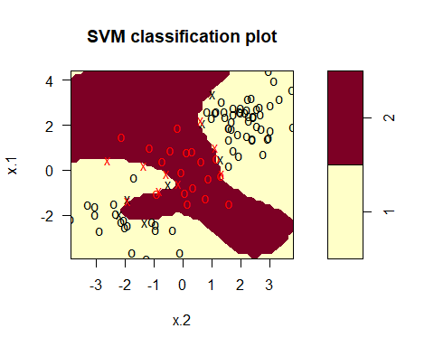

set.seed(1)  
tune.out=tune(svm, y~., data=dat[train,], kernel="radial", ranges=list(cost=c(0.1,1,10,100,1000),gamma=c(0.5,1,2,3,4)))  
summary(tune.out)

##   
 ## Parameter tuning of 'svm':  
 ##   
 ## - sampling method: 10-fold cross validation   
 ##   
 ## - best parameters:  
 ## cost gamma  
 ## 1 0.5  
 ##   
 ## - best performance: 0.07   
 ##   
 ## - Detailed performance results:  
 ## cost gamma error dispersion  
 ## 1 1e-01 0.5 0.26 0.15776213  
 ## 2 1e+00 0.5 0.07 0.08232726  
 ## 3 1e+01 0.5 0.07 0.08232726  
 ## 4 1e+02 0.5 0.14 0.15055453  
 ## 5 1e+03 0.5 0.11 0.07378648  
 ## 6 1e-01 1.0 0.22 0.16193277  
 ## 7 1e+00 1.0 0.07 0.08232726  
 ## 8 1e+01 1.0 0.09 0.07378648  
 ## 9 1e+02 1.0 0.12 0.12292726  
 ## 10 1e+03 1.0 0.11 0.11005049  
 ## 11 1e-01 2.0 0.27 0.15670212  
 ## 12 1e+00 2.0 0.07 0.08232726  
 ## 13 1e+01 2.0 0.11 0.07378648  
 ## 14 1e+02 2.0 0.12 0.13165612  
 ## 15 1e+03 2.0 0.16 0.13498971  
 ## 16 1e-01 3.0 0.27 0.15670212  
 ## 17 1e+00 3.0 0.07 0.08232726  
 ## 18 1e+01 3.0 0.08 0.07888106  
 ## 19 1e+02 3.0 0.13 0.14181365  
 ## 20 1e+03 3.0 0.15 0.13540064  
 ## 21 1e-01 4.0 0.27 0.15670212  
 ## 22 1e+00 4.0 0.07 0.08232726  
 ## 23 1e+01 4.0 0.09 0.07378648  
 ## 24 1e+02 4.0 0.13 0.14181365  
 ## 25 1e+03 4.0 0.15 0.13540064

table(true=dat[-train,"y"], pred=predict(tune.out$best.model,newx=dat[-train,]))

## pred  
 ## true 1 2  
 ## 1 54 23  
 ## 2 17 6

# Krzywe ROC  
  
library(ROCR)

## Warning: package 'ROCR' was built under R version 3.6.3

## Loading required package: gplots

## Warning: package 'gplots' was built under R version 3.6.3

##   
 ## Attaching package: 'gplots'

## The following object is masked from 'package:stats':  
 ##   
 ## lowess

rocplot=function(pred, truth, ...){  
 predob = prediction(pred, truth)  
 perf = performance(predob, "tpr", "fpr")  
 plot(perf,...)}  
svmfit.opt=svm(y~., data=dat[train,], kernel="radial",gamma=2, cost=1,decision.values=T)  
fitted=attributes(predict(svmfit.opt,dat[train,],decision.values=TRUE))$decision.values  
par(mfrow=c(1,2))  
rocplot(fitted,dat[train,"y"],main="Training Data")  
svmfit.flex=svm(y~., data=dat[train,], kernel="radial",gamma=50, cost=1, decision.values=T)  
fitted=attributes(predict(svmfit.flex,dat[train,],decision.values=T))$decision.values  
rocplot(fitted,dat[train,"y"],add=T,col="red")  
fitted=attributes(predict(svmfit.opt,dat[-train,],decision.values=T))$decision.values  
rocplot(fitted,dat[-train,"y"],main="Test Data")  
fitted=attributes(predict(svmfit.flex,dat[-train,],decision.values=T))$decision.values  
rocplot(fitted,dat[-train,"y"],add=T,col="red")

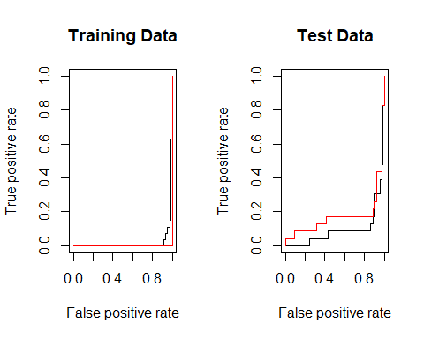

# SVM z wieloma klasami  
  
set.seed(1)  
x=rbind(x, matrix(rnorm(50*2), ncol=2))  
y=c(y, rep(0,50))  
x[y==0,2]=x[y==0,2]+2  
dat=data.frame(x=x, y=as.factor(y))  
par(mfrow=c(1,1))  
plot(x,col=(y+1))

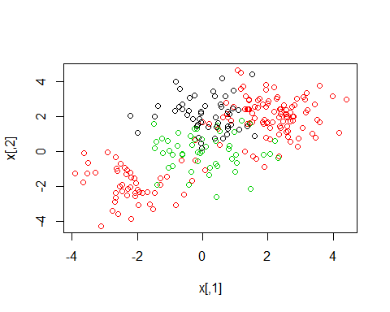

svmfit=svm(y~., data=dat, kernel="radial", cost=10, gamma=1)  
plot(svmfit, dat)

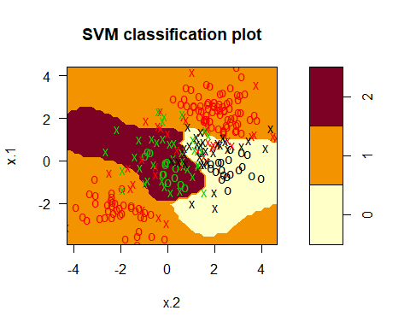

# Dane dotyczą klasyfikacji rodzaju nowotworu  
  
library(ISLR)

## Warning: package 'ISLR' was built under R version 3.6.3

names(Khan)

## [1] "xtrain" "xtest" "ytrain" "ytest"

dim(Khan$xtrain)

## [1] 63 2308

dim(Khan$xtest)

## [1] 20 2308

length(Khan$ytrain)

## [1] 63

length(Khan$ytest)

## [1] 20

table(Khan$ytrain)

##   
 ## 1 2 3 4   
 ## 8 23 12 20

table(Khan$ytest)

##   
 ## 1 2 3 4   
 ## 3 6 6 5

dat=data.frame(x=Khan$xtrain, y=as.factor(Khan$ytrain))  
out=svm(y~., data=dat, kernel="linear",cost=10)  
summary(out)

##   
 ## Call:  
 ## svm(formula = y ~ ., data = dat, kernel = "linear", cost = 10)  
 ##   
 ##   
 ## Parameters:  
 ## SVM-Type: C-classification   
 ## SVM-Kernel: linear   
 ## cost: 10   
 ##   
 ## Number of Support Vectors: 58  
 ##   
 ## ( 20 20 11 7 )  
 ##   
 ##   
 ## Number of Classes: 4   
 ##   
 ## Levels:   
 ## 1 2 3 4

table(out$fitted, dat$y)

##   
 ## 1 2 3 4  
 ## 1 8 0 0 0  
 ## 2 0 23 0 0  
 ## 3 0 0 12 0  
 ## 4 0 0 0 20

dat.te=data.frame(x=Khan$xtest, y=as.factor(Khan$ytest))  
pred.te=predict(out, newdata=dat.te)  
table(pred.te, dat.te$y)

##   
 ## pred.te 1 2 3 4  
 ## 1 3 0 0 0  
 ## 2 0 6 2 0  
 ## 3 0 0 4 0  
 ## 4 0 0 0 5