RML_080.R

darki

2020-04-03

# Rozdział 8 - Drzewa decyzyjne  
  
rm(list=ls())  
  
library(tree)  
library(ISLR)

## Warning: package 'ISLR' was built under R version 3.6.3

# Dane sprzedazowe fotelików dziecięcych  
attach(Carseats)  
High=ifelse(Sales<=8,"No","Yes")  
Carseats=data.frame(Carseats,High)  
tree.carseats=tree(High~.-Sales,Carseats)  
summary(tree.carseats)

##   
 ## Classification tree:  
 ## tree(formula = High ~ . - Sales, data = Carseats)  
 ## Variables actually used in tree construction:  
 ## [1] "ShelveLoc" "Price" "Income" "CompPrice" "Population"   
 ## [6] "Advertising" "Age" "US"   
 ## Number of terminal nodes: 27   
 ## Residual mean deviance: 0.4575 = 170.7 / 373   
 ## Misclassification error rate: 0.09 = 36 / 400

plot(tree.carseats)  
text(tree.carseats,pretty=0)

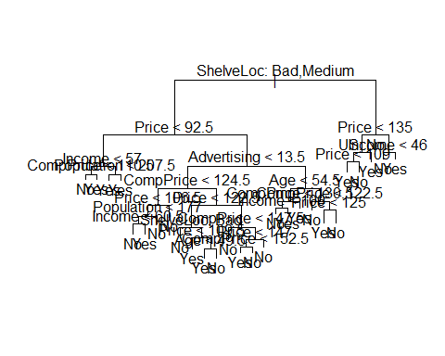

tree.carseats

## node), split, n, deviance, yval, (yprob)  
 ## * denotes terminal node  
 ##   
 ## 1) root 400 541.500 No ( 0.59000 0.41000 )   
 ## 2) ShelveLoc: Bad,Medium 315 390.600 No ( 0.68889 0.31111 )   
 ## 4) Price < 92.5 46 56.530 Yes ( 0.30435 0.69565 )   
 ## 8) Income < 57 10 12.220 No ( 0.70000 0.30000 )   
 ## 16) CompPrice < 110.5 5 0.000 No ( 1.00000 0.00000 ) *  
 ## 17) CompPrice > 110.5 5 6.730 Yes ( 0.40000 0.60000 ) *  
 ## 9) Income > 57 36 35.470 Yes ( 0.19444 0.80556 )   
 ## 18) Population < 207.5 16 21.170 Yes ( 0.37500 0.62500 ) *  
 ## 19) Population > 207.5 20 7.941 Yes ( 0.05000 0.95000 ) *  
 ## 5) Price > 92.5 269 299.800 No ( 0.75465 0.24535 )   
 ## 10) Advertising < 13.5 224 213.200 No ( 0.81696 0.18304 )   
 ## 20) CompPrice < 124.5 96 44.890 No ( 0.93750 0.06250 )   
 ## 40) Price < 106.5 38 33.150 No ( 0.84211 0.15789 )   
 ## 80) Population < 177 12 16.300 No ( 0.58333 0.41667 )   
 ## 160) Income < 60.5 6 0.000 No ( 1.00000 0.00000 ) *  
 ## 161) Income > 60.5 6 5.407 Yes ( 0.16667 0.83333 ) *  
 ## 81) Population > 177 26 8.477 No ( 0.96154 0.03846 ) *  
 ## 41) Price > 106.5 58 0.000 No ( 1.00000 0.00000 ) *  
 ## 21) CompPrice > 124.5 128 150.200 No ( 0.72656 0.27344 )   
 ## 42) Price < 122.5 51 70.680 Yes ( 0.49020 0.50980 )   
 ## 84) ShelveLoc: Bad 11 6.702 No ( 0.90909 0.09091 ) *  
 ## 85) ShelveLoc: Medium 40 52.930 Yes ( 0.37500 0.62500 )   
 ## 170) Price < 109.5 16 7.481 Yes ( 0.06250 0.93750 ) *  
 ## 171) Price > 109.5 24 32.600 No ( 0.58333 0.41667 )   
 ## 342) Age < 49.5 13 16.050 Yes ( 0.30769 0.69231 ) *  
 ## 343) Age > 49.5 11 6.702 No ( 0.90909 0.09091 ) *  
 ## 43) Price > 122.5 77 55.540 No ( 0.88312 0.11688 )   
 ## 86) CompPrice < 147.5 58 17.400 No ( 0.96552 0.03448 ) *  
 ## 87) CompPrice > 147.5 19 25.010 No ( 0.63158 0.36842 )   
 ## 174) Price < 147 12 16.300 Yes ( 0.41667 0.58333 )   
 ## 348) CompPrice < 152.5 7 5.742 Yes ( 0.14286 0.85714 ) *  
 ## 349) CompPrice > 152.5 5 5.004 No ( 0.80000 0.20000 ) *  
 ## 175) Price > 147 7 0.000 No ( 1.00000 0.00000 ) *  
 ## 11) Advertising > 13.5 45 61.830 Yes ( 0.44444 0.55556 )   
 ## 22) Age < 54.5 25 25.020 Yes ( 0.20000 0.80000 )   
 ## 44) CompPrice < 130.5 14 18.250 Yes ( 0.35714 0.64286 )   
 ## 88) Income < 100 9 12.370 No ( 0.55556 0.44444 ) *  
 ## 89) Income > 100 5 0.000 Yes ( 0.00000 1.00000 ) *  
 ## 45) CompPrice > 130.5 11 0.000 Yes ( 0.00000 1.00000 ) *  
 ## 23) Age > 54.5 20 22.490 No ( 0.75000 0.25000 )   
 ## 46) CompPrice < 122.5 10 0.000 No ( 1.00000 0.00000 ) *  
 ## 47) CompPrice > 122.5 10 13.860 No ( 0.50000 0.50000 )   
 ## 94) Price < 125 5 0.000 Yes ( 0.00000 1.00000 ) *  
 ## 95) Price > 125 5 0.000 No ( 1.00000 0.00000 ) *  
 ## 3) ShelveLoc: Good 85 90.330 Yes ( 0.22353 0.77647 )   
 ## 6) Price < 135 68 49.260 Yes ( 0.11765 0.88235 )   
 ## 12) US: No 17 22.070 Yes ( 0.35294 0.64706 )   
 ## 24) Price < 109 8 0.000 Yes ( 0.00000 1.00000 ) *  
 ## 25) Price > 109 9 11.460 No ( 0.66667 0.33333 ) *  
 ## 13) US: Yes 51 16.880 Yes ( 0.03922 0.96078 ) *  
 ## 7) Price > 135 17 22.070 No ( 0.64706 0.35294 )   
 ## 14) Income < 46 6 0.000 No ( 1.00000 0.00000 ) *  
 ## 15) Income > 46 11 15.160 Yes ( 0.45455 0.54545 ) *

set.seed(2)  
train=sample(1:nrow(Carseats), 200)  
Carseats.test=Carseats[-train,]  
High.test=High[-train]  
tree.carseats=tree(High~.-Sales,Carseats,subset=train)  
tree.pred=predict(tree.carseats,Carseats.test,type="class")  
table(tree.pred,High.test)

## High.test  
 ## tree.pred No Yes  
 ## No 104 33  
 ## Yes 13 50

(86+57)/200

## [1] 0.715

set.seed(3)  
cv.carseats=cv.tree(tree.carseats,FUN=prune.misclass)  
names(cv.carseats)

## [1] "size" "dev" "k" "method"

cv.carseats

## $size  
 ## [1] 21 19 14 9 8 5 3 2 1  
 ##   
 ## $dev  
 ## [1] 74 76 81 81 75 77 78 85 81  
 ##   
 ## $k  
 ## [1] -Inf 0.0 1.0 1.4 2.0 3.0 4.0 9.0 18.0  
 ##   
 ## $method  
 ## [1] "misclass"  
 ##   
 ## attr(,"class")  
 ## [1] "prune" "tree.sequence"

par(mfrow=c(1,2))  
plot(cv.carseats$size,cv.carseats$dev,type="b")  
plot(cv.carseats$k,cv.carseats$dev,type="b")

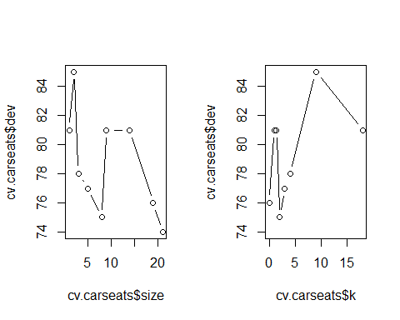

prune.carseats=prune.misclass(tree.carseats,best=9)  
plot(prune.carseats)  
text(prune.carseats,pretty=0)  
tree.pred=predict(prune.carseats,Carseats.test,type="class")  
table(tree.pred,High.test)

## High.test  
 ## tree.pred No Yes  
 ## No 97 25  
 ## Yes 20 58

(94+60)/200

## [1] 0.77

prune.carseats=prune.misclass(tree.carseats,best=15)  
plot(prune.carseats)  
text(prune.carseats,pretty=0)

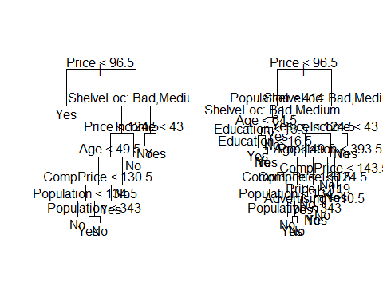

tree.pred=predict(prune.carseats,Carseats.test,type="class")  
table(tree.pred,High.test)

## High.test  
 ## tree.pred No Yes  
 ## No 102 30  
 ## Yes 15 53

(86+62)/200

## [1] 0.74

# Dane dotyczące nieruchomości z Bostonu  
  
library(MASS)  
set.seed(1)  
train = sample(1:nrow(Boston), nrow(Boston)/2)  
tree.boston=tree(medv~.,Boston,subset=train)  
summary(tree.boston)

##   
 ## Regression tree:  
 ## tree(formula = medv ~ ., data = Boston, subset = train)  
 ## Variables actually used in tree construction:  
 ## [1] "rm" "lstat" "crim" "age"   
 ## Number of terminal nodes: 7   
 ## Residual mean deviance: 10.38 = 2555 / 246   
 ## Distribution of residuals:  
 ## Min. 1st Qu. Median Mean 3rd Qu. Max.   
 ## -10.1800 -1.7770 -0.1775 0.0000 1.9230 16.5800

plot(tree.boston)  
text(tree.boston,pretty=0)  
cv.boston=cv.tree(tree.boston)  
plot(cv.boston$size,cv.boston$dev,type='b')

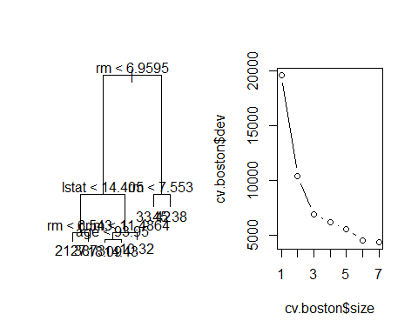

prune.boston=prune.tree(tree.boston,best=5)  
plot(prune.boston)  
text(prune.boston,pretty=0)  
yhat=predict(tree.boston,newdata=Boston[-train,])  
boston.test=Boston[-train,"medv"]  
plot(yhat,boston.test)  
abline(0,1)

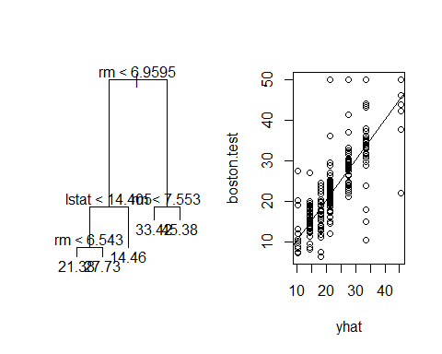

mean((yhat-boston.test)^2)

## [1] 35.28688

# Bagging i Random Forests  
  
library(randomForest)

## Warning: package 'randomForest' was built under R version 3.6.3

## randomForest 4.6-14

## Type rfNews() to see new features/changes/bug fixes.

set.seed(1)  
bag.boston=randomForest(medv~.,data=Boston,subset=train,mtry=13,importance=TRUE)  
bag.boston

##   
 ## Call:  
 ## randomForest(formula = medv ~ ., data = Boston, mtry = 13, importance = TRUE, subset = train)   
 ## Type of random forest: regression  
 ## Number of trees: 500  
 ## No. of variables tried at each split: 13  
 ##   
 ## Mean of squared residuals: 11.31906  
 ## % Var explained: 85.27

yhat.bag = predict(bag.boston,newdata=Boston[-train,])  
plot(yhat.bag, boston.test)  
abline(0,1)  
mean((yhat.bag-boston.test)^2)

## [1] 23.7502

bag.boston=randomForest(medv~.,data=Boston,subset=train,mtry=13,ntree=25)  
yhat.bag = predict(bag.boston,newdata=Boston[-train,])  
mean((yhat.bag-boston.test)^2)

## [1] 23.68989

set.seed(1)  
rf.boston=randomForest(medv~.,data=Boston,subset=train,mtry=6,importance=TRUE)  
yhat.rf = predict(rf.boston,newdata=Boston[-train,])  
mean((yhat.rf-boston.test)^2)

## [1] 19.61697

importance(rf.boston)

## %IncMSE IncNodePurity  
 ## crim 17.0442581 987.13442  
 ## zn 2.1108327 110.45366  
 ## indus 4.6380490 490.38864  
 ## chas -0.4413687 24.19869  
 ## nox 12.2817765 714.25855  
 ## rm 33.4997063 8090.07282  
 ## age 14.5835591 610.50332  
 ## dis 9.3643277 751.36403  
 ## rad 1.8905322 95.37784  
 ## tax 9.4121234 369.21753  
 ## ptratio 8.6565653 801.17516  
 ## black 8.6392281 263.21789  
 ## lstat 28.4816846 6109.89306

varImpPlot(rf.boston)

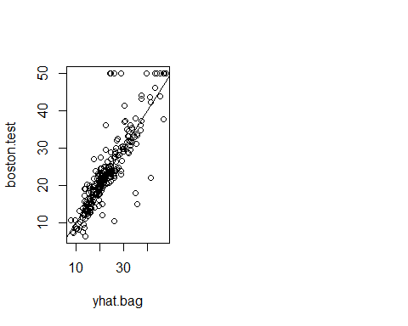

# Boosting  
  
library(gbm)

## Warning: package 'gbm' was built under R version 3.6.3

## Loaded gbm 2.1.5

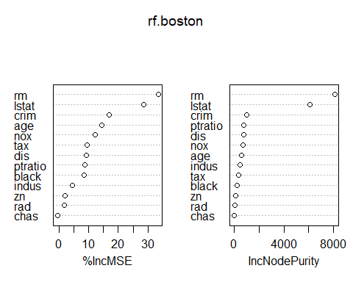

set.seed(1)  
boost.boston=gbm(medv~.,data=Boston[train,],distribution="gaussian",n.trees=5000,interaction.depth=4)  
summary(boost.boston)

## var rel.inf  
 ## rm rm 43.9895329  
 ## lstat lstat 33.1225998  
 ## crim crim 4.2594998  
 ## dis dis 4.0132369  
 ## nox nox 3.4365974  
 ## black black 2.8272175  
 ## age age 2.6099433  
 ## ptratio ptratio 2.5408663  
 ## tax tax 1.4565517  
 ## indus indus 0.8007188  
 ## rad rad 0.6537811  
 ## zn zn 0.1449800  
 ## chas chas 0.1444744

par(mfrow=c(1,2))

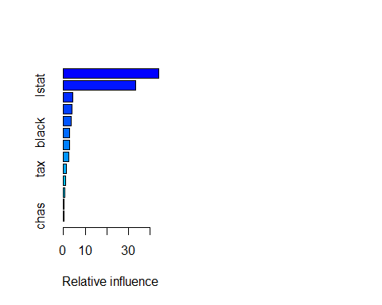

plot(boost.boston,i="rm")

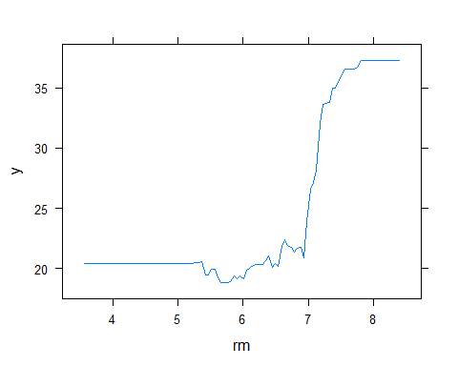

plot(boost.boston,i="lstat")

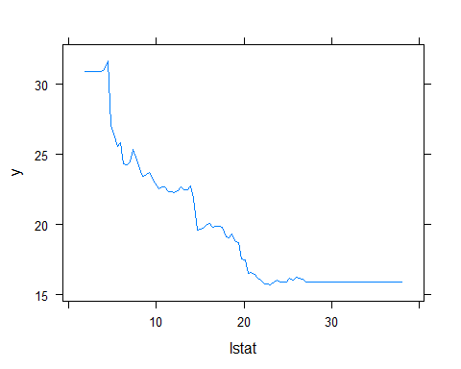

yhat.boost=predict(boost.boston,newdata=Boston[-train,],n.trees=5000)  
mean((yhat.boost-boston.test)^2)

## [1] 18.77339

boost.boston=gbm(medv~.,data=Boston[train,],distribution="gaussian",n.trees=5000,interaction.depth=4,shrinkage=0.2,verbose=F)  
yhat.boost=predict(boost.boston,newdata=Boston[-train,],n.trees=5000)  
mean((yhat.boost-boston.test)^2)

## [1] 19.16513