Enroute Flight Navigation
Version 2.1.0.
User Guide
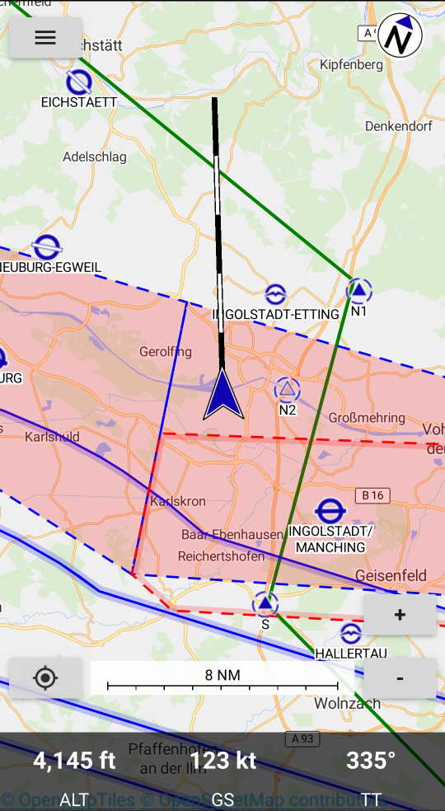
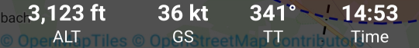
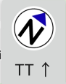

Preliminaries

Copyright

This document is Copyright © 2020 by the development team. Contributors are listed below. You may distribute it and/or modify it under the terms of either the GNU General Public License (http://www.gnu.org/licenses/gpl.html), version 3 or later.

All trademarks within this guide belong to their legitimate owners.

Contributors

Stefan Kebekus

Michael Horbaschk

Feedback

Please direct any comments or suggestions about this document to the development team via the link given in the App.

Publication date and software version

Published November 2020. Based on Enroute Flight Navigation 2.0.0.

Tabelle 1: List of Revisions
Version | Date | Description | Author
1 | 20.06.2020 | Initial Version | MH
1.8.1 | 09.08.2020 | Updates for Version 1.8 | MH
2 | 09.11.2020 | Updates for Version 2.0 (Weather) | MH
2.1 | 1212.2020 | Update for North Up Mode | MH

Contents
Preliminaries 2
Copyright 2
General Information 4
Definitions 4
Chapter 1 Introducing Enroute Flight Navigation 5
What is Enroute Flight Navigation? 5
Limitations 5
Parts of the main window 6
Chapter 2 Operation of Enroute Flight Navigation 9
Starting Enroute Flight Navigation 9
Ground Mode 9
Flight Mode 10
Switch Track Up and North Up 11
Waypoint Selection 12
Airport Selection 13
Direct Navigation 14
Route Planning 14
Route – Aircraft and Wind 16
Ending Enroute Flight Navigation 17
Chapter 3 Map Display 18
Aeronautical maps 18
Base Map 19
Airspace 20
Airfields 22
Chapter 4 Menu 25
Route 25
Nearby Waypoints 26
Weather 27
Set Altimeter 29
Settings 29
About Enroute Flight Navigation 30
Bug Report 30
Participate 30
Exit 30
Chapter 5 Troubleshooting 31
Occasional App Freezing 31

General Information

Definitions

The following convention for special Information are made for this Manual:
Warning
Indicates a hazardous situation that, if not avoided, could result in severe equipment damage, death or serious injury.

Caution
Indicates a hazardous situation that, if not avoided, could result in equipment damage, minor or moderate injury.

Note
Indicates information considered important but not hazard related.
Tip
Indicates information considered helpful for use of the software.

Chapter 1
Introducing Enroute Flight Navigation

What is Enroute Flight Navigation?

Enroute Flight Navigation is a no-cost flight navigation app for Android and other devices. Designed to be simple, functional and elegant, it takes the stress out of your next flight. The program has been written by flight enthusiasts, as a project of Akaflieg Freiburg, a flight club based in Freiburg, Germany.

Enroute Flight Navigation features a moving map, similar in style to the official ICAO maps. Your current position and your flight path for the next five minutes are marked, and so is your intended flight route. A double tap on the display gives you all the information about airspaces, airfields and navaids – complete with frequencies, codes, elevations and runway information.

Our free aeronautical maps can be downloaded for offline use. In addition to airspaces, airfields and navaids, selected maps also show traffic circuits as well as flight procedures for control zones. The maps receive near-weekly updates and cover large parts of the world.

Enroute Flight Navigation includes flight weather data downloaded from the
N O A A - N A T I O N A L W E A T H E R S E R V I C E - AVIATION WEATHER CENTER

While Enroute Flight Navigation is no substitute for full-featured flight planning software, it allows you to quickly and easily compute distances, courses and headings, and gives you an estimate for flight time and fuel consumption. If the weather turns bad, the app will show you the closest airfields for landing, complete with distances, directions, runway information and frequencies.

Limitations

Warning
Always use official flight navigation data for flight preparation and navigate by officially authorized means. The use of non-certified navigation devices and software like Enroute Flight Navigation as primary source of navigation may cause accidents leading to loss of lives.
Enroute Flight Navigation is not an officially approved flight navigation tool nor do consumer electronic devices provide certified aeronautical navigation data.
The navigational data and airspace information provided by Enroute Flight Navigation is provided as is without any official validation, certification or warranty.
The use of Enroute Flight Navigation does not fulfill the requirement of REGULATION (EU) No 923/2012:

SERA.2010 Responsibilities:

(b) Pre-flight action Before beginning a flight, the pilot-in-command of an aircraft shall become familiar with all available information appropriate to the intended operation.

Enroute Flight Navigation may just be used to increase the comfort of operation, but the information given has always to be validated using an official navigation and airspace data source.

Parts of the main window
Map Area
Flight Paths Vector
Own Position
Flight Data
Zoom in
Zoom Out
Device Status
Track Up Mode
North Indicator
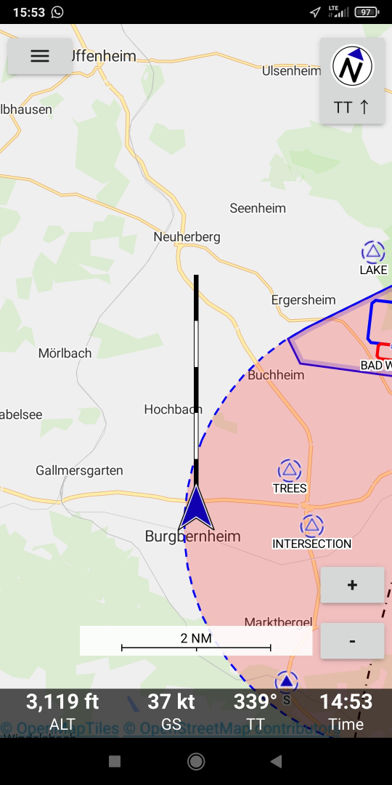Figure 1: Main Window

When you start Enroute Flight Navigation it will automatically go to the main window.

The main Window is shown in two modes:
- Ground Mode Figure 2: Ground Mode
  - The Ground Mode is shown when the sensed speed is below the threshold
- Flight Mode Figure 1: Main Window will
  - Display the flight data on the lower side of the screen
  - The own position symbol will change to an arrow and the flight paths vector will be displayed.
  - The Flight Mode is shown when the sensed speed is above the threshold.

Note
The threshold to switch from Ground Mode to Flight Mode is 30 knots.
Automatic switching between flight and Ground mode may be turned off in “Settings”.
When “Settings” – “Automatic flight detection” is not selected the Flight data line will always be displayed.

The elements of the Main Window have the following function:
- Menu
  - The Menu offers a selection of additional functions
- Weather
  - Touching the Menu Symbol and afterward touching “Weather” will open a page showing station weather from an area of about 200NM. The closest stations will be at the top. QNH and sunrise or sunset will be separately shown in a line at the bottom of the screen. Weather
Caution
Flight into bad weather is a common source of accidents in aviation.
Always consult officially approved weather briefing resource before flight. The Flight weather data provided by Enroute Flight Navigation does not constitute a weather briefing as required by SERA.
- Map Area
  - The Map Area shows the aeronautical Map information
- Flight Paths Vector
  - The flight pats vector shows the current flight Vector for the next 5 minutes

The flight paths vector calculation is based on current sensed velocity vector.

Each segment of the flight paths vector has the lengths of the distance traveled during one minute.

Own Position
Flight Paths Vector
End of Minute 4
End of Minute 3

Note
The Flight Vector is only shown in Flight Mode
- Own Position
  - The Own Position is shown based on GPS.

The color of the own position symbol will be
    - Grey when no valid GPS position is available
    - Blue when a valid GPS position is available

Note
The Symbol for the own position changes between Ground Mode and Flight Mode

- Center on Position
  - Touching the Center on Position Symbol will center the Map on the own Position and turn the Map to North Up.
The Center on Position Symbol is only shown after the screen has been moved.
- Note

The screen may be moved by shifting one or more fingers on the display.
- Flight Data
  - The Flight Data line will give the following information:
    - Altitude in feet
    - Ground speed in knots
    - Current True Track
- Device Status
  - The Status of you mobile device is shown by Android®.
Caution
Loosing a navigation assistance device may cause temporary high workload.
Make sure the battery of your mobile device is sufficiently charged for the planned duration of the flight and have proper backup navigation ready for use.
- Note

The Status of the Position Service is shown in the top line.
- North Indicator
  - The North Indicator will show the True North Direction
- Zoom in
  - Touching the Zoom in will switch the scale to the next higher level of detail
- Zoom out
  - Touching the Zoom in will switch the scale to the next lower level of detail
- Note

The actual Zoom level is given by the scale bar next to the Zoom controls

- Note

The Zoom level may also be changed by touching the display with two fingers and increasing or decreasing the distance between the fingers.

Chapter 2
Operation of Enroute Flight Navigation

Starting Enroute Flight Navigation
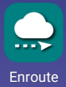
To start Enroute Flight Navigation touch the Enroute Symbol on the Screen of your mobile device.
Enroute Flight Navigation will display the map with the most recent route after start.

Ground Mode
On the ground Enroute Flight Navigation may be used to display the map data or pre-plan a route.

Own Position
(GPS not valid)
Menu
North Indicator
Zoom in
Zoom Out
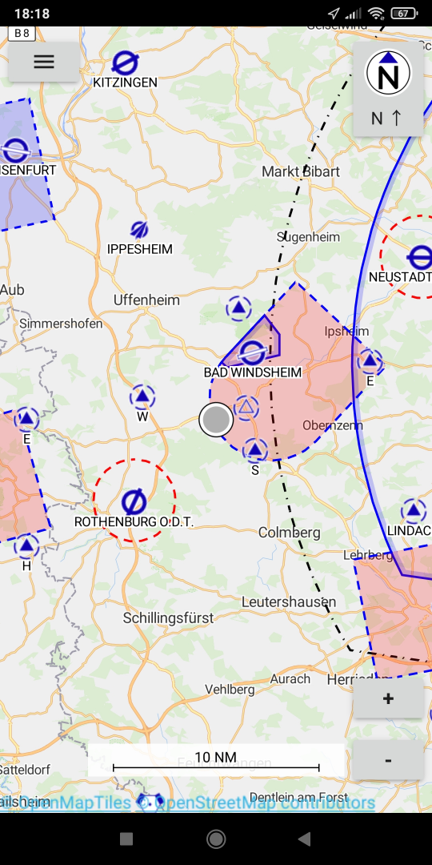Figure 2: Ground Mode

Flight Mode
When Enroute Flight Navigation senses a speed above the threshold it will automatically switch to flight mode.
For the displays given in flight mode refer to Figure 3: Flight Mode (Track Up)
In flight mode the following additional items will be displayed:
- The own position will be changes from a dot to an arrow
- A segmented flight path for the next 5 minutes will be indicated
- A flight data line will indicate the following GPS data:
  - Altitude in feet (or meters if metric units selected)
  - Ground Speed in knots (or km/h if metric units selected)
  - Track in reference to true north

Map Area
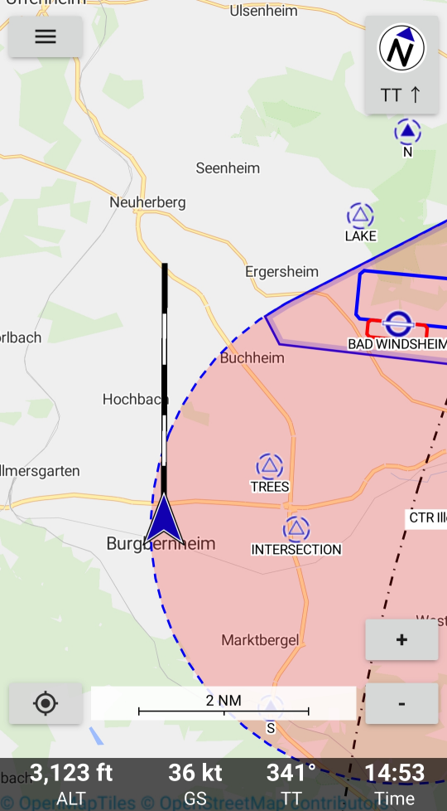
North Indicator
Menu

Flight Paths Vector
Own Position

Zoom in
Zoom Out
Center on Position
Flight Data
Figure 3: Flight Mode (Track Up)

The Enroute Flight Navigation map display is automatically centered to display the own position to have about 80 % of the display area in direction of flight..
The map display may be shifted by touching the display and moving it to the desired position. After shifting the “Center on Position” Symbol will be displayed. After touching he “Center on Position” Symbol the map will be centered to give maximum map area in direction of flight again.

Switch Track Up and North Up
The Enroute Flight Navigation map display may be switched between a Track Up display and a North Up display by touching the gray window in the upper right area.
Touching the display orientation area toggles between North up and Track Up.

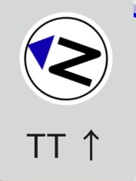
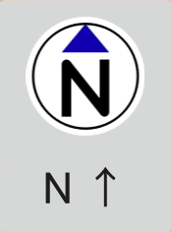
Track
Up
North
Up
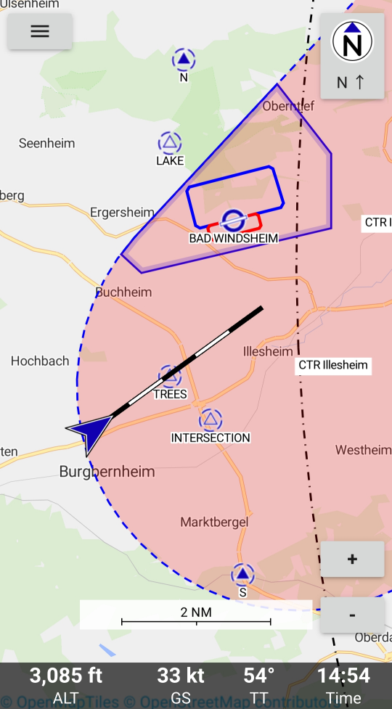

Menu
Area to Toggle
North Up and
Track Up in
North Up Mode

Map Area

Flight Paths Vector
Own Position

Zoom in

Zoom Out
Flight Data

Figure 4: Flight Mode (North Up)

The North Up mode provides a map display always showing the map north up.
The Enroute Flight Navigation map display in North Up mode will center the display to provide about 80% area in direction of flight.

Waypoint Selection

Whenever Enroute Flight Navigation senses double clicking a point on the map display the Waypoint data is opened.

A waypoint may be any position on the map. In case any aeronautical designation is applicable to the waypoint it will be named accordingly. All way points without designation will be named “Waypoint”.
Actions
Name of Waypoint
Airspace Data
Relative Position
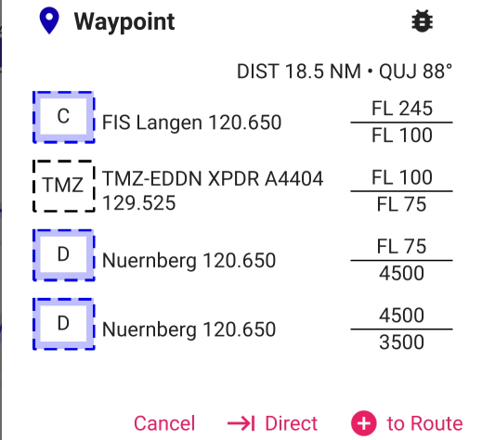Figure 5: Waypoint
- Name of Waypoint
  - The name of the Waypoint is given if applicable. For points without any designation “Waypoint” is used
- Airspace Data
  - The airspace data for the position is listed giving:
    - Airspace category
    - Airspace designation
    - Control Frequency and IFF Mode 3 code if applicable
    - Upper and lower altitude limit
- Relative Position
  - The relative position to the selected point is indicated giving
    - Distance in NM (or km if metric units selected)
    - True Bearing to Point (QIJ)
- Actions
  - Cancel
    - Pressing cancel will close the waypoint window without any further changes.
  - Direct to
    - See Direct Navigation
  - Add to Route
    - See Route Planning

- Note

Selecting a waypoint is a very effective way to find out the airspace information about any location.

Airport Selection

Whenever Enroute Flight Navigation senses double clicking on the position of an airport on the map display the Airport data is opened.
Actions
Airport Name and Type
Airport Data
Relative Position
Airspace Data
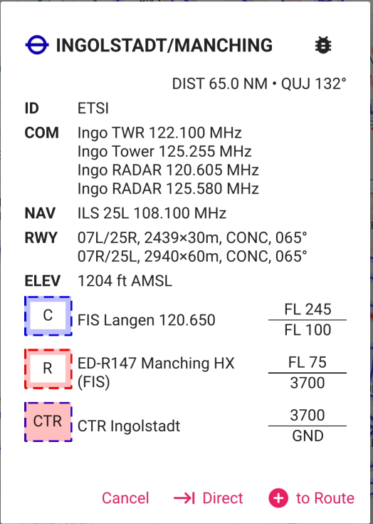Figure 6: Airport

For Airports additionally to the information given for a waypoint the following data is given.
- Airport Name and Type
  - The airport symbol gives the type of the airport and the direction of the main runway
  - The Airport Name
  - The Airport ICAO identifier is given below in the field “ID”
- Airport Data
  - ID
  - COM: Callsigns and communication frequencies
  - NAV: Navaids with type and frequency
  - RWY: Available Runways with:
    - Orientation
    - Dimension
    - Surface type
    - Magnetic Orientation

Direct Navigation
Direct Navigation is the most simple way to determine a course line and basic navigational data to a desired waypoint.
When you to have selected a waypoint on the map the lower line of the waypoint data will show the field “Direct ”. By clicking “Direct” a green line showing the paths from the actual position to the waypoint will appear on the map. The following navigation data between the current position and the waypoint is shown in the Route page:
  - Distance
  - Time calculated using the cruise speed set in the “Aircraft and Wind” page
  - True Course
  - True Heading

Route Planning
Enroute Flight Navigation provides direct planning of one Route. A Route can not be saved, however the Route will remain present until it is cleared.
Route planning is entered via the Menu point Route. The Menu is entered via the Menu Symbol in the upper left corner of the map area. Then the Route Symbol has to be touched to go to the Route area.



Figure 7: Route Symbol

A Route may be planned in the following ways:
  - “Direct” in the waypoint window will provide a Route between current position and desired waypoint
  - “to Route” in the waypoint window will add the waypoint to the last position of the Route.
  - “to Route” in the Route window will open a selection window for a waypoint and add the selected waypoint to the route.

The Route Display will show the following information:
  - Symbol of the waypoint
  - Designation of the waypoint
  - Route Point Menu
  - Navigation Data
    - Distance between way points
    - Time calculated between way points using the cruise speed set in the “Aircraft and Wind” page
    - True Course between way points
    - True Heading between way points

Note
A Route may also be imported from a GPX file from another PC. After sending the GPX file as Email attachment Enroute Flight Navigation will offer to open the GPX file.
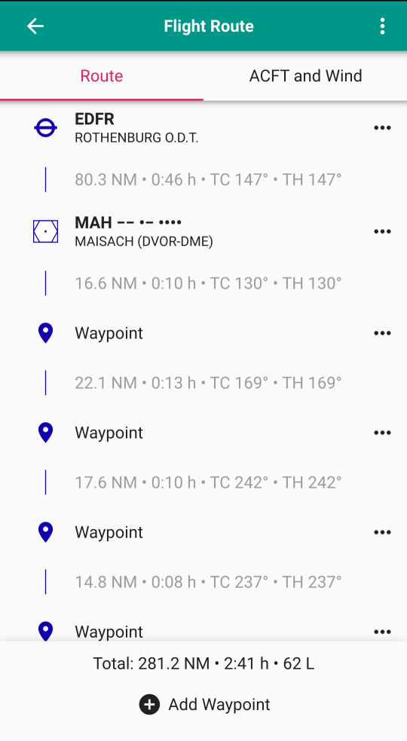
Figure 8: Route Page
Route Waypoint Data
Navigation Data
Route Data
Route Menu
Route Point Menu
Add Waypoint Button

The Route Point Menu provides the option to:
  - Move a waypoint up in the Route
  - Move a waypoint down in the Route
  - Remove a waypoint from the Route

The Route Menu is entered by touching the Route Menu Symbol on the Route page.

The following options are available from the Route Menu:
  - Open a previously stored route from the library
  - Save the current route to the library
  - View the route library
  - Import a Route from an external source
  - Send the Route in JSON or GPX format
  - Open the Route in another APP using the JSON or GPX format
  - Clear Route
  - Reverse Route
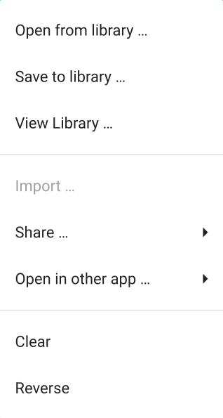
Figure 9: Route Menu
The previously created and stored routes will be kept in a data base within Enroute Flight Navigation. Routes consist of the data for the selected way points. The Route data may be exported for use in other applications.

Route – Aircraft and Wind

The Aircraft and Wind sub-page of the Route page allows to enter aircraft performance and wind data required for navigational calculations.

The Aircraft Data will be used to determine the distance of the flight and the true course.

The Wind data will will be used to calculate the true heading and duration of the flight. The duration of the flight will determine the fuel used.

Enroute Flight Navigation only offers a very superficial flight planning and cannot replace a full flight planning, but is only intended to provide quick reference.

Warning
Always perform a full flight preparation in accordance with the flight manual of the aircraft used. The use of Enroute Flight Navigation as primary flight planning may cause accidents leading to loss of lives.

The Aircraft and Wind sub-page of the Route page offers the following input fields:
  - Aircraft
    - Cruise Speed: Average Speed for Route
    - Descent Speed: Allows to enter a different speed for the descent phase (Currently not used)
    - Fuel Consumption: Average Fuel consumption per hour
  - Wind
    - Direction in degrees
    - Speed in knots

Only one speed, fuel consumption and wind may be entered for the whole route.
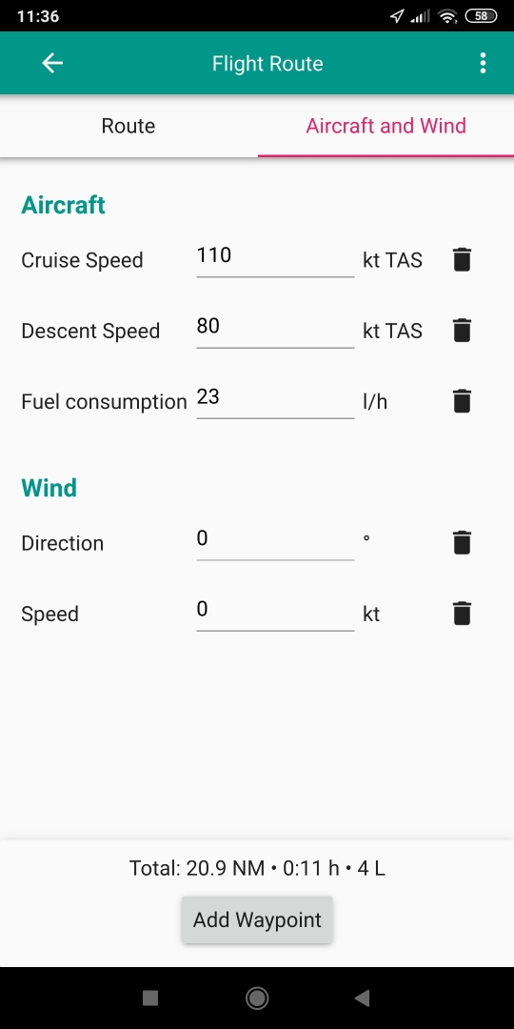
Figure 10: Aircraft and Wind Data
Aircraft Data
Add Waypoint Button
Wind Data
Route Menu
Route Data

Ending Enroute Flight Navigation
To end Enroute Flight Navigation use the Menu and touch the EXIT area.
- Note

To release the app memory completely the Enroute Flight Navigation may also have to be removed from the list of current active Windows in the Android® System using the Multi Window Symbol □.

Chapter 3
Map Display

The Map display is composed of two layers:
- Aeronatical Map
- Base Map

Aeronautical maps

The Aeronautical Map layers is showing the airspace data on the Map screen. If no Base Map is installed for the area only the information coming from the Aviation Map data is displayed.

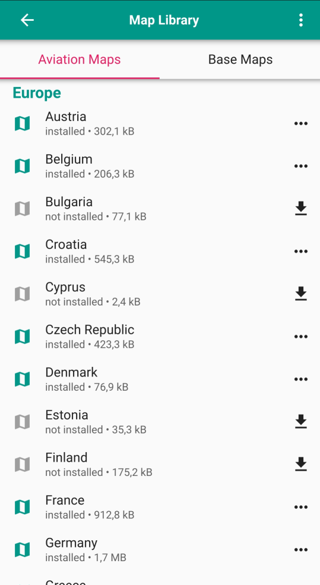
11: Aeronautical Map selection
Country not installed
Install Button
Update Menu
Country installed
Uninstall Button

The Aeronautical Map contains:
- Airfields
- Airspace boundaries
- Navaids
- Reporting points and routes (if available)

Class 1 and Class 2 maps
- Class 1 maps are compiled from openAIP and open flightmaps data. These maps contain complete information about airspaces, airfields and navaids. In addition, the maps contain (mandatory) reporting points. Some of our tier 1 maps also show traffic circuits and flight procedures for control zones.
- Class 2 maps are compiled from openAIP data only. They contain complete information about airspaces, airfields and navaids.

Details on the maps may be found at https://akaflieg-freiburg.github.io/enroute/maps/

The Aeronautical Map data is selected on the “Map Library” – “Aviation Data” page accessed via the “Settings” Menu.

To update the list of available maps the “…” option in the upper right corner of the screen may be used.

You may install or uninstall the aviation Map data for a county by the selection on the right hand side of the country list. To find a country you have to scroll up and down in the list.

The shown Map displays Figure 3: Flight Mode (Track Up) show a combination of Aviation Map and Base Map.
Tip
To have optimum presentation of the Enroute Flight Navigation map display install the Aviation Map and the Base Map for all areas you intend to use Enroute Flight Navigation.
Caution
No airspace information will be provided in country when the Aeronautical Map is not installed for it.

Note
“Enroute Flight Navigation” will automatically check for updated Maps on the Enroute server and show a pop-up window after start if updated maps have been detected.
You will be asked if you want to update the map or delay the update.

Base Map

The Base Map layers is showing the geographic data on the Map screen. If no Base Map is shown for an area it will be shown in the white background color. If no Aviation Map is installed for the area only the information coming from the Base Map data is displayed. The Base Map is organized in tiles. This will result in not stopping the Base Map display abruptly at the border of an installed country, but showing some overlap.

The Base Map will show:
- Landmass
- Water Surface (oceans, lakes and rivers)
- Forests
- Main Roads
- Railroad lines
- City names
Tip
To have optimum presentation of the Enroute Flight Navigation map display install the Aeronautical Map and the Base Map for all areas you intend to use Enroute Flight Navigation.

Note
“Enroute Flight Navigation” will not show most cultural build ups and limits or settled area boundaries to reduce the map size.

Airspace

The display of airspace will generally follow the common ICAO symbology.

Restricted Airspace

Restricted airspace will be surrounded by an intense red dashed line and a thick transparent red line inside the restricted area boundaries.

When selecting a point inside the restricted area by double touching the screen the information to the related area is given with the waypoint pop-up window:
- Area Name
- Area altitude limits
- Area activation time
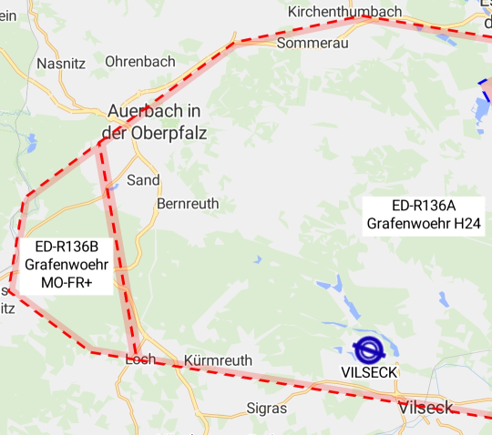
Figure 12: Restricted Airspace

Controlled Airspace

All boundaries of controlled airspace are shown by a solid blue line and a thick transparent blue line inside the airspace. Figure 13: Controlled Airspace

When selecting a point inside the controlled airspace by double touching the screen the information to the related area is given with the waypoint pop-up window:
- Area Name
- Area altitude limits
Caution
All controlled airspace (Class A – Class D) are shown in the same way even if different restrictions or ATC clearance requirements may be present.

Control Zone

The Control Zone of an airport is shown with a dashed blue line filled in transparent red color. Figure 13: Controlled Airspace

When selecting a point inside the Control Zone (CTR) by double touching the screen the information to the related area is given with the waypoint pop-up window:
- Area Name
- Area altitude limits
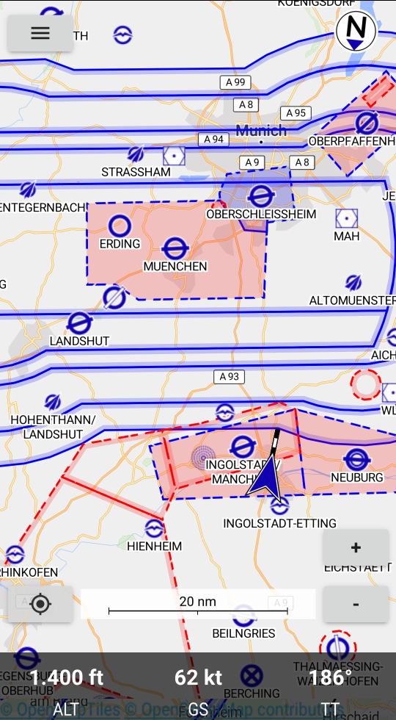
Figure 13: Controlled Airspace
Boundary of
controlled airspace
Control Zone CTR
Navaid
Restricted Area

Transponder Mandatory Zones

Transponder Mandatory Zones TMZ are shown with a black dashed outline.

When selecting a point inside the Transponder Mandatory Zone (TMZ) by double touching the screen the information to the related ares is given with the waypoint pop-up window:
- Area Name
- Area altitude limits
- Monitoring Frequency
- Mode 3 Squawk

Radio Mandatory Zone

Radio Mandatory Zones (RMZ) are shown with a solid blue dashed outline and filled in transparent blue.

When selecting a point inside the Radio Mandatory Zone (RMZ) by double touching the screen the information to the related area is given with the waypoint pop-up window:
- Area Name
- Area altitude limits
- Radio Frequency

Parachute Jumping Areas

Parachute Jumping Exercise areas (PJE) are shown with a solid red dashed outline.

When selecting a point inside the PJE by double touching the screen the information to the related area is given with the waypoint pop-up window:
- Area Name
- Area altitude limits
- Radio Frequency

Airfields

The symbology used to display airfields follows the ICAO rules.

Airfield Information

When selecting an airfield by double touching the screen the related information is given in a pop-up window:
- Airfield Name and Identifier
- Radio Frequency including COM and Information frequencies
- Navaid frequencies
- Runway orientation, dimensions and surface
- Field elevation
- Data for associated airspace

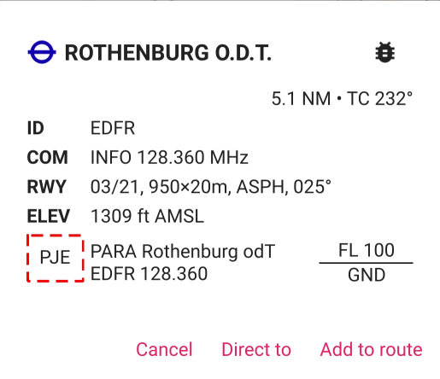
Figure 14: Airfield data

Approach Routes

Approach routes to airfields are shown as solid blue lines. The designation of the route is written along the paths. The associated reporting points are shown as blue triangles with a dashed circle and the reporting point designation.

Note
Approach Routes will only be displayed when zooming into the area.

Traffic Pattern

Traffic pattern for motorized aircraft are shown as blue lines.

Traffic circuits for gliders or Ultralight aircraft are shown as red lines.

Entry and exit routes to traffic pattern are indicated by open ends of the pattern.

Note
Traffic pattern will only be displayed when zooming into the area.

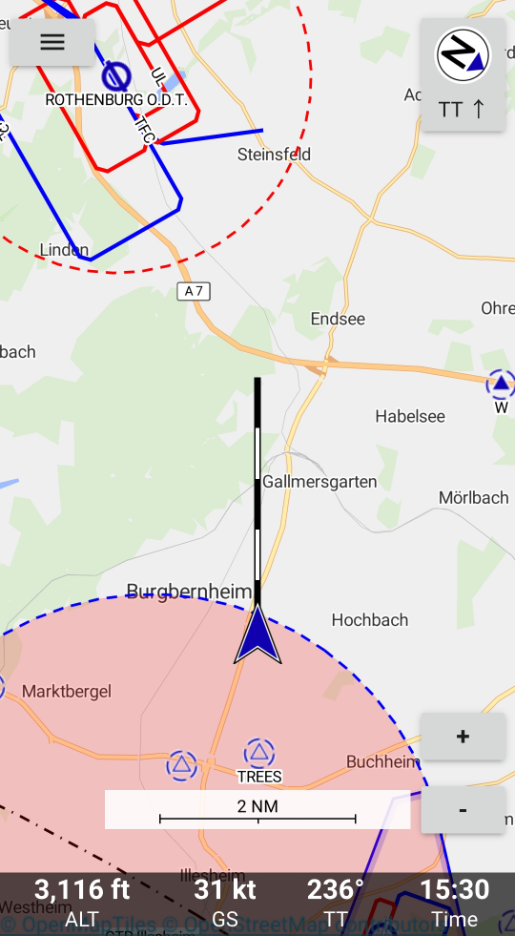
Figure 15: Approach to Airfield
Traffic pattern for
non-powered or
Ultralight aircraft
Traffic pattern for
powered aircraft
Entry for
traffic pattern for
powered aircraft

Chapter 4
Menu

Figure 16: Menu Symbol

When touching the Menu area in the left upper corner of the screen the menu will open and give the following options:
- Route
- Nearby Waypoints
- Weather
- Set Altimeter
- Settings
- Information
  - Satellite Status
  - Manual
  - About Enroute Flight Navigation
  - Participate
  - Donate
- Bug Report
- Exit
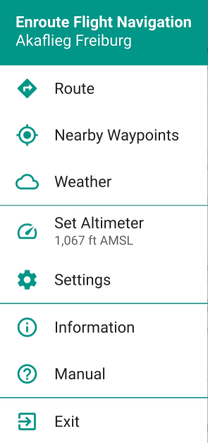
Figure 17: Menu

Route

The Route planning functions are described in the section Route Planning in Chapter 2 Operation of Enroute Flight Navigation.

Routes may be planned and stored on the device, opened afterwards and also exported and re-imported.

Nearby Waypoints
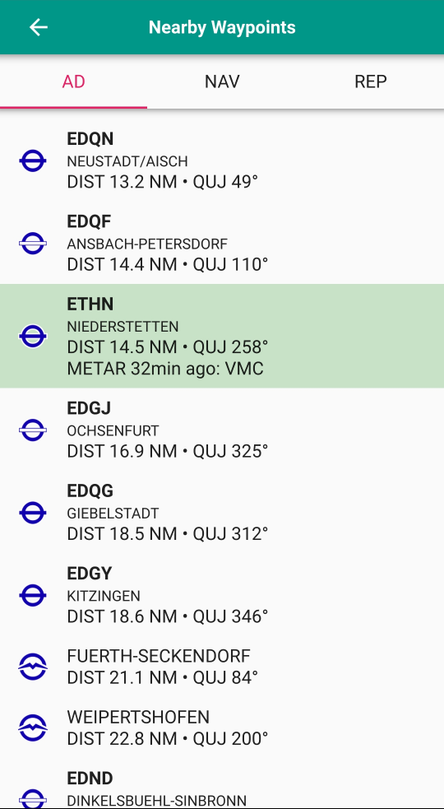
Figure 18: Nearby Airfields
Selection for type
of Waypoints
Weather Code shown
for Waypoint
The Nearby Waypoints window is available to show information about
- AD: Nearby Airfields
- NAV: Nearby Navaids
- REP: Nearby Reporting Points
The nearby airfields option will display a list of the nearest 20 airfields with the following information:
- Airfield category by the standard ICAO symbol
- Airfield Identifier and name
- Distance and true bearing (QUJ) to the airfield
Touching the line of an airfield will open the waypoint menu for the airfield Figure 6: Airport and allow to add it to the route or start direct navigation to the airfield. The airfield waypoint page will also give the available airfield information.(see Figure 6: Airport)

Weather

The Weather page is opened via the Menu (see Figure 17: Menu ) by touching the “Weather” entry.
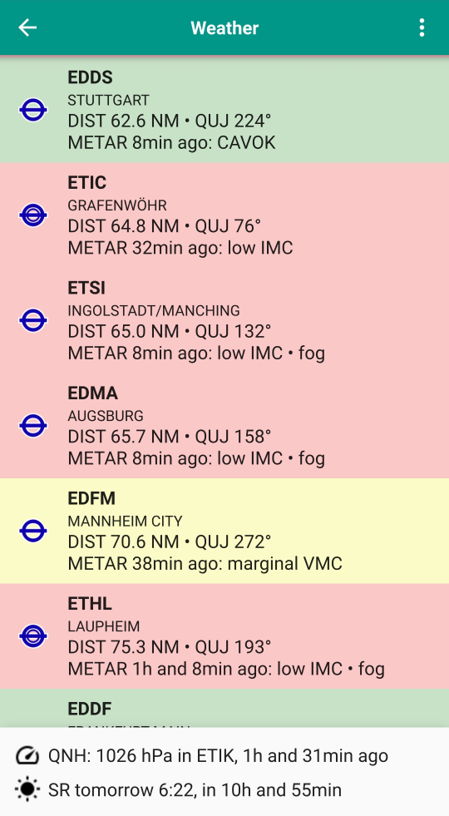
Figure 19: Weather

The weather data is downloaded from the National Weather Service of the United States of America.

Note
When opening the Weather page the first time you will have to confirm that you agree to download data from the NWS server to use this service.

The Weather overview window will provide the following information based on the METAR:
- ICAO identifier for Station and Airport name
- Distance and magnetic Bearing to Airport
- Time of METAR and summary weather state

The information of each airport will be color coded by a system established by the US National Weather Service. The coding scheme is explained in the table below.

When touching a station line METAR and TAF (if available) will be shown in a weather detail sub-page Figure 20: Weather Station Detail.
Caution
The color coding used for station weather does not match to European VFR criteria. Assessment of meteorological flight conditions has to be done via an officially approved source of flight weather.
Category | Color | Ceiling |  | Visibility
IFR Instrument Flight Rules | Red | 500 to below 1,000 feet AGL | and/or | 1 mile to less than 3 miles
MVFR Marginal Visual Flight Rules | Yellow | 1,000 to 3,000 feet AGL | and/or | 3 to 5 miles
VFR Visual Flight Rules | Green | greater than 3,000 feet AGL | and | greater than 5 miles
NOTES:
By definition, IFR is ceiling less than 1,000 feet AGL.
By definition, VFR is ceiling greater than or equal to 3,000 feet AGL and visibility greater than or equal to 5 miles while MVFR is a sub-category of VFR.

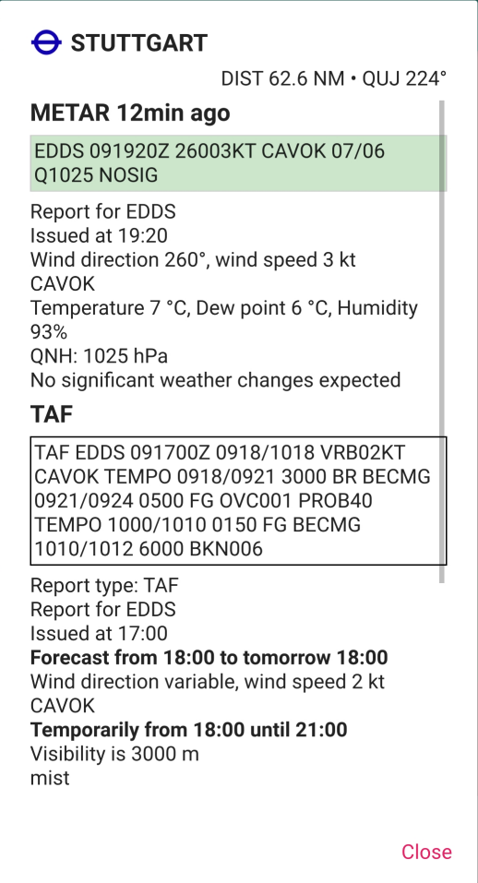
Figure 20: Weather Station Detail

Set Altimeter

The Set Altimeter function allows to enter a corrected present altitude. The indicated altitude is derived from GPS. If you enter a corrected altitude and touch “Apply” based on a known location like the field elevation of an airport the difference will be used as an offset for indicated altitude.

Touching the “Use Sat” area will make Enroute Flight Navigation use the GPS altitude as reference again.

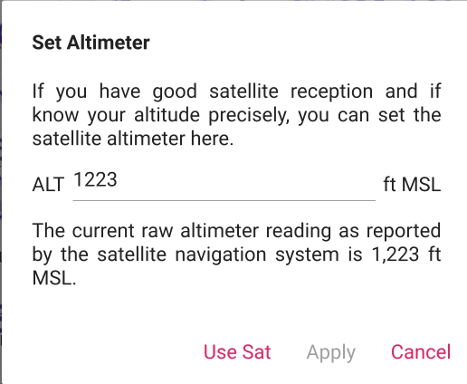
Figure 21: Set Altimeter

Note
When touching the area indicating the altitude in flight mode the Set Altimeter window will also pop-up.

Settings

The settings Menu will allow to customize Enroute Flight Navigation and give access to program status.

The settings Menu gives the following options:
- “Hide Airspace above FL 100” will make Enroute Flight Navigation not show airspace above FL100
- Note
If you do not select “Hide Airspace above FL 100” the FIS frequencies for the Airspace C above FL100 will be displayed. In most cases this frequency is the same as the INFORMATION frequency applicable below FL100.
- Automatic flight detection
- Note
When Automatic flight detection is not selected the display will always be in flight mode.
- “Flight Routes” will show a window with the previously stored routes
- “Maps” will show a window with the available and previously installed Aviation and Base Maps
- “Use metric units”
- “Use English” will switch to English Language
- Note
If “Use English” is not selected the standard language selected for your device will be used if available.
- “Satellite Status” will open a sub-window showing the GPS data currently received

About Enroute Flight Navigation

Selecting “About Enroute Flight Navigation” will open a window showing information about the App, the Author and License Information.

Bug Report

The “Bug Report” selection will open a Window to transmit bug reports to the Authoring Team via:
- GitHub issue Tracker
- Email

Participate

The “Participate” selection opens a window showing information for people who want to contribute to the development of Enroute Flight Navigation.
Tip
Enroute Flight Navigation is a non-commercial project created and maintained by volunteers. If you have related skills in C++/Qt programming or other related skills and would like to contribute contact the Author.

Exit

The “Exit” selection will end the program.

Note
The “Enroute Flight Navigation” task may remain in the Android task list and has to be ended separately for complete removal from memory. This is a common property of all Android Apps.

Chapter 5
Troubleshooting

Occasional App Freezing

During startup the “Enroute Flight Navigation” is not receiving sufficient resources due to battery safe settings of the system.

An aggressive battery saving may also terminate the position service while using “Enroute Flight Navigation”. This may cause the app to not respond to user inputs.

If you encounter stability problems while using “Enroute Flight Navigation” as a first step turn off “Safe Battery” for “Enroute Flight Navigation”.

The cause of action to turn off energy saving for specific apps depends on the type of your phone. Generally you have to follow the steps below:
- Settings
- Battery & Performance
- Energy Saving for Apps
- Select “Enroute Flight Navigation”
- Select “No Limitation”

