Lorenz Attractor

Bryan Takemoto

**Goal:**

*Program the Atmega328 to provide basic support for basic floating-point operations. Then connect a MCP4725 DAC to the I2C port of the Atmega328 and output analog values to the oscilloscope which the signal are interpreted as a solution of the floating-point problem.*

**Deliverables:**

*The purpose of this project is to demonstrate floating-point capability of the Atmega328 by computing the Lorenz system which is a non-linear ordinary differential equation proposed by Edward Lorenz. The solution will be then visually graphed onto the oscilloscope via MCP4725. Because of the limitation of the oscilloscope, the graph will be 2D (XY) even though the Lorenz attractor is 3D (XYZ).*

# Literature survey[1]

Mathematical computation has been the primary motivation to the development of processors. The task of computing data and returning useful solution to the user can be as large as a mainframe rendering 3D animated scenes to something as small as an ECU found in cars that controls the operation of the engine by adjusting the throttle body or the injection of fuel to maximize performance in high-end sport cars or the best fuel economy for daily commuters. A lot of these application will most likely require the MCU [microcontroller] to evaluate an equation with data fed into its input and output the solution to the user. Every MCU can compute an equation that accepts integers and output an integer. These are simple functions expected from an MCU but unfortunately there are plethora of problems that require fractional solutions and neglecting [truncate the fractional part] them will return unwanted consequences to the user. In the case of this project, the Lorenz attractor is an equation that has low tolerance for truncated results.

The Lorenz attractor is a unique equation because it exhibits a nonlinear behavior. In other words, a nonlinear system’s output change will not be proportional to the change of its input. Lorenz demonstrates this by its chaotic set of solutions. Having chaotic set of solutions

# Components

## Component 1

Lorem ipsum dolor sit amet, consectetuer adipiscing elit. Nullam pulvinar wisi ac elit. Sed congue pretium nibh. Curabitur felis nulla, tincidunt sed, lacinia ac, varius ut, tellus. Nullam ac neque ac magna gravida porta. Fusce condimentum odio ut dolor. Morbi ante ipsum, ultrices vel, hendrerit eu, porta eget, felis. Donec ac ligula non tellus semper pretium. Morbi purus orci, hendrerit vitae, condimentum sit amet, suscipit vel, nisl. Nunc nulla erat, cursus id, dapibus sit amet, ornare sit amet, mauris. Nam eget diam et nisl pharetra tincidunt. Suspendisse vel velit vitae diam vestibulum tincidunt. Aenean rhoncus pellentesque purus. Nullam volutpat felis vitae quam. Donec rutrum.

## Component 2

Lorem ipsum dolor sit amet, consectetuer adipiscing elit. Nullam pulvinar wisi ac elit. Sed congue pretium nibh. Curabitur felis nulla, tincidunt sed, lacinia ac, varius ut, tellus. Nullam ac neque ac magna gravida porta. Fusce condimentum odio ut dolor. Morbi ante ipsum, ultrices vel, hendrerit eu, porta eget, felis. Donec ac ligula non tellus semper pretium. Morbi purus orci, hendrerit vitae, condimentum sit amet, suscipit vel, nisl. Nunc nulla erat, cursus id, dapibus sit amet, ornare sit amet, mauris. Nam eget diam et nisl pharetra tincidunt. Suspendisse vel velit vitae diam vestibulum tincidunt. Aenean rhoncus pellentesque purus. Nullam volutpat felis vitae quam. Donec rutrum.

## Component 3

Lorem ipsum dolor sit amet, consectetuer adipiscing elit. Nullam pulvinar wisi ac elit. Sed congue pretium nibh. Curabitur felis nulla, tincidunt sed, lacinia ac, varius ut, tellus. Nullam ac neque ac magna gravida porta. Fusce condimentum odio ut dolor. Morbi ante ipsum, ultrices vel, hendrerit eu, porta eget, felis. Donec ac ligula non tellus semper pretium. Morbi purus orci, hendrerit vitae, condimentum sit amet, suscipit vel, nisl. Nunc nulla erat, cursus id, dapibus sit amet, ornare sit amet, mauris. Nam eget diam et nisl pharetra tincidunt. Suspendisse vel velit vitae diam vestibulum tincidunt. Aenean rhoncus pellentesque purus. Nullam volutpat felis vitae quam. Donec rutrum.

# Schematics

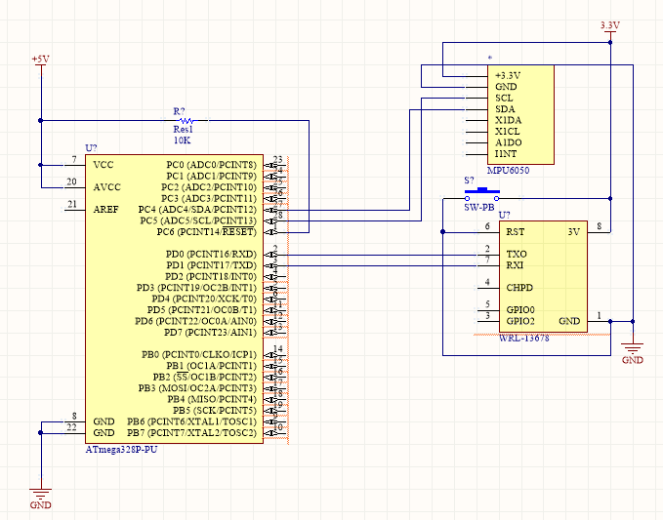

Figure 1: Figure caption centered

# Implementation

Lorem ipsum dolor sit amet, consectetuer adipiscing elit. Nullam pulvinar wisi ac elit. Sed congue pretium nibh. Curabitur felis nulla, tincidunt sed, lacinia ac, varius ut, tellus. Nullam ac neque ac magna gravida porta. Fusce condimentum odio ut dolor. Morbi ante ipsum, ultrices vel, hendrerit eu, porta eget, felis. Donec ac ligula non tellus semper pretium. Morbi purus orci, hendrerit vitae, condimentum sit amet, suscipit vel, nisl. Nunc nulla erat, cursus id, dapibus sit amet, ornare sit amet, mauris. Nam eget diam et nisl pharetra tincidunt. Suspendisse vel velit vitae diam vestibulum tincidunt. Aenean rhoncus pellentesque purus. Nullam volutpat felis vitae quam. Donec rutrum.

# Snapshots and

# Links

# Conclusion

Please include a brief summary of the possible clinical implications of your work in the conclusion section. Although a conclusion may review the main points of the paper, do not replicate the abstract as the conclusion. Consider elaborating on the translational importance of the work or suggest applications and extensions.

Appendix

Appendixes, if needed, appear before the acknowledgment.

Acknowledgment

References

1. G. O. Young, “Synthetic structure of industrial plastics (Book style with paper title and editor),” in *Plastics*, 2nd ed. vol. 3, J. Peters, Ed. New York: McGraw-Hill, 1964, pp. 15–64.
2. W.-K. Chen, *Linear Networks and Systems* (Book style)*.* Belmont, CA: Wadsworth, 1993, pp. 123–135.
3. H. Poor, *An Introduction to Signal Detection and Estimation*. New York: Springer-Verlag, 1985, ch. 4.
4. B. Smith, “An approach to graphs of linear forms (Unpublished work style),” unpublished.
5. E. H. Miller, “A note on reflector arrays (Periodical style—Accepted for publication),” *IEEE Trans. Antennas Propagat.*, to be published.
6. J. Wang, “Fundamentals of erbium-doped fiber amplifiers arrays (Periodical style—Submitted for publication),” *IEEE J. Quantum Electron.*, submitted for publication.
7. C. J. Kaufman, Rocky Mountain Research Lab., Boulder, CO, private communication, May 1995.
8. Y. Yorozu, M. Hirano, K. Oka, and Y. Tagawa, “Electron spectroscopy studies on magneto-optical media and plastic substrate interfaces (Translation Journals style),” *IEEE Transl. J. Magn.Jpn.*, vol. 2, Aug. 1987, pp. 740–741 [*Dig. 9th Annu. Conf. Magnetics* Japan, 1982, p. 301].
9. M. Young, *The Techincal Writers Handbook.* Mill Valley, CA: University Science, 1989.
10. E. E. Reber, R. L. Michell, and C. J. Carter, “Oxygen absorption in the Earth’s atmosphere,” Aerospace Corp., Los Angeles, CA, Tech. Rep. TR-0200 (420-46)-3, Nov. 1988.
11. (Handbook style) *Transmission Systems for Communications,* 3rd ed., Western Electric Co., Winston-Salem, NC, 1985, pp. 44–60.
12. *Motorola Semiconductor Data Manual,* Motorola Semiconductor Products Inc., Phoenix, AZ, 1989.
13. (Basic Book/Monograph Online Sources) J. K. Author. (year, month, day). *Title* (edition) [Type of medium]. Volume (issue). Available: <http://www.(URL>)
14. J. Jones. (1991, May 10). Networks (2nd ed.) [Online]. Available: <http://www.atm.com>
15. (Journal Online Sources style) K. Author. (year, month). Title. *Journal* [Type of medium]. Volume(issue), paging if given. Available: <http://www.(URL>)
16. R. J. Vidmar. (1992, August). On the use of atmospheric plasmas as electromagnetic reflectors. *IEEE Trans. Plasma Sci.* [Online]. *21(3).* pp. 876–880. Available: http://www.halcyon.com/pub/journals/21ps03-vidmar

1.