Bryan Takemoto

CPE301 – SPRING 2018

Design Assignment 4

**DO NOT REMOVE THIS PAGE DURING SUBMISSION:**

The student understands that all required components should be submitted in complete for grading of this assignment.

|  |  |  |  |
| --- | --- | --- | --- |
| **NO** | **SUBMISSION ITEM** | **COMPLETED (Y/N)** | **MARKS**  **(/MAX)** |
| 1 | COMPONENTS LIST |  |  |
| 2. | TASK 1 [DC MOTOR] SCHEMATIC AND BREADBOARD |  |  |
| 3. | TASK 1 [DC MOTOR] C CODE |  |  |
| 4. | TASK 1 [DC MOTOR] FLOW CHART |  |  |
| 5. | TASK 2 [STEPPER MOTOR] SCHEMATIC AND BREADBOARD |  |  |
| 6. | TASK 2 [STEPPER MOTOR] C CODE |  |  |
| 7. | TASK 2 [STEPPER MOTOR] FLOW CHART |  |  |
| 8. | TASK 3 [SERVO MOTOR] SCHEMATIC AND BREADBOARD |  |  |
| 9. | TASK 3 [SERVO MOTOR] C CODE |  |  |
| 10. | TASK 3 [SERVO MOTOR] FLOW CHART |  |  |
| 11. | VIDEO LINKS TO ALL TASKS |  |  |
|  |  |  |  |
|  |  |  |  |

1. **COMPONENTS LIST AND CONNECTION BLOCK DIAGRAM w/ PINS**

List of Components used:

Switch

Capacitors and Resistors

DC Motor

Stepper Motor

Servo Motor

Potentiometer

1. **TASK 1 [DC MOTOR] SCHEMATIC AND BREADBOARD**

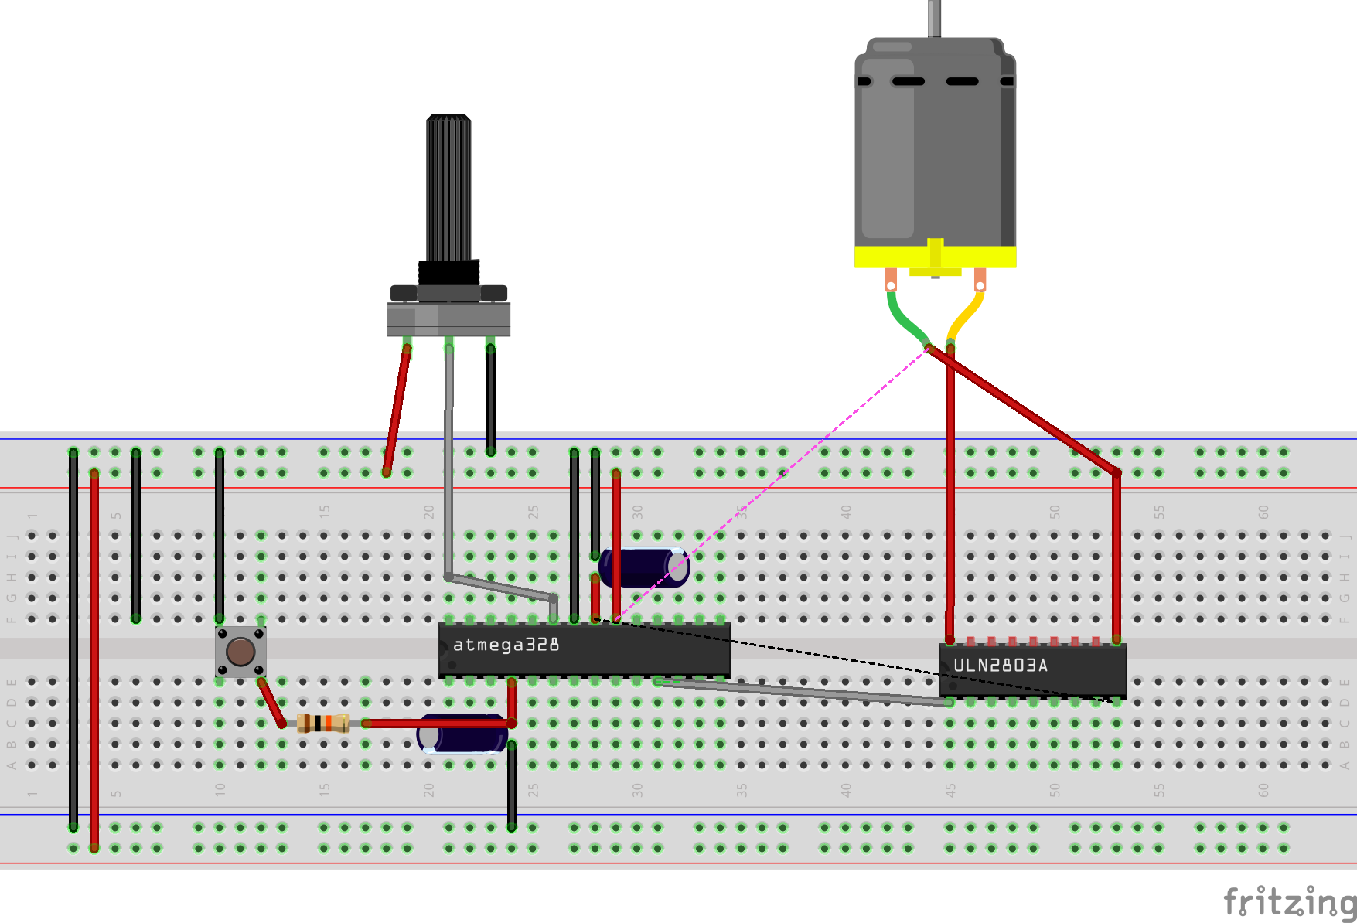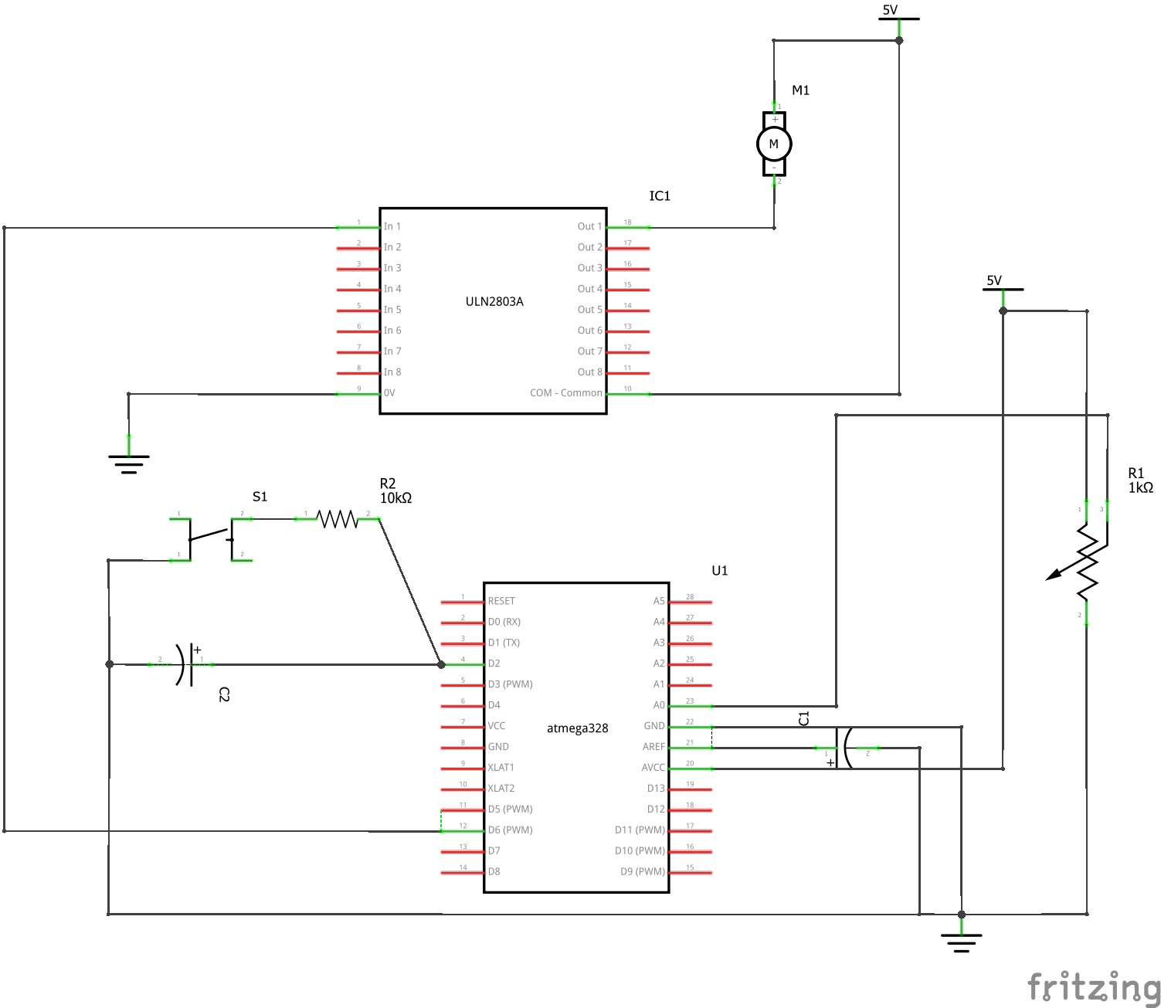

1. **TASK 1 [DC MOTOR] C CODE**

#include <avr/io.h>

#include <stdint.h>

#include <avr/interrupt.h>

int main(void)

{

volatile *uint16_t* ADCvalue;

DDRD |= (1 << 6); // PD.6 is output [PWM]

PORTD |= (1 << 2); // Pull up the resistor for INT0

EIMSK |= (1 << INT0); // Enable interrupt for INT0

EICRA |= 0x2; // Trigger on falling edge

// ADC settings

ADMUX |= (1 << REFS0); // AVcc with external capacitor at AREF pin

ADCSRA |= (1 << ADPS2) | (1 << ADPS1) | (1 << ADPS0); // Set prescalar to 128

ADCSRA |= (1 << ADEN); // Enable ADC

// PWM Settings

DDRD = (1 << 6); // Set OC0A as output (PD6)

TCCR0A |= (1 << COM0A1) | (1 << COM0A0); // Inverting mode

TCCR0A |= (1 << WGM01) | (1 << WGM00); // Fast PWM mode

TCCR0B |= (1 << CS02) | (1 << CS00); // Fosc/1024

sei();

while (1)

{

ADCSRA |= (1 << ADSC); // Start conversion

while((ADCSRA & (1 << ADIF)) == 0); // Wait for conversion

ADCvalue = ADC >> 2;

ADCvalue = 0xFF - ADCvalue;

OCR0A = ADCvalue; // Adjust motor speed

}

return 0;

}

// Switch to turn on and off the motor

ISR(INT0_vect)

{

TCCR0A ^= (1 << COM0A1) | (1 << COM0A0); // Turn off motor

EIFR = (1 << INTF0); // Clear interrupt flag

}

1. **TASK 1 [DC MOTOR] FLOW CHART**

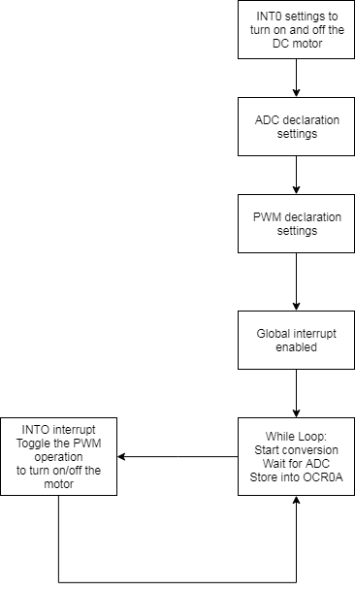

1. **TASK 2 [STEPPER MOTOR] SCHEMATIC AND BREADBOARD**

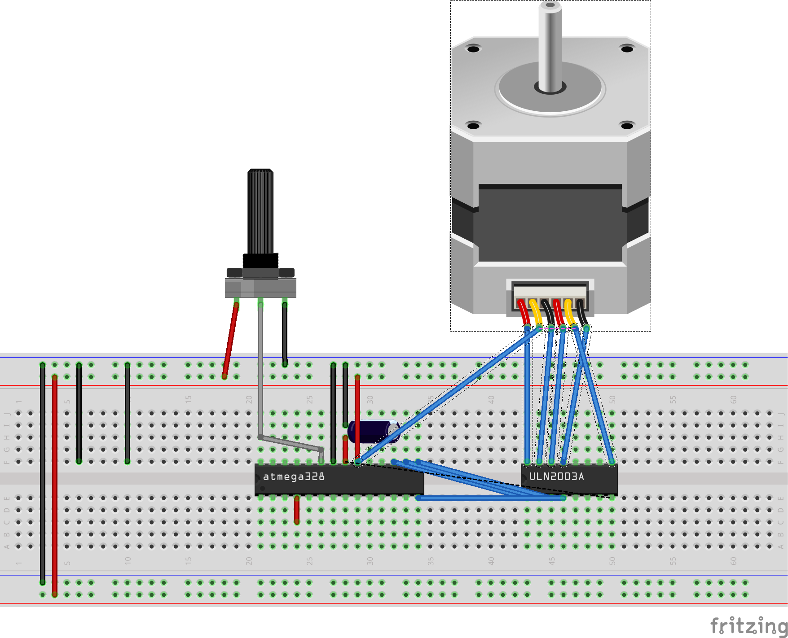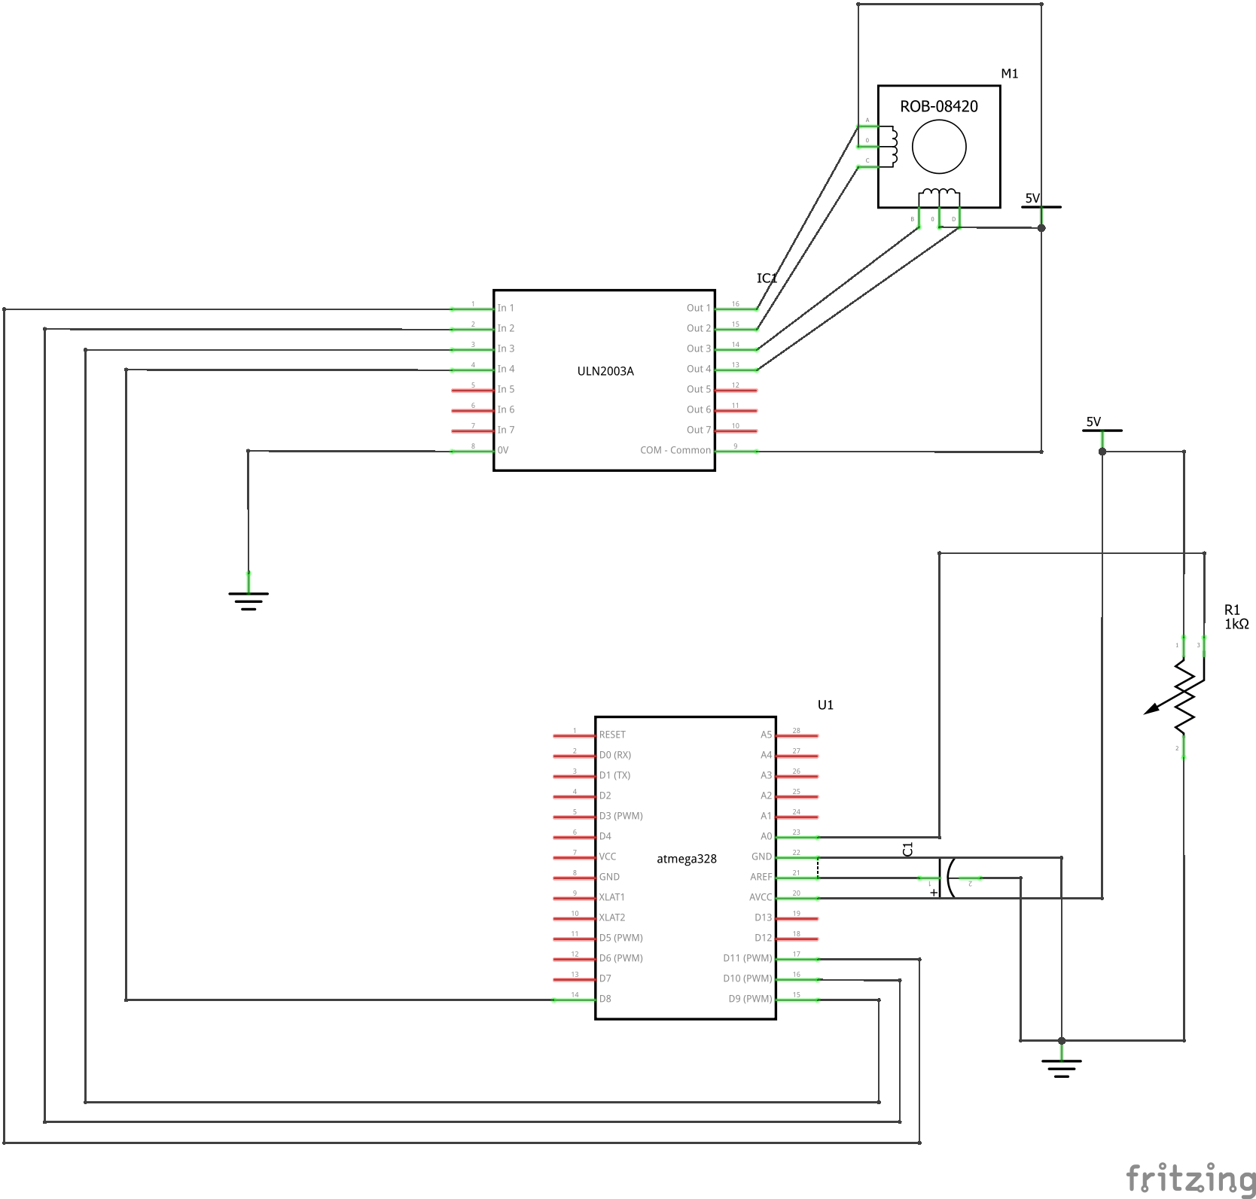

1. **TASK 2 [STEPPER MOTOR] C CODE**

#include <avr/io.h>

#include <stdint.h>

#include <avr/interrupt.h>

volatile *uint8_t* stepperPos;

volatile *uint16_t* ADCvalue;

int main(void)

{

// Port initialization

DDRB |= 0x0F;

PORTB = 0x00;

// ADC settings

ADMUX |= (1 << REFS0);

ADCSRA |= (1 << ADPS2) | (1 << ADPS1) | (1 << ADPS0);

ADCSRA |= (1 << ADEN);

// Timer1 settings

TCCR1B |= (1 << WGM12); // CTC mode

TCCR1B |= (1 << CS11); // Prescalar of 8

TIMSK1 |= (1 << OCIE1A); // CTC interrupt

TCNT1 = 0x00;

OCR1A = 65535;

// Initialize stepperPos

stepperPos = 0x06;

sei();

while (1)

{

ADCSRA |= (1 << ADSC); // Start conversion

while((ADCSRA & (1 << ADIF)) == 0); // Wait for conversion

ADCvalue = ADC << 5;

}

return 0;

}

// CTC ISR

ISR(TIMER1_COMPA_vect)

{

OCR1A = 65535 - ADCvalue; // Speed of the stepper

if(ADCvalue > 32)

{

switch(stepperPos) // Set next state of stepper

{

case 0x06:

stepperPos = 0x0C;

break;

case 0x0C:

stepperPos = 0x09;

break;

case 0x09:

stepperPos = 0x03;

break;

case 0x03:

stepperPos = 0x06;

break;

default:

break;

}

PORTB = stepperPos;

}

else

PORTB = 0x00;

TIFR1 |= (1 << OCF1A); // Clear flag

}

1. **TASK 2 [STEPPER MOTOR] FLOW CHART**

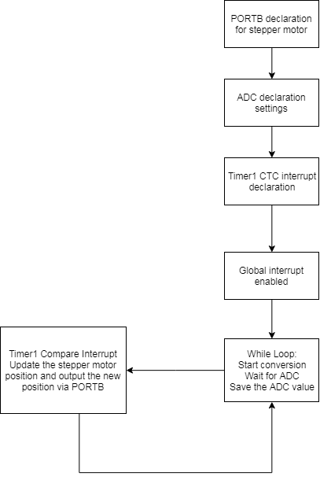

1. **TASK 3 [SERVO MOTOR] SCHEMATIC AND BREADBOARD**

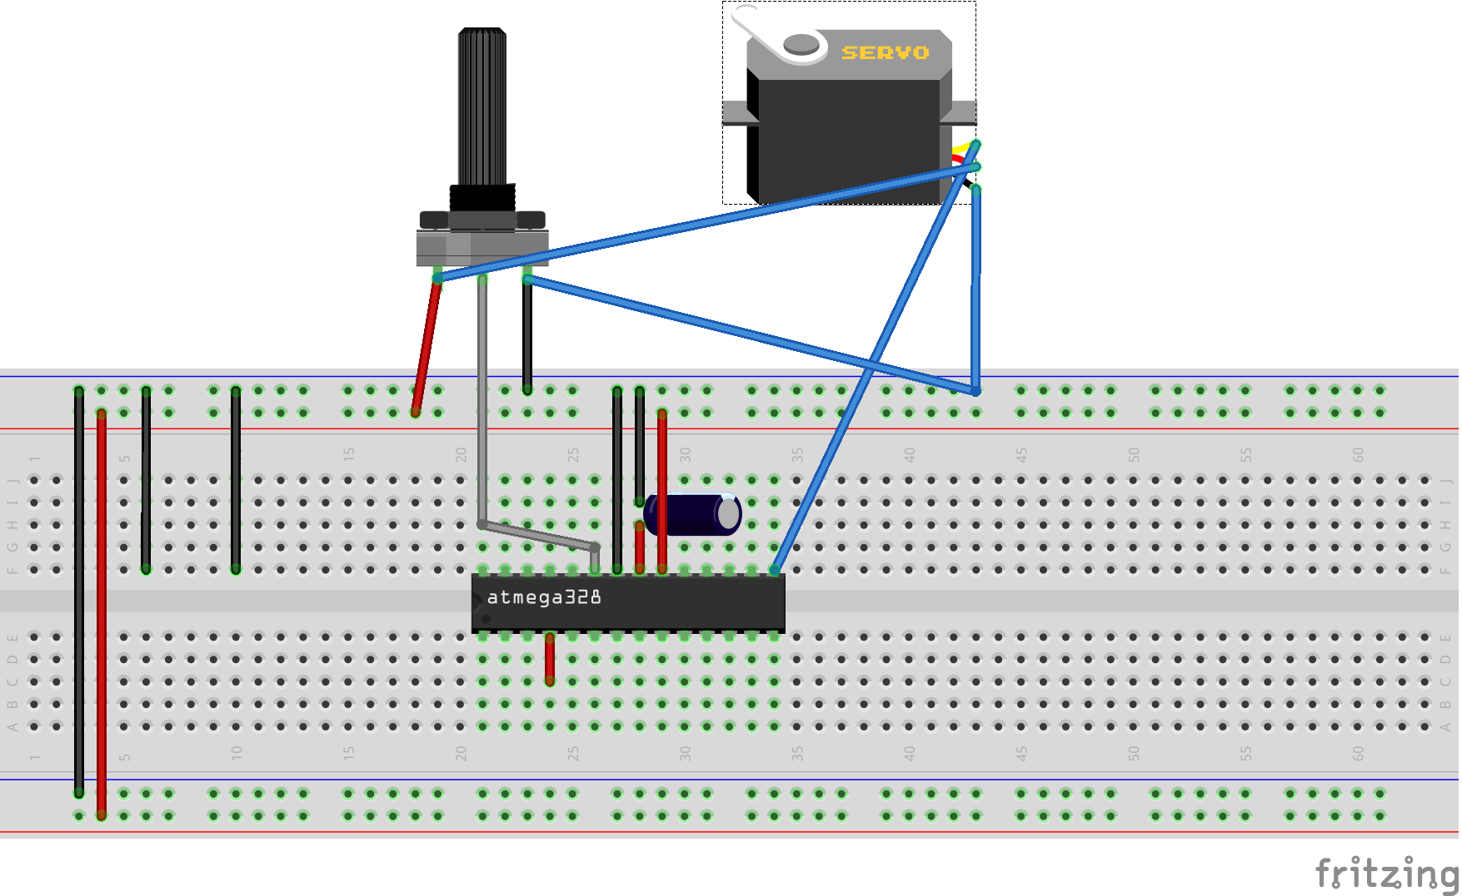

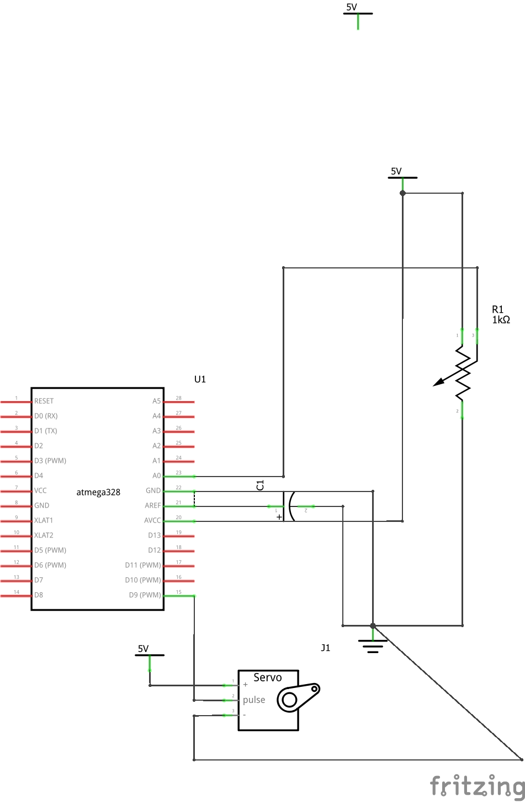

1. **TASK 3 [SERVO MOTOR] C CODE**

#include <avr/io.h>

#include <stdint.h>

int main(void)

{

// ADC settings

ADMUX |= (1 << REFS0); // AVcc with external capacitor at AREF pin

ADCSRA |= (1 << ADPS2) | (1 << ADPS1) | (1 << ADPS0); // Set prescalar to 128

ADCSRA |= (1 << ADEN); // Enable ADC

// PWM Settings

DDRB = (1 << 1); // Set OC1A as output (PB1)

ICR1 = 5000; // Set top

TCCR1A |= (1 << COM1A1) | (1 << COM1B1); // Set OC1A high on compare

TCCR1A |= (1 << WGM11);

TCCR1B |= (1 << WGM12) | (1 << WGM13); // Fast PWM Mode

TCCR1B |= (1 << CS11) | (1 << CS10); // Clocked divided by 64

while (1)

{

ADCSRA |= (1 << ADSC); // Start ADC conversion

while((ADCSRA & (1 << ADIF)) == 0); // Wait for conversion

OCR1A = (ADC/3) + 200; // Assign ADC value to PWM

}

}

1. **TASK 3 [SERVO MOTOR] FLOW CHART**

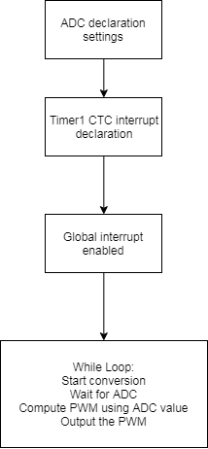

1. **VIDEO LINKS TO ALL TASKS**

Task 1: <https://youtu.be/eb3BTntd4Lc>

Task 2: <https://youtu.be/4yAEPqhDWnU>

Task 3: <https://youtu.be/4R--y87nlpA>

**Student Academic Misconduct Policy**

<http://studentconduct.unlv.edu/misconduct/policy.html>

“This assignment submission is my own, original work”.

Bryan Takemoto