Machine Learning Feature: Event Recommender

The app includes an event recommender feature that can be found and navigated through the main home page or navigation bar to make it easier for users to find relevant events instead of going through everything manually.

Instead of just filtering by category, it uses a scoring system. Each event is given a score based on different factors. If the event matches the category selected by the user, it gets more points. It also checks the user’s preferred category from the user dataset, so if that matches as well, the score increases further.

There’s also a small amount of behaviour tracking. When a user registers for an event, that category is stored using localStorage. This means that when the recommender is used again, events from those categories are given a slight boost, making the results more personalised over time.

The event date is also taken into account. Events that are happening sooner are given more points so they appear higher in the list. There’s also a small check on the time format to slightly adjust the scoring.

After the scores are calculated, the events are sorted from highest to lowest and only the top results are displayed. The highest ranked event is marked as “Top Match”, and a confidence percentage is shown to indicate how strong the recommendation is.

This means the system is not just filtering events but ranking them based on relevance using multiple factors.

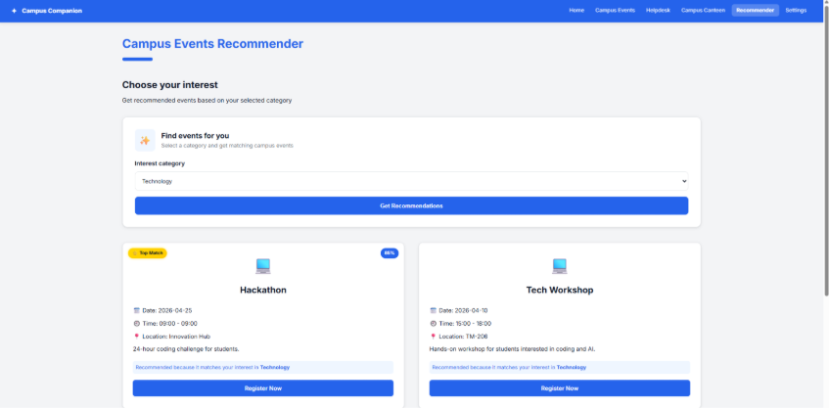

Evaluation
To test the recommender, different categories were selected and the results were checked.

When categories such as Technology or Sports were chosen, the events returned matched correctly. The results were also ordered based on relevance, with events happening sooner or matching user preferences appearing higher in the list.

The Top Match label and confidence percentage make it clearer which event is the most relevant.

Registering for events was also tested, and after doing this, the recommendations began to reflect those categories more often. This shows that the system is using previous interactions to influence future results.

The recommender produces more useful results compared to simply filtering events by category.

