**Selenium Hands-on:**

Frames:

QUESTION 2

----------

URL : https://netbanking.hdfcbank.com/netbanking/?_ga=2.176378149.1819882415.1533883212-608727520.1532670997

NOTE: Click submit without enter the user id.

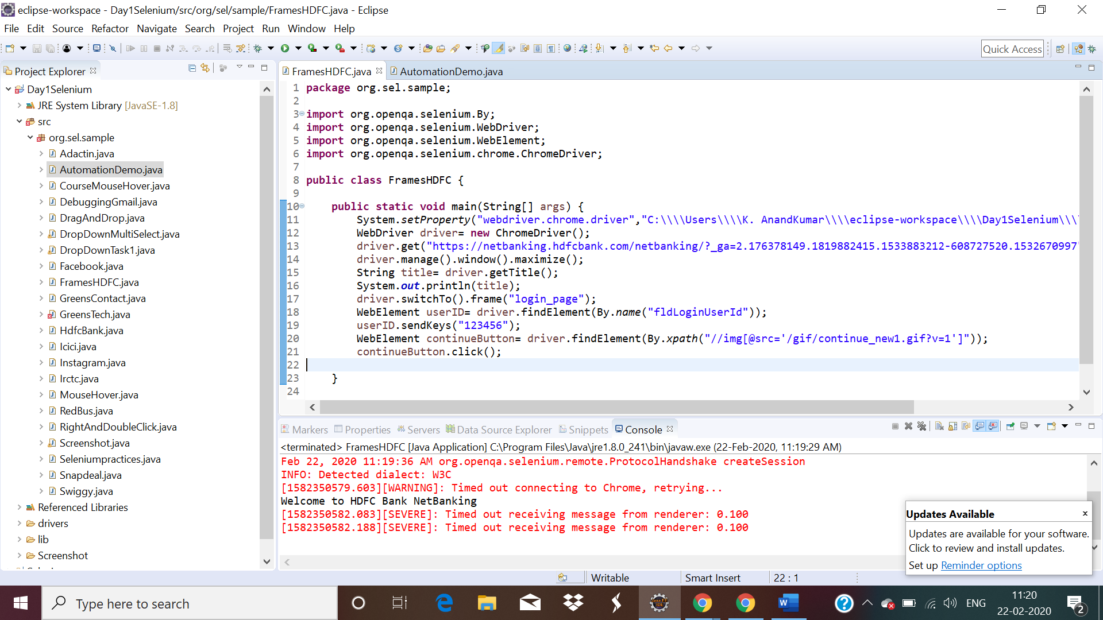

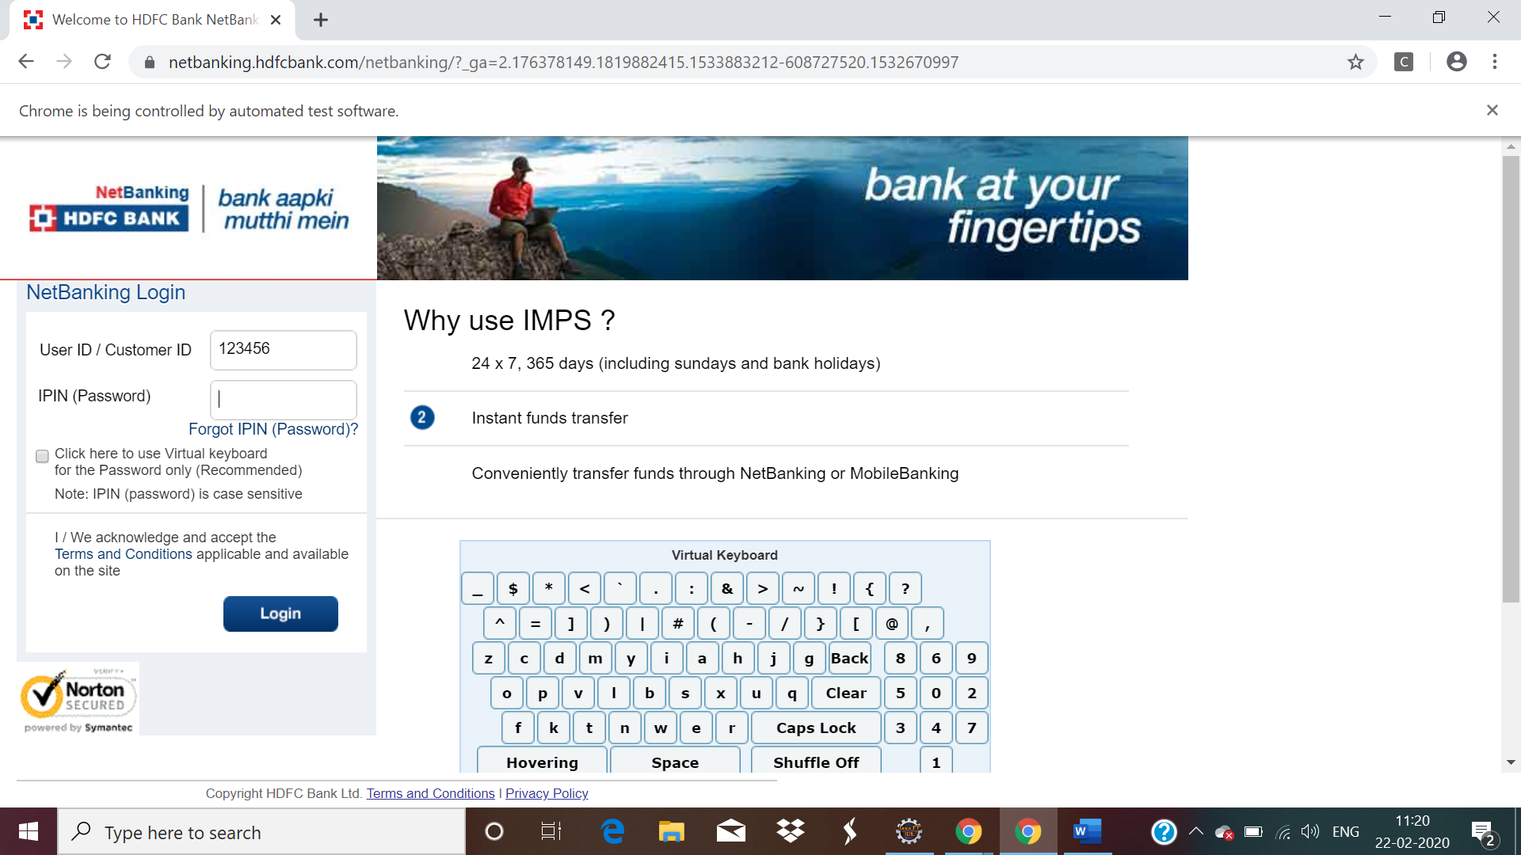

URL : http://demo.automationtesting.in/Alerts.html

NOTE: Perform all alert.

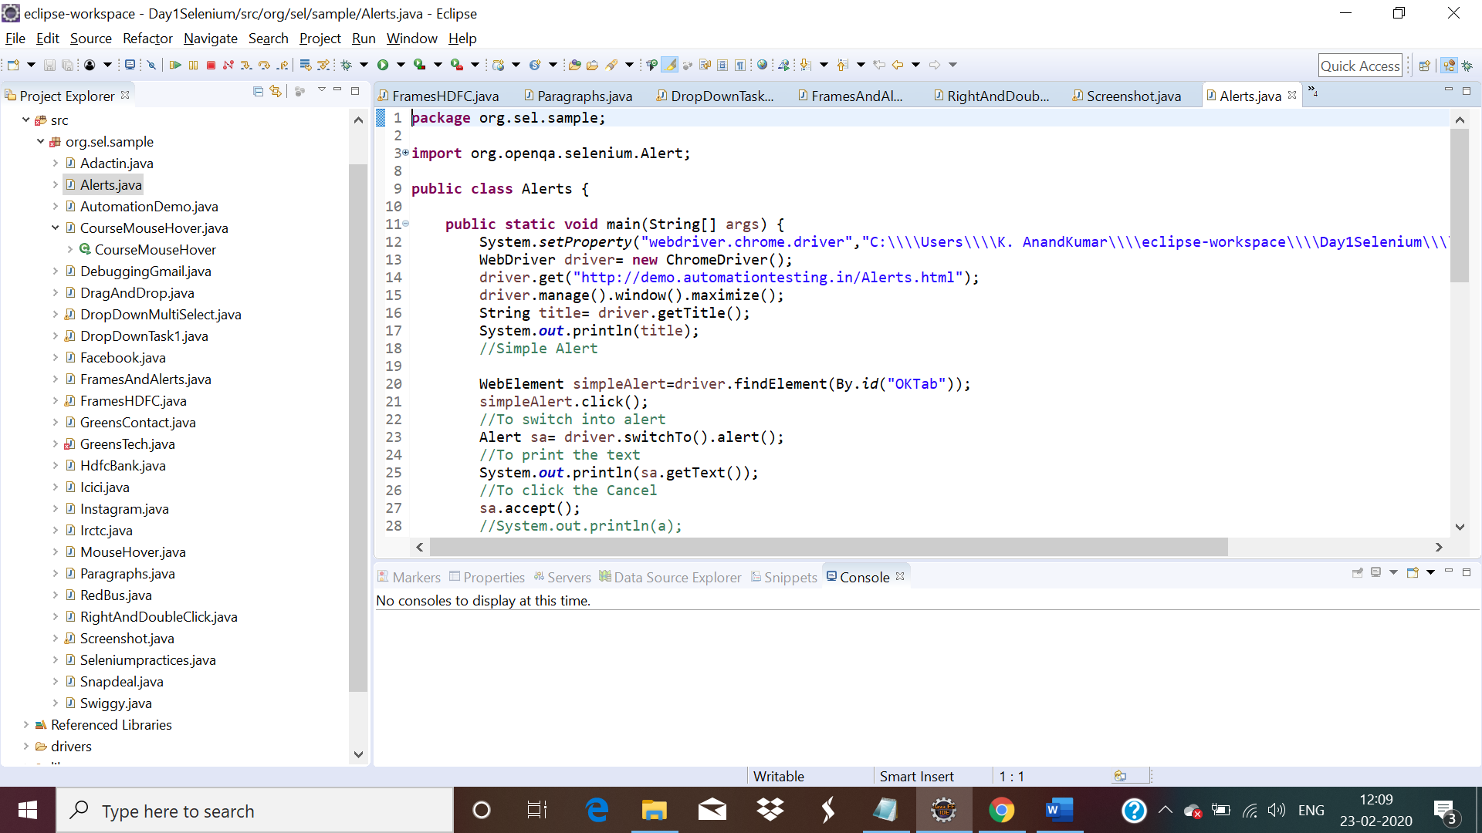

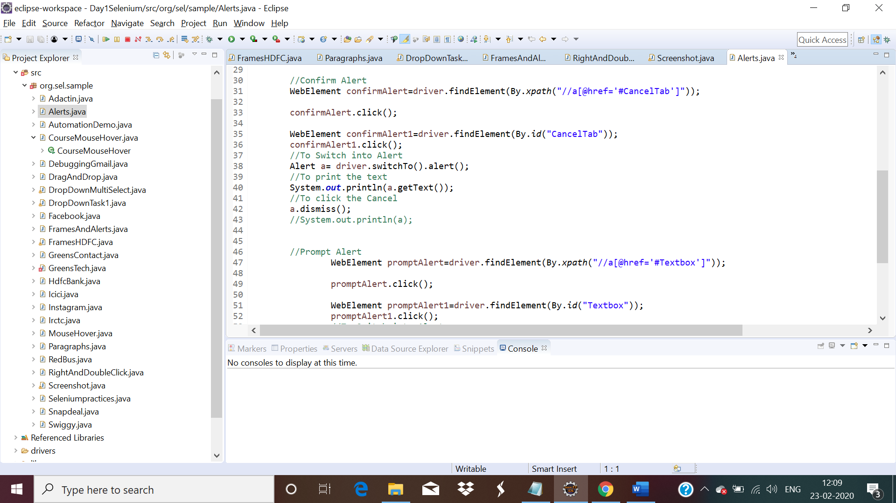

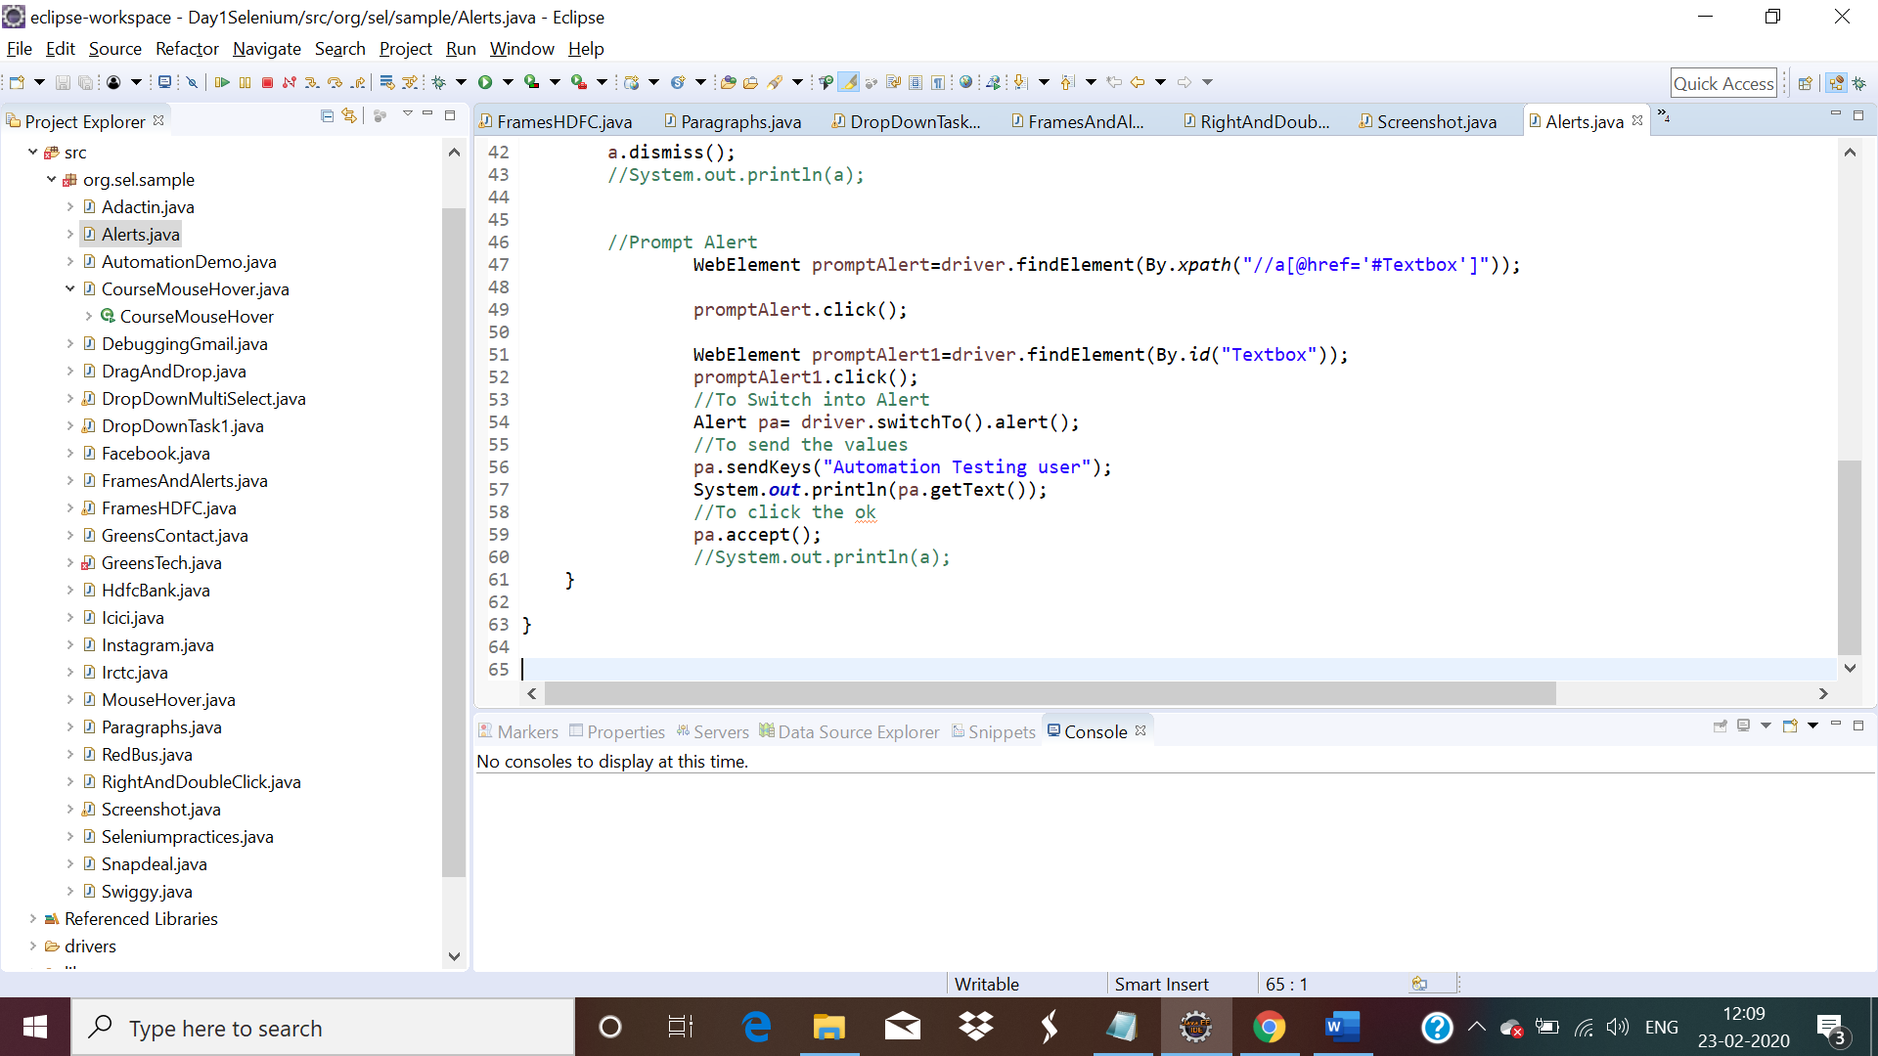

URL : https://netbanking.hdfcbank.com/netbanking/

NOTE: Enter the userId,click continue.Enter password.

