MATLAB-9(EXPERIMENT)

NAME- AKALPYA KHARE
SECTION- CSE02
ROLL NUMBER-24051757

Aim of the Experiment : Simulation of single phase half wave rectifier with R Load Where peak Voltage=230V, f=50Hz, V=30V and R=5 ohms. Plot the Output Waveform of Input Voltage and Output Voltage with respect to time and output voltage and output current with respect to time.

Objective :To simulate a single-phase half-wave rectifier with resistive (R) load using MATLAB Simulink and to analyze the output characteristics. The experiment aims to plot:

Input voltage vs time
- Output voltage vs time
- Output current vs time
and understand the behavior of the rectifier circuit.

Theory A half-wave rectifier is a circuit that converts alternating current (AC) into direct current (DC) by allowing only one half-cycle of the AC waveform to pass through.

During the positive half cycle, the diode is forward-biased and conducts current.

During the negative half cycle, the diode is reverse-biased and blocks current.
Thus, the output consists of only positive half cycles, resulting in a pulsating DC output.

Key Concepts:
- Input voltage: sinusoidal AC (230V peak, 50 Hz).
- Output voltage: only positive half cycles
- Load: purely resistive (R = 5 ohms)
- Output current follows Ohm’s Law:
I=V/R

Important Observations:
- Output is not smooth DC → contains ripples
- Frequency of output = same as input (for half-wave)
- Average output voltage is lower than peak input

Equipment Required
In MATLAB Simulink, the following blocks are used:
- AC Voltage Source – to provide sinusoidal input
- Diode – to allow current in one direction only
- Resistor (R Load) – represents load (5 ohms)
- Scope – to visualize waveforms
- Current Measurement Block – to measure output current
- Voltage Measurement Block – to measure output voltage
- Ground Block – for circuit completion
- Simulink Solver Configuration – for simulation setup
Circuit Diagram
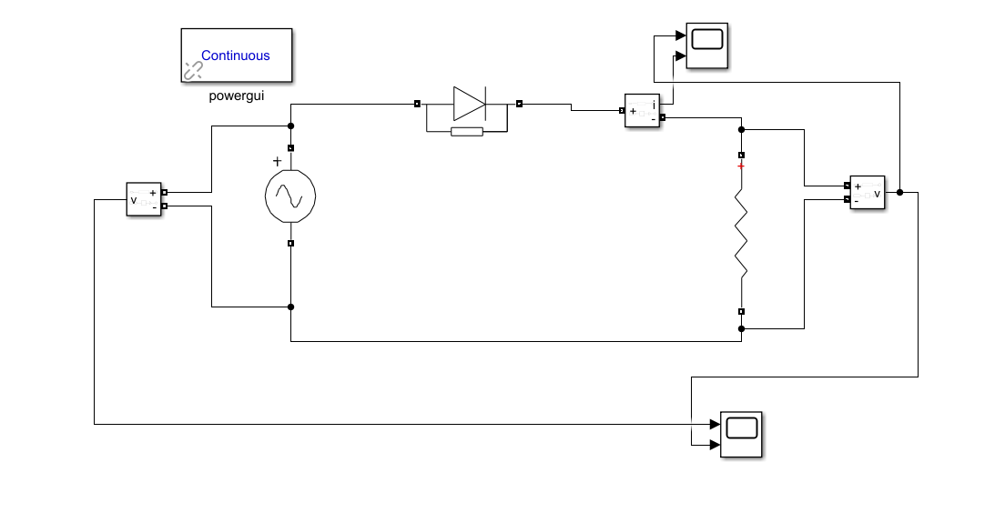

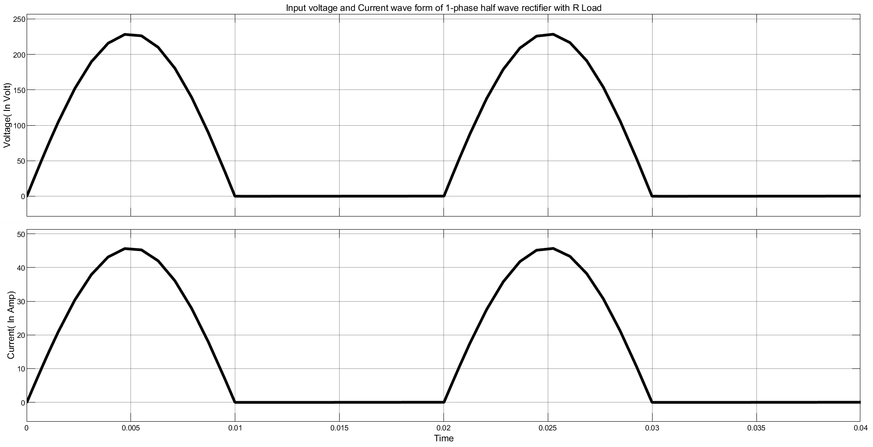

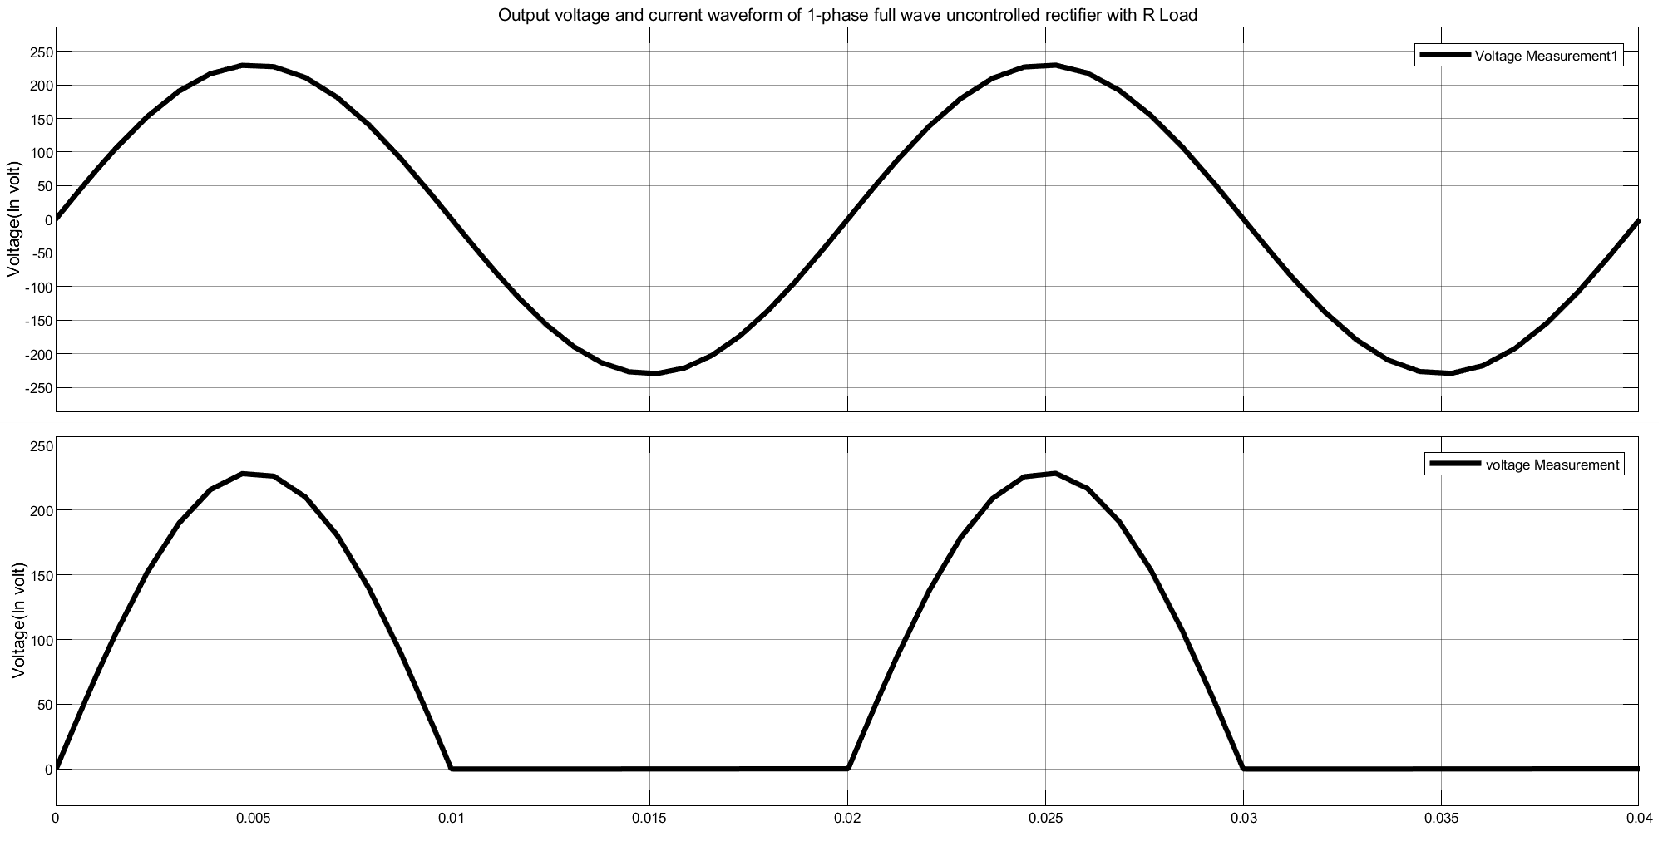

Result Analysis

Waveform Behavior:
- Input Voltage: A complete sinusoidal waveform (both positive and negative cycles).
- Output Voltage: Only positive half cycles appear; negative part is completely removed.
- Output Current: Follows the shape of output voltage (since load is resistive).

Behavior of the Graphs:
- The output waveform is pulsating DC, not smooth.
- Current and voltage are in phase (due to resistive load).
- During negative half cycles:
- Voltage = 0
- Current = 0

Key Observations:
- The diode acts as a switch, conducting only in one direction.
- There is a loss of half the input signal, reducing efficiency.
- Output contains ripples, meaning filtering is required for smooth DC.

Conclusion:
The simulation of the single-phase half-wave rectifier was successfully carried out using MATLAB Simulink. The results confirm that:
- The rectifier allows only the positive half cycle of AC input.
- The output is a pulsating DC signal.
- The output current follows the voltage waveform due to the resistive load.
This experiment helps in understanding the basic working of rectifiers and highlights their limitations, such as low efficiency and ripple content.

