NAME - AKALPYA KHARE
ROLL NUMBER -24051757
SECTION-CSE-02

MATLAB TEST

- The equation x3+2x-2=0 has root between 0 and 1. Find the root upto 1 decimal places using bisection method.Plot the error.Assume error tolerance as per your choice.

clc;
clear;
close all;

syms x;
y = x^3 + 2*x - 2;

a = 0;
b = 1;
e = 0.1;

fa = eval(subs(y, x, a));
fb = eval(subs(y, x, b));

if fa * fb > 0
fprintf('No root in the given interval\n');
else
fprintf('\n a\t\t b\t\t c\t\t f(c)\t\t Error\n');
errors = [];
c_old = a;
while abs(b - a) > e
c = (a + b) / 2;
fc = eval(subs(y, x, c));
err = abs(c - c_old);
errors = [errors err];
fprintf('%f\t%f\t%f\t%f\t%f\n', a, b, c, fc, err);
if fa * fc < 0
b = c;
fb = fc;
else
a = c;
fa = fc;
end
c_old = c;
end
fprintf('\nRoot up to one decimal place is: %.1f\n', c);
figure;
plot(1:length(errors), errors, '-o','LineWidth',1.5);
xlabel('Iteration');
ylabel('Absolute Error');
title('Error graph');
grid on;
end

Output

0.000000 1.000000 0.500000 -0.875000 0.500000
0.500000 1.000000 0.750000 -0.078125 0.250000
0.750000 1.000000 0.875000 0.419922 0.125000
0.750000 0.875000 0.812500 0.161377 0.062500

Root up to one decimal place is: 0.8

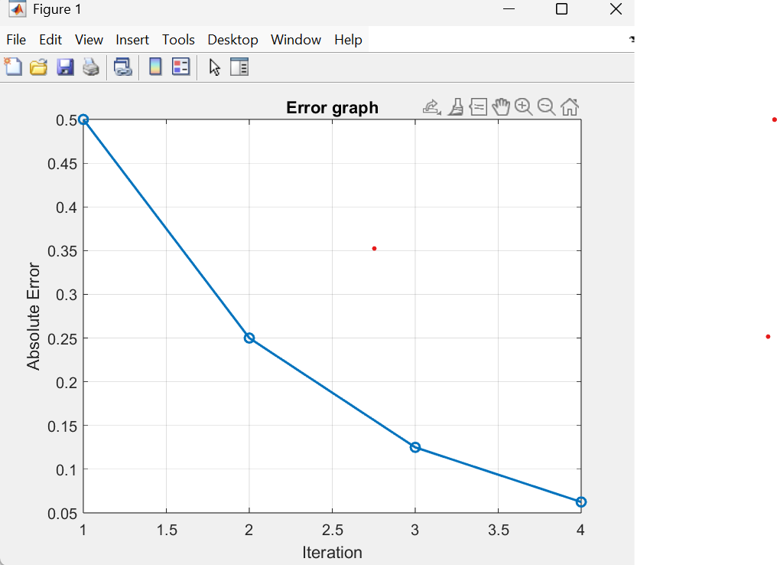

- Find the root of the equation x3-x-2 in the interval [1,2] using regula falsi method.Assume error tolerance as per your choice.

clc;
clear;
close all;

f=@(x)x^3-x-2;
a=1;
b=2;
tol=0.1;

fprintf('Enter the non liner equation : x^3 - x - 2\n');
fprintf('Enter the value of 1st interval : %d\n', a);
fprintf('Enter the value of 2nd interval : %d\n', b);
fprintf('Tolorance error is %f\n', tol);

fa=f(a);
fb=f(b);

c_values = [];

c = (a*fb - b*fa)/(fb - fa);
fc = f(c);
fprintf('%f\t%f\t%f\t%f\t%f\t%f\n', a, b, c, fa, fb, fc);

while abs(fc) > tol
if fa*fc < 0
b = c;
fb = fc;
else
a = c;
fa = fc;
end

c = (a*fb - b*fa)/(fb - fa);
fc = f(c);

fprintf('%f \t %f \t %f \t %f\n', a, b, c, abs(fc));
c_values = [c_values c];
end

fprintf('Root is : %f\n', c);

OUTPUT

Enter the non liner equation : x^3 - x - 2
Enter the value of 1st interval : 1
Enter the value of 2nd interval : 2
Tolorance error is 0.100000
1.000000 2.000000 1.333333 -2.000000 4.000000 -0.962963
1.333333 2.000000 1.462687 0.333339
1.462687 2.000000 1.504019 0.101818
1.504019 2.000000 1.516331 0.029895
Root is : 1.516331

