Draft Functional Requirements Document
RPF Grievance Redressal System

INTRODUCTION
The Railway Protection Force (RPF) is an Armed Force of the Union of India, established by the Railway Protection Force Act, 1957. It is entrusted with protecting railway passengers, passenger area and railway property of the Indian Railways.
Railway Protection Force (RPF) is having multi-tier organizational structure. Railway Board at the highest level - headed by DG/RPF, Zonal HQ headed by IG-cum-PCSC and Divisional HQ headed by Sr DSC/DSC. Divisional unit is further divided into RPF Posts (some posts have also outposts under them). RPF Post is the last-mile unit in the organizational structure and helps the organisation in achieving its objectives i.e. the role of protecting and safeguarding Passenger, Passenger area and Railway property and also ensuring the smooth operation of Railway movement.
In order to achieve its objectives and improve its functioning, it is important to keep the force personnel at high motivation level. Vital part of that process will be to address the grievances of the force. In the time of restricted movement in the COVID-19 crisis, it is imperative to provide avenue for the staff to voice their grievances. RPF Post Grievance Redressal system intends to address the issue by providing the digital channel to voice their grievances.

Purpose
To provide a digital channel of communication to the staff of RPF Post to address the grievance(s) through online web portal and/or mobile application.

Scope
The document intends to explain the process involved in the grievance redressal mechanism, to provide logic for each operation with flow chart, to identify intended user for each logic. The document is in no way intend to replace or represent the rules and circulars issued from the Railway Board or any other administrative units of organisation. In case of any clarification required, the same shall only be obtained from original circular or guidelines issued from time to time.

Background

The Railway Protection Force has its origin since 1882 when the Railway Companies then in existence appointed their own security for each Department. This arrangement was found to be satisfactory till 1918. With an increase in traffic; there was a steep rise in the incidence of thefts of goods entrusted to Railways. This led to the Government of India to appoint a committee to enquire into causes thereof and suggest corrective measures.

Acting on the Committee’s recommendations, most of the Class I Railways reorganized their security as a separate unit under a superior officer. But this too proved inadequate, and in the aftermath of the Second World War, losses due to thefts and claims on the Railways assumed huge size and needed serious attention.

The Government of India, therefore in year 1954, instituted a special enquiry through Director, Intelligence Bureau (Ministry of Home Affairs) who in his report, forcefully brought out the necessity of the security in railways on a statutory basis. The Railway Board also appointed a Security Adviser to the Railway Board in July, 1953 to work out the details for the reorganization of the Security department. It was decided in consultation with the Ministry of Home Affairs that there should be an integrated well organized force on the model of the Police with adequate supervisory staff specially trained to meet the peculiar aspects of crime that were prevalent in Railways and act as a second line to the States Police with whom, under the Constitution, policing on Railways was rested. This led to introduction of the R.P.F. Bill in the Parliament of India for the better protection and security of Railway property and the same was passed as The Railway Protection Force Act, 1957 (No.23 of 1957).

Gradually and steadily the force has evolved in many aspects from then onwards and there after The RPF Act, 1957 was modified by Parliament for the first time in 1985 vide Act No.60 for the constitution and maintenance of the Force as an Armed Force of the Union and for the second time in 2003 with Railway Act vide which the additional responsibilities of Passenger Safety and Security of their belongings were laid on the shoulder of the Force by extending the powers of execution of 29 sections of Railway Act. At present the Force is escorting maximum number of mail/express trains throughout the length and breadth of the nation beside the access control duties at important stations.

This is the only armed force of the Union of India which has power to arrest, investigate and prosecute criminals. In common parlance the Force is referred to as RPF. The Force is under the authority of Ministry of Railways, Government of India. The strength of RPF is about 65,000. RPF is headed by Director General (DG). Shri Arun Kumar, an IPS officer of the 1985 batch of Uttar Pradesh Cadre has been appointed DG on 01 October 2018.

FUNCTIONAL REQUIREMENTS

Context
- Generic Context Diagram
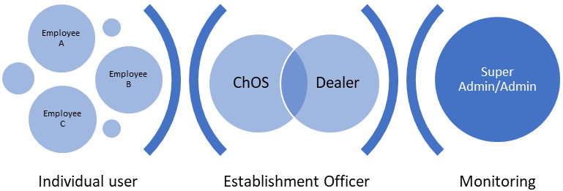

User Requirements
There are two types of users of this application:
- Employee: RPF Employee enters his/her grievances through online web portal or mobile application.
- Administrative users: Six type of administrative users will be responsible for handling various processes in the portal.
Their roles and responsibilities are defined in the following pages.

Requirements of Employee:
- To be provided with individual login with PF number as user name and PF number as default password. The user should change the password of his choice in the first login.
- After the successful login, the dashboard should be visible reflecting following parameters:
- Total Number of Grievances: The count of number of grievances which are entered through the portal and which are either closed/not closed to be mentioned
- Number of Grievances pending: The count of number of grievances which are entered through the portal and which are not closed to be mentioned
- Number of Grievances Closed: The count of number of grievances which are entered through the portal and which are closed to be mentioned
- In the left side, following options should be available in the main menu:
- Lodge a Grievance
- Account Activity: Details of dashboard
- Profile setting
- Sign out
- In the profile setting page, following details will be available:
- Name (Field cannot be edited)
- Employee Number/ PF Number (Field cannot be edited)
- Date of Birth (Field cannot be edited)
- Mobile Number (Field to be edited through OTPs received through old number as well as new number)
- E Mail ID: (Field can be edited) (Optional)
- Password (Field can be edited through a one-time password sent through the registered mobile number/mail id)

Requirement of Administrative user:
There are six type of administrative users:
- Super Admin
- Admin
- Establishment Officer
- Post Commander
- Chief Office Superintendent
- Dealer

1. Super Admin:
Gazetted Officers of the level of SrDSC/DSC of the RPF/Chennai division are the super admins of the web portal. Besides the activities that can be done by admins, super admins can perform following activities:
- Ability to monitor the grievances of all staff of Chennai division.
- Approve the new addition of user in the portal
- Removal of user from the portal
- To provide remarks wherever applicable
- Assigning a role of Establishment Officer to any of the admins

2. Admin:
Gazetted Officers of the level of ASC of the RPF/Chennai division are the admins of the web portal. Activities of the admins are:
- Ability to monitor the grievances of staff under their control through a dashboard: Admin should be able to view a screen that should have a summary of grievances redressed.
- In the dashboard, he may view the summary of the grievances. Following are the components:
- Total Number of Grievances: The count of number of grievances which are entered through the portal and which are either closed/not closed to be mentioned of his/her jurisdiction
- Number of Grievances pending: The count of number of grievances which are entered through the portal and which are not closed to be mentioned of his/her jurisdiction
- Number of Grievances Closed: The count of number of grievances which are entered through the portal and which are closed to be mentioned of his/her jurisdiction
- On clicking, “Total number of Grievances pending” in the dashboard i.e. pending: the admin should be able to view the grievances that are pending. The timeline filter to be provided to filter the grievances based on a. Date, b. Last Month, c. A Particular Month, d. Last three months, e. Any three months and f. Financial Year. On clicking any of the grievances listed, details of particular grievance to be seen.
- On Clicking, “Number of Grievances Closed” in the dashboard, the admin should be able to view the grievances that are closed. The timeline filter to be provided to filter the grievances based on a. Date, b. Last Month, c. A Particular Month, d. Last three months, e. Any three months and f. Financial Year. On clicking any of the grievances listed, details of particular grievance to be seen.
- Once the grievance is entered by the RPF Employee and forwarded by Post Commander to divisional HQ, he may add a remark to the grievance of staff mentioned.
- Once the grievance is closed and provided certificate to this effect by the Chief Office Superintendent the admin may escalate to Super Admin if he/she desires the grievance is not addressed properly.
- Admin also should have a similar login credential page.
- In the left side main menu, he should have two options: To view the dashboard and profile settings (Similar to RPF Employee)
3. Establishment Officer (EO):
Establishment Officer is Gazetted Officer and will be from one among the Admin. He supervises the work of all Establishment related matters and monitors the progress of the redressal of grievance system. Activities of Establishment Officer in this portal are:
One of the ASC of RPF/Chennai division is nominated by Sr DSC as an Establishment Officer. Activities of the Establishment Officer include all the activities of admin except he could view the details of all the staff. Besides that, specific activities performed by EO are:
- Approval of Completion Certificate given by Chief Office Superintendent.
- Prepare a monthly report of grievance redressal.
- Monthly report will have summary of category-wise, sub-category-wise report along with count. The report should be downloadable in PDF format.
- Report also to indicate average time taken to complete the grievance category-wise and sub-category-wise
- Escalate the grievance to Super Admin if it concerns with Headquarter or Railway Board.
4. Post Commander (PC):
- Post Commander should have a similar login page.
- In the dashboard of PC, following component should be visible.
- Total number of new Grievances which are yet to be sent divisional HQ.
- Total Number of Grievances which are sent to HQ: The count of number of grievances which are sent through the portal and which are either closed/not closed to be mentioned of his/her jurisdiction
- Number of Grievances pending: The count of number of grievances which are entered through the portal and which are not closed to be mentioned of his/her jurisdiction
- Number of Grievances Closed: The count of number of grievances which are entered through the portal and which are closed to be mentioned of his/her jurisdiction

- Adding a remark to the grievances entered by the staff and forward to divisional HQ.
- Ability to close the grievance the grievance by adding a remark.
6. Chief Office Superintendent (ChOS):
- ChOS should have a similar login credential page.
- Dashboard of the ChOS: He/She should be in a position view the new grievances count as well as old grievances. Therefore, the dashboard will have following components:
- Total number of new Grievances which are yet to be assigned to a dealer
- Total Number of Grievances: The count of number of grievances which are entered through the portal and which are either closed/not closed to be mentioned of his/her jurisdiction
- Number of Grievances pending: The count of number of grievances which are entered through the portal and which are not closed to be mentioned of his/her jurisdiction
- Number of Grievances Closed: The count of number of grievances which are entered through the portal and which are closed to be mentioned of his/her jurisdiction

- Chief Office Superintendent assigns the grievance ticket generated to a particular dealer. Dealer to be notified by a message or e-mail. He/She may add a remark in the grievance of the staff.
- Escalate the grievance to EO if it concerns with Headquarter or Railway Board. Once the grievance is completed, he/she should close the complaint
- Completion Certificate should be generated and send it to EO for approval
- Once the approval given by EO, the grievance ticket to be closed. A notification to be sent to a staff concerned.
6. Dealer:
- Dealer should have a similar login process.
- Dashboard of the dealer should have following components:
- Total number of new Grievances which are assigned to his/her account.
- Total Number of Grievances: The count of number of grievances which are entered through the portal and which are either closed/not closed to be mentioned of his/her jurisdiction
- Number of Grievances pending: The count of number of grievances which are entered through the portal and which are not closed to be mentioned of his/her jurisdiction
- Number of Grievances Closed: The count of number of grievances which are entered through the portal and which are closed to be mentioned of his/her jurisdiction
- Once the grievance is addressed, he/she sends it back to ChOS for closure. He/She may attach a document for proof of completion.

Data Flow Diagrams
Processes:
A. First stage: Complaint Generation by the staff:

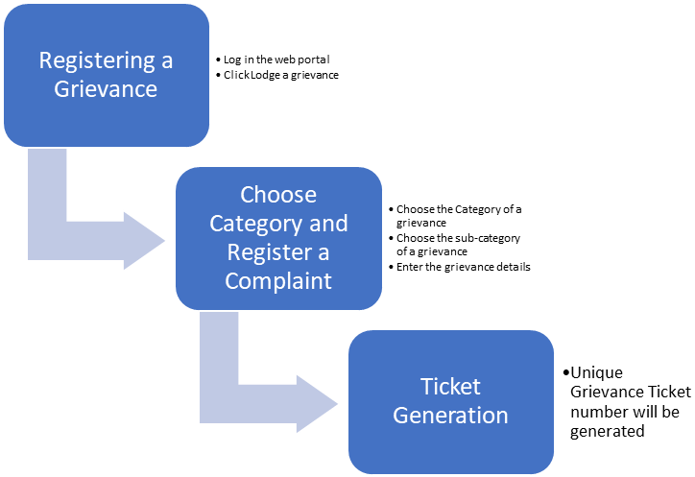

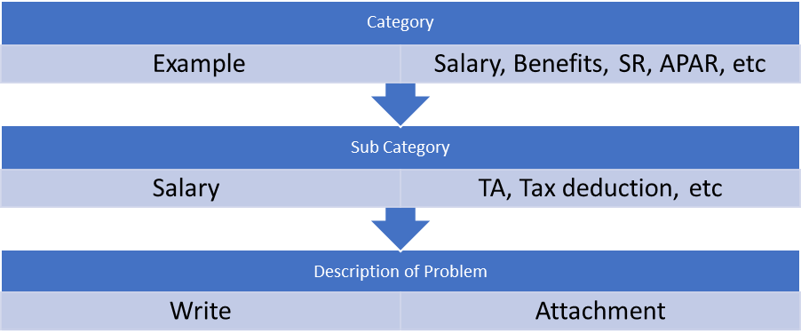

B. Second stage: Dealing the Grievance at Post level
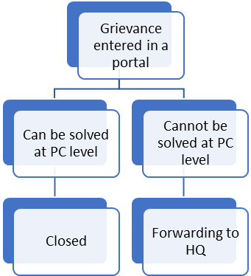
C. Third Stage: Receipt by Divisional HQ
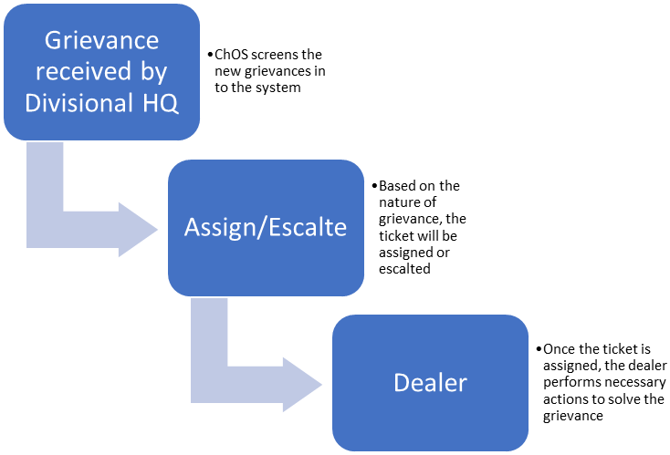

D. Fourth Stage: Solving the grievance:
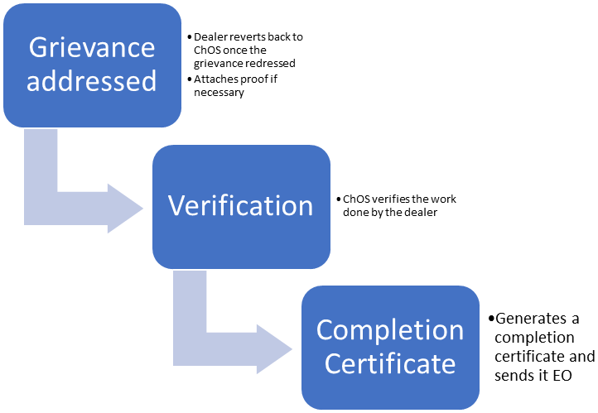

E. Fifth Stage: Closure of the grievance
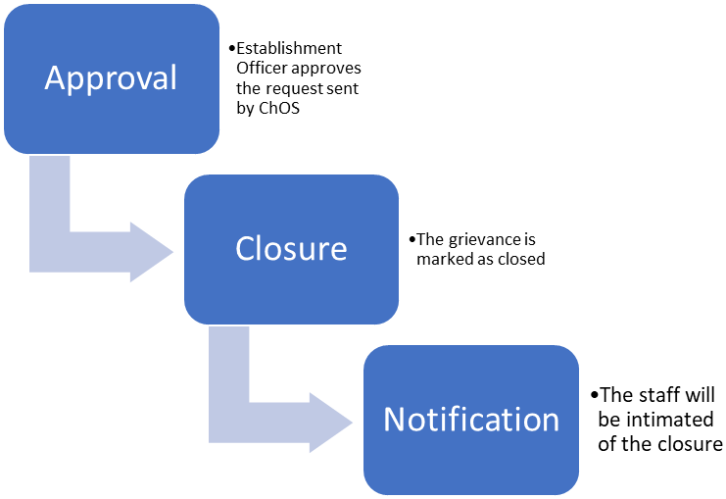

F. Overall Flowchart for Grievance Ticket Generation:
