GEMICATES PORTAL USER ID & LOG IN:

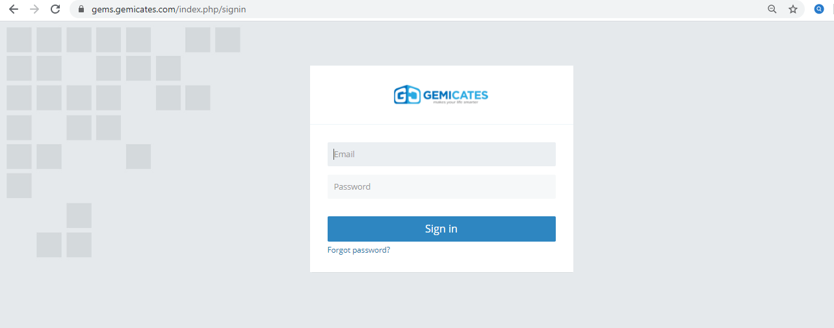

Gemicates Portal Dashboard:

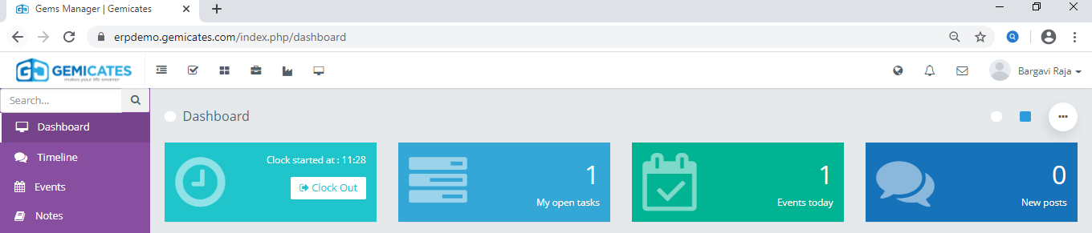

For modules usage:

First userd name & Id LOG in:

The move to the dashboard: with views of Modules:

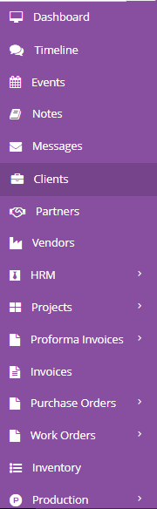

In that ---🡪: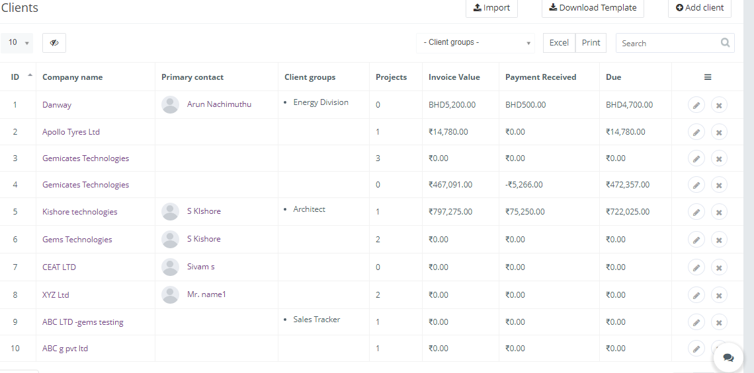

Where we can add the basic client details with client Modules , name ,details, groups, Invoice value. Their payment details , DUE for Accounting & recording purpose.

Announcenments:

Here we can able to create the announcments , for anything to be known newly, with valid information with date & end date….with time repeat monthly.

