GEMICATES PORTAL USER ID & LOG IN:

First user name & Id LOG in for getting in portal:

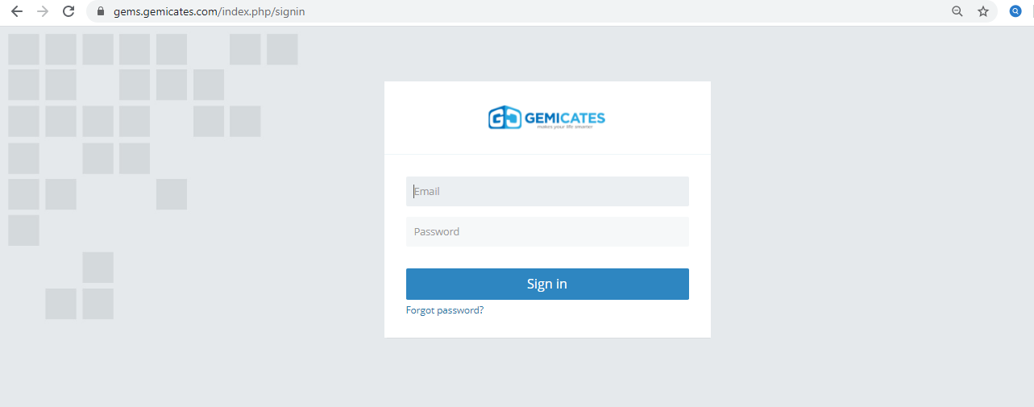

Gemicates Portal Dashboard:

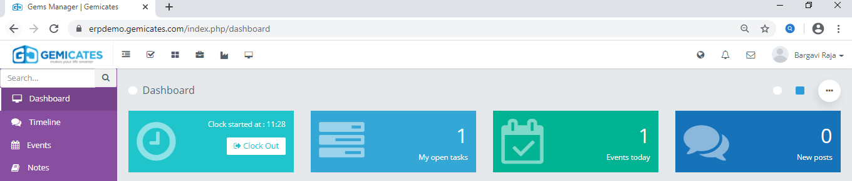

For modules usage:

The move to the dashboard: with views of Modules:

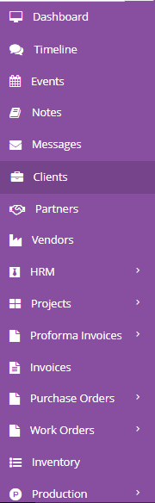

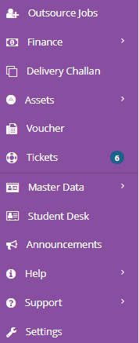

**Portal Overview:**

1.In that ---🡪: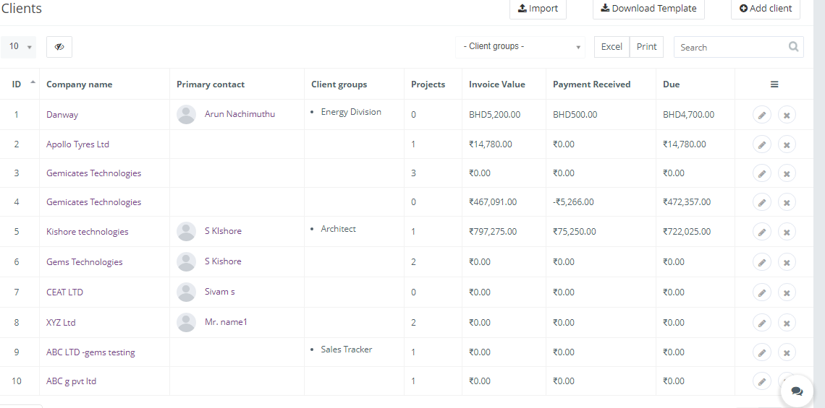

Where we can add the basic client details with client Modules , name ,details, groups, Invoice value. Their payment details , DUE for Accounting & recording purpose. Clients play role in giving Projects to us .

2.Announcements:

Here we can able to create the announcement’s , for anything to be known newly, with valid information with date & end date….with time repeat monthly.it helps us to know important details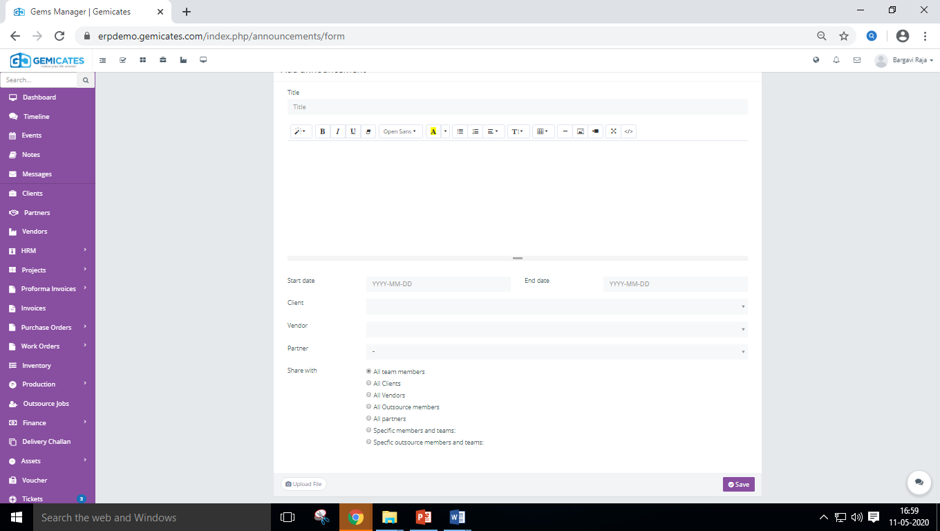 of company rule & regulations

**3.Partner:**

In this module, Partners details has to be filled given, since it has to categorized under groups.

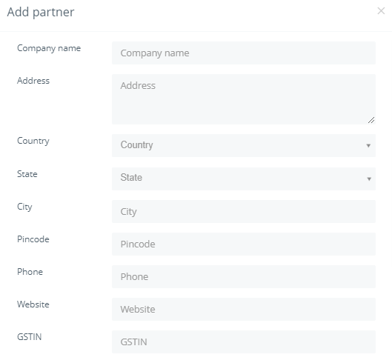

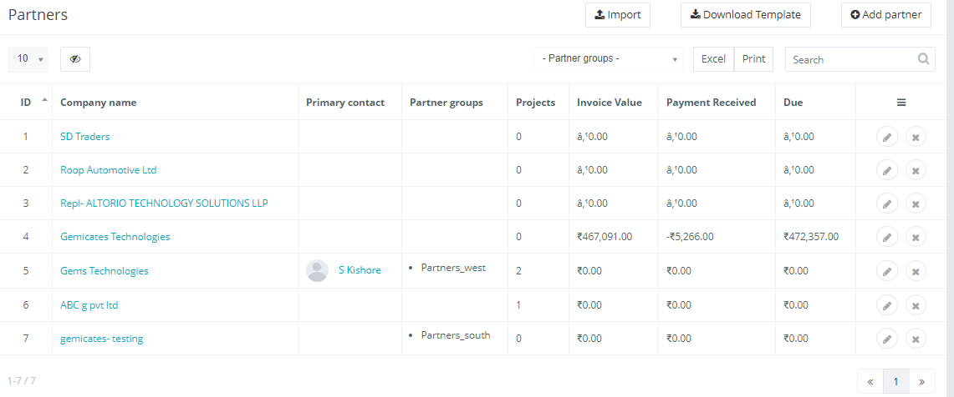

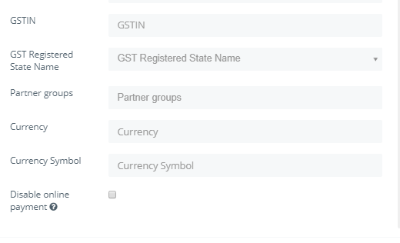

**4.VENDOR:**

The same as per Partner portal only, vendor groups are to be specified and created & updated for saving purpose in portal.

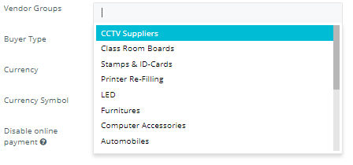

5.ASSETS:

IN this it such as name, It HAS BEEN “Assets “ named, so the comaonies most Confedintail things are to be noted & saved in that.

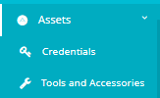

**Credentials:**

**The storage of User name & password in the System to be used & stored For some usage.**

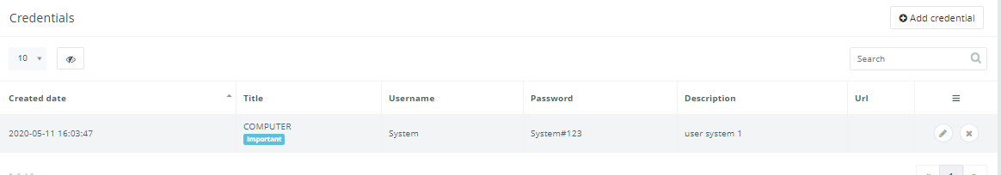

TOOLS And Accessories:

For the Maintence of up keeping stock list for recording purpose & updation in system.

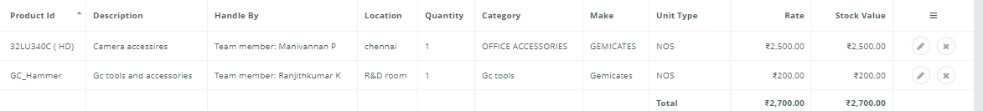

Delivery challan:

**Delivery challan is used to track the items which are delivered without invoice. But the items has been delivered by the site persons.**

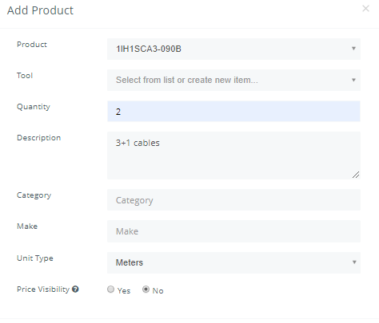

Delivery challan to be previewed a can be modified as Returned & sold, returned, modifed

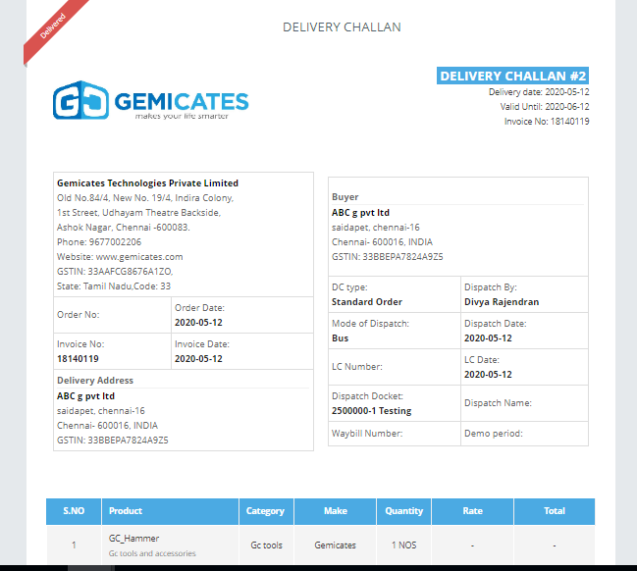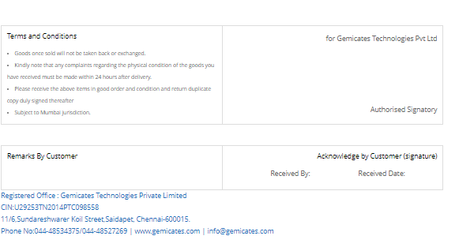

HRM:

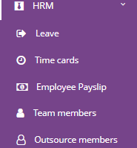

HRM::- Human resource management” record of details of each individual Members –

**like-log in, log out, (Time cards),Total hours Of worked :**

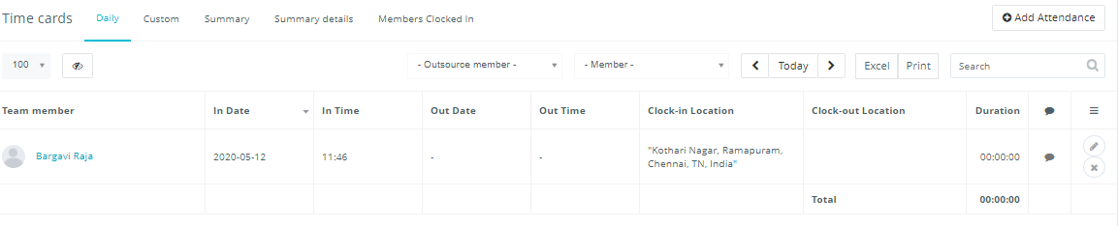

Leave:- to be applied before leave taken & approved by TL & Admin team. With the Types of leave specifically leave.

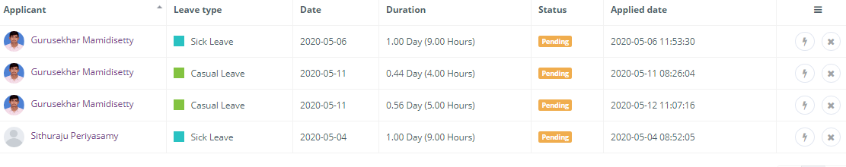

**Employee payslip:**

The Payslip will be Generated on the basis day hours worked, calculated day on basis worked. It will be bases on the date it will be auto generated with the Serailno, number

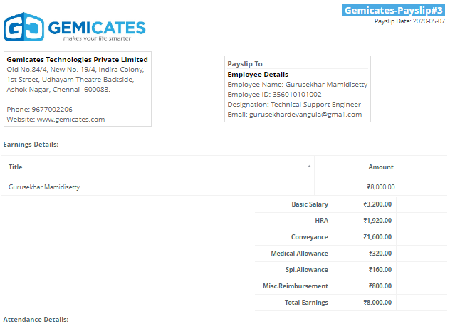

Team Members &Outsource members:

Team Members: is the list of members which are details given individually with the below with the systemized record,To be noted.

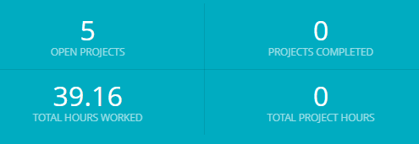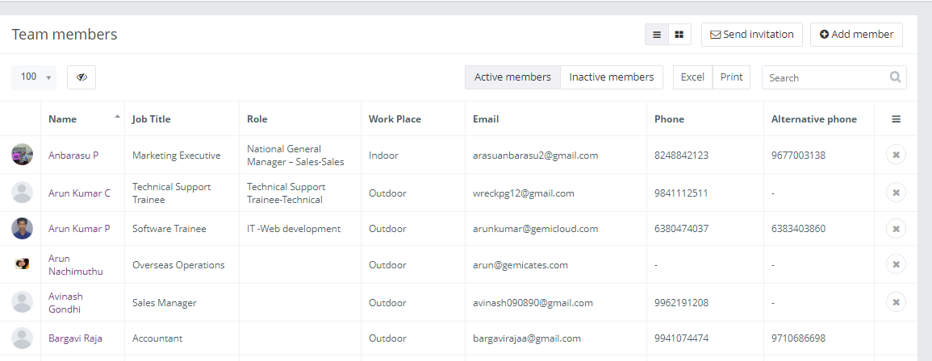

OUTSOURCE member’s:

Its details of other people other than company for systematic use.

