Project Development Phase
Model Performance Test

Date | 30 September 2026
Team ID | MKU201Team26ab4da31a238dc999eb5cc00
Project Name | Streamlining IT Procurement: Automating Standard Laptop Orders with Flow Designer
Maximum Marks

Model Performance Testing:
Project team shall fill the following information in model performance testing template.
S.No. | Parameter | Values | Screenshot
 | Model Summary | Automation model for standard laptop procurement: a ServiceNow Flow Designer flow (“Standard Laptop Task”) triggered from the Service Catalog that creates a Catalog Task and assigns it to the Hardware group. Rule-based – no trained ML model. | 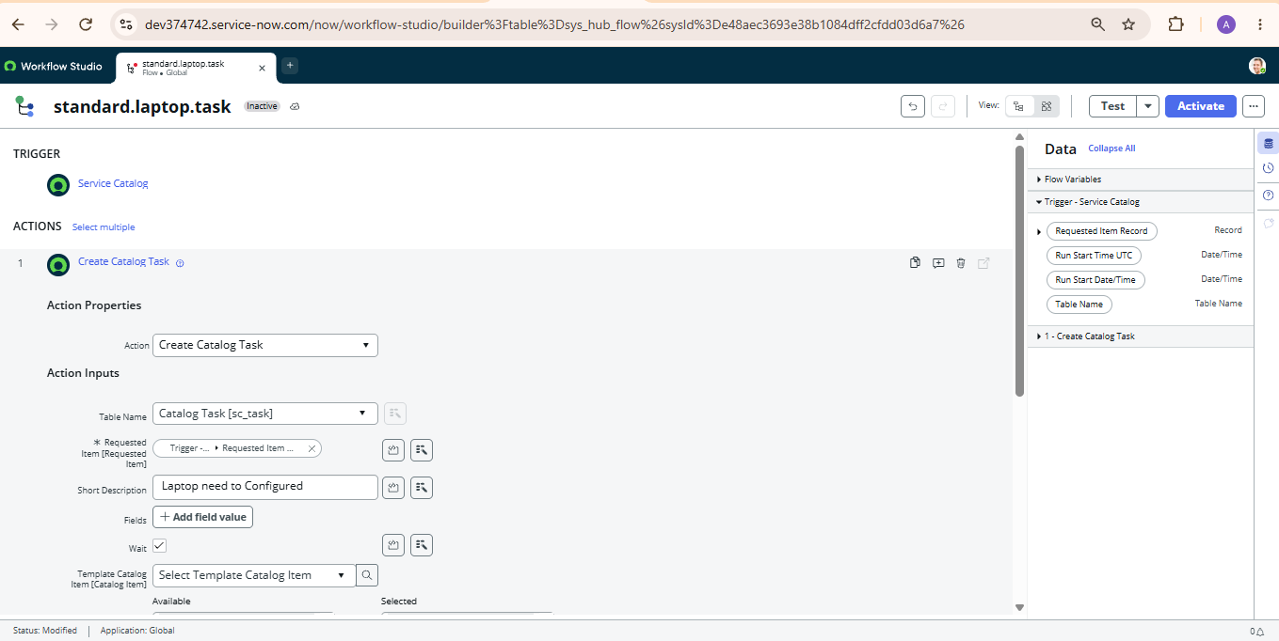
 | Accuracy | Training Accuracy - Not applicable (no training; rule-based flow)  Validation Accuracy - 100% (1 of 1 test order generated the expected Catalog Task) | 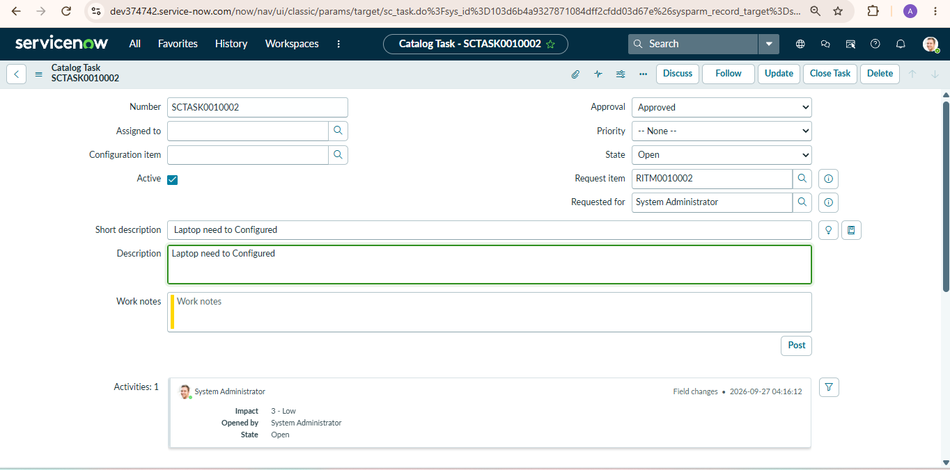
3. | Fine Tunning Result( if Done) | Validation Accuracy - 100% – after assigning the flow to the Standard Laptop catalog item (Process Engine → Flow), the approved order created the task with the expected Short Description and Assignment Group. | 