Ideation Phase
Define the Problem Statements
Date | 30 September 2026
Team ID | MKU201Team26ab4da31a238dc999eb5cc00
Project Name | Streamlining IT Procurement: Automating Standard Laptop Orders with Flow Designer
Maximum Marks | 2 Marks
Customer Problem Statement Template:
Create a problem statement to understand your customer's point of view. The Customer Problem Statement template helps you focus on what matters to create experiences people will love.
A well-articulated customer problem statement allows you and your team to find the ideal solution for the challenges your customers face. Throughout the process, you’ll also be able to empathize with your customers, which helps you better understand how they perceive your product or service.
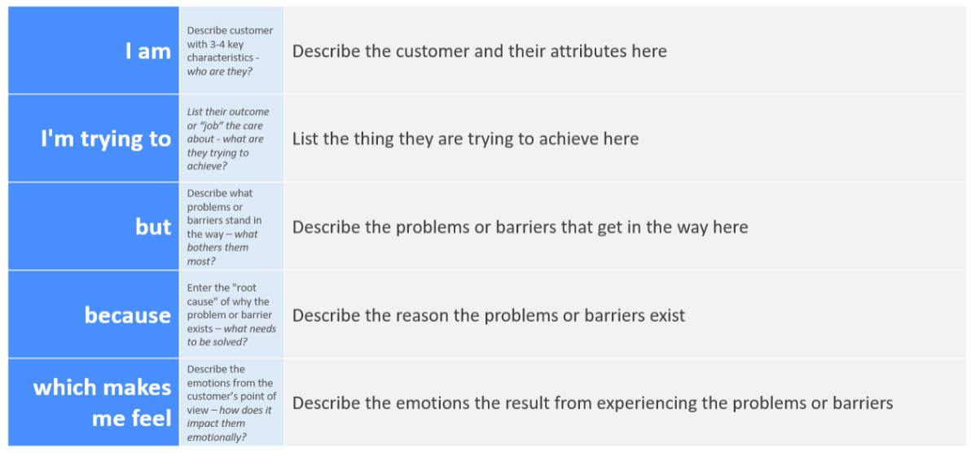
Reference: https://miro.com/templates/customer-problem-statement/
Example:
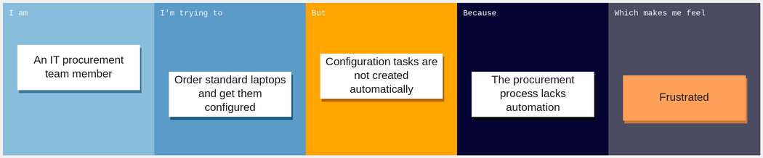
Problem Statement (PS) | I am (Customer) | I’m trying to | But | Because | Which makes me feel
PS-1 | A member of the IT procurement team | Order standard laptops and have them configured promptly on arrival | The configuration task is not automatically created or assigned to Hardware | The process lacks automation, so the configuration step may be overlooked or delayed | Frustrated and concerned about delays and extra manual effort
PS-2 | A user who has requested a standard laptop | Receive a configured laptop without a long waiting time | The laptop is not ready for use because its configuration is delayed | No task is automatically raised for the Hardware team after approval, wasting IT resources | Inconvenienced and dissatisfied with the wait

