Ideation Phase
Empathize & Discover
Date | 30 September 2026
Team ID | MKU201Team26ab4da31a238dc999eb5cc00
Project Name | Streamlining IT Procurement: Automating Standard Laptop Orders with Flow Designer
Maximum Marks | 4 Marks
Empathy Map Canvas:
An empathy map is a simple, easy-to-digest visual that captures knowledge about a user’s behaviours and attitudes.
It is a useful tool to helps teams better understand their users.
Creating an effective solution requires understanding the true problem and the person who is experiencing it. The exercise of creating the map helps participants consider things from the user’s perspective along with his or her goals and challenges.
Example:
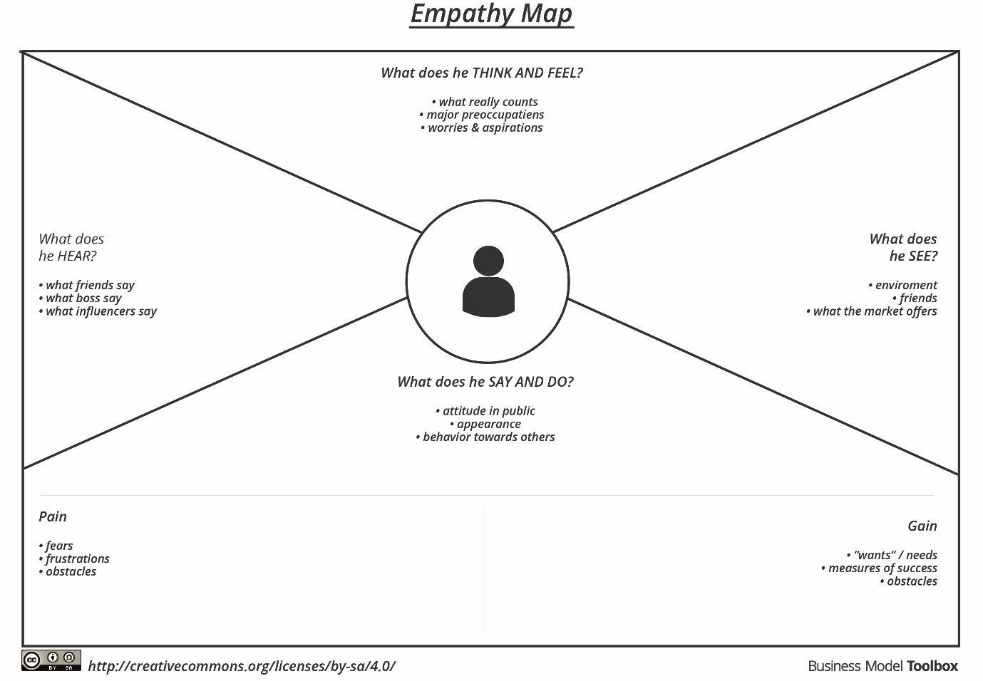
Reference: https://www.mural.co/templates/empathy-map-canvas
Example: Standard Laptop Procurement Automation
