Project Planning Phase
Project Planning Template (Product Backlog, Sprint Planning, Stories, Story points)
Date | 30 September 2026
Team ID | MKU201Team26ab4da31a238dc999eb5cc00
Project Name | Streamlining IT Procurement: Automating Standard Laptop Orders with Flow Designer
Maximum Marks | 5 Marks
Product Backlog, Sprint Schedule, and Estimation (4 Marks)
Use the below template to create product backlog and sprint schedule
Sprint | Functional Requirement (Epic) | User Story Number | User Story / Task | Story Points | Priority | Team Members
Sprint-1 | Flow | USN-1 | As an IT procurement team member, I can create a new flow named "Standard Laptop Task" in Flow Designer (Global application, Run As: System User) with Service Catalog as the trigger. | 5 | High
Sprint-1 |  | USN-2 | As an IT procurement team member, I can add the Create Catalog Task action and map the Requested Item Record to the Request Item field. | 5 | High
Sprint-1 |  | USN-3 | As an IT procurement team member, I can set the Short Description and Description as "Laptop need to be Configured". | 3 | High
Sprint-1 |  | USN-4 | As an IT procurement team member, I can assign the task to the Hardware group and set the Approval value as Approved. | 4 | High
Sprint-1 |  | USN-5 | As an IT procurement team member, I can save and activate the flow. | 3 | High
Sprint-2 | Flow Assignment | USN-6 | As an IT procurement team member, I can open Maintain Items and select the Standard Laptop catalog item. | 5 | High
Sprint-2 |  | USN-7 | As an IT procurement team member, I can remove the existing automation configurations in the Process Engine section and select Flow as the process option. | 8 | High
Sprint-2 |  | USN-8 | As an IT procurement team member, I can add the "Standard Laptop Task" flow and save the catalog item configuration. | 7 | High
Sprint-3 | Service Catalog | USN-9 | As a user, I can open Service Catalog > Hardware, select Standard Laptop, click Order Now and check the order status and Request Number. | 4 | High
Sprint-3 |  | USN-10 | As an approver, I can open the Approvers section of the request and approve the request. | 4 | High
Sprint-3 |  | USN-11 | As a Hardware team member, I can see a Catalog Task automatically created under the Catalog Tasks section of the Requested Item. | 6 | High
Sprint-3 |  | USN-12 | As an IT procurement team member, I can verify the created task shows the updated Short Description and Assignment Group. | 6 | Medium
Project Tracker, Velocity & Burndown Chart: (4 Marks)
Sprint | Total Story Points | Duration | Sprint Start Date | Sprint End Date (Planned) | Story Points Completed (as on Planned End Date) | Sprint Release Date (Actual)
Sprint-1 | 20 | 6 Days | 05 Oct 2026 | 10 Oct 2026
Sprint-2 | 20 | 6 Days | 12 Oct 2026 | 17 Oct 2026
Sprint-3 | 20 | 6 Days | 19 Oct 2026 | 24 Oct 2026
Velocity:
Our sprint duration is 6 days, and the velocity of the team is 20 (points per sprint). Let’s calculate the team’s average velocity (AV) per iteration unit (story points per day)
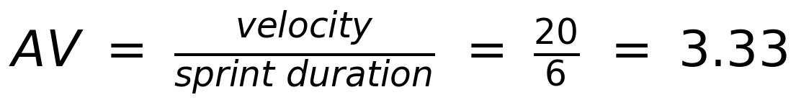
Burndown Chart:
A burn down chart is a graphical representation of work left to do versus time. It is often used in agile software development methodologies such as Scrum. However, burn down charts can be applied to any project containing measurable progress over time.
https://www.visual-paradigm.com/scrum/scrum-burndown-chart/
https://www.atlassian.com/agile/tutorials/burndown-charts
Reference:
https://www.atlassian.com/agile/project-management
https://www.atlassian.com/agile/tutorials/how-to-do-scrum-with-jira-software
https://www.atlassian.com/agile/tutorials/epics
https://www.atlassian.com/agile/tutorials/sprints
https://www.atlassian.com/agile/project-management/estimation
https://www.atlassian.com/agile/tutorials/burndown-charts

