Project Development Phase
Model Performance Test

Date | 30 September 2026
Team ID | MKU201Team26ab4da31a238dc999eb5cc00
Project Name | Streamlining IT Procurement: Automating Standard Laptop Orders with Flow Designer
Maximum Marks

Model Performance Testing:
Project team shall fill the following information in model performance testing template.
S.No. | Parameter | Values | Screenshot
 | Model Summary | ServiceNow automation setup for IT procurement using Flow Designer, Service Catalog and Catalog Tasks.  Note : A Standard Laptop request ordered from the Service Catalog and approved automatically creates a Catalog Task that is assigned to the Hardware team. | 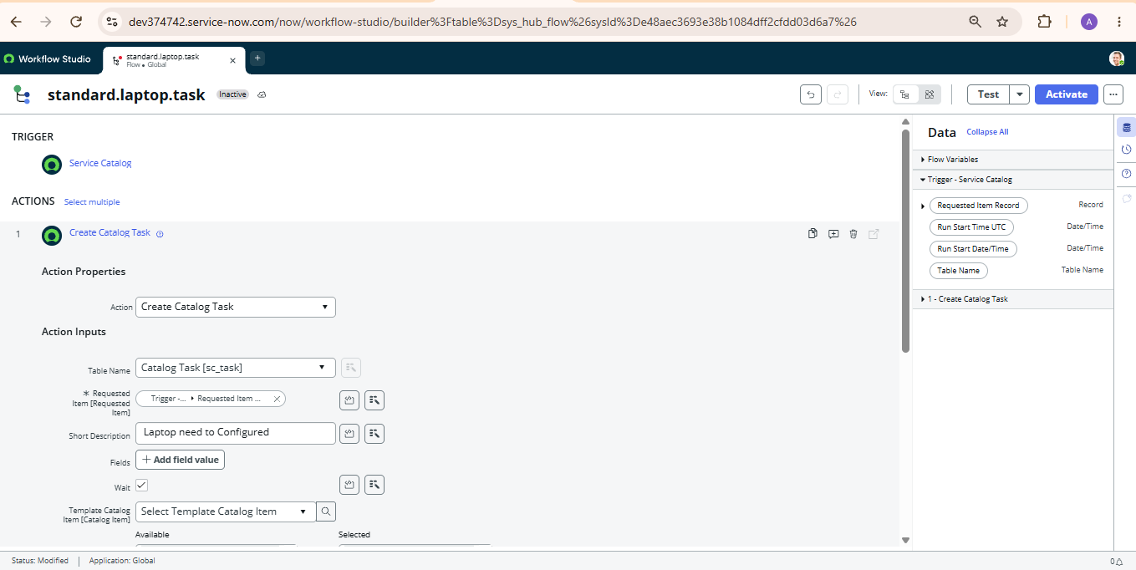
 | Accuracy | Training Accuracy - Not applicable (rule-based flow)  Validation Accuracy - 100% (1 of 1 test order) | 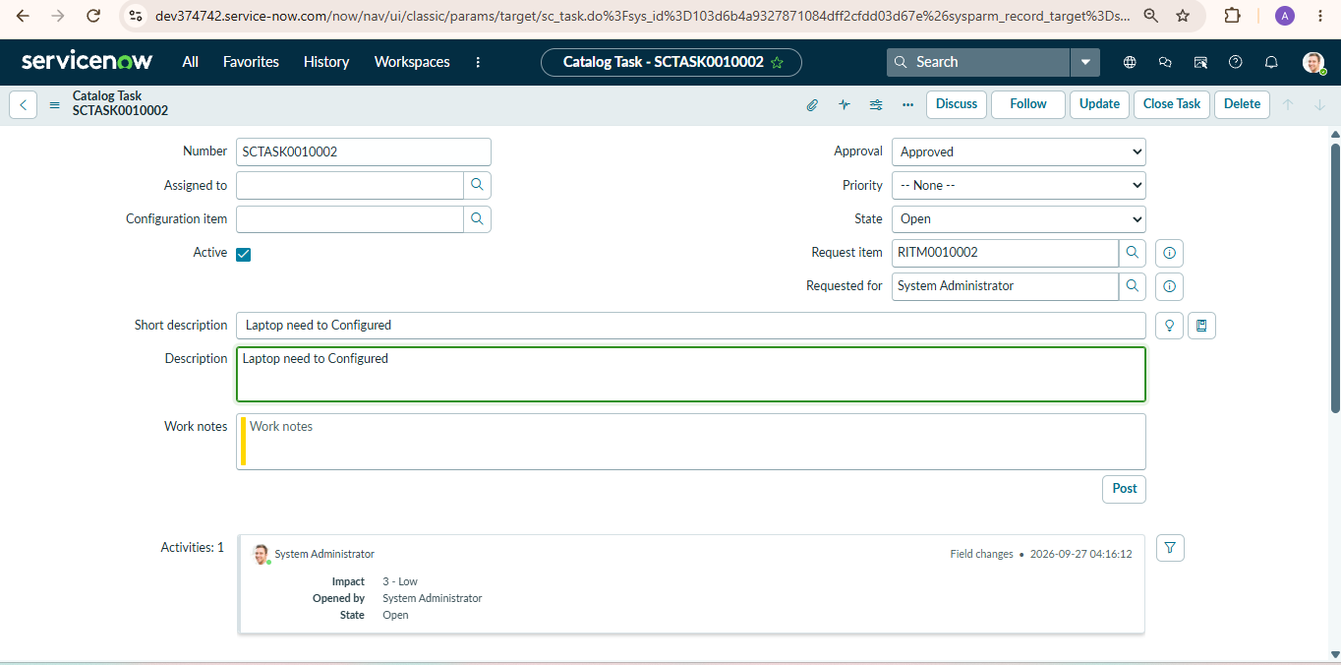
3. | Confidence Score (Only Yolo Projects) | Class Detected - Catalog item “Standard Laptop” (Hardware category) detected and mapped to the “Standard Laptop Task” flow  Confidence Score - 100% – the expected Catalog Task (SCTASK0010002) was generated for the approved request | 