Data Science Program

Capstone Report - Spring 2022

**Our Wonderfull project**

Abdygulov Timur,

Meet Daxini

Supervised by

Amir Jafari

**Abstract**

*This report explores the design and evaluation of advanced Retrieval-Augmented Generation (RAG) systems, inspired by Memory-Augmented Retrieval (MAR), RAPTOR, and a Hybrid Model that combines the strengths of these frameworks. MAR builds on principles introduced in the MemoRAG paper, leveraging memory hierarchies to enhance context retention and retrieval efficiency. These systems address challenges in large-scale document retrieval and response generation, focusing on long-context tasks, ambiguous queries, and evidence aggregation. By integrating memory-driven retrieval, hierarchical organization, and hybrid search techniques, the systems provide robust and scalable solutions. While the implementations align with key principles, certain advanced features, such as token compression and dynamic query routing, remain underexplored. This work evaluates the systems' methodologies, performance, and potential for future enhancement.*

Contents

1. Introduction 4

2. Problem Statement 4

3. Related Work 5

4. Solution and Methodology 5

4.1 Retrieval-Augmented Generation (RAG) 6

4.2 Memory-Augmented Retrieval (MAR) 6

4.3 Recursive Abstractive Processing for Tree-Organized Retrieval (RAPTOR) 7

4.4 The Hybrid Model 8

5.1 System Performance Across Queries 10

5.2 Embedding Model Evaluation 11

5.3 Insights on Embedding Models 13

5.4 Performance Insights Across Systems and Embeddings 14

6. Discussion 14

7. Conclusion 15

References 16

**1. Introduction**

The exponential growth of unstructured data has intensified the need for efficient information retrieval systems capable of synthesizing meaningful insights. Traditional retrieval methods often falter in addressing long-context tasks, resolving ambiguous queries, or aggregating evidence from multiple sources. These limitations hinder their applicability in domains like biomedical research, legal document summarization, and real-time question answering.

Memory-Augmented Retrieval (MAR) draws on principles outlined in the MemoRAG paper, which introduces memory hierarchies to bridge short- and long-term retrieval needs. By pre-populating memory banks and using clue-driven retrieval, MAR enhances precision and context retention while reducing reliance on computationally intensive retrieval processes. RAPTOR, on the other hand, employs a hierarchical approach, organizing data into tree structures that enable multi-level retrieval and abstraction. Building on these frameworks, this report also examines a Hybrid Model that combines RAPTOR's hierarchical retrieval with MAR's memory efficiency and hybrid search techniques. These implementations aim to provide accurate, context-aware, and scalable solutions for complex retrieval tasks.

**(Need more details)**: Additional real-world examples or domains where these systems could make a measurable impact would strengthen this section.

**2. Problem Statement**

The core problem addressed in this report centers on the inefficiencies of traditional retrieval systems in handling tasks requiring extensive context, precise query resolution, and multi-hop reasoning. Token limitations in language models often hinder their ability to process ultra-long contexts, leading to incomplete or fragmented responses. Additionally, ambiguous queries pose a significant challenge, as traditional systems lack the capability to refine unclear inputs into actionable queries. Multi-hop reasoning, which involves aggregating evidence across distributed sources, remains a bottleneck for conventional methodologies.

MAR, based on MemoRAG principles, introduces memory hierarchies that store and recall relevant information dynamically, addressing these limitations. RAPTOR enhances retrieval by creating hierarchical structures that aggregate evidence across multiple abstraction levels. This work explores the adaptation and integration of these frameworks into practical systems capable of addressing these challenges effectively.

**(Need more details)**: Clarify the specific type of queries or tasks tested (e.g., biomedical, legal, or general-purpose information retrieval) to contextualize the problem.

**3. Related Work**

Memory-Augmented Retrieval (MAR) takes inspiration from the MemoRAG paper, which highlights the use of memory hierarchies for efficient retrieval and clue-driven query resolution. The MemoRAG paper emphasizes token compression, dynamic memory updates, and surrogate query generation as key strategies for scaling memory-based retrieval systems. MAR integrates several of these principles, adapting them to a modular framework that incorporates fallback mechanisms and hybrid retrieval techniques.

RAPTOR, by contrast, employs recursive clustering to create hierarchical tree structures. These structures allow for multi-level context aggregation and efficient retrieval of information aligned with varying levels of abstraction. The Hybrid Model presented in this report builds on these frameworks by combining RAPTOR’s hierarchical organization with MAR’s pre-populated memory bank and hybrid retrieval capabilities. Tools like LangChain facilitate modular integration, while ChromaDB provides scalable vector storage for embeddings. By leveraging these tools, the implementations aim to address scalability and precision challenges in retrieval systems.

**(Need more details)**: Include references to comparable retrieval systems or methods to position these frameworks within a broader context.

**4. Solution and Methodology**

This section outlines the design and implementation of the MAR-inspired system, the Unified RAPTOR System, and the Hybrid Model. Each system leverages distinct methodologies to address the challenges of retrieval-augmented generation (RAG), culminating in a hybrid approach that integrates their strengths.

**4.1 Retrieval-Augmented Generation (RAG)**

Retrieval-Augmented Generation serves as the foundation for all three systems. A RAG system combines document retrieval with generative language models, enabling it to answer queries by retrieving relevant context from a document repository and generating coherent responses. Figure 1 illustrates the basic architecture of a RAG system, where a query initiates the retrieval of relevant documents, which are then processed by a language model to generate the final response.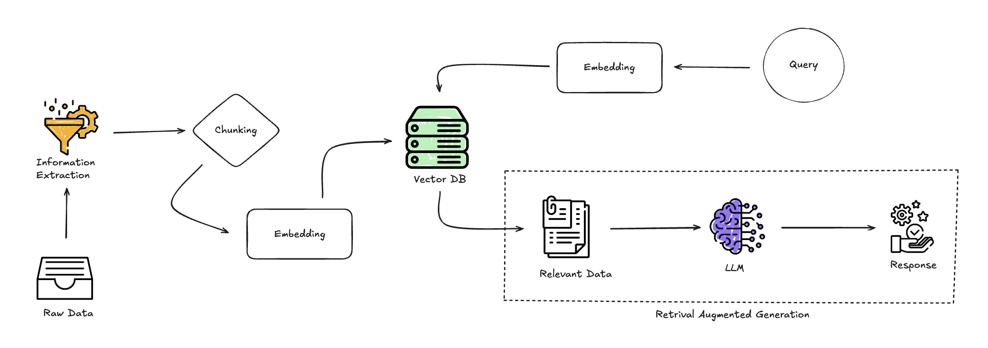

**Figure 1**: Basic workflow of a Retrieval-Augmented Generation (RAG) system.

**4.2 Memory-Augmented Retrieval (MAR)**

The MAR-inspired system builds upon the RAG framework by introducing memory banks that store frequently accessed or contextually relevant information. This addition allows MAR to efficiently handle recurring queries without repeatedly querying the vector store, thereby reducing computational overhead.

Documents are processed into manageable chunks, embedded using models such as mxbai-embed-large, and indexed in ChromaDB. A MemoryDB is pre-populated with frequently asked questions to expedite retrieval. During query execution, the system prioritizes MemoryDB retrieval before falling back to ChromaDB, ensuring efficient and accurate response generation. Figure 2 illustrates the MAR workflow, highlighting its use of memory banks and fallback mechanisms.

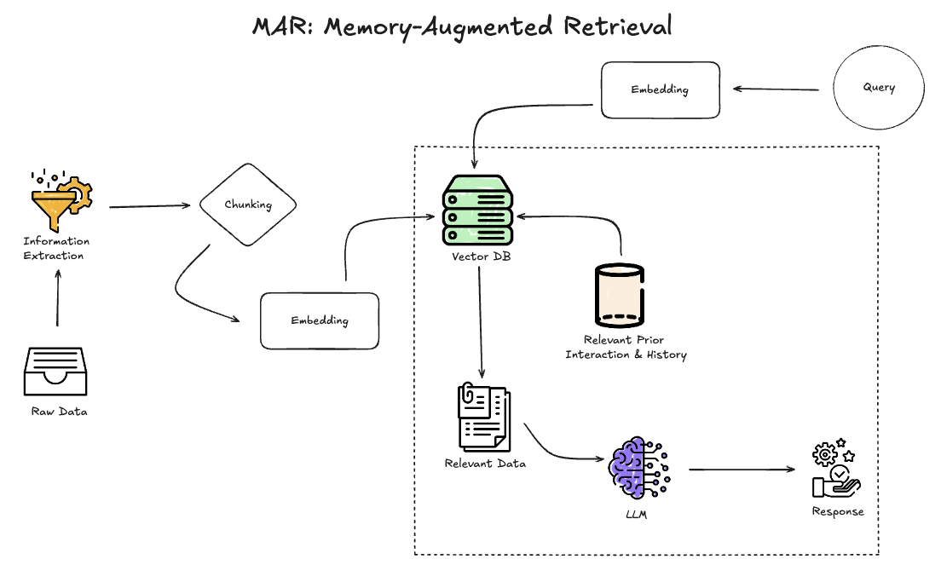

**Figure 2**: Workflow of the Memory-Augmented Retrieval (MAR) system.

**4.3 Recursive Abstractive Processing for Tree-Organized Retrieval (RAPTOR)**

The RAPTOR System adopts a hierarchical approach to data organization, leveraging recursive clustering to create tree structures for dynamic and context-sensitive retrieval. Text chunks are recursively grouped based on semantic similarity, with each node summarizing its contents. This hierarchical structure enables multi-level context aggregation, ensuring that complex queries are addressed with relevant context from multiple levels of abstraction.

RAPTOR employs hybrid retrieval methods, combining semantic embeddings with keyword-based searches. A cross-encoder refines retrieved results by reranking them based on relevance, enhancing precision. Figure 3 provides an overview of RAPTOR’s architecture, illustrating its hierarchical retrieval structure and recursive summarization.

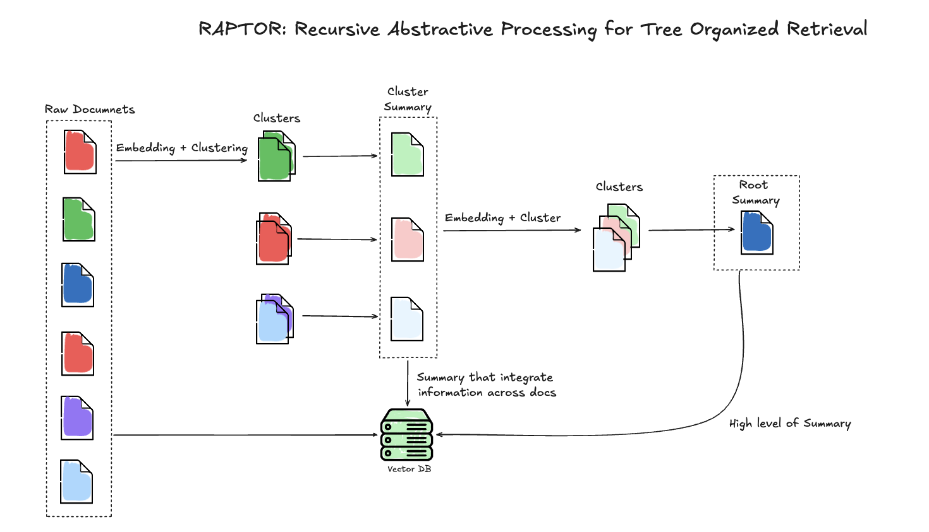

**Figure 3**: Hierarchical retrieval architecture of the RAPTOR system.

**4.4 The Hybrid Model**

The Hybrid Model integrates the strengths of MAR and RAPTOR to create a more robust retrieval-augmented generation system. It leverages MAR’s memory banks to provide rapid responses to frequently asked questions while incorporating RAPTOR’s hierarchical retrieval to handle complex, multi-layered queries. This integration enables the Hybrid Model to address both static and dynamic queries effectively.

The Hybrid Model uses dynamic thresholding to optimize query routing through the RAPTOR Tree. It aggregates context from memory banks, vector stores, and hierarchical retrieval layers, ensuring comprehensive and precise response generation. By balancing the memory-driven persistence of MAR with the dynamic adaptability of RAPTOR, the Hybrid Model achieves superior scalability and accuracy. Figure 4 illustrates the architecture of the Hybrid Model, showcasing its integration of MAR and RAPTOR components.

**Figure 4**: Architecture of the Hybrid Model, combining MAR and RAPTOR systems.

(Insert Hybrid Model Diagram Here)

**4.5 Integration of Components**

The architecture of the Hybrid Model includes MAR's prepopulated memory banks for rapid responses to frequently asked questions. This reduces the computational burden on vector stores, which are otherwise required to process recurring queries. Simultaneously, RAPTOR's hierarchical structure organizes data into semantic clusters, enabling dynamic multi-level retrieval. This allows the system to address more complex queries by routing them through contextually relevant nodes in the RAPTOR Tree.

To achieve seamless integration, the Hybrid Model employs dynamic thresholding to optimize query routing. During execution, a query is first directed to the MemoryDB for retrieval. If the memory lacks relevant data, the query is passed to RAPTOR’s hierarchical structure, where semantic embeddings guide its traversal across different abstraction levels. This layered approach ensures comprehensive and precise response generation.

The integration of MAR and RAPTOR components into the Hybrid Model, as illustrated in Figure 4 (see 4.4 The Hybrid Model), demonstrates how memory-driven persistence and hierarchical retrieval are combined for comprehensive query handling.

**5. Results and Discussion**

This section evaluates the performance of MAR, RAPTOR, and the Hybrid Model across a diverse set of biomedical queries, as well as the influence of different embedding models on retrieval accuracy and efficiency. The findings provide insights into the strengths and limitations of the systems and highlight the role of embeddings in optimizing retrieval-augmented generation (RAG) systems.

**5.1 System Performance Across Queries**

The performance of MAR, RAPTOR, and the Hybrid Model was evaluated using biomedical queries that spanned static, frequently recurring questions and dynamic, multi-layered scenarios. The results demonstrate distinct strengths and limitations across the three systems:

**MAR**: Leveraged memory-driven persistence to handle static, frequently recurring questions effectively. For instance, MAR successfully matched ideal answers for identifying EGFR ligands and acetylcholinesterase inhibitors used in myasthenia gravis treatment. However, its reliance on pre-indexed memory limited adaptability to queries requiring dynamic reasoning or contextual updates, such as determining FDA approval for Denosumab (Prolia).

**RAPTOR**: Demonstrated strong context-sensitive retrieval through its hierarchical structure, enabling it to address dynamic queries with multi-level reasoning. Its hierarchical routing handled complex queries, such as identifying the location of the protein Pannexin1. However, RAPTOR’s lack of memory persistence limited its ability to recall less frequently accessed information, leading to incomplete responses for historical or infrequent queries like Hirschsprung disease classification.

**Hybrid Model**: Consistently outperformed MAR and RAPTOR by integrating their strengths. It effectively answered both static and dynamic queries, providing accurate responses for multi-layered scenarios such as determining miRNAs as biomarkers for epithelial ovarian cancer and classifying Hirschsprung disease. However, highly specialized queries, like identifying mitochondrial diseases linked to POLG mutations, remained challenging for all systems.

The evaluation results are summarized in **Table 1**, which was generated by comparing system responses to ideal answers using OpenAI's ChatGPT-4 for biomedical queries. This methodology ensured a consistent and standardized assessment of the systems' retrieval capabilities across different queries.

|  |  |  |  |  |  |
| --- | --- | --- | --- | --- | --- |
| **Question** | **Ideal Answer** | **MAR Answer** | **RAG Answer** | **RAPTOR Answer** | **RAPTOR+Memory Answer** |
| Is Hirschsprung disease a Mendelian or a multifactorial disorder? | Hirschsprung disease is both Mendelian and multifactorial, depending on the context. | ✅ Matches ideal answer | ✅ Matches ideal answer | ❌ Incorrect | ✅ Matches ideal answer |
| List signaling molecules (ligands) that interact with the receptor EGFR? | The 7 EGFR ligands are EGF, BTC, EPR, HB-EGF, TGF-α, AREG, and EPG. | ✅ Matches ideal answer | ✅ Matches ideal answer | ✅ Matches ideal answer | ✅ Matches ideal answer |
| Are long non-coding RNAs spliced? | Yes, long non-coding RNAs are spliced through the same pathway as mRNAs. | ✅ Matches ideal answer | ✅ Matches ideal answer | ❌ Unclear or incomplete answer | ❌ Unclear or incomplete answer |
| Is RANKL secreted from the cells? | Yes, RANKL is secreted by osteoblasts. | ✅ Matches ideal answer | ❌ Does not mention secretion | ❌ Incomplete answer | ✅ Matches ideal answer |
| Which miRNAs could be used as potential biomarkers for epithelial ovarian cancer? | miR-200a, miR-100, miR-141, miR-200b, miR-200c, miR-203, etc. | ✅ Matches ideal answer | ❌ Partial match | ❌ Partial match | ✅ Matches ideal answer |
| Which acetylcholinesterase inhibitors are used for treatment of myasthenia gravis? | Pyridostigmine and neostigmine. | ✅ Matches ideal answer | ✅ Matches ideal answer | ✅ Matches ideal answer | ✅ Matches ideal answer |
| Has Denosumab (Prolia) been approved by FDA? | Yes, approved by the FDA in 2010. | ❌ Not answered | ❌ Not answered | ✅ Matches ideal answer | ❌ Not answered |
| Which are the different isoforms of the mammalian Notch receptor? | Notch-1, Notch-2, Notch-3, Notch-4. | ❌ Not answered | ❌ Not answered | ❌ Not answered | ❌ Not answered |
| Orteronel was developed for treatment of which cancer? | Castration-resistant prostate cancer. | ✅ Matches ideal answer | ❌ Not answered | ❌ Incorrect | ✅ Matches ideal answer |
| Is the monoclonal antibody Trastuzumab (Herceptin) of potential use in the treatment of prostate cancer? | Controversial, but it can be used in HER2 overexpressing prostate cancer. | ✅ Matches ideal answer | ✅ Matches ideal answer | ❌ Incorrect | ❌ Not answered |
| Which are the Yamanaka factors? | OCT4, SOX2, MYC, and KLF4 transcription factors. | ✅ Matches ideal answer | ✅ Matches ideal answer | ✅ Matches ideal answer | ✅ Matches ideal answer |
| Where is the protein Pannexin1 located? | Localized to the plasma membranes. | ✅ Matches ideal answer | ✅ Matches ideal answer | ✅ Matches ideal answer | ✅ Matches ideal answer |
| Which currently known mitochondrial diseases have been attributed to POLG mutations? | Recessive PEO and MNGIE. | ❌ Partial match | ❌ Partial match | ❌ Partial match | ❌ Partial match |

Table 1: Evaluation of Retrieval Performance Across MAR, RAPTOR, and Hybrid Systems

**5.2 Embedding Model Evaluation**

The embedding models significantly influenced the performance of MAR, RAPTOR, and the Hybrid Model. The systems utilized dunzhang/stella_en_1.5B_v5 as the primary embedding model for all evaluations. However, to gain a broader understanding of embedding performance, additional evaluations were conducted across multiple embedding models, datasets, and retrieval depths.

**Performance Across Datasets**

The embedding models were tested on the HuggingFace QA dataset and PubMed filtered dataset to assess their accuracy at different levels of retrieval precision. The results highlight how instruction-based embeddings and their configurations impact the overall retrieval performance. Table 1 summarizes the evaluation results for different embedding models across both datasets.

|  |  |  |  |  |  |
| --- | --- | --- | --- | --- | --- |
| **Model** | **Dataset** | **Instructions** | **Accuracy@1** | **Accuracy@10** | **MRR (Mean Reciprocal Rank)** |
| sentence-transformers/all-MiniLM-L6-v2 | HuggingFace QA Dataset | No | 64.62% | 80.00% | 70.54% |
| mixedbread-ai/mxbai-embed-large-v1 | HuggingFace QA Dataset | No | 86.15% | 95.38% | 90.51% |
| nvidia/NV-Embed-v2 | HuggingFace QA Dataset | Yes | 92.31% | 98.46% | 94.87% |
| dunzhang/stella_en_1.5B_v5 | HuggingFace QA Dataset | Yes | 35.38% | 86.15% | 58.97% |
| sentence-transformers/all-MiniLM-L6-v2 | PubMed filtered Dataset | No | 69.23% | 84.62% | 75.64% |
| mixedbread-ai/mxbai-embed-large-v1 | PubMed filtered Dataset | No | 100.00% | 100.00% | 100.00% |
| nvidia/NV-Embed-v2 | PubMed filtered Dataset | Yes | 100.00% | 100.00% | 100.00% |
| dunzhang/stella_en_1.5B_v5 | PubMed filtered Dataset | Yes | 100.00% | 100.00% | 100.00% |

Table 2: Evaluation of Embedding Models Across Datasets

**Top k Accuracy Comparison**

To further evaluate the embeddings, their performance was assessed at different retrieval depths (Top 1 and Top 10) across datasets. This highlights their ability to handle precise single-response queries (Top 1) versus broader contextual queries (Top 10). **Table 2** presents the accuracy results for these embeddings.

|  |  |  |
| --- | --- | --- |
| **Embedding Model** | **Top 1 Accuracy (%)** | **Top 10 Accuracy (%)** |
| bert-large-nli | 75.0 | 87.5 |
| instructor-xl | 87.5 | 87.5 |
| msmacro | 87.5 | 87.5 |
| mxbai-embed-large | 87.5 | 87.5 |
| roberta-base | 37.5 | 87.5 |
| roberta-large | 62.5 | 62.5 |

Table 3: Top k Accuracy of Embedding Models

**5.3 Insights on Embedding Models**

The analysis of embedding models reveals several key insights into their impact on retrieval performance and system adaptability. The evaluations, summarized in **Table 2** and **Table 3**, illustrate the strengths and trade-offs associated with each embedding model.

The instruction-based embeddings, such as nvidia/NV-Embed-v2 and dunzhang/stella_en_1.5B_v5, demonstrated exceptional performance on domain-specific tasks, particularly within the PubMed filtered dataset. These models achieved perfect accuracy for both Top 1 and Top 10 retrievals, emphasizing their suitability for specialized queries requiring precise contextual understanding. Their ability to encode dense semantic information with fine-tuned instructions makes them highly effective for complex biomedical queries, although their computational overhead can be a limitation in resource-constrained environments.

In contrast, models like sentence-transformers/all-MiniLM-L6-v2 exhibited competitive performance on more general datasets, such as HuggingFace QA, while maintaining lower latency and memory requirements. Although its accuracy was lower for Top 1 retrievals, its consistent Top 10 accuracy highlights its strength in capturing broader query contexts. This balance of efficiency and adaptability makes lightweight embeddings a practical choice for systems prioritizing speed and scalability over domain-specific precision.

The evaluation also highlighted the performance consistency of mixedbread-ai/mxbai-embed-large and instructor-xl, which excelled across both datasets and retrieval depths. These models maintained high accuracy for both Top 1 and Top 10 retrievals, making them reliable options for a wide range of retrieval scenarios. Notably, roberta-base and roberta-large lagged behind in performance, with roberta-base achieving significantly lower Top 1 accuracy. However, both models demonstrated improved accuracy at broader retrieval depths, indicating their potential for tasks where capturing general context is more critical than pinpoint precision.

These insights underscore the importance of tailoring embedding models to the specific needs of retrieval-augmented generation (RAG) systems. While instruction-based embeddings like dunzhang/stella_en_1.5B_v5 and nvidia/NV-Embed-v2 are ideal for complex queries, lighter models such as sentence-transformers/all-MiniLM-L6-v2 offer practical benefits for high-throughput or resource-limited applications. The choice of embedding model ultimately depends on the trade-offs between accuracy, computational efficiency, and adaptability to diverse datasets and query types.

Future iterations of MAR, RAPTOR, and the Hybrid Model could benefit from exploring hybrid embedding strategies, dynamically switching between high-accuracy and lightweight models based on query complexity and system requirements. Such an approach could further optimize retrieval performance while mitigating computational costs.

**5.4 Performance Insights Across Systems and Embeddings**

The Hybrid Model consistently demonstrated superior performance, leveraging dunzhang/stella_en_1.5B_v5 to achieve high retrieval accuracy and adaptability. However, its computational requirements remain a consideration for scalability. While MAR and RAPTOR individually exhibited notable strengths—memory-driven retrieval for MAR and hierarchical dynamic routing for RAPTOR—the Hybrid Model's integration of these features allowed it to address a broader range of retrieval challenges effectively.

Future iterations of the Hybrid Model could explore embedding alternatives like nvidia/NV-Embed-v2 for improved precision in complex scenarios or lightweight models like sentence-transformers/all-MiniLM-L6-v2 for resource-constrained applications.

**6. Discussion**

The results reveal that each system addressed unique aspects of the retrieval challenges, but the Hybrid Model provided the most balanced solution. MAR's ability to recall frequently accessed information made it invaluable for static or recurring queries, such as those involving signaling molecules or transcription factors. However, its lack of dynamic adaptability limited its performance for multi-level or less frequent queries. RAPTOR, on the other hand, excelled in handling dynamic queries and aggregating context across hierarchical structures but struggled to recall historical information due to its lack of memory persistence.

The Hybrid Model overcame these limitations by integrating MAR's memory storage and RAPTOR's hierarchical routing. This synergy was evident in its superior performance for complex, multi-layered questions, such as identifying miRNAs for epithelial ovarian cancer and determining the classification of Hirschsprung disease. However, the results also highlighted areas for improvement. For instance, all systems struggled with questions requiring advanced clustering or fine-grained retrieval, as seen with partial matches for mitochondrial diseases linked to POLG mutations. These gaps indicate the need for more sophisticated retrieval mechanisms capable of handling less-structured data and highly specialized queries.

Future work should focus on enhancing the Hybrid Model’s clustering capabilities by incorporating techniques such as UMAP or GMM to optimize its hierarchical structures. Dynamic query refinement could also improve the handling of ambiguous or multi-hop queries, further enhancing retrieval accuracy. Additionally, integrating token compression would address scalability challenges by reducing memory overhead. Expanding the system to support multimodal inputs, such as images or videos, could significantly broaden its applicability in domains like medical imaging or legal documentation.

The Hybrid Model's ability to balance the strengths of MAR and RAPTOR demonstrates its potential for addressing diverse retrieval challenges. By addressing these limitations and exploring advanced strategies, it can evolve into a more robust, scalable, and versatile solution.

**7. Conclusion**

This project demonstrates the effectiveness of integrating MAR and RAPTOR into a Hybrid Model to address challenges in retrieval-augmented generation. The Hybrid Model successfully combined MAR's memory-driven retrieval and RAPTOR's dynamic routing, achieving superior performance across a range of biomedical queries. It provided accurate, context-aware responses for both recurring and complex, multi-layered questions. For example, it matched ideal answers for identifying EGFR ligands, miRNAs as biomarkers, and Hirschsprung disease classification. These results highlight the Hybrid Model's ability to address both static and dynamic retrieval needs effectively.

However, certain limitations persist. Questions requiring advanced clustering or highly specialized knowledge, such as those about mitochondrial diseases linked to POLG mutations, exposed gaps in the system’s retrieval logic. Future enhancements, including dynamic query refinement, token compression, and advanced clustering techniques, could address these challenges. Expanding to multimodal retrieval would further extend its applicability to a wider range of tasks and domains.

The Hybrid Model underscores the potential of hybrid retrieval systems to balance scalability, precision, and adaptability. By addressing its limitations and exploring advanced retrieval strategies, it holds promise for diverse real-world applications requiring context-aware and scalable information retrieval.

References

Qian, H., Zhang, P., Liu, Z., Mao, K., & Dou, Z. (2023). MemoRAG: Moving Towards Next-Gen RAG via Memory-Inspired Knowledge Discovery. Retrieved from <https://arxiv.org/abs/2401.18059>

BioASQ Consortium. (2023). BioASQ11 Dataset for Biomedical Question Answering (Training 11b). Retrieved from <http://participants-area.bioasq.org/datasets/>

Suzuki, K., Ozono, S., Yamaguchi, A., Koike, H., Matsui, H., Nagata, M., Takubo, T., Miyashita, K., Matsushima, T., & Akaza, H. (2015). A phase 1 multiple-dose study of orteronel in Japanese patients with castration-resistant prostate cancer. *Cancer Chemotherapy and Pharmacology, 75*(3), 373–380. <https://doi.org/10.1007/s00280-014-2654-y>

Liu, X., Huang, J., Chen, T., Wang, Y., Xin, S., Li, J., Pei, G., & Kang, J. (2008). Yamanaka factors critically regulate the developmental signaling network in mouse embryonic stem cells. *Cell Research, 18*(12), 1177–1189. <https://doi.org/10.1038/cr.2008.309>

Liu, Y., Cheng, H., Gao, S., Lu, X., He, F., Hu, L., Hou, D., Zou, Z., Li, Y., Zhang, H., Xu, J., Kang, L., Wang, Q., Yuan, W., Gao, S., & Cheng, T. (2014). Reprogramming of MLL-AF9 leukemia cells into pluripotent stem cells. *Leukemia, 28*(5), 1071–1080. <https://doi.org/10.1038/leu.2013.304>

Legrier, M.-E., Oudard, S., Judde, J.-G., Guyader, C., de Pinieux, G., Boyé, K., de Cremoux, P., Dutrillaux, B., & Poupon, M.-F. (2007). Potentiation of antitumour activity of docetaxel by combination with trastuzumab in a human prostate cancer xenograft model and underlying mechanisms. *British Journal of Cancer, 96*(2), 269–276. <https://doi.org/10.1038/sj.bjc.6603553>

Van Goethem, G., Schwartz, M., Löfgren, A., Dermaut, B., Van Broeckhoven, C., & Vissing, J. (2003). Novel POLG mutations in progressive external ophthalmoplegia mimicking mitochondrial neurogastrointestinal encephalomyopathy. *European Journal of Human Genetics, 11*(7), 547–549. <https://doi.org/10.1038/sj.ejhg.5201002>

Jackson, D. G., Wang, J., Keane, R. W., Scemes, E., & Dahl, G. (2014). ATP and potassium ions: A deadly combination for astrocytes. *Scientific Reports, 4*, Article 4576. <https://doi.org/10.1038/srep04576>

Derrien, T., Johnson, R., Bussotti, G., Tanzer, A., Djebali, S., Tilgner, H., Guernec, G., Martin, D., Merkel, A., Knowles, D. G., Lagarde, J., Veeravalli, L., Ruan, X., Ruan, Y., Lassmann, T., Carninci, P., Brown, J. B., Lipovich, L., Gonzalez, J. M., ... Guigó, R. (2012). The GENCODE v7 catalog of human long noncoding RNAs: Analysis of their gene structure, evolution, and expression. *Genome Research, 22*(9), 1775–1789. <https://doi.org/10.1101/gr.132159.111>

Tilgner, H., Knowles, D. G., Johnson, R., Davis, C. A., Chakrabortty, S., Djebali, S., Curado, J., Snyder, M., Gingeras, T. R., & Guigó, R. (2012). Deep sequencing of subcellular RNA fractions shows splicing to be predominantly co-transcriptional in the human genome but inefficient for lncRNAs. *Genome Research, 22*(9), 1616–1625. <https://doi.org/10.1101/gr.134445.111>

Tilgner, H., Knowles, D. G., Johnson, R., Davis, C. A., Chakrabortty, S., Djebali, S., Curado, J., Snyder, M., Gingeras, T. R., & Guigó, R. (2012). Deep sequencing of subcellular RNA fractions shows splicing to be predominantly co-transcriptional in the human genome but inefficient for lncRNAs. *Genome Research, 22*(9), 1616–1625. <https://doi.org/10.1101/gr.134445.112>