**TECHNICAL REPORT ON STUDENT INDUSTRIAL WORK EXPERIENCE SCHEME (SIWES)**

**CARRIED OUT AT**

**DANGOTE SUGAR REFINERY, SAVANNA,**

**NUMAN, ADAMAWA STATE**

**FROM: 4TH JANUARY, 2023**

**TO: 4TH MAY, 2023**

**BY**

**YUSUF GUBI YAKUBU**

**ST/CS/ND/21/081**

**SUBMITTED TO**

**THE DEPARTMENT OF COMPUTER SCIENCE**

**SCHOOL OF SCIENCE AND TECHNOLOGY**

**FEDERAL POLYTECHNIC MUBI**

**IN PARTIAL FULFILLMENT FOR THE AWARD OF NATIONAL DIPLOMA (ND) IN COMPUTER SCIENCE**

**JUNE, 2023**

**DEDICATION**

I dedicate this report to the Almighty God for the guidance and protection accorded me throughout the programme.

# ACKNOWLEDGMENTS

I thank God Almighty for making me to undergo students industrial work experience scheme (SIWES) successfully.

My gratitude goes to my parent for their prayers, financial and moral support during my attachment.

I also appreciate the kind gesture of my brothers and sisters and those who supports me in prayers and contribution during my industrial attachment.

I whole heartedly thank my Head of department Mallam Adamu Garba Mubi, SIWES coordinator and all lectures of Computer Science for their effort to ensure my success as their students.

I am greatly indebted to my co-SIWES students to mention, may God strengthen our relationship together and grant us academic excellence.

I sincerely thank you all for your contribution and support.

**ABSTRACT**

*The report summarizes the result of work done during my SIWES experience, the technical report consists of four chapters, which comprises of introduction, history and criteria’s of SIWES in chapter one followed by their aims and objectives, historical background, organizational structure of the organization in chapter two, while chapter three consist of the work and experience gained during the SIWES programme and lastly chapter four consist of the summary, conclusions and recommendation.*

**Table of Contents**

**Title page - - - - - - - - - - i**

**Approval page - - - - - - - - ii**

**Dedication - - - - - - - - - - iii**

**Abstract - - - - - - - - - - iv**

**CHAPTER ONE**

1.0 Introduction - - - - - - - - - 1

1.1 Background of SIWES - - - - - - - 1

1.2 Brief History of SIWES - - - - - - - 1

1.3 Aims and Objectives of SIWES - - - - - - 2

**CHAPTER TWO**

2.1 Brief History of the Organization. - - - - - - 3

2.2 The Objective of the Organization. - - - - - - 3

2.3 Organizational Chart - - - - - - - - 3

**CHAPTER THREE**

3.1 Introduction to Networking - - - - - - - 5

3.2 Network Bandwidth - - - - - - - - 12

3.3 Transmission Media - - - - - - - - 13

**CHAPTER FOUR**

4.1 Summary - - - - - - - - - 21

4.2 Conclusion - - - - - - - - - 21

4.3 Problems - - - - - - - - - 21

4.4 Recommendations - - - - - - - - 22

REFERENCES - - - - - - - - - 23

**CHAPTER ONE**

1. **INTRODUCTION**

The concept behind industrial training schemes is to acquire practical, knowledge in addition to what has been learn institution. The four months mandatory supervised industrial attachment is program instituted by the federal government to help student for their different field of studies.

* 1. **BACKGROUND OF SIWES**

It aims at exposing student to the practical and the actualization of work situation which they may meet after graduation and the learning is meanly expected to produce graduate qualification to meet man power of employments of (ITF), there was growing concern amount the industrialist that graduate of higher learning do not passes adequate background student for the opinion that theoretical education going higher institution was responsive enough to meet the need of employers of the labour as a requirement of national board for technical education (NBTE) polytechnic training before obtaining the National Diploma (ND).

Experience scheme (SIWES), is a National programme introduced by Government in 1974 for student in tertiary institution.

### 1.2 BRIEF HISTORY OF SIWES

**SIWES** was established by **ITF** in 1973 to solve the problem of lack of adequate practical skills preparatory for employment in industries by Nigerian graduates of tertiary institutions.

The program “Student industrial work experience scheme” is a pure skill-acquisition program structured for the tertiary institutions as a complementary and enhancement program to the theoretical education, laboratory and workshop practices engaged in by student in different higher institutions. The SIWES was initiated to improve the student’s technical abilities (performance/knowledge) and expose them to industrial culture thereby preparing them to be acquainted with the roles to play towards the technological advancement of the nation.

It is there for a practical aspect of the academic works, which the students may not be opportune to carry out throughout their stay in the higher institutions. Based on this fact, the Federal Government decided to establish a body (regulatory) which engages in the training of the technical manpower. The body is named industrial Training Fund (ITF). The government also undertook to make up for the deficiencies by structuring and established Students Industrial Training (SIT) as it was then called but in 1973 the SIWES was formed which is the subsidiary.

### 1.3 AIMS AND OBJECTIVES OF SIWES

1. One of the objectives of SIWES is to create an avenue for students to acquire industrial skills to complement their theoretical knowledge and improve their experiences in their course of study.
2. The program prepares the students for industrial working conditions prior to their graduation.
3. To enable the students to learn personal relationship with employers and co-employees on graduation.
4. It exposes the student to working methods and techniques in handling equipment and machinery.
5. It develops the student in make critical and realistic approaches to solving problem.
6. It serves as a way of improving the abilities of the students and to contribute to the growth of the nation.
7. It gives the students the opportunity to practice what they have been taught in various disciplines.
8. The SIWES program strengthens the employer’s involvement in preparing the students for employment.

**CHAPTER TWO**

**2.1 BRIEF HISTORY OF DANGOTE SUGAR REFINERY**

The Dangote Sugar Company (D S C) was established I the early 1970s by Federal Government Nigeria. The company was acquired by Dangote Industrials Limited (DIL) from Bureau of public Enterprises (B P E) in 2003 but was official handed over to Dangote Industrial Limited in 2004. It has an installed capacity of 50,000 metric tunes of Sugar; But presently Utilized capacity stands of 29,080 metric tunes of Sugar. Dangote Industrial Limited is sitting on 32,000 hectares of lands in Numan, Adamawa State Nigeria. With about 7,182 heaters presently under cane (planted).

## 2.1 Organizational Chart of Dangote Sugar Company (DSC)

General Managing Director

Managing Director

Human Resource

Admin Manager

Head of Transport and Mechanics

Workshop Supervisors

Manpower

SIWES student

Workshop Managers

Workshop Superintendents

Figure 2.1: Organizational structure of Dangote Sugar Company.

**CHAPTER THREE**

**EXPEREIENCE GAINED**

**3.1 INTRODUCTION TO NETWORKING**

Networking, also known as computer networking, is the practice of transporting and exchanging data between nodes over a shared medium in an information system. Networking comprises not only the design, construction and use of a network, but also the management, maintenance and operation of the network infrastructure, software and policies.

Computer networking enables devices and endpoints to be connected to each other on a local area network (LAN) or to a larger network, such as the internet or a private wide area network (WAN). This is an essential function for service providers, businesses and consumers worldwide to share resources, use or offer services, and communicate. Networking facilitates everything from telephone calls to text messaging to streaming video to the internet of things (IoT).

The level of skill required to operate a network directly correlates to the complexity of a given network. For example, a large enterprise may have thousands of nodes and rigorous security requirements, such as end-to-end encryption, requiring specialized network administrators to oversee the network.

At the other end of the spectrum, a layperson may set up and perform basic troubleshooting for a home Wi-Fi network with a short instruction manual. Both examples constitute computer networking.

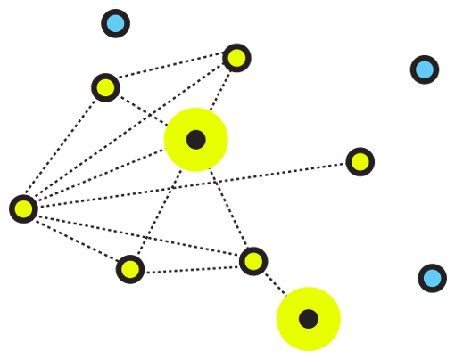

Figure 3.1: An illustrative image for networking

**3.1.2 Computer Network Types**

A computer network is a group of computers linked to each other that enables the computer to communicate with another computer and share their resources, data, and applications. A computer network can be categorized by their size. A **computer network** is mainly of **four types**

1. LAN (Local Area Network)
2. PAN (Personal Area Network)
3. MAN (Metropolitan Area Network)
4. WAN (Wide Area Network)

## LAN (Local Area Network)

1. Local Area Network is a group of computers connected to each other in a small area such as building, office.
2. LAN is used for connecting two or more personal computers through a communication medium such as twisted pair, coaxial cable, etc.
3. It is less costly as it is built with inexpensive hardware such as hubs, network adapters, and Ethernet cables.
4. The data is transferred at an extremely faster rate in Local Area Network.
5. Local Area Network provides higher security.

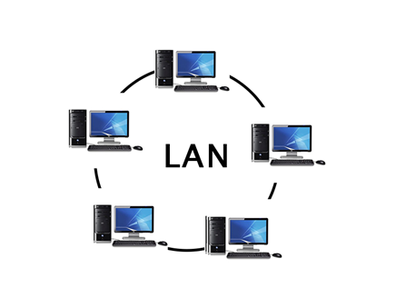

Figure 3.2: Local area network

## PAN (Personal Area Network)

1. Personal Area Network is a network arranged within an individual person, typically within a range of 10 meters.
2. Personal Area Network is used for connecting the computer devices of personal use is known as Personal Area Network.
3. **Thomas Zimmerman** was the first research scientist to bring the idea of the Personal Area Network.
4. Personal Area Network covers an area of **30 feet**.
5. Personal computer devices that are used to develop the personal area network are the laptop, mobile phones, media player and play stations.

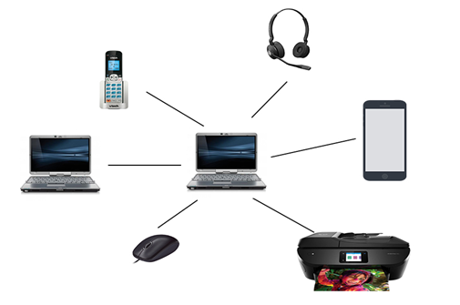

Figure 3.3: Personal area network PAN

**There are two types of Personal Area Network:**

1. Wired Personal Area Network
2. Wireless Personal Area Network

**Wireless Personal Area Network:** Wireless Personal Area Network is developed by simply using wireless technologies such as Wi-Fi, Bluetooth. It is a low range network.

**Wired Personal Area Network:** Wired Personal Area Network is created by using the USB.

### Examples of Personal Area Network:

1. **Body Area Network:** Body Area Network is a network that moves with a person. **For example**, a mobile network moves with a person. Suppose a person establishes a network connection and then creates a connection with another device to share the information.
2. **Offline Network:** An offline network can be created inside the home, so it is also known as a **home network**. A home network is designed to integrate the devices such as printers, computer, television but they are not connected to the internet.
3. **Small Home Office:** It is used to connect a variety of devices to the internet and to a corporate network using a VPN

## MAN (Metropolitan Area Network)

1. A metropolitan area network is a network that covers a larger geographic area by interconnecting a different LAN to form a larger network.
2. Government agencies use MAN to connect to the citizens and private industries.
3. In MAN, various LANs are connected to each other through a telephone exchange line.
4. The most widely used protocols in MAN are RS-232, Frame Relay, ATM, ISDN, OC-3, ADSL, etc.
5. It has a higher range than Local Area Network (LAN

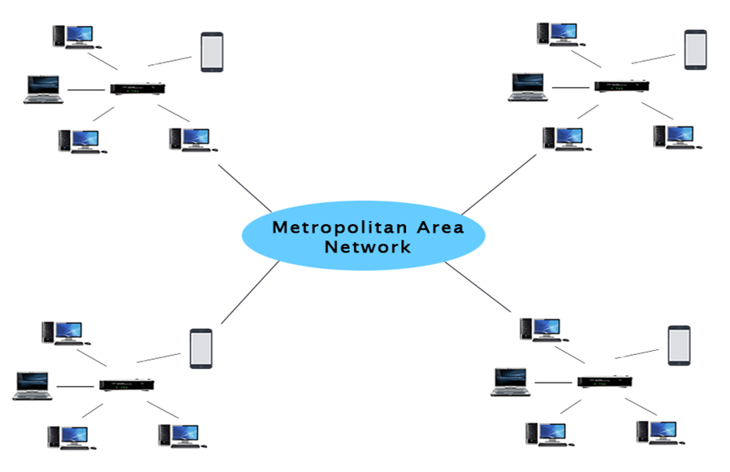

Figure 3.4: Metropolitan area network

### Uses of Metropolitan Area Network:

1. MAN is used in communication between the banks in a city.
2. It can be used in an Airline Reservation.
3. It can be used in a college within a city.
4. It can also be used for communication in the military.

## WAN (Wide Area Network)

1. A Wide Area Network is a network that extends over a large geographical area such as states or countries.
2. A Wide Area Network is quite bigger network than the LAN.
3. A Wide Area Network is not limited to a single location, but it spans over a large geographical area through a telephone line, fiber optic cable or satellite links.
4. The internet is one of the biggest WAN in the world.
5. A Wide Area Network is widely used in the field of Business, government, and education.

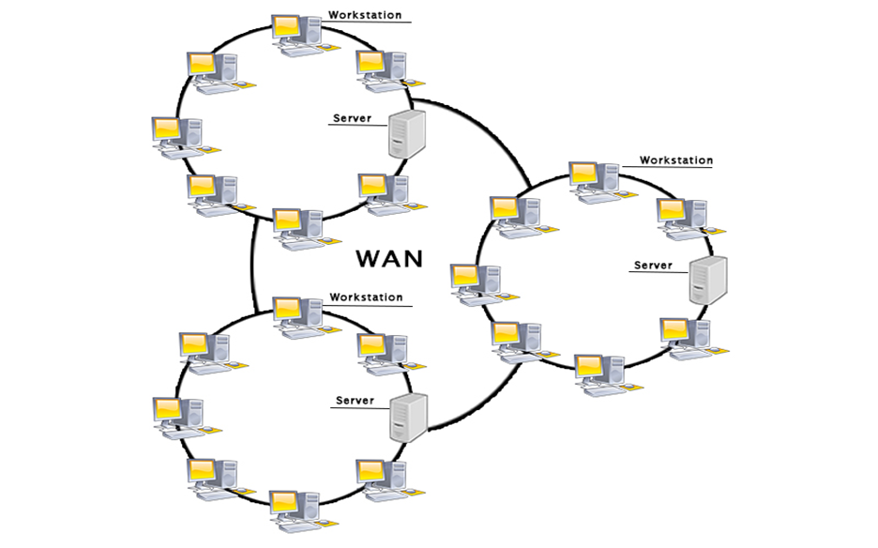

Figure 3.5: Wide area network

**3.1.4 AN ETHERNET CABLE**

Purchasing Ethernet cables can be quite expensive and pre-made lengths are not always the length you need.  Making Ethernet cables is easy with a box of bulk Category 5e Ethernet cable and RJ-45 connectors that are attached to the cut ends of your preferred cable length.

Bulk Ethernet Cable - Category 5e or CAT5e

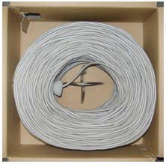

Figure 3.6: Bulk Ethernet Cable - Category 5e or CAT5e

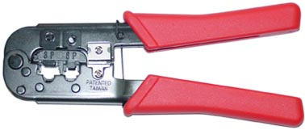

Figure 3.7: RJ-45 Crimping tool

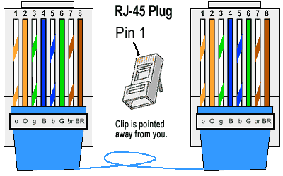

Figure 3.8: RJ45 diagram

**3.1.5 TYPES OF ETHERNET CABLES**

There are two kinds of Ethernet cables you can make, **Straight Through**and **Crossover**.  
**STRAIGHT THROUGH** Ethernet cables are the standard cable used for almost all purposes, and are often called "patch cables". It is highly recommend you duplicate the color order as shown on the left. Note how the green pair is not side-by-side as are all the other pairs. This configuration allows for longer wire runs.

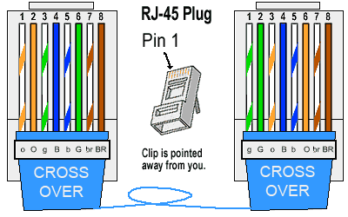

Figure 3.9: Straight through cable

**CROSSOVER CABLES** - The purpose of a Crossover Ethernet cable is to directly connect one computer to another computer (or device) without going through a router, switch or hub.

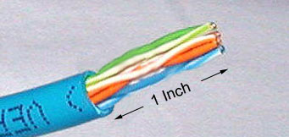

Figure 3.10: Cross over cable

Cut into the plastic sheath about 1inch (2.5 cm) from the end of the cut cable. The crimping tool has a razor blade that will do the trick with practice.

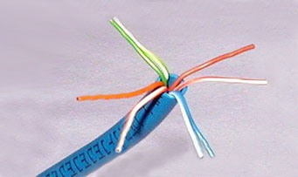

Figure 3.11: Unwind and pair the similar colors.

Pinch the wires between your fingers and straighten them out as shown. The color order is important to get correct.

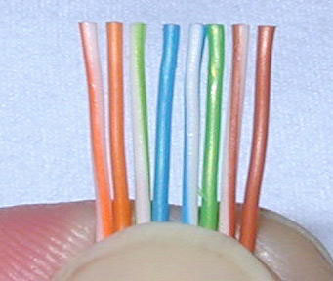

Figure 3.12: Colour order of cables

Use scissors to make a straight cut across the 8 wires to shorten them to 1/2 Inch (1.3 cm) from the cut sleeve to the end of the wires.



Figure 3.12: Scissors

Carefully push all 8 unstripped colored wires into the connector. Note the position of the blue plastic sleeve. Also note how the wires go all the way to the end.

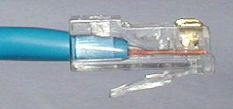

Figure 3.13: Inserting the wires

A view from the top. All the wires are all the way in. There are no short wires.

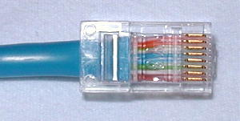

Figure 3.14: Top view of the inserted wires

**WRONG WAY** - Note how the blue plastic sleeve is not inside the connector where it can be locked into place. The wires are too long. The wires should extend only 1/2 inch from the blue cut sleeve. Note how the wires do not go all the way to the end of the connector.

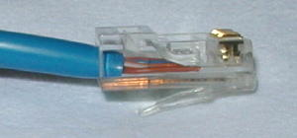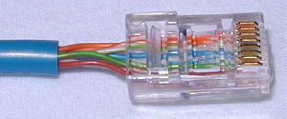

Figure 3.15: Wrong way of inserting the wires

**CRIMPING THE CABLE** ... carefully place the connector into the Ethernet Crimper and cinch down on the handles tightly. The copper splicing tabs on the connector will pierce into each of the eight wires. There is also a locking tab that holds the blue plastic sleeve in place for a tight compression fit. When you remove the cable from the crimper, that end is ready to use.

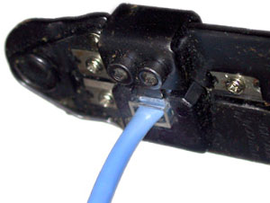

Figure 3.16: Crimping the cable

For a standard "Straight Through" cable, repeat all steps and wire color order on the other end of cable. For a cross-over cable, the other end will have a different color order as shown by the crossover picture above. Make sure to test the cables before installing them. An inexpensive Ethernet cable tester does this quite well.

**3.2 NETWORK BANDWIDTH**

Bandwidth refers to the maximum amount of data that can be transmitted over a network connection within a given time frame. It is typically measured in bits per second (bps) or multiples of bps such as kilobits per second (Kbps), megabits per second (Mbps), or gigabits per second (Gbps).

Bandwidth is an essential aspect of any network, as it determines the speed at which data can be transmitted between devices. A higher bandwidth connection allows for faster data transfer rates and enables larger amounts of data to be transmitted in less time.

The term bandwidth is often used interchangeably with internet speed, although they are not the same thing. Internet speed refers to the actual data transfer rate achieved by a user when using their internet connection, which is affected by factors such as network congestion, latency, and packet loss. Bandwidth, on the other hand, refers to the maximum theoretical capacity of a connection.

**TYPES OF BANDWIDTH IN NETWORKING**

Symmetric bandwidth and asymmetric bandwidth are two different types of bandwidth used in networking.

1. Symmetric bandwidth: In symmetric bandwidth, the upload and download speeds of a network connection are the same. This means that if the network has a bandwidth of 10 Mbps, the upload and download speeds will be 10 Mbps each. Symmetric bandwidth is commonly used in enterprise networks, where data transmission in both directions is critical, such as in video conferencing and file sharing applications.
2. Asymmetric bandwidth: In asymmetric bandwidth, the upload and download speeds of a network connection are different. This means that if the network has a bandwidth of 10 Mbps, the upload speed may be 1 Mbps, while the download speed may be 9 Mbps. Asymmetric bandwidth is commonly used in residential networks, where data is mostly downloaded from the internet, such as in web browsing and streaming applications.

Asymmetric bandwidth is often less expensive than symmetric bandwidth, as it requires less network resources. However, it may not be suitable for applications that require high-speed data transmission in both directions. On the other hand, symmetric bandwidth is more expensive but offers faster and more reliable data transmission in both directions.

When choosing a network connection, it is important to consider the type of bandwidth required for the intended use. For applications that require fast and reliable data transmission in both directions, such as video conferencing and file sharing, a symmetric bandwidth connection may be more suitable. For applications that require fast download speeds but slower upload speeds, such as web browsing and streaming, an asymmetric bandwidth connection may be sufficient.

**3.3 TRANSMISSION MEDIA**

In data communication terminology, a transmission medium is a physical path between the transmitter and the receiver i.e. it is the channel through which data is sent from one place to another.

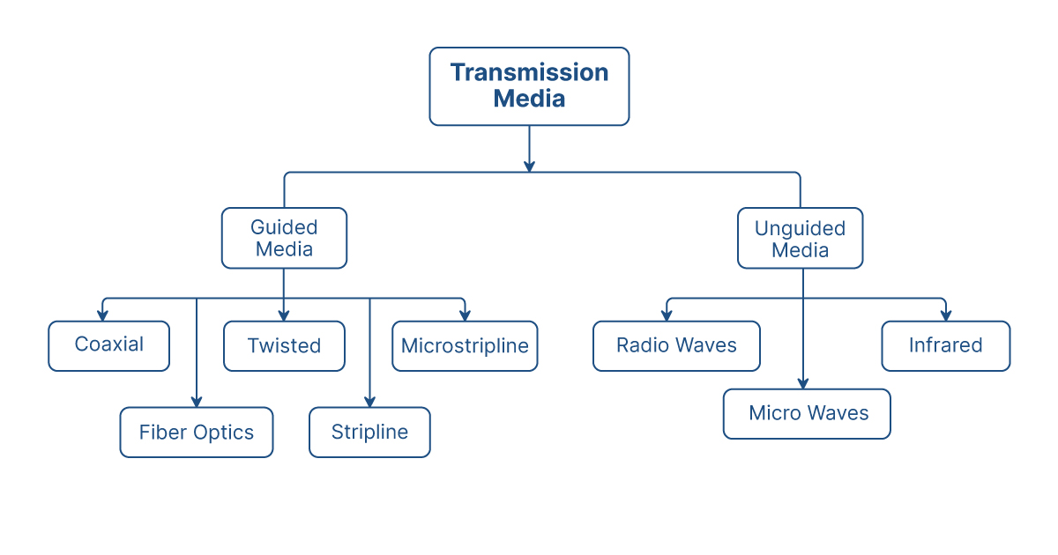

Figure 3.17: Transmission Media in Networking

**Guided Media:** It is also referred to as Wired or Bounded transmission media. Signals being transmitted are directed and confined in a narrow pathway by using physical links.

**Features:**

1. High Speed
2. Secure
3. Used for comparatively shorter distances

There are 3 major types of Guided Media:

**(i) Twisted Pair Cable:** It consists of 2 separately insulated conductor wires wound about each other. Generally, several such pairs are bundled together in a protective sheath. They are the most widely used Transmission Media. Twisted Pair is of two types:

1. **Unshielded Twisted Pair (UTP):** UTP consists of two insulated copper wires twisted around one another. This type of cable has the ability to block interference and does not depend on a physical shield for this purpose. It is used for telephonic applications.



Figure 3.18: Unshielded Twisted Pair

**Applications:**

Used in telephone connections and LAN networks

1. **Shielded Twisted Pair (STP):** This type of cable consists of a special jacket (a copper braid covering or a foil shield) to block external interference. It is used in fast-data-rate Ethernet and in voice and data channels of telephone lines.

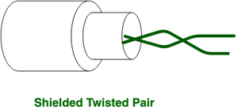

Figure 3.19: Shielded Twisted Pair

**Applications:**

The shielded twisted pair type of cable is most frequently used in extremely cold climates, where the additional layer of outer covering makes it perfect for withstanding such temperatures or for shielding the interior components.

**(ii) Coaxial Cable:** It has an outer plastic covering containing an insulation layer made of PVC or Teflon and 2 parallel conductors each having a separate insulated protection cover. The coaxial cable transmits information in two modes: Baseband mode(dedicated cable bandwidth) and Broadband mode(cable bandwidth is split into separate ranges). Cable TVs and analog television networks widely use Coaxial cables.

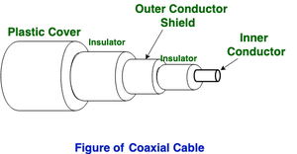

Figure 3.20: Coaxial cable

**Applications:**

Radio frequency signals are sent over coaxial wire. It can be used for cable television signal distribution, digital audio (S/PDIF), computer network connections (like Ethernet), and feedlines that connect radio transmitters and receivers to their antennas.

**(iii) Optical Fiber Cable:** It uses the concept of refraction of light through a core made up of glass or plastic. The core is surrounded by a less dense glass or plastic covering called the cladding. It is used for the transmission of large volumes of data.

The cable can be unidirectional or bidirectional. The WDM (Wavelength Division Multiplexer) supports two modes, namely unidirectional and bidirectional mode.

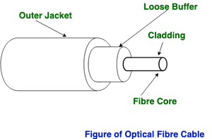

Figure 3.21: Fibre Optic cable

**Applications:**

1. Medical Purpose: Used in several types of medical instruments.
2. Defence Purpose: Used in transmission of data in aerospace.
3. For Communication: This is largely used in formation of internet cables.
4. Industrial Purpose: Used for lighting purposes and safety measures in designing the interior and exterior of automobiles.

**(iv) Stripline**

Stripline is a transverse electromagnetic (TEM) transmission line medium invented by Robert M. Barrett of the Air Force Cambridge Research Centre in the 1950s. Stripline is the earliest form of the planar transmission line. It uses a conducting material to transmit high-frequency waves it is also called a waveguide. This conducting material is sandwiched between two layers of the ground plane which are usually shorted to provide EMI immunity.

**(v) Microstripline**

In this, the conducting material is separated from the ground plane by a layer of dielectric.

**2. Unguided Media:** It is also referred to as Wireless or Unbounded transmission media. No physical medium is required for the transmission of electromagnetic signals.

**Features:**

1. The signal is broadcasted through air
2. Less Secure
3. Used for larger distances

There are 3 types of Signals transmitted through unguided media:

**(i) Radio waves:** These are easy to generate and can penetrate through buildings. The sending and receiving antennas need not be aligned. Frequency Range:3KHz – 1GHz. AM and FM radios and cordless phones use Radio waves for transmission.

**(ii) Microwaves:** It is a line of sight transmission i.e. the sending and receiving antennas need to be properly aligned with each other. The distance covered by the signal is directly proportional to the height of the antenna. Frequency Range:1GHz – 300GHz. These are majorly used for mobile phone communication and television distribution.

**(iii) Infrared:** Infrared waves are used for very short distance communication. They cannot penetrate through obstacles. This prevents interference between systems. Frequency Range:300GHz – 400THz. It is used in TV remotes, wireless mouse, keyboard, printer, etc.

**CHAPTER FOUR**

**SUMMARY, CONCLUSION, PROBLEMS AND RECOMMENDATIONS**

## 4.1 SUMMARY

The relevance of the SIWES program cannot be over emphasized considering the fact that it has significantly reduced the gap between my theoretical and practical knowledge about computer hardware and software, installations, maintenance and networking. The processes of communication which include data and telecommunication the use of switch in the networking and what networking is all about.

The program is indeed a commendable one in that it affords students ample opportunities of being exposed to good working relationship with colleagues and the field experience with customers. This little exposure has widened my knowledge about my course of study, not only that it has automatically changed my views about lift in general. The firm at large has taught me how to be independent of my own how to be conscious of my health and safety at its peak relating to the environment where I carried out my SIWES program. It was indeed a highly rewarding experience to be with Dangote Sugar Refinery, Numan, Adamawa State.

**4.2 CONCLUSION**

In conclusion, I thank ITF in general for their effort towards the Student Industrial Training Scheme. The contribution that the industrial training offered to student will not be over emphasized. It has exposed me seriously to a certain depth and length of practical capability on Computer Knowledge and practical Know how.

It has also acquainted me with the working condition, which I am expected to encounter in the near future. I will say that SIWES has a greater advantage on me, it has greatly exposed me to the practical application of all that I have been through in the school, SIWES is an experience that all student must pass through this is because it gives a full practical knowledge of what has been through in classroom.

Finally, I have a strong believe that this comprehensive based on the experience, I acquired during the industrial training scheme will convince every user training is not difficult.

I therefore strong conclude that the continuous existence of SIWES programme as it is very necessary since it plays a dominant role in the development of student of Computer Science in the acquisition of practical experience.

## 4.3 PROBLEMS OBSERVED DURING MY PROGRAM

1. The time frame set for the program is too short as some of the aspects of the program where not completed.
2. Lack of Financial support from the company to aid transportation to and from training.
3. Attentions are not given to the IT students by the workers it is learn if you want to learn or ask if you want to know.
4. Cost of Training: The Student has to be registered as a student of a particular organization in order to carry out the program.

**4.4 RECOMMENDATIONS**

Below are the recommendations that should be given serious consideration so as alleviate the suffering of students undergoing SIWES.

Firstly, the Federal Government of Nigerian should make a positive effort in reducing the overall cost of production so that companies should be producing to fill capacity and accommodate SIWES populaces. Also, certain monthly allowance may be given to the student by company accepted then (student to ease transportation problem).

Secondly, the Industrial Training Fund (ITF), should try and increase the money paid at the end of SIWES to the student so as to justify the Cost of Living we experienced.

Finally, the ITF official should please continue visiting the students, to ensure that what they are learning is in line with the ITF requirement.

**REFERENCES**

Kurose, F. & Keith W. (2005). *Computer Networking*: A Top-Down Approach Featuring the Internet, Pearson Education.

Wendell, o. & Rus, D. (2010). *CCIE Routing and Switching*. Indianapolis, IN: Cisco Press

William, S. (2004). *Computer Networking with Internet Protocols and Technology*, Pearson Education.