**A TECHNICAL REPORT ON**

**STUDENT INDUSTRIAL WORK EXPERIENCE SCHEME (SIWES)**

**CARRIED OUT AT**

**AMERICAN UNIVERSITY OF NIGERIA (AUN),**

**YOLA, ADAMAWA STATE**

**FROM: 4TH JANUARY, 2023**

**TO: 4TH MAY, 2023**

**BY**

**AUGUSTINE STELLA MOMBOYA**

**ST/CS/ND/21/063**

**SUBMITTED TO**

**THE DEPARTMENT OF COMPUTER SCIENCE**

**SCHOOL OF SCIENCE AND TECHNOLOGY**

**FEDERAL POLYTECHNIC MUBI**

**IN PARTIAL FULFILLMENT FOR THE AWARD OF NATIONAL DIPLOMA (ND) IN COMPUTER SCIENCE**

**JUNE, 2022**

**DEDICATION**

I dedicate this report to the Almighty God for the guidance and protection accorded me throughout the programme.

# ACKNOWLEDGMENTS

I thank God Almighty for making me to undergo students industrial work experience scheme (SIWES) successfully.

My gratitude goes to my parent for their prayers, financial and moral support during my attachment.

I also appreciate the kind gesture of my brothers and sisters and those who supports me in prayers and contribution during my industrial attachment.

I whole heartedly thank my Head of department Mallam Adamu Garba Mubi, SIWES coordinator and all lectures of Computer Science for their effort to ensure my success as their students.

I am greatly indebted to my co-SIWES students to mention, may God strengthen our relationship together and grant us academic excellence.

I sincerely thank you all for your contribution and support.

**ABSTRACT**

*The report summarises the result of work done during my SIWES experience, the technical report consists of four chapters, which comprises of introduction, history and criteria’s of SIWES in chapter one followed by their aims and objectives, historical background, organizational structure of the organization in chapter two, while chapter three consist of the work actually carried out during the SIWES programme and lastly chapter four consist of the summary, conclusions and recommendation.*

**Table of Contents**

**Title page - - - - - - - - - - i**

**Approval page - - - - - - - - ii**

**Dedication - - - - - - - - - - iii**

**Abstract - - - - - - - - - - iv**

**CHAPTER ONE**

1.0 Introduction - - - - - - - - - 1

1.1 Background of SIWES - - - - - - - 1

1.2 Brief History of SIWES - - - - - - - 1

1.3 Aims and Objectives of SIWES - - - - - - 2

**CHAPTER TWO**

2.1 Brief History of the Organization. - - - - - - 3

2.2 Organizational Chart - - - - - - - - 4

**CHAPTER THREE**

**EXPERIENCE ACQUIRED**

# 3.1 Introduction Computer - - - - - - - 5

## 3.2 Computer Maintenance - - - - - - - 8

**CHAPTER FOUR**

4.1 Summary - - - - - - - - - 17

4.2 Conclusion - - - - - - - - - 17

4.3 Problems - - - - - - - - - 18

4.4 Recommendations - - - - - - - - 18

REFERENCES - - - - - - - - - 19

**CHAPTER ONE**

**1.0 INTRODUCTION**

The concept behind industrial training schemes is to acquire practical, knowledge in addition to what has been learn institution. The four months mandatory supervised industrial attachment is program instituted by the federal government to help student for their different field of studies.

### 1.1 BACKGROUND OF SIWES

It aims at exposing student to the practical and the actualization of work situation which they may meet after graduation and the learning is meanly expected to produce graduate qualification to meet man power of employments of (ITF), there was growing concern amount the industrialist that graduate of higher learning do not passes adequate background student for the opinion that theoretical education going higher institution was responsive enough to meet the need of employers of the labour as a requirement of national board for technical education (NBTE) polytechnic training before obtaining the National Diploma (ND).

Experience scheme (SIWES), is a National programme introduced by Government in 1974 for student in tertiary institution

### 1.2 BRIEF HISTORY OF SIWES

**SIWES** was established by **ITF** in 1973 to solve the problem of lack of adequate practical skills preparatory for employment in industries by Nigerian graduates of tertiary institutions.

The program “Student industrial work experience scheme” is a pure skill-acquisition program structured for the tertiary institutions as a complementary and enhancement program to the theoretical education, laboratory and workshop practices engaged in by student in different higher institutions. The SIWES was initiated to improve the student’s technical abilities (performance/knowledge) and expose them to industrial culture thereby preparing them to be acquainted with the roles to play towards the technological advancement of the nation.

It is there for a practical aspect of the academic works, which the students may not be opportune to carry out throughout their stay in the higher institutions. Based on this fact, the Federal Government decided to establish a body (regulatory) which engages in the training of the technical manpower. The body is named industrial Training Fund (ITF). The government also undertook to make up for the deficiencies by structuring and established Students Industrial Training (SIT) as it was then called but in 1973 the SIWES was formed which is the subsidiary.

### 1.3 AIMS AND OBJECTIVES OF SIWES

1. One of the objectives of SIWES is to create an avenue for students to acquire industrial skills to complement their theoretical knowledge and improve their experiences in their course of study.
2. The program prepares the students for industrial working conditions prior to their graduation.
3. To enable the students to learn personal relationship with employers and co-employees on graduation.
4. It exposes the student to working methods and techniques in handling equipment and machinery.
5. It develops the student in make critical and realistic approaches to solving problem.
6. It serves as a way of improving the abilities of the students and to contribute to the growth of the nation.
7. It gives the students the opportunity to practice what they have been taught in various disciplines.
8. The SIWES program strengthens the employer’s involvement in preparing the students for employment.

# CHAPTER TWO

### 2.1 BRIEF HISTORY OF American University of Nigeria

### The American University of Nigeria (AUN) is a private university located in Yola, Adamawa State, Nigeria. It was founded in 2003 by Atiku Abubakar, a Nigerian politician and former Vice President of Nigeria. The university was established with the vision of providing quality American-style higher education in Nigeria.

### AUN's establishment was a response to the need for a world-class institution that would offer Nigerian students the opportunity to receive an education that meets international standards. The university's curriculum is based on the American model of education, and it places a strong emphasis on critical thinking, practical experience, and entrepreneurship. The university's campus is situated on a 300-hectare site in Yola, providing a serene and conducive environment for learning. Over the years, AUN has expanded its infrastructure and facilities, including state-of-the-art classrooms, laboratories, libraries, and student housing.

### AUN offers a wide range of undergraduate and graduate programs across various disciplines, including business administration, computer science, international and comparative politics, communications and multimedia design, economics, and many others. The university also promotes interdisciplinary studies, allowing students to explore multiple fields of interest. One notable aspect of AUN is its commitment to community service and social development. The university's founders believed that education should not only focus on academic excellence but also contribute to the betterment of society. AUN's community development programs include initiatives in healthcare, education, and economic empowerment, aimed at improving the lives of people in the surrounding communities. Over the years, the American University of Nigeria has gained recognition both nationally and internationally for its commitment to excellence in education. It has attracted students from Nigeria and other countries, creating a diverse and vibrant learning community. The university has also formed partnerships with renowned institutions and organizations worldwide, fostering collaborations and exchange programs that enhance the educational experience for its students.

### Today, the American University of Nigeria continues to thrive as a center of academic excellence, providing quality education and contributing to the development of Nigeria and beyond. It remains dedicated to its mission of preparing students to be ethical leaders and entrepreneurs who will make a positive impact in their communities and the world.

### 2.2 ORGANIZATIONAL STRUCTURE

Director

Admission officer

Exam officer

Application Lecturer

Networking Lecturer

Programming Lecturer

Maintenance Lecturer

Security

Cleaner

Figure 2.1: Organizational Chart

**CHAPTER THREE**

**EXPERIENCE ACQUIRED DURING THE TRAINING**

**3.1 INTRODUCTION TO COMPUTER**

A computer system be it micro, main frame or super computer consist of both software and hardware, it is an electronic machine capable of accepting data and process the data into a meaningful information as an output.

A computer is a machine or tool which is capable of

1. Taking input data
2. Storing the input data
3. Processing the input data
4. Producing the output reports on paper or computer store for future.

The term computer is obtained from the word compute. A computer is an electronic device that input (take in) fact(data)and then process(manipulate) storing (saving) output (information).

**3.1.2 INFORMATION TECHNOLOGY**

In simple language information technology (IT) refers to the development, maintenance, and use of computer software, system and networks. It includes their use for processing and distribution of data. Data means information’s, facts statistics, etc, gathered together for reference, storage or analysis.

Information technology is the design and implementation of computer networks for data processing and communication.

This include designing the hardware for processing information and connecting separate components, and developing software that can efficiently and faultlessly analyze and distribute this data.

**3.1.3 PART OF COMPUTER SYSTEM**

There are two main part of computer Hardware and software

**HARDWARE**

This are all part of the computer which you can see and touch. Computer hardware is the collection of physical parts of a computer system. This includes the computer case such monitor, keyboard and mouse it includes all the parts insides the computer case, such as the hard disk drive, mother board video card and many other.

There are five main hardware components in a computer system.

1. Input
2. Processing
3. Storage
4. Output
5. Communication

**INPUT AND OUTPUT DEVICES**

An input device sends information to a computer system for processing, and an output device reproduces or displays the results of that processing.

Input devices only allows for input of data to a computer and out devices only receives the output of data from another devices.

**Input devices list**

1. Graphic tablets
2. Camera
3. Video capture Hardware
4. Keyboards
5. Scanner
6. Webcam
7. Microphone
8. Electronic white board

**Output devices list**

1. Monitor (LED, LCD, CRT etc)
2. Printers (all type)
3. Projector
4. LCD Projection Panels
5. Head Phones
6. Film Recorder
7. Visual display Unit
8. Speakers

**SOFTWARE**

The software have physical presence, they are stored in digital forms within computer memory. There are different categories of software, including the system software, utilities software and applications software.

1. System software
2. Utility software
3. Application software

**SYSTEM SOFTWARE**

This is the software used to manage and control the hardware components abd which allows interaction between the hardware and other types of software. The most obvious types of software is the computer operating system but device driver is are also included within this categories

**UTILITY SOFTWARE**

This is the software such as anti-virus software, firewalls, disk defragmenters and so on which helps to maintain and protect the interface with the hardware.

**APPLICATIONS SOFTWARE**

This are designed to allow the user of the system complete a specific task or set of tasks. They includes programs such as web browsers, office software, games and so on. They are usually the reason you bought the computer system in the first place and they are unconcerned with the management of the system itself

**3.2 COMPUTER REPAIRS AND MAINTENANCE TOOLS**

To accurately and easily troubleshoot a system, a computer engineering needs to possess all the basic tools required for computer maintenance and other relevant tools also. But first proper precautions should be taking like;

Some of these tools include;

1. Putting all component to be worked on, on an insulated table
2. Always be careful of other close component
3. Do not work on a live board.

**3.2.1**  **HARDWARE TOOLS**

1. 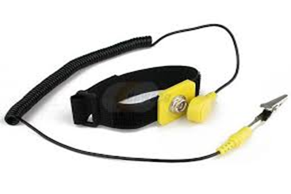**Anti-static wrist band:** The computer is made up of some of components that require very little electric charges to operate. The static electricity in the body may be far greater than the required charge, thus the destruction of such component. The anti-static wrist strap is used to prevent static electricity charges from destroying the computer parts by grounding your body. The metal clip is connected to a bare metal part of the computer case like the metal case of a PC.

Fig 2.1: Anti-static wrist band

This can also be achieved partially but no safely by touching the ground at intervals to Discharge the static electricity to the ground.

1. **Tweezers:** It is a too; used for picking up and manipulating objects too small to be handled with the human hand.

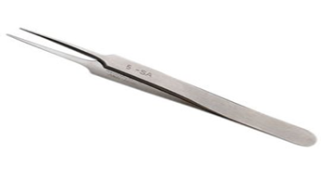

Fig 2.2: A tweezers

1. **Long Nose Plier**: It used to cut wires and can get in and out of tight spots, unlike regular pliers.

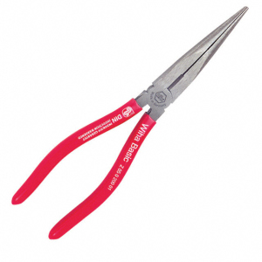

Figure 2.3: A plier

1. **Soldering Iron**: It is essential for repairs on mother board but with extreme care. When used carelessly, it can destroy the board as well as injure the engineer.

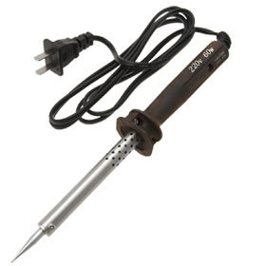

Figure 2.4: Soldering Iron

1. **8” Wire Cutter/ Stripper**: It is for wire cutting and stripping insulation on a single, multiple, fine stranded of wire cables with plastic or rubber insulation.

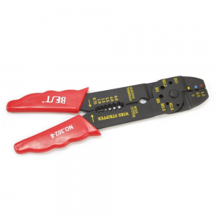

Figure 2.5: 8” wire cutter

1. **Hot air blower/Rework Station:** This is used in desoldering parts that are faulty or have been being wrongly soldered. It weakens the lead. It is also used in the application of paste (heat dependent gum) on board.

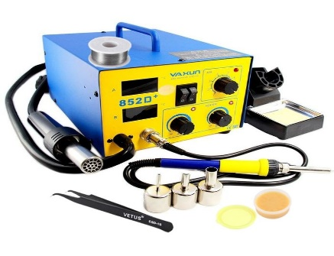

Figure 2.6: Hot air blower

1. **Set of Screw Drivers:** The different parts of the computer are made of nuts and screws of different sizes, thus the need for multi-mouth screw driver set. It is used in the loosening of nuts and screws.

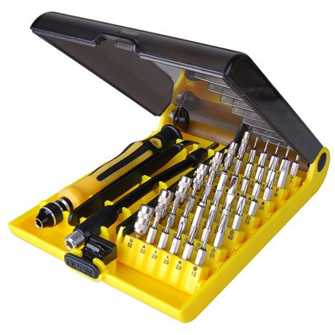

Figure 2.7: Set of screw drivers

1. **Paste flux:** This is a heat dependent non-insulating joining paste used to attach components on the board.

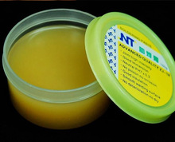

Figure 2.8: Paste flux

1. **Soldering wire/ lead:** This is a metallic conductive joining material. It is applied using the soldering iron at high temperature. Soldering on the motherboard requires a high level of care as the soldering iron lacks precision(mouth-size of 2mm-3mm)

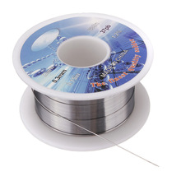

Figure 2.9: Soldering lead

1. **Multi-meter:** It is used to measure voltage, current, continuity of wire or motherboard, resistances at different points on the board and a lot more.

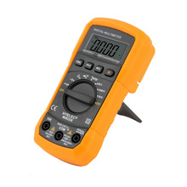

Figure 2.10: A digital multi-meter

1. **Storage (USB Flash and External Hard disk):** This stores all the engineer’s working soft wares. Without which the engineer can do so little.
2. **Magnifying Lamp:** It is used while working on the board to magnify the size of the board for accuracy and speed.

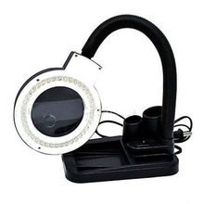

Figure 2.11: A magnifying lamp

**3.2.2 Software Tools**

Like hardware tools, there are a variety of software tools that can be used to help technicians pinpoint and troubleshoot problems. Many of these tools are free and several come with the Windows operating system. Examples are;

1. **Disk Management tools:** Initializes disks, creates partitions, and formats partitions.
2. **Scandisk*:*** Checks the integrity of files and folders on a hard drive by scanning the file system. These tools might also check the disk surface for physical errors.
3. **DiskCleanup:** Clears space on a hard drive by searching for files that can be safely deleted.
4. **HP Diagnostic tool:** It troubleshoots the inactive hardware’s and tries activating them, on request. When unable to fix a problem, it gives the cause of such problem (e.g. missing drive).
5. **Driver Pack Online:** It scans a system and then lists the missing drives or drives that need update in the system.
6. **Windows Update Diagnostic:** It is preinstalled software that scans and updates system component drivers and also preinstalled soft wares.
7. **HP Support Solutions Framework:** It scans faulty systems and provides online solutions.

**3.2.3 PROTECTION TOOLS**

  Virus and spyware can damage operating systems, applications, and data. Computers that have been infected may even have problems with hardware performance or component failure, thus the need for protection tools.

1. **Windows Action Center:** Checks the status of essential security settings. The Action Center continuously checks to make sure that the software firewall and antivirus programs are running. It also ensures that automatic updates download and install automatically.
2. **Antivirus program:** Protects the system against virus attacks.
3. **Antispyware program:** Protects against software that sends information about web surfing habits to an attacker. Spyware can be installed without the knowledge or consent of the user.
4. **Windows Firewall:** Runs continuously to protect against unauthorized communications to and from your computer. But when a system has a working anti-virus, the operating system automatically disables the windows firewall, as the two perform same function.

**3.2.4 COMPUTER TROUBLESHOOTING**

**How to remove or replace a laptop keyboard**

Removing a [keyboard](https://www.computerhope.com/jargon/k/keyboard.htm) on a laptop is not a simple task. Nearly all [components](https://www.computerhope.com/jargon/c/component.htm) in a laptop require more time or expertise to change than desktop components, including the keyboard. If you do not have experience disassembling a laptop, we recommend having a computer technician replace the keyboard for you. If you have the experience or insist on doing it yourself, review the information in the sections below for guidance.

### Remove screws on bottom of laptop

The first step is to remove some screws on the bottom of the laptop. Some laptops display a small keyboard icon next to the screws that you need to remove. Other laptops don't have the keyboard icon, so you need to look closely to find the appropriate screws. The screws on most laptops are recessed in the bottom of the casing and are circular holes. However, some laptops have rubber pieces that cover the screws. If you have that type of laptop, you need to remove the rubber pieces to access them.

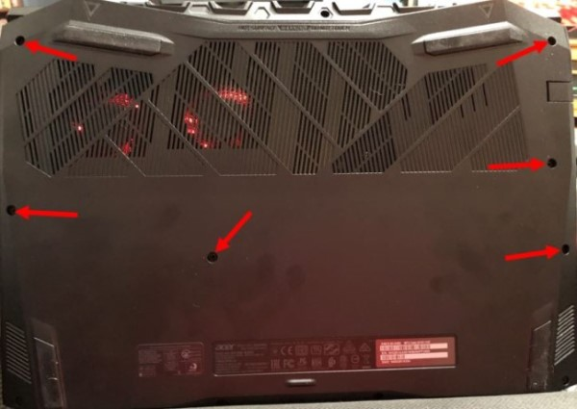

Figure 3.1: Bottom side of the laptop

Once you find the screws, remove them and set them aside in a safe place so you don't lose them.

### Remove keyboard or top part of laptop casing

With the screws removed, turn the laptop over and open the lid to see the keyboard. Depending on your brand and model, you can remove the keyboard directly, or you may need to remove the top casing around the keyboard before proceeding.

First, try lifting the keyboard. You may need a small, flat-head screwdriver to raise the edges. If you cannot access the edges of the keyboard because the casing prevents it, you need to remove the casing (as we mentioned above). If you can lift the keyboard out, skip to the section about [disconnecting the laptop cable](https://www.computerhope.com/issues/ch002101.htm#disconnect-cable).

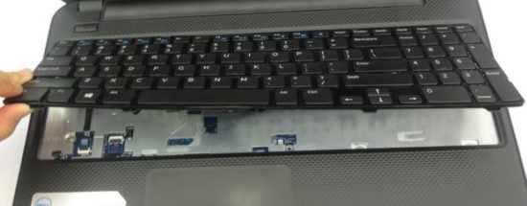

Figure 4.3: Figure 3.1: Laptop keyboard being removed

To remove the keyboard casing, start around the laptop edge and find a seam between the casing around the keyboard and the bottom casing. Carefully lift on the top section to pop it loose from the laptop. Be gentle to avoid cracking the casing, while still applying enough force to lift and remove it. Also, be aware of any plastic tabs used to secure the case so that you don't damage them.

The exact method needed to remove the casing differs by laptop brand and model, so check your owner's manual for specific steps.

### Remove Keyboard Screws and Keyboard

With the laptop casing around the keyboard removed, locate any screws that secure the keyboard in place from the top. Although there may be more, in most cases, there are three to five screws, if any. If you don't find any screws, skip to the next section.

Remove the keyboard screws and set them aside in a safe place, so you don't lose them. Then, lift the keyboard up from the rest of the laptop.

### Disconnect Keyboard Cable

With the keyboard lifted up, you need to disconnect the [cable](https://www.computerhope.com/jargon/c/cable.htm) that connects the keyboard to the [motherboard](https://www.computerhope.com/jargon/m/mothboar.htm). Use caution; carefully disconnect the cable from the motherboard by pulling gently.

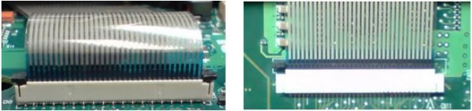

Figure 4.4: Keyboard connector

After disconnecting the keyboard cable, set the keyboard aside.

## 5. Install new laptop keyboard

### Connect Keyboard Cable

First, connect the keyboard's cable to the motherboard by carefully inserting the cable into the connector. Apply mild pressure until it is secured in place.

### Place Keyboard in the Laptop Case

After connecting the keyboard ribbon cable, insert the keyboard into the case. The most common method requires you to insert the top or bottom edge of the keyboard first. The edge may snap into place or line up with metal tabs that help secure the keyboard. Then, insert and snap the other edge of the keyboard in place or line up the metal tabs.

### Add screws to secure the keyboard

If you removed screws that secured the keyboard in place, screw them back into the keyboard. Otherwise, skip to the next section.

### Attach top casing around the keyboard

If you removed the casing around the keyboard, carefully reattach it, snapping into place where applicable. Use gentle pressure to attach the casing to avoid cracking or breaking it.

**Add screws to bottom of laptop**

[**HOW TO CHANGE A COMPUTER HARD DRIVE DISK**](https://www.wikihow.com/Change-a-Computer-Hard-Drive-Disk)

To replace a hard drive, you'll need to back up any data you want to keep, uninstall the old hard drive, install the new hard drive, and then restore the backed up data.

Here's a bit more on the three required steps:

1. Backing up the data you want to keep is the most important step in this process! The hard drive isn't the valuable thing—it's the priceless files you've created and collected over the years.
2. Creating a backup could mean something as simple as [copying files](https://www.lifewire.com/how-do-i-copy-a-file-in-windows-2619210) you want over to a large [flash drive](https://www.lifewire.com/what-is-a-flash-drive-2625794) or other storage you're not using. Better yet, if you're not backing up regularly already, use this as an opportunity to start with a [cloud backup service](https://www.lifewire.com/online-backup-services-reviewed-2624712), so you never even run the chance of losing a file again.
3. Uninstalling the existing hard drive is easy. Make sure your computer is turned off and then disconnect the hard drive and physically remove it.
4. The details here depend on the type of computer you have, but in general, this means removing data and power cables or sliding the hard drive out from the bay that it's installed into.
5. Installing the new hard drive is as simple as reversing the steps you took to uninstall the one you're replacing! Secure the drive where the old one was before, and then reconnect the same power and data cables.
6. Once your computer is back on, it's time to [format the hard drive](https://www.lifewire.com/how-to-format-a-hard-drive-2626077), so it's ready to store files. Once that's done, copy the data you backed up to the new drive, and you're set!

**CHAPTER FOUR**

**SUMMARY, CONCLUSION, PROBLEMS AND RECOMMENDATION**

# 4.1 SUMMARY

The relevance of the SIWES program cannot be over emphasized considering the fact that it has significantly reduced the gap between my theoretical and practical knowledge about computer hardware and software, installations, maintenance and networking. The processes of communication which include data and telecommunication the use of switch in the networking and what networking is all about.

The program is indeed a commendable one in that it affords students ample opportunities of being exposed to good working relationship with colleagues and the field experience with customers. This little exposure has widened my knowledge about my course of study, not only that it has automatically changed my views about lift in general. The firm at large has taught me how to be independent of my own how to be conscious of my health and safety at its peak relating to the environment where I carried out my SIWES program. It was indeed a highly rewarding experience to be with American University of Nigeria, Yola, Adamawa State.

**4.2 CONCLUSION**

In conclusion, I thank ITF in general for their effort towards the Student Industrial Training Scheme. The contribution that the industrial training offered to student will not be over emphasized. It has exposed me seriously to a certain depth and length of practical capability on Web Designs.

It has also acquainted me with the working condition, which I am expected to encounter in the near future. I will say that SIWES has a greater advantage on me, it has greatly exposed me to the practical application of all that I have been through in the school, SIWES is an experience that all student must pass through this is because it gives a full practical knowledge of what has been through in classroom.

Finally, I have a strong believe that this comprehensive based on the experience, I acquired during the industrial training scheme will convince every user training is not difficult.

I therefore strong conclude that the continuous existence of SIWES programme as it is very necessary since it plays a dominant role in the development of student of Computer Science in the acquisition of practical experience.

# 4.3 PROBLEMS OBSERVED DURING MY PROGRAM

1. The time frame set for the program is too short as some of the aspects of the program where not completed.
2. Lack of Financial support from the company to aid transportation to and from training.
3. Attentions are not given to the IT students by the workers it is learn if you want to learn or ask if you want to know.
4. Cost of Training: The Student has to be registered as a student of a particular organization in order to carry out the program.
5. Lack of Visits to the various places of Attachment by the ITF Officials to ensure that the student is actually carrying out the program.

**4.4 RECOMMENDATIONS**

Below are the recommendations that should be given serious consideration so as alleviate the suffering of students undergoing SIWES.

Firstly, the Federal Government of Nigerian should make a positive effort in reducing the overall cost of production so that companies should be producing to fill capacity and accommodate SIWES populaces. Also, certain monthly allowance may be given to the student by company accepted then (student to ease transportation problem).

Secondly, the Industrial Training Fund (ITF), should try and increase the money paid at the end of SIWES to the student so as to justify the Cost of Living we experienced.

Thirdly, the period set for the SIWES should be increase to six mouths so as to enable the student involved and gain enough experience since it is widely believed that experience is the best teacher. Again, this period should also be in line with Nigerian University Commission curriculum for the university undergraduate student on industrial attachment.

Finally, the ITF official should please continue visiting the students, to ensure that what they are learning is in line with the ITF requirement.

**REFERENCES**

Edward, B. (2003). The Effect of SIWES on a student, Federal Ministry of Works, Lagos. Nigeria.

Samuel, J. (2017). *Visual Basic (VB) Tutorial Overview.* Retrieved 25 July, 2022 from [www.tutlane.com/tutorial/visual-basic](http://www.tutlane.com/tutorial/visual-basic)