# Top 15 things we must know about www.aka.ms/phonelink

[**www.aka.ms/phonelink**](https://akamsphonelink.us/) is Ultimate Solution for Syncing Your Phone with Your Windows PC. The digital era has ushered in an increasing need for seamless integration between various devices, particularly smartphones and personal computers. Microsoft’s offering, accessible via [www.aka.ms/phonelink,](https://akamsphonelink.us/) provides a solution tailored to this very requirement. The initiative primarily aims to enable smooth synchronization between Android or iPhone devices and Windows PCs, revolutionizing the way users interact with their gadgets.

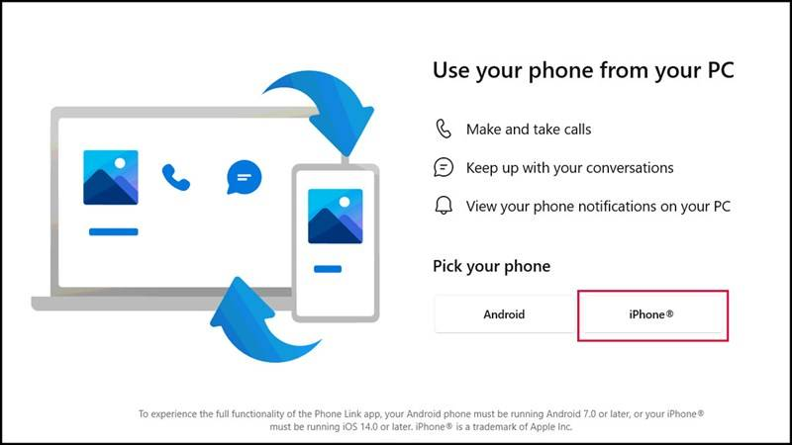

Through the Microsoft Phone Link app, users can experience an unparalleled level of connectivity between their smartphones and computers. By visiting the www.aka.ms/phonelink link, users can start the process that will allow them to manage notifications, make calls, and send texts directly from their PC. functionality greatly enhances user convenience, reducing the need to switch between devices constantly and allowing for a more cohesive and efficient workflow.

The digital age has transformed how we interact with technology, and device synchronization has become a crucial part of our daily routines. Whether you’re managing professional tasks or personal activities, switching between a smartphone and a computer can be cumbersome. This is where Microsoft’scomes into play.

The portal offers a powerful solution to bridge the gap between Android or iPhone devices and Windows PCs, allowing users to interact with their phones directly from their computers. This feature-rich platform gives users the ability to make calls, send texts, access apps, and even view photos without ever picking up their phones. The result? A more cohesive, streamlined digital environment that enhances productivity and reduces distractions.

By visiting [www.aka.ms/phonelink](https://akamsphonelink.us/), you initiate the setup that links your phone to your Windows PC via the **Microsoft Phone Link** app, which offers a range of features that cater to both casual users and professionals. This guide will take you through the entire process of linking your phone, exploring the app’s benefits, setup steps, system requirements, troubleshooting, and much more.

Whether it is for personal use or professional environments, www.aka.ms/phonelink offers substantial benefits. Users can mirror their phone’s screen to their PC, access mobile apps on a larger display, and even transfer files quickly and effortlessly. This multifaceted application bridges the gap between mobile and desktop computing, making it a vital tool for anyone looking to streamline their digital interactions.

Moreover, the setup process is straightforward and user-friendly. By navigating to, users are provided with clear instructions on how to link their devices. Regardless of whether one is tech-savvy or a novice, the simplified steps ensure that the advantages of device synchronization are accessible to all.

Phone link functionality greatly enhances user convenience, reducing the need to switch between devices constantly and allowing for a more cohesive and efficient workflow.

Whether it is for personal use or professional environments, offers substantial benefits. Users can mirror their phone’s screen to their PC, access mobile apps on a larger display, and even transfer files quickly and effortlessly. This multifaceted application bridges the gap between mobile and desktop computing, making it a vital tool for anyone looking to streamline their digital interactions.

Moreover, the setup process is straightforward and user-friendly. By navigating to www.aka.ms/phonelink, users are provided with clear instructions on how to link their devices. Regardless of whether one is tech-savvy or a novice, the simplified steps ensure that the advantages of device synchronization are accessible to all.

In essence, embodies the future of interconnected technology, wherein phones and PCs function as extensions of one another, multiplying productivity and ease of access. As we delve deeper into this guide, we will explore the comprehensive features and practical applications of Microsoft Phone Link, elucidating its role as an indispensable tool for modern technology users.

## 1. What are the Benefits if you use www.aka.ms/phonelink?

Linking your smartphone to your Windows PC via [**www.aka.ms/phonelink**](https://akamsphonelink.us/) offers a variety of benefits designed to make your workflow more efficient and your digital interactions smoother. Below are some of the key advantages you can experience:

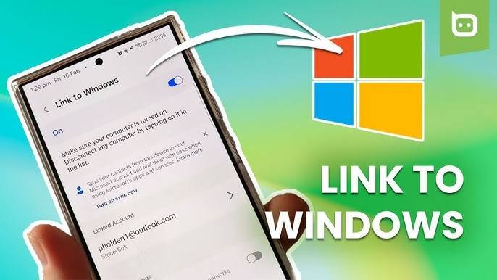

### 1. Making and Receiving Calls:

One of the standout features of the Microsoft Phone Link app is its ability to let you make and receive calls directly from your computer. This is particularly useful in situations where your phone may be out of reach, or if you prefer to keep your hands free while working. Once your phone is linked to your PC, you can handle all your calls through your desktop’s microphone and speakers, creating a more convenient experience.

For instance, imagine you’re deep into work on your PC, and your phone rings. Instead of interrupting your workflow by searching for your phone, you can simply answer the call on your PC, thanks to Phone Link. This feature is especially handy for professionals who spend a lot of time on conference calls or multitask across devices.

### 2. Viewing and Managing Photos:

Managing and transferring photos between devices can often be a hassle. However, with www.aka.ms/phonelink Phone Link, you can easily view, access, and manage your phone’s photo library right on your Windows PC. No need to email or transfer files manually. Whether you want to edit images, share them via social media, or move them to cloud storage, the Phone Link app makes the process seamless.

This feature is particularly useful for creatives who need to edit photos from their smartphones on a larger screen. You can drag and drop photos between apps, making content creation smoother.

### 3. Using Mobile Apps on PC:

Do you have favorite apps on your phone that you wish you could use on your computer? The www.aka.ms/phonelink Phone Link app allows you to run your Android apps directly on your Windows PC. Whether it’s social media apps, messaging apps, or productivity tools, you can use them right from your desktop, eliminating the need to switch back and forth between devices.

Imagine being able to check Instagram, WhatsApp, or even order food via your favorite delivery app—all without leaving your computer screen. For professionals, running business apps like Slack or Zoom from a PC can improve multitasking and productivity.

## 2. What are the Requirements for Android System to activate www.aka.ms/phonelink?

Before linking your [Android](https://www.android.com/) device to your Windows PC, it’s essential to ensure that your phone meets the minimum system requirements. The Phone Link app works on most modern Android devices, but the following criteria must be met:

* **Operating System:** Your phone must be running Android 7.0 (Nougat) or higher.
* **App Availability:** The “Link to Windows” app must either be pre-installed on your device or downloaded from the Google Play Store.
* **Account Access:** You must have a Microsoft account, which will be used to sync your devices.

Many popular Android devices, such as Samsung Galaxy and OnePlus, come with built-in support for linking to Windows. This makes the process even simpler, allowing you to skip manual setup steps. However, if your phone doesn’t come pre-equipped with the www.aka.ms/phonelink Link to Windows app, you can easily download it for free.