**CircleCI**

Logged in and below is the welcome page.

Created a sample project.

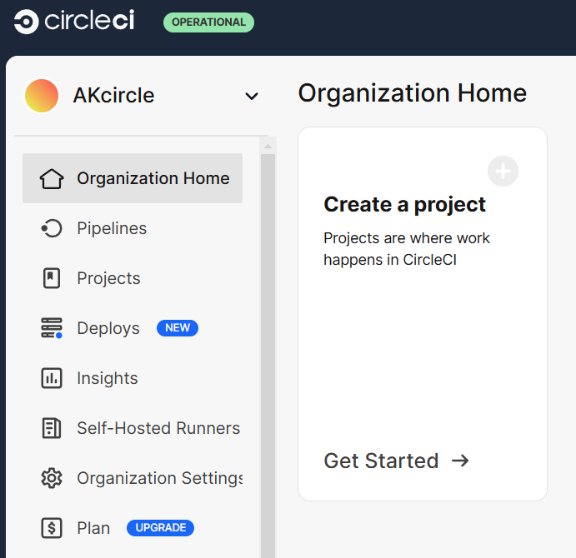

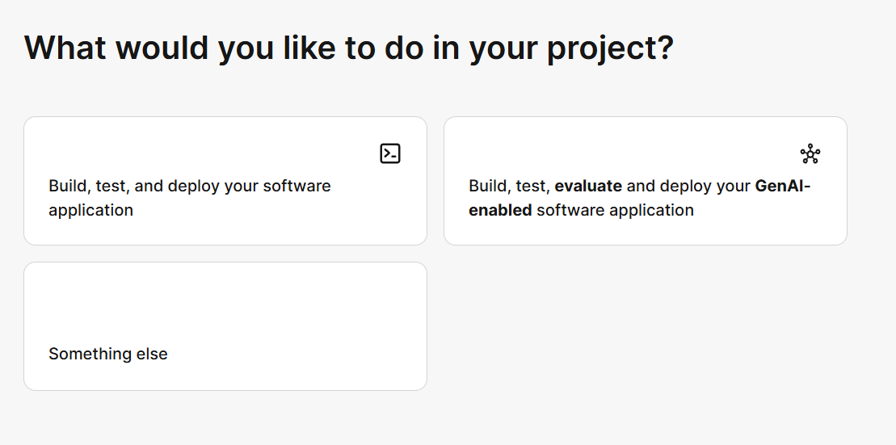

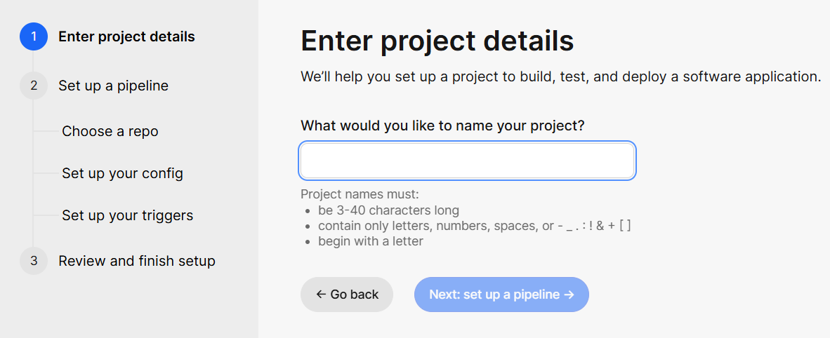

Named the project as -- AKcircleProject

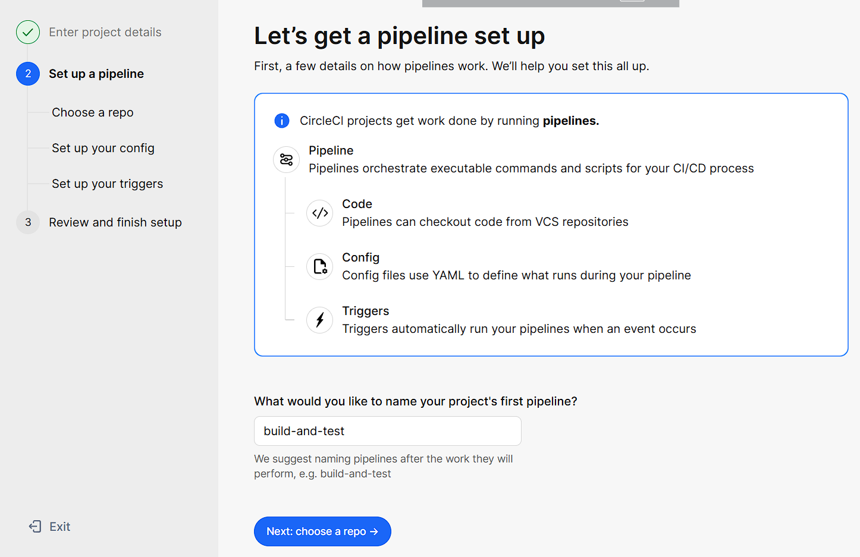

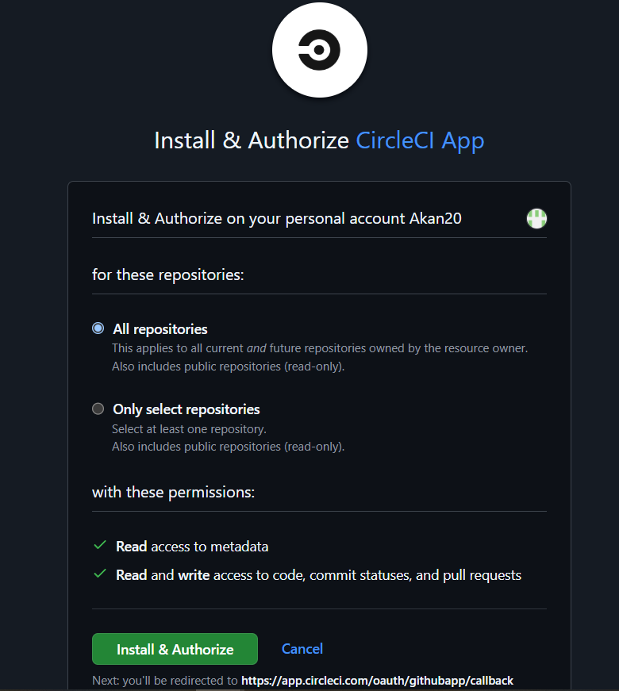

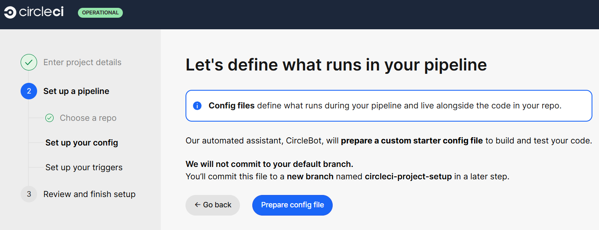

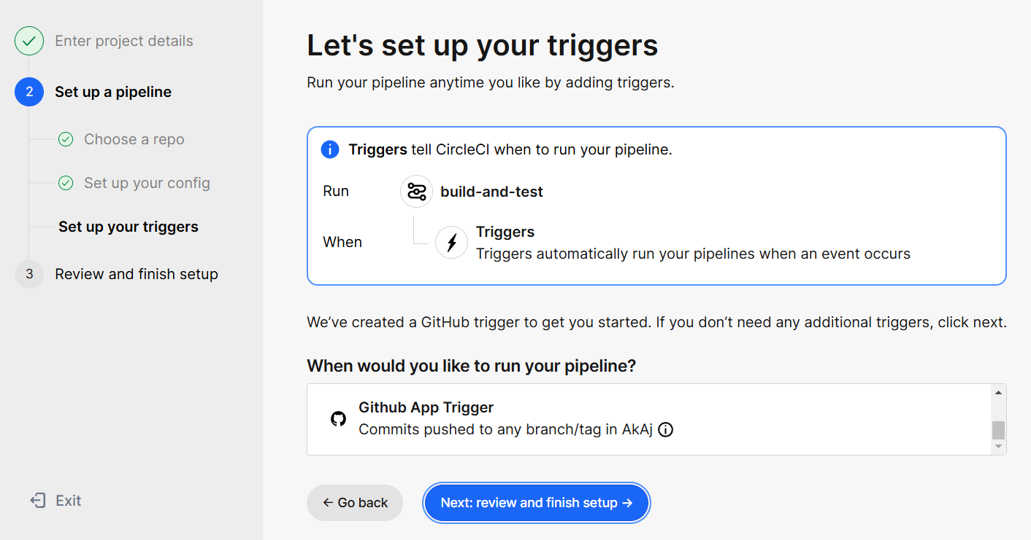

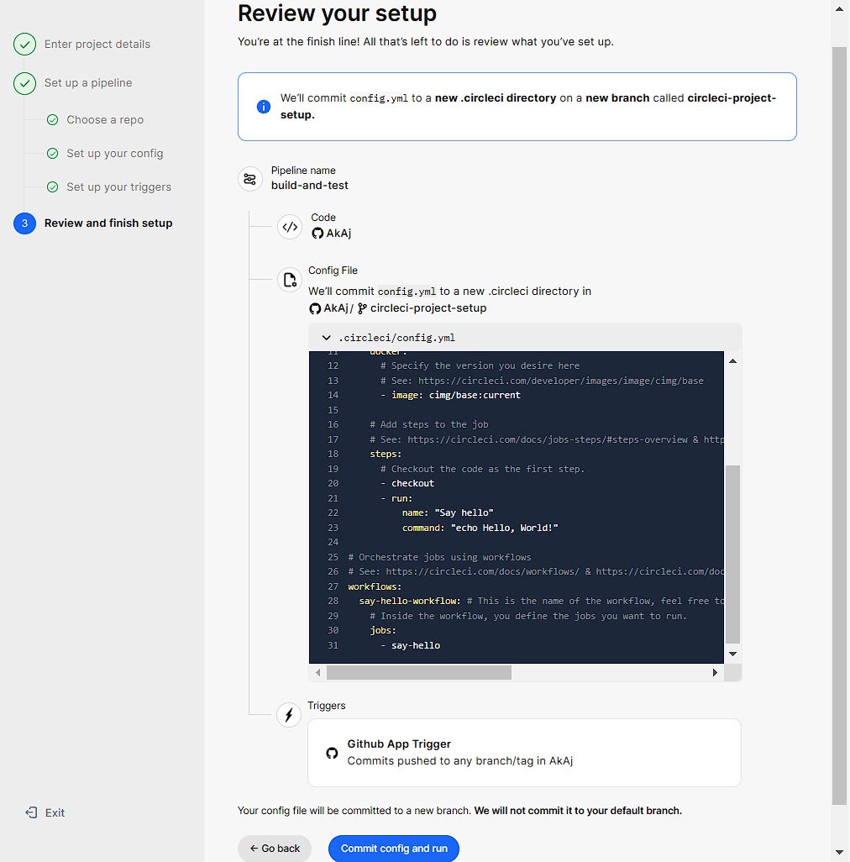

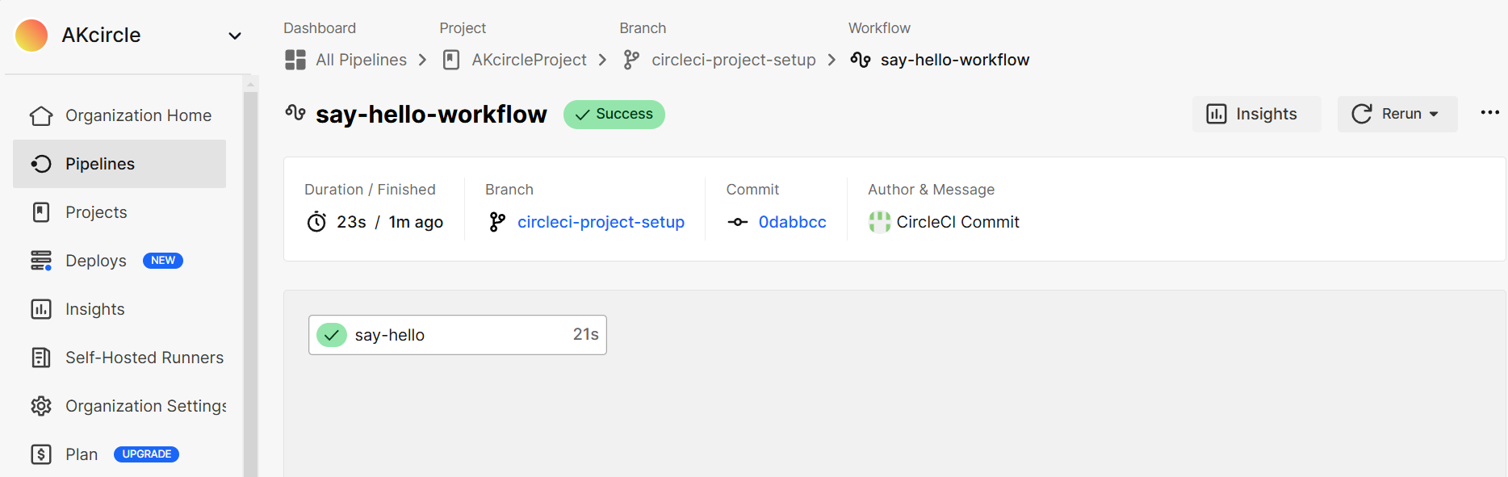

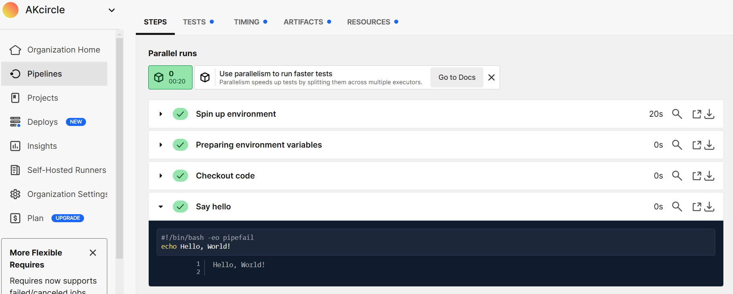

**CircleCI in your workflow**

A software repository on a supported version control system (VCS) needs to be authorized and added as a project on CircleCI

. Every code change then triggers automated tests in a clean container or virtual machine. CircleCI runs each job in a separate container or virtual machine.

**Orbs overview**

* Orbs are reusable packages of parameterizable configuration that can be used in any project. They are made up of reusable configuration elements, for example, jobs, commands, and executors. Orbs are available for many languages, platforms, services, and tools.
* An orb syntax 🡪 contains the namespace, and orb name. A namespace is a unique identifier referring to the organization authoring a set of orbs. The orb name will be followed by an @ symbol and a semantic version string, identifying which version of the orb is being used.
  + Eg: <namespace>/<orb-name>@1.2.3
* After the orb has been imported into the configuration file, the elements provided by the orb are available as <orb-name>/<element>. Orb elements can include jobs, commands, and executors.
* The Orb Registry is an open repository of all published orbs.