

**North South University**

**CSE-299 Junior Design Project**

**“Project Proposal Report”**

**Title:**

**“Smart Bin indicator using raspberry pi and ultrasonic sensor and mobile android app”**

Date of Submission: 04. 07.19

Section: 07

Group: 06

Course: CSE299

Submitted To: ZBZ

Group Members and Id:

1.Sajjad Hasan Rabbi - 1512138042

2.Rokeya Akanda Sriti -1620165042

3.Md. Farhanuzzaman Reza Famous-15103042

**Problem Statement:**

The greatest problem regarding trash management in developing countries like Bangladesh begins at the very beginning point of the process. Due to lack of proper good systems for disposal and collections, trashes and garbage’s end up in the roads and surrounding.

What we have seen is that regulating or managing garbage throughout the city manually has become an inefficient process and tiresome for the workers. The late collection of garbage in some areas has also let the landfill areas to be polluted. Regarding this issue, we want to develop an internet of things (Iot) base system which will tell the men who are at work, when to pick the trash bin or not. This will help to build a cleaner and pollution free society.

According to a report Zurburg 2002, the amount of waste generation in 2010 was around20,000 tons per day, and it is estimated that by 2025 the amount will be no less than around 47000 tons per day. With the existing methods of collecting and disposal it is near impossible to manage such amount of waste in the future as around 30% of trash end up on the roads and public places due to insufficient disposing and collecting methods. And Also, there is even no systematic methodology for the collected trash for treating and recycling, thus most of them end up in and filling and river water, making the environment polluted. The prime impediment of implementing smart trash bin indicator based on IoT in a developing country is the social and economic infrastructure of the country itself. The initial stage of this system comprises of proper disposal and collection, which is the biggest challenge.

**Introduction :**

In this modern day world everything is supervised or controlled through digital platforms. More and more systems are built around the internet of things(Iot) and every day of our lives are becoming part of it. Technology is built for making life easy. So with that in mind, we want to implement our ideas on making a system which will give information to the garbage collectors through an android application which will be built around microcontroller sensor base system and tells the user if the waste container is empty or not, or does it need to be emptied.

Managing waste from trash bin to trash bin has always been a major issue to the urban areas. With growing population, overflowing of wastes around waste container are becoming more of a problem for the residential areas. The places around waste container are becoming dirty and with time, wastes are rotting and giving of bad smells. This leads to spreading of diseases and unhealthy society.

Trash management is one of the major concerns of modern era. As peoples around the world are developing, their concerns and accountability for a healthier and sustainable environment is also increasing. While developed countries are inventing and implementing smart solutions for trash management and bringing about huge positive impacts, trash management seems to be a play out of the league for the under developed or developing countries. There are numerous categories and each with different classifications of waste materials, like clinical to nuclear, biodegradable to non-bio-degradable and common household to industrial toxic waste. While developed countries are able to manage and treat these waste materials of different categories, developing countries like India and Bangladesh are still struggling with the collections and proper disposal of common household waste materials. Disorganized management and dumping of waste is a noticeable cause for ruining the environment in the major cities of these developing countries. Currently, according to a UNFPA report, Dhaka is one of the most polluted cities in the world and one of the issues concerned is the management of municipal waste. Implementing existing smart solutions for trash management systems in developing countries like Bangladesh is a far greater challenge due to many different factors e.g.: socio-economic environment, and the unplanned infrastructural issues. Trash are carried and thrown improperly leading to unhealthy and inhabitable environment that costs the government insane amount of money with not at all positive impact. Therefore, wastes and garbage need to be packed, dumped, collected, transported, manipulated and recycled properly in such ways that garbage becomes a precious wealth of the country.

As we all know the garbage truck collector roams around town for collecting wastes but there are times when certain area’s waste container are not full or not even close to 50%. At this point, the truck has already used a lot of fuel and it was just too inefficient. Then there are other places were the bin gets full more quickly and it overflows. But this all can be reduced with the help of

the indicator and monitoring base system. The device will be installed inside the waste container and the ultrasonic sensor will continuously detect the distance between the sensor and waste as it gets slowly filled. The information is then sent to the microcontroller processor then through the internet to the cloud/server then send to android user device, who will be able to keep track of the waste container in real time. This will make the overall process more efficient and less usage of fuels and human efforts.

The application will interact with the user on two basis, first is when the waste container is 80% and the second time is when the container is 20% or 30% but two days old. The longer the waste stays the more it affects the surrounding and places tends to smell bad. In this basis the user have to empty the waste container in time.

**Literature review :**

In the modern era with the touch of science and technology  we use technologies to make our life more easier and more comfortable. Like we are using  our mobile to book our bus tickets, movie tickets and even we can make an order of food which can be delivered with in  30 minutes. We are trying to make a project named smart trash bin detector using raspberry pi. Our aim will be to build a device which can detect the garbage on a trash bin  and can notify us when the garbage reaches more than 70% in the trash. In the following link we get the idea to when the device send notification.

<https://www.instructables.com/id/Smart-Garbage-Monitoring-System-Using-Internet-of-/?fbclid=IwAR1-GNvZ505WHPY6GhM7ICSmLzXJc_ESlTSRpmv75n6S1pA_9uSptIPcMD8>  If the trash will getting 50% full then we don’t need to empty the trash. It is required when the trash is getting 75% full. In other case, if the trash will only 20% full in seven days and the percentage are not changing then we’ll have to empty our trash. In the following link we get our Idea how we can make the device and which equipment we need to manage to build the device. [https://www.skyfilabs.com/project-ideas/smart-trash-can-using-internet-of-things?fbclid=IwAR1Jpgdlpvn9D62LVqkqAPHvFyBhA0fqehd1_UhmILtfm0VyUn4JHjvQBl8](%20https://www.skyfilabs.com/project-ideas/smart-trash-can-using-internet-of-things?fbclid=IwAR1Jpgdlpvn9D62LVqkqAPHvFyBhA0fqehd1_UhmILtfm0VyUn4JHjvQBl8) we will use raspberry pi, ultrasonic sensor, a wifi module which will be for single chip devices to capable to wifi. We will use the mobile gps system to use our location service. We’ll develop our software using android studio , database using MySQL, our language will be java, framework will be sprint boot, protocol will be HTTP,MQTT, broker will be EMQ and our platform will be Android.

**Timeline :**

Stage - 1: Buying all components required for the project and testing everything is ok or not.

Date - Within **8th July**

Stage - 2: Implementing the sensor, microprocessor controller and other components for a demo version.

Date - Within **19th July**

Stage - 3: Implementing using android sdk for making application for the physical device.

Date - Within **30th July**

Stage - 4 : Continuous testing of both device and application for better accuracy and less bugs.

Date - Within **7th August**

**Planning :**

**P**rocess :

The device will be installed on top of the inside surface of the trash bin. The device will be a raspberry pi  which will take data from the sensor and will send it to the cloud/server using a wifi module to connect to the internet. The sensor which we will be using is ultrasonic wave sensor. The sensor will continuously send ultrasonic wave to keep in check of the depth of the bin. When the depth of the bin gradually decreases due to objects or waste.

The system will alert the user. It will follow two important steps first it will detect if the container is 80% or not, if it is 80% or above then the system will alert the user to empty the container. The second is when the container is around 20% to 30% and haven't been touched two days or more then this will also notify the user to empty the bin. For each bin user will get

location address from the map. This will prevent areas from getting polluted and will reduce fuel consumption  and human labour.

**S**oftware :

1.Database - mySQL

2.Language - java

3.Framework - Spring boot

4.Protocol - HTTP, MQTT

5.Broker: EMQ

6.Platform: Android

**H**ardware:

1.Raspberry pi

2.Ultrasonic Sensor

3.modem

4.resistor

5.led

6.breadboard

7.wires

8.batteries

9.small plastic box

10.trash bin

**E**R Diagram:

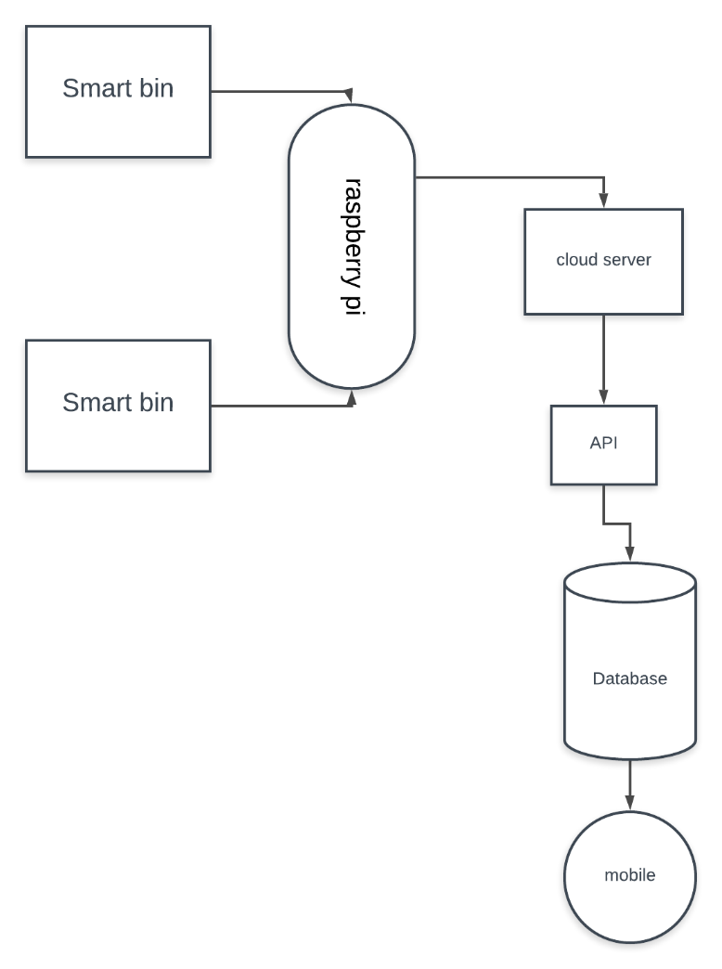

Flowcharts:

