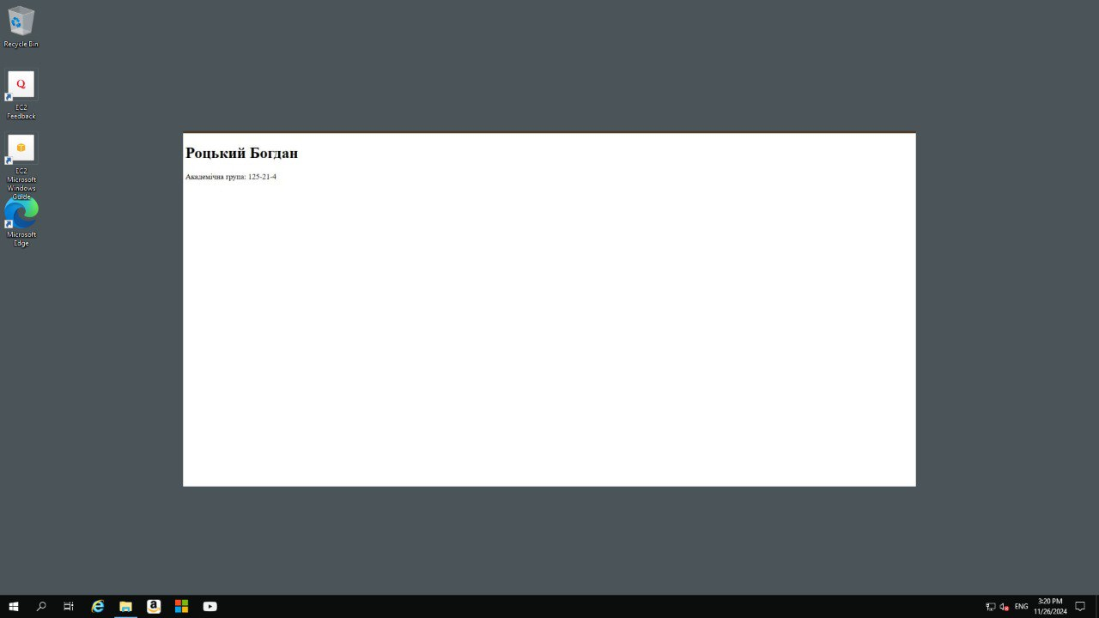
Public IP:
54.234.7.165
Password:
3.ueDsx%)lN&*?g3w2U2xXW;?*ZG8ZSV

