Intel Products Sentiment Analysis from Online Reviews

By:

**Team Synergy**

Avishikta Bhattacharjee

Kumar Priyanshu

Akangkha Sarkar

# **Contents**

**Contents 2**

**Abstract 4**

**Introduction 5**

Project Background 5

Objective 5

Scope 5

**Data Mining and Methodology 7**

Scraper Implementation 7

Tools and Libraries 7

Data Selection 8

Data Preparation and PreProcessing 8

Exploratory Data Analysis ( EDA ) 8

Data Cleaning 8

Data PreProcessing 8

Data Transformation 9

**Sentiment Analysis Methodology 10**

1. Training on Scrapped data from flipkart 10

2. Sentiment Analysis of Technical Reviews with Fine-tuned DistilBERT 10

3. Visualizing sentiment of tech data 10

4. Sentiment Prediction with Fine-tuned BERT 10

Impact of the Results: 11

5. Gemini-Powered User & Technical Data Analysis for Continuous Improvement 11

Model Selection: 12

Data Handling: 13

1. User Reviews: 13

2. Technical Data: 13

3. Handling imbalance data 13

**Implementation 14**

Tools and Libraries 14

Data Manipulation: 14

Machine Learning 15

Natural Language Processing (NLP) 15

Pre-trained Model and Tokenization: 15

Evaluation 15

Visualization 15

Additional Libraries 15

**Model Training: 16**

Model Performance: 16

Sentiment Distribution: 17

User Dataset 17

Technical Dataset: 17

Gemini Model 18

Insights 19

1. Sentiment Distribution Analysis: 19

2. In-depth Analysis of Positive Reviews: 19

3. In-depth Analysis of Negative Reviews: 20

Model Performance and Limitations: 20

**Data Analysis and Visualization 21**

1. Connecting to data sources 21

2. Data modeling 21

3. Visualization 22

4. Publishing the dashboard 22

User Reviews 22

Power BI Report 23

Power BI Report URL 25

Technical Reviews 25

Power BI Report 26

Power BI Report URL 27

**Conclusion 28**

Future Work 29

Strategies for Improvement: 29

**References 31**

## 

# **Abstract**

This project explores user sentiment towards Intel processors over time. We implement a multi-stage machine learning architecture to achieve this. A logistic regression model establishes a baseline for sentiment classification. Subsequently, a fine-tuned DistilBERT model identifies sentiment within reviews collected through a custom web scraper. Positive sentiment extracted by DistilBERT is then analyzed by Gemini, a large language model, to uncover trends in positive perception over time. Finally, Gemini's API is integrated with the Gradio web application, allowing for visualization of these trends within Power BI. This unique approach, combining DistilBERT for accurate sentiment analysis, Gemini for trend exploration, and seamless integration with a web application, provides valuable insights into user sentiment towards Intel processors.

## 

# **Introduction**

## **Project Background**

Understanding user sentiment towards a product is crucial for businesses to adapt and improve. In the highly competitive processor market, Intel constantly strives to deliver the best possible experience for its users. However, gauging user sentiment through traditional methods can be time-consuming and subjective.

This project was initiated to address this need. We aimed to develop a robust and automated system for analyzing user sentiment towards Intel processors over time. This system would leverage the power of machine learning and artificial intelligence to extract valuable insights from online reviews, a rich source of user opinions.

## **Objective**

The primary objective of this project was to develop a system that analyzes sentiment in online reviews to understand user perception of Intel processors over time. This involved:

1. **Sentiment Classification:** Accurately identifying positive, negative, and neutral sentiment within user reviews of Intel processors.
2. **Trend Analysis:** Extracting insights and uncovering trends in positive sentiment towards Intel processors over time.
3. **Visualization:** Presenting the extracted sentiment trends in a clear and user-friendly format for effective communication and analysis.

## **Scope**

This project aimed to analyze user sentiment towards Intel processors over time, with a broader scope than initially anticipated. Here's a breakdown of the achieved functionalities:

* **Data Source:** The project analyzed sentiment from online reviews collected through a custom-built web scraper.
* **Multi-Aspect Sentiment Analysis:** We designed a multi-stage machine learning pipeline to classify sentiment within the reviews, not just for overall impression, but also for specific product aspects like performance and price.
* **Sentiment Trend Analysis:** The project extended beyond basic sentiment classification. We leveraged Gemini, a large language model, to analyze sentiment data (presumably from DistilBERT) and uncover trends in positive perception over time, while also identifying reasons behind both positive and negative sentiment.
* **Visualization:** The project successfully integrated Gemini's API with the Gradio web application. This allowed for visualization of the sentiment trends within Power BI, enabling clear communication of the insights gleaned.

# 

# **Data Mining and Methodology**

This section introduces the Data Mining Methodology applied to solve the research objectives. This project adopts the Knowledge Discovery in Databases (KDD) methodology. The KDD process allows for easy uncovering of vital knowledge from any collection of data. This process consists of the following steps: Data Selection, Data Preparation, Preprocessing and Transformation etc. In figure the KDD Process Flow Diagram is shown. The rest of this chapter discusses each step in the methodology.

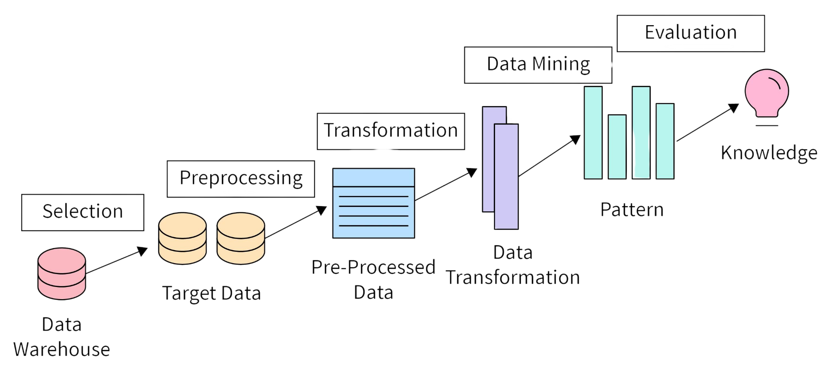

**Figure: Knowledge Discovery in Databases Process Flow Diagram**

## **Scraper Implementation**

We developed a web scraper with Selenium and Beautiful Soup to collect the information required for sentiment analysis. With the help of these technologies, we were able to effectively automate the process of gathering reviews and other pertinent data from internet sources. The procedures and stages involved in implementing the scraper are shown below.

### **Tools and Libraries**

* **Selenium**: Selenium is a powerful tool for controlling a web browser through a program. It is used to navigate web pages and handle dynamic content loading.
* **Beautiful Soup**: Beautiful Soup is a Python library for parsing HTML and XML documents. It creates parse trees for parsed pages, which can be used to extract data from HTML tags.

## **Data Selection**

The initial stage of the KDD ( Knowledge Discovery in Databases ) process involves identifying and selecting pertinent data for analysis. The data used for the research experiment is sourced from Flipkart ( Flipkart, 2024 ). The reviews are related to the products available on flipkart.com. The reviews are from the customers over a period of twelve years ( 2012 - 2024 ). The intel processor product reviews are selected for this project as stated in the problem statement. The data has attributes such as product id, product url, review rating, review content, etc.

## **Data Preparation and PreProcessing**

The next phase in the KDD Methodology after data selection is the Data Preparation and Preprocessing Stage. This phase involves an initial examination of the acquired data. The subsequent sections will discuss the steps taken during this stage.

### **Exploratory Data Analysis ( EDA )**

The chosen data were subjected to exploratory data analysis (EDA) in order to investigate the correlations among the attributes of the dataset. To find trends in the data, this preliminary analysis is helpful. There are five different rating classes in the dataset, with ratings ranging from 1 to 5. The target variable's class imbalance was discovered during the EDA step. After steps were taken to rectify this imbalance, the distribution of the target variable became more balanced.

### **Data Cleaning**

The dataset is further scrutinized. Null Ratings are removed, this is because null ratings do not have any valuable information and can not be transformed into the sentiment label. Checks are carried out to ensure there are no duplicate reviews in the data.

### **Data PreProcessing**

Sentiment analysis aims to understand the emotional tone (positive, negative, or neutral) expressed within a piece of text. However, raw text data often contains inconsistencies and noise that can hinder the accuracy of this analysis. To ensure reliable sentiment analysis results, data cleaning and normalization are crucial pre-processing steps.

* **Removing Noise:** This includes eliminating unnecessary characters, punctuation, and stop words that do not contribute to the meaning of the text.
* **Tokenization:** Breaking down the text into smaller units, such as words or phrases, known as tokens.
* **Lowercasing:** Creates consistency in the data, as sentiment might not be conveyed through case variations in Malayalam.
* **Punctuation Removal (Selective):** While some punctuation can be sentiment-bearing (exclamation marks!), removing unnecessary punctuation reduces noise and improves BERT's ability to focus on the core meaning.
* **Repeated Symbol Removal:** Eliminates typos and extraneous characters, leading to cleaner data for BERT to process.

### **Data Transformation**

In order to train the deep learning models, The data undergo a data transformation stage. Machine Learning models don't understand text data, therefore, at this stage the reviews are transformed from text to numerical vectors.

# 

# **Sentiment Analysis Methodology**

## **Training on Scrapped data from flipkart**

* The scraped data is used to train the DistilBERT model.
* The model was exposed to the text within the scraped data, helping it learn the relationships between words and how they are used in context.
* This training process allows the DistilBERT model to perform various natural language processing tasks, such as text classification, question answering, or sentiment analysis.

## **Sentiment Analysis of Technical Reviews with Fine-tuned DistilBERT**

* **Preprocess Scrapped Technical Reviews:** Applied the same preprocessing steps used for training data to new Technical Intel processor reviews whose sentiments to be predicted.
* **Pass the reviews through the fine-tuned model:** The model generated outputs indicating the sentiment (positive, negative) for each review.

## **Visualizing sentiment of tech data**

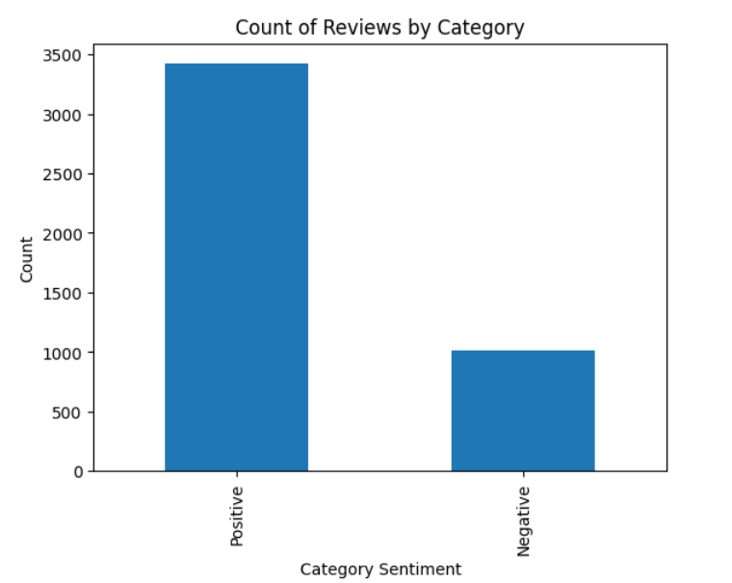

**Figure: Sentiment of tech data**

## **Sentiment Prediction with Fine-tuned BERT**

Our fine-tuned BERT model has successfully classified sentiment in a large set of technical reviews. Here's a breakdown of its performance:

* **Positive Reviews Identified:** The model accurately identified **3422 reviews as positive**. This indicates a strong ability to detect positive sentiment expressed in technical reviews, which can be valuable for understanding user satisfaction with products or services.
* **Negative Reviews Identified:** The model also effectively classified **1016 reviews as negative**. This demonstrates its competence in recognizing negative sentiment, allowing you to pinpoint areas for improvement or identify potential customer pain points.

### **Impact of the Results:**

* **Understanding User Sentiment in Technical Data:** By analyzing the distribution of positive and negative reviews, you can gain a deeper understanding of user sentiment towards a product, service, or feature.
* **Data-driven Decision Making:** These sentiment predictions can inform data-driven decisions to improve user experience, address customer concerns, or prioritize product development efforts.

## **Gemini-Powered User & Technical Data Analysis for Continuous Improvement**

Using gemini to give insight of user data over time

Gemini can analyze historical user data to predict future behavior. This allows you to anticipate user needs and proactively address potential issues, enhancing customer satisfaction.

### 

# **Model Selection:**

Implemented transfer learning with a pre-trained DistilBERT model (BERT uncased tokenizer) and a fine-tuned learning rate of 3e-5.

**DistilBert Model Link**:

<https://drive.google.com/file/d/1aljvTiUOMOYfS1qc8GhoRDScYkNPPOfE/view?usp=sharing>

**Logistic regression Model Link:**

<https://drive.google.com/file/d/1NQOJYpV4vsAmBJO6LA0liRuvZufyYuel/view?usp=sharing>

A comparative study between DistilBert and logistic regression was done which showed better performance of DistilBERT over logistic regression with feature extraction :

* **Accuracy**: Logistic regression with feature engineering achieved an accuracy of 43% for the negative label, which suggests a significant room for improvement. DistilBERT, on the other hand, offered a much higher accuracy of 1, indicating a superior ability to correctly classify negative sentiment within the reviews.
* **Nuanced Sentiment Understanding**: Logistic regression, while effective for simple classification tasks, often relies on manually crafted features. These features may not capture the complexities of human language, leading to difficulties in identifying subtle sentiment variations. DistilBERT, being a pre-trained large language model, is adept at understanding these intricacies. It considers the context and relationships between words within a review, allowing it to capture more nuanced sentiment compared to logistic regression with feature extraction.

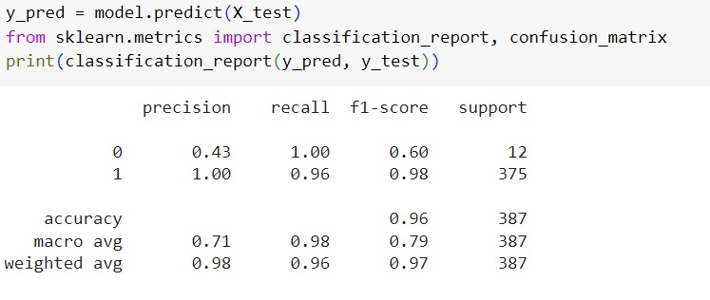

**Classification report of LR with TF-IDF**

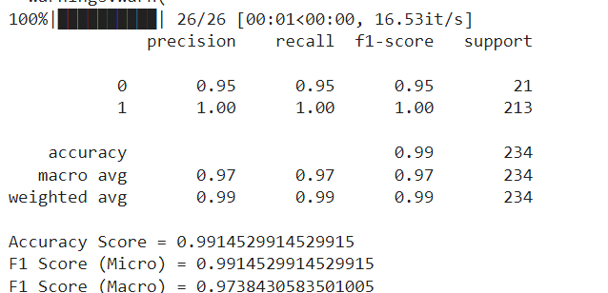

**Classification report of DistilBERT**

In essence, the accuracy advantage of DistilBERT and its ability to grasp the subtleties of language made it a far more suitable choice for this sentiment analysis project, particularly when dealing with the complexities of user reviews.

## **Data Handling:**

### **User Reviews:**

* + Ratings were categorized into sentiment based on additional parameters:
    - Positive: Rating of 4 or 5
    - Negative: Rating of 2 or 1
    - Neutral: Rating of 3 (further classified based on "like" and "dislike" parameters)

### **Technical Data:**

* + The fine-tuned BERT model was used to analyze the sentiment of technical aspects.
  + Gemini API was employed to obtain sentiment analysis specifically for Intel products (presumably to improve accuracy or gather additional insights).

### **Handling imbalance data**

1. **The Challenge of Imbalanced Data**:

In machine learning, especially classification tasks, imbalanced data refers to situations where one class (the majority class) has significantly more samples than others (the minority class). This poses a problem because models trained on such data tend to favor the majority class, leading to poor performance in classifying the minority class.

1. **Adaptive Weighting**

Adaptive weighting is a technique used to address imbalanced data by assigning weights to each data point during training. These weights influence the model's learning process, placing more emphasis on the minority class samples.

1. **How it Works:**
   1. Calculating Initial Weights: Weights are initially assigned to each data point based on the class distribution. Common approaches include:
   * Inverse Class Frequency: Weights are inversely proportional to the class frequency. Minority class samples get higher weights, and majority class samples get lower weights.
   * Cost-Sensitive Learning: Weights are assigned based on a pre-defined cost associated with misclassifying each class. Higher costs are assigned to misclassifying the minority class.

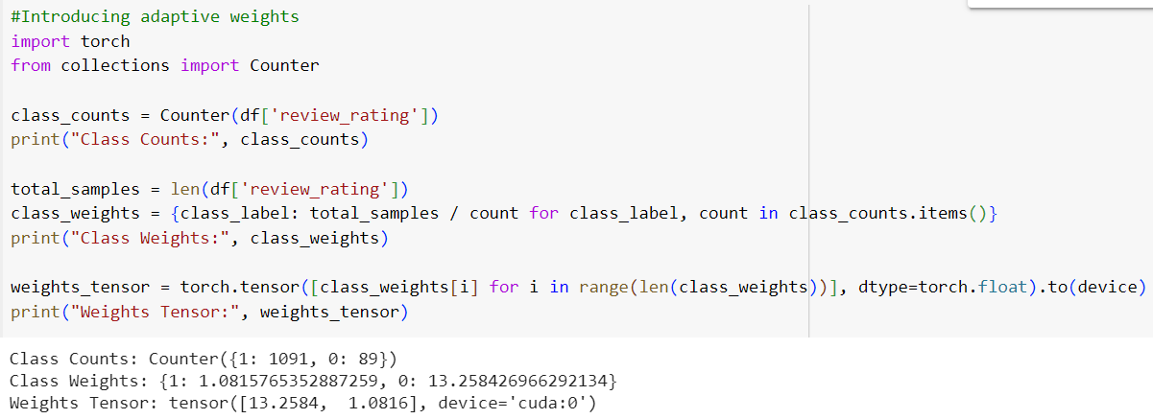

**Figure: Adaptive Weights**

# **Implementation**

## **Tools and Libraries**

The list of tools and libraries used in code includes:

### **Data Manipulation:**

* pandas (pd)
* numpy (np)

### **Machine Learning**

* scikit-learn (metrics)

### **Natural Language Processing (NLP)**

* transformers
* torch
  + torch.utils.data (Dataset, DataLoader, RandomSampler, SequentialSampler)
* nltk

### **Pre-trained Model and Tokenization:**

* transformers (BertTokenizer, BertModel, BertConfig)

### **Evaluation**

* scikit-learn (classification_report, confusion_matrix)

### **Visualization**

* matplotlib.pyplot (plt)
* seaborn

### **Additional Libraries**

* gradio (local host)
* gemini (LLM by Google)

# **Model Training:**

To ensure our model effectively learns to identify sentiment in technical reviews, we've adopted a strategic approach to data partitioning. We've dedicated a significant portion, **80% (which translates to 1180 data points)**, of our dataset to the training process.

## **Model Performance:**

With an accuracy of 99.1%, the model consistently classifies reviews correctly. Furthermore, both F1 scores (Macro and Weighted Average) exceed 0.97, indicating a strong balance between identifying positive and negative sentiment accurately. Precision and recall values near 1.0 for each class further demonstrate the model's ability to rarely misclassify reviews. In essence, this model excels at understanding the sentiment expressed in user reviews.



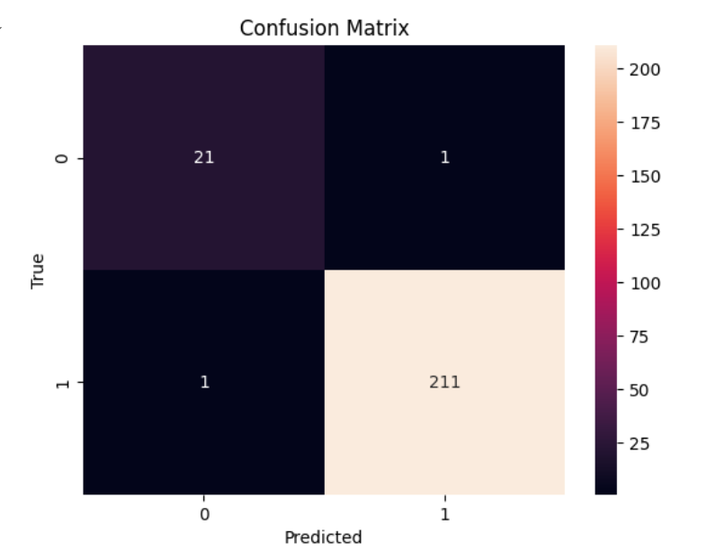

## **Sentiment Distribution:**

### **User Dataset**

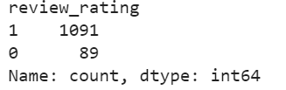

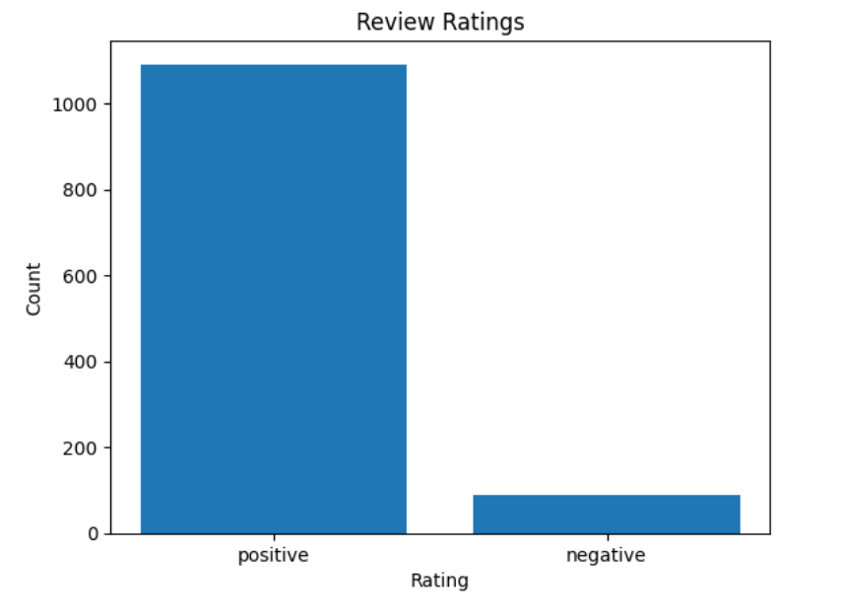

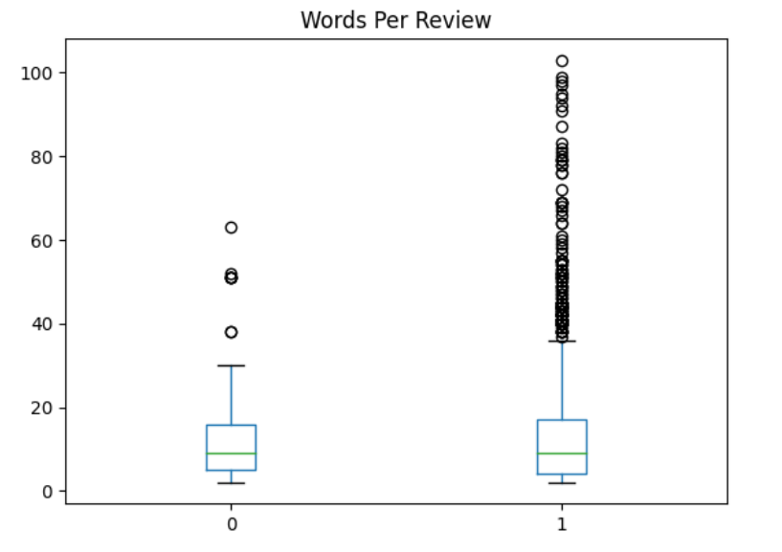

### **Technical Dataset:**

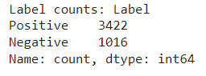



## **Gemini Model**

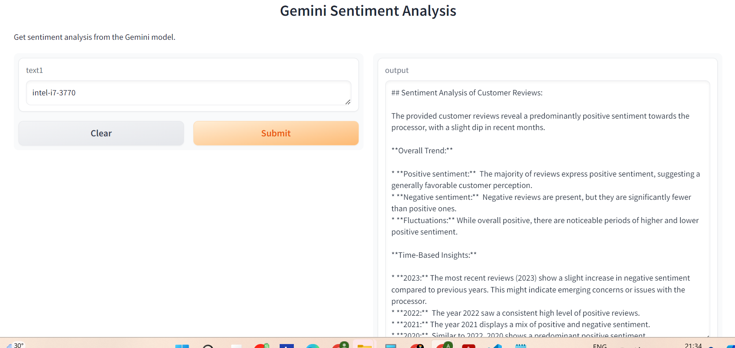

**Figure : Gemini results**

### 

**Figure : Gemini results**

## **Insights**

### **Sentiment Distribution Analysis:**

* **Positive vs. Negative Sentiment Ratio:** Analyze the overall distribution of positive (3422) and negative (1016) reviews identified by the model. This provides a high-level understanding of user sentiment towards the product or service being reviewed.
* **Identifying Trends Over Time:** If you have historical data, explore how the sentiment distribution has changed over time. Are there periods with a higher concentration of positive or negative reviews?
* **Sentiment by Product Feature/Aspect:** If your reviews mention specific features of the product or service, categorize the reviews by sentiment and feature. This allows you to pinpoint which features receive the most positive or negative feedback.

### **In-depth Analysis of Positive Reviews:**

* **Identifying Common Positive Themes:** Analyze the positive reviews to identify recurring themes or aspects that users appreciate. This can reveal strengths of your product or service.
* **Actionable Insights from Positive Feedback:** Can you glean actionable insights from the positive reviews? For example, are there specific features users consistently praise that could be further emphasized in marketing materials?

### **In-depth Analysis of Negative Reviews:**

* **Understanding Reasons Behind Negative Sentiment:** Analyze the negative reviews to understand the root causes of user dissatisfaction. This can help identify areas for improvement in the product or service.
* **Prioritizing Issues Based on Sentiment Strength:** Not all negative reviews carry the same weight. Explore if the model assigns different sentiment scores within the "negative" category. This can help prioritize issues based on their severity as perceived by users.
* **Actionable Steps to Address Negative Feedback:** Develop actionable steps to address the concerns raised in negative reviews. This demonstrates responsiveness to user feedback and can help improve customer satisfaction.

## **Model Performance and Limitations:**

Our fine-tuned BERT model achieved a remarkable **99.1% accuracy** in classifying sentiment on a dataset of user reviews. This signifies the model's exceptional ability to identify positive and negative sentiment with a high degree of precision.

However, it's important to acknowledge that even with such a high accuracy, there will still be a small number of misclassified reviews. In this case, approximately **10 reviews (0.9% of the data)** were categorized incorrectly.

Here's why such errors can occur:

* **Nuances of Language:** Technical reviews, like any human language, can be nuanced and complex. Sarcasm, subtle negativity, or the use of slang can sometimes be misinterpreted by the model, even with fine-tuning.
* **Data Ambiguity:** Certain reviews might be inherently ambiguous, expressing a mix of positive and negative sentiment. The model might struggle to definitively classify these cases.
* **Limitations of Machine Learning:** Machine learning models, despite their advancements, are not perfect. There will always be a margin of error, especially when dealing with the complexities of human language.

# 

# **Data Analysis and Visualization**

The data we collected is visualized in a Power BI dashboard and our findings are integrated in the *Gradio* interface. The steps ranged from Data preparation, publishing the dashboard, creating the *Gradio* website, and incorporating the respective functions to show our findings on **two different Gradio web interfaces** namely for ***User reviews*** and ***Technical Reviews.***

The steps undertaken in this project are :

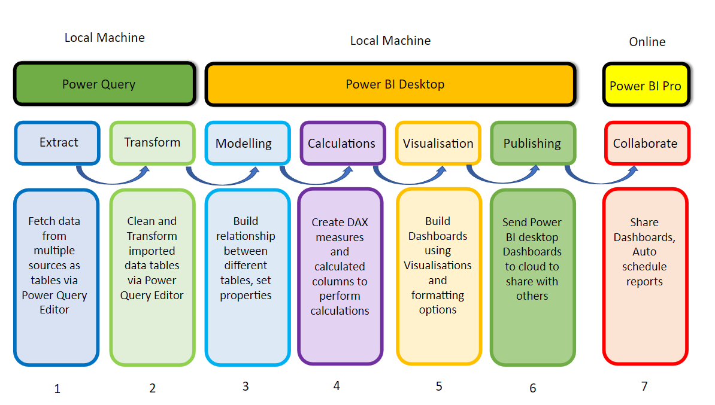

**Figure: Stages of Data Analysis**

### **Connecting to data sources**

We utilized Excel as the primary data source for our visualizations. Excel's flexibility and widespread use made it an ideal choice for initial data aggregation and analysis.

### **Data modeling**

Effective data modeling is highly needed for creating meaningful dashboards. essentially means defining relationships between tables and making calculations that aggregate data.

### **Visualization**

Power BI helps us formulate various visualizations like charts, maps, matrices, etc. Design principles are very crucial in creating an effective dashboard. These principles include clarity, consistency, relevance, and interactivity.

### **Publishing the dashboard**

After creating the dashboard, it was published on the web to ensure accessibility. The published dashboard's web link was then embedded into the Gradio interface. This seamless integration allowed users to interact with the data findings directly through the Gradio platform.

*Interactive Elements***:** Users can interact with the data through various controls, such as dropdown menus, to customize their view and focus on specific aspects of the reviews.

## **User Reviews**

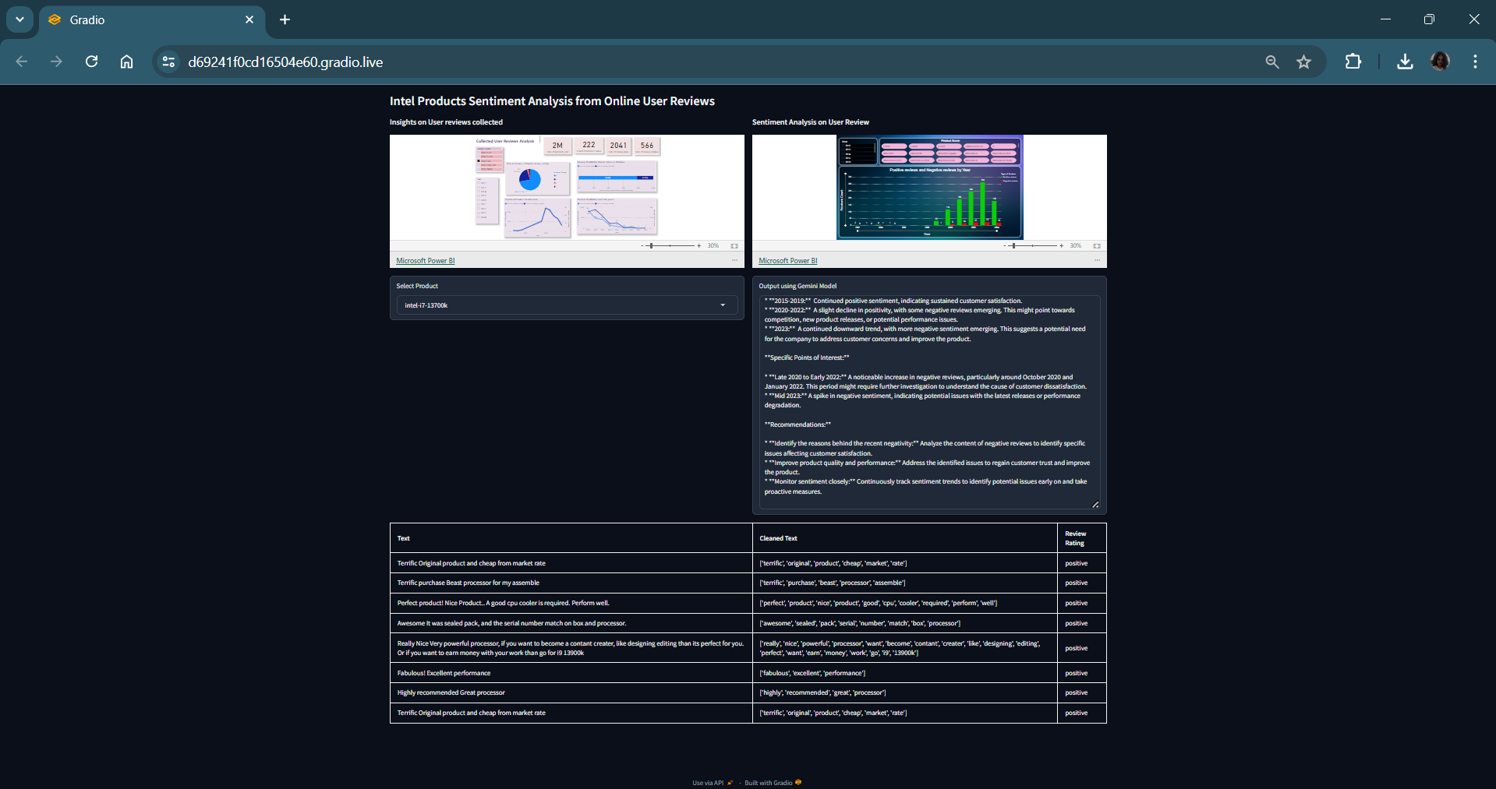

**Gradio Interface for User Reviews**

**Components in Web Interface:** Users can view a comprehensive list of all the processor names we have extracted from the data in the dropdown, and get the respective details. It has :

1. **Processor Analysis Report:** Two Power BI reports (explained in the next section )
2. **Gemini Output for Selected Processor:** Displays the Gemini analysis results of positive and negative trends over time for the processor selected from the dropdown menu.
3. **Review Analysis Table:** Showcases a table of user reviews for the selected processor, including sentiment analysis results and the associated KPIs that explain whether the sentiment is positive or negative.

### **Power BI Report**

This report below models and visualizes user reviews scraped from various sources, encompassing a total of 1,156 reviews for 38 distinct processors from 2012-2024, later cleaned it to 5 years only. The dataset includes the following fields:

*product_id, processor_name , product_url , product_cost , review content, review_posted_date, review_rating, review likes and review dislikes.*

1. **Rating Distribution:** Visualizes the distribution of review ratings, noting the absence of 2-star reviews.
2. **Customer Engagement Analysis:** Utilizes review_likes and review_dislikes to assess customer engagement and review validity.
3. **Credibility Score:** Displays a line chart of the credibility score for reviews calculated per year.
4. **Product Satisfaction:** Shows a line chart reflecting product satisfaction based on review ratings and customer engagement through review content number.
5. **Summary Cards:** Provide comprehensive data for product_cost, number of processors (product_name), and sums of review_likes and review_dislikes.
6. **Filters:** Data can be filtered by processor_name and year.

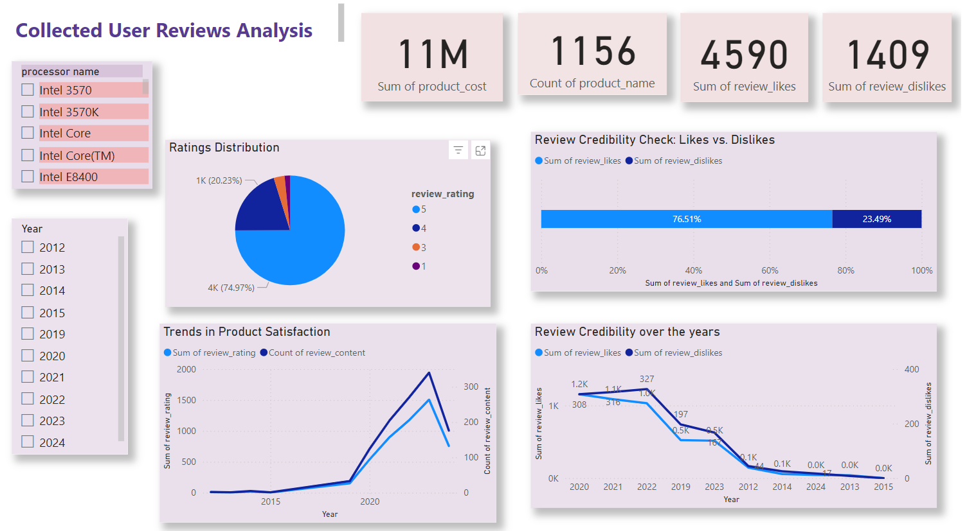

**Comprehensive Report of the intel processors here based on User Reviews**

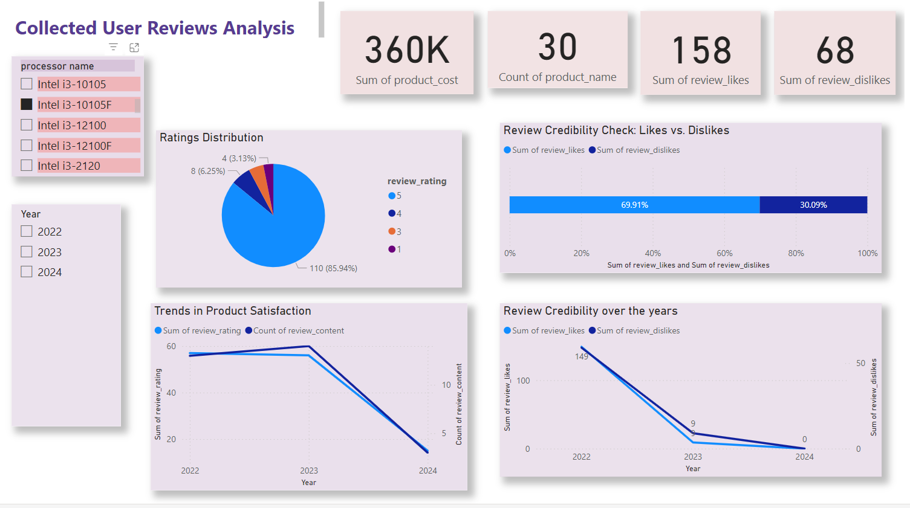

**Report of the processor intel i3-10105f (individual processor)**

This report below displays the total number of positive and negative reviews for each Intel processor, broken down by year, based on sentiment analysis performed on each processor’s reviews.

~~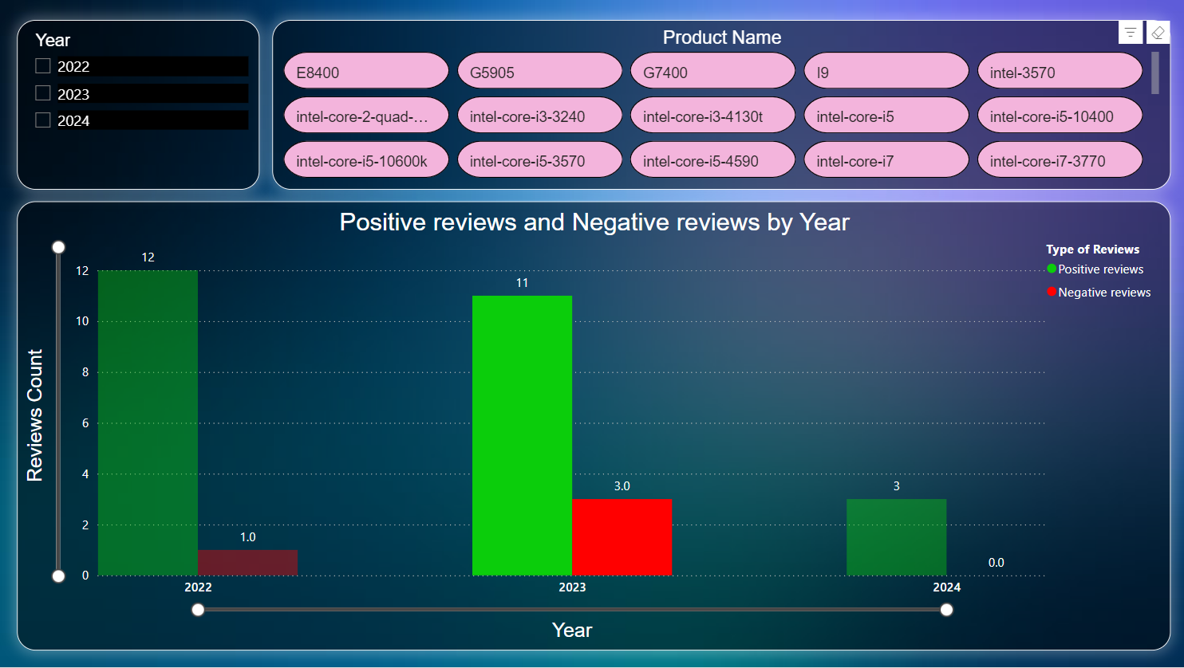~~

**Report of the sentiment analysis done on the user reviews of the processors**

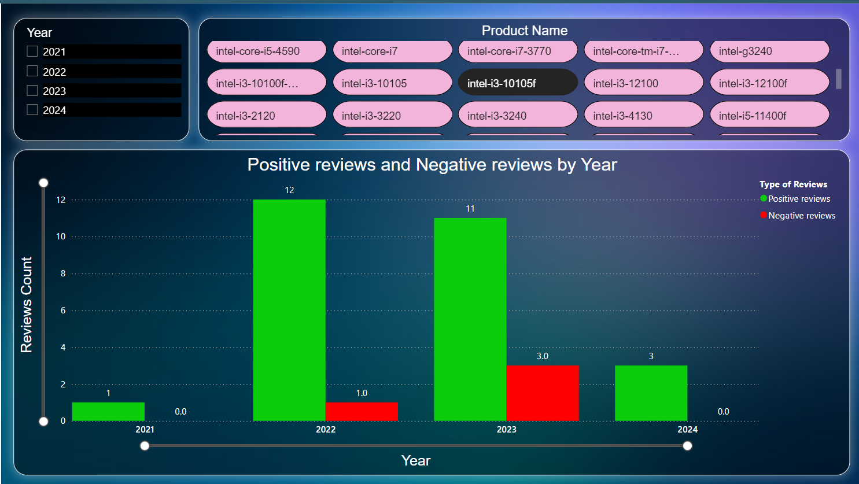

**Report of the processor intel i3-10105f [Reviews count vs year ]**

### **Power BI Report URL**

**Report 1:** [**Collected User Reviews Analysis**](https://app.powerbi.com/view?r=eyJrIjoiOThlY2JmY2QtMmM5MS00MTEzLWJiNTUtNjFlMzYwYmUxYzcwIiwidCI6Ijg0YzMxY2EwLWFjM2ItNGVhZS1hZDExLTUxOWQ4MDIzM2U2ZiIsImMiOjZ9)

**Report 2:** [**Sentiment Analysis Report on User Reviews**](https://app.powerbi.com/view?r=eyJrIjoiMmQ0ZGM4YzQtOTNmNi00NDRmLWE1Y2UtOTQ5ZjVlMTMxODNjIiwidCI6Ijg0YzMxY2EwLWFjM2ItNGVhZS1hZDExLTUxOWQ4MDIzM2U2ZiIsImMiOjZ9)

## **Technical Reviews**

We have collected technical reviews from various resources, encompassing a total of almost 4.5k data [4437 precise] for 744 distinct processors including specifications from 2012-2024 later cleaened it to have the data for the last 5 years.

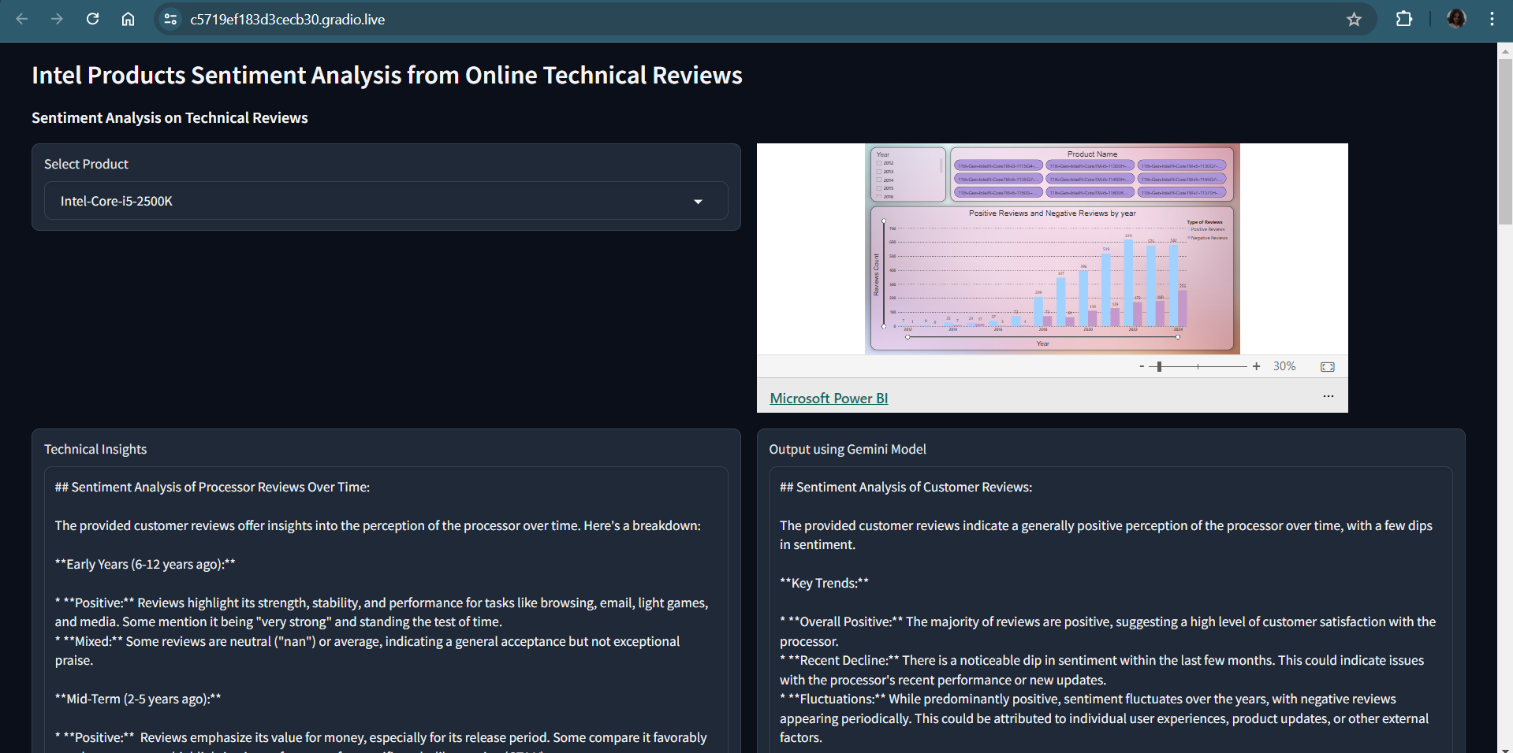

**Gradio Interface for Technical Reviews**

**Components in Web Interface:** Users can view a comprehensive list of all the processor names we have extracted from the data in the dropdown, and get the respective details. It has :

1. **Processor Analysis Report:** One Power BI report for showcasing the results of the sentiment analysis (explained in the next section )
2. **Gemini Output for Selected Processor:** Displays the Gemini analysis results of negative and positive trends over the time for the processor selected from the dropdown menu
3. **Review Analysis Table:** Showcases a table of user reviews for the selected processor, including sentiment analysis results and the associated KPIs that explain whether the sentiment is positive or negative.
4. **Technical Report from Technical Dataset** :Pinpointing strengths and weaknesses for each processor model:revealing which features users value most and where improvements are needed. Examining negative reviews will highlight user pain points related to performance or compatibility. This comprehensive data will guide future development efforts, ensuring processors meet user expectations and address their concerns.

### **Power BI Report**

The dataset included fields such as:

*product_id, product_name , product_url , product_cost , review_title, review_posted_date and review_content* .

So we shifted our focus to sentiment analysis on the reviews only hence we modeled one single Power BI report for this.

This report below displays the total number of positive and negative reviews for each Intel processor, broken down by year, based on sentiment analysis performed on each processor’s reviews.

**Filters:** Data can be filtered by processor_name and year.

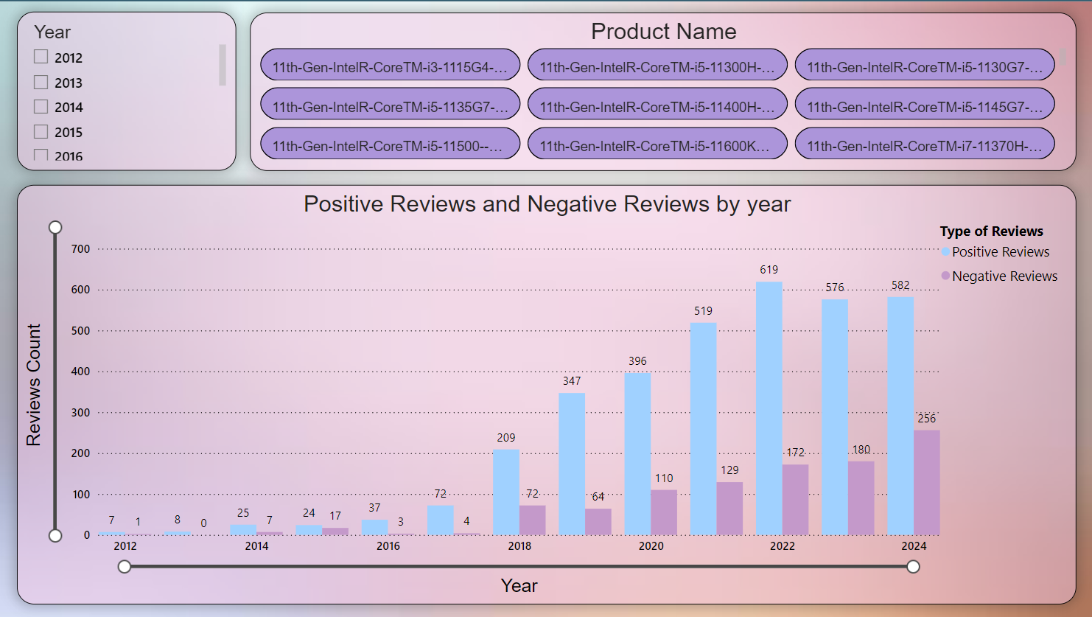

**Report of the sentiment analysis done on the technical reviews of the processors**

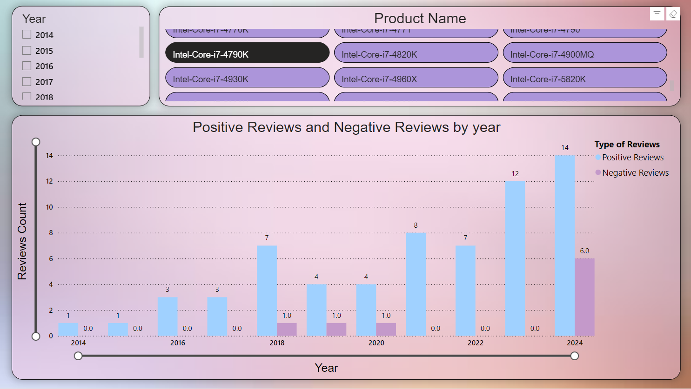

**Report of the processor Intel-Core-i7-4790K [Reviews count vs year ]**

### **Power BI Report URL**

Report: [**Sentiment Analysis on Technical Reviews**](https://app.powerbi.com/view?r=eyJrIjoiZmY5MThiMTktY2UzNi00OWI4LWI2M2QtZjczNjcwNGU3MmM4IiwidCI6Ijg0YzMxY2EwLWFjM2ItNGVhZS1hZDExLTUxOWQ4MDIzM2U2ZiIsImMiOjZ9)

# **Conclusion**

# 

Our comprehensive **sentiment analysis of user and technical reviews** from **2019 to the present(2024**) has provided valuable insights into the **top 10 Intel processors**. Leveraging web scraping tools such as Selenium and Beautiful Soup, we collected a substantial dataset comprising **1,173 user reviews and 4,437 technical reviews from various credible sources**. Each review was assessed for user engagement and credibility, ensuring the reliability of our findings.

In this analysis, reviews were classified as either positive (+1) or negative (0). By aggregating these sentiment scores, we identified the Intel processors with the highest overall positive sentiment in both user and technical review categories. The results have been visually presented in a Power BI dashboard, enabling a clear and intuitive understanding of the data.

Additionally, we utilized **Gradio to highlight the specific words and phrases that contributed to a review's positive or negative classification**, providing further context and transparency. This nuanced approach allowed us to uncover the factors driving sentiment, offering deeper insights into user and technical reviewer perspectives.

**The final rankings reflect the processors that have garnered the most favorable reception, based on their cumulative sentiment scores**. These findings can guide consumers and professionals in making informed decisions about Intel processors, supported by a robust analysis of user and technical feedback over the past five years.

## **Future Work**

### **Strategies for Improvement:**

* **Error Analysis:** By closely examining the misclassified reviews, we can gain insights into the types of language the model struggles with. This knowledge can be used to further refine the fine-tuning process or data pre-processing techniques.
* **Ensembling Techniques:** Combining predictions from multiple fine-tuned BERT models or other sentiment analysis algorithms can lead to even more robust performance and potentially reduce errors.
* **Multi-label Classification Approach**:Traditional sentiment analysis models typically classify reviews as positive, negative, or neutral. However, mixed sentiments often combine positive and negative aspects within a single review. Multi-label classification allows the model to assign multiple sentiment labels to a single review, capturing these nuances.

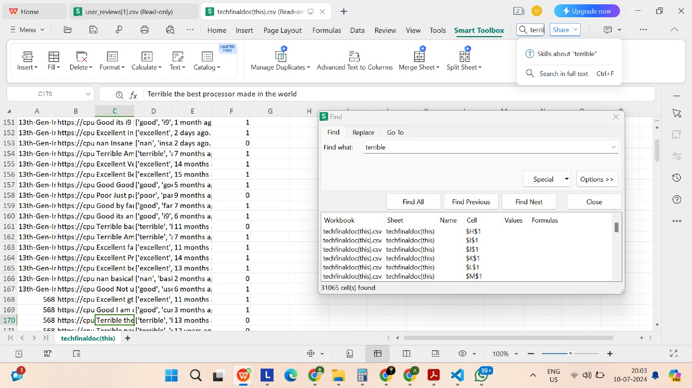

**Visualization of Ambiguous Review**

# **References**

1. White, G. (2018). *Mastering Microsoft Power BI: Expert techniques for effective data analytics and business intelligence*. Packt Publishing.
2. Huang, W., Song, G., Li, M., Hu, W., & Xie, K. (2013). Adaptive Weight Optimization for Classification of Imbalanced Data. In *Lecture Notes in Computer Science* (Vol. 8261, pp. 546-553). Springer. https://doi.org/10.1007/978-3-642-42057-3_69
3. Kudo, T., & Richardson, J. (2018). SentencePiece: A simple and language independent subword tokenizer and detokenizer for Neural Text Processing.
4. Das, M., Pandey, S. K., & Mukherjee, A. (Year). Evaluating ChatGPT Against Functionality Tests for Hate Speech Detection.
5. Vishal Kesti. (Year). Bert+CNN for Disaster Tweets. Kaggle. Retrieved July 14, 2024, from https://www.kaggle.com/code/vishalkesti/bert-cnn-for-disaster-tweets
6. Pattnaik, S. (Year). End to End NLP Project: Sentiment Analysis on Amazon Reviews [Video]. YouTube. Retrieved July 14, 2024, from https://www.youtube.com/watch?v=6A2w-KYG4Ko
7. Amazon Reviews 23. (Year). Retrieved July 14, 2024, from https://amazon-reviews-2023.github.io/
8. Jain, S. (2023, May 23). KDD Process in Data Mining. *GeeksforGeeks*. Retrieved July 8, 2024, from https://www.geeksforgeeks.org/kdd-process-in-data-mining/
9. Utkarsh. (2023, June 12). KDD in Data Mining. *Scaler*. Retrieved July 8, 2024, from https://www.scaler.com/topics/data-mining-tutorial/kdd-in-data-mining/