RESUME

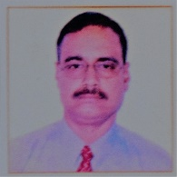

**NAME** : -MANABENDRA GOASWAMI

**FATHERS NAME**  : - (L) Bidyadhar Goswami

**ADDRESS** : - House No – 29, Madhabdev Pur,

Rehabari, Guwahati Kamrup (Metro),

Assam, Pin - 781008

**QUALIFICATION**  : - B.Sc from GUWAHATI UNIVERSITY in the year of 1985

**Date of Birth** : - 1st April 1965

**Experience: -**

1. Worked as MEDICAL REPRESENTATIVE from 1986 with HQ GUWAHATI in a reputed Pharmaceutical House of Calcutta.
2. Worked as an AREA MANAGER from 1988 with HQ GUWAHATI covering entire N.E.Region including for two years in your reputed organization M/S, DIAMND DRUGS & CHEMICAL WORKS, KOLKATA
3. Worked as SR.AREA MANAGER from 2009 in a reputed NEW DELHI based Pharmaceutical House with HQ GUWAHATI