**Practical – 01**

**Aim :**

Installation of MetaMask and study spending Ether per transaction..

Screenshot (71).png

**Search for the Metamask Extension on the chrome and doen the extension.**

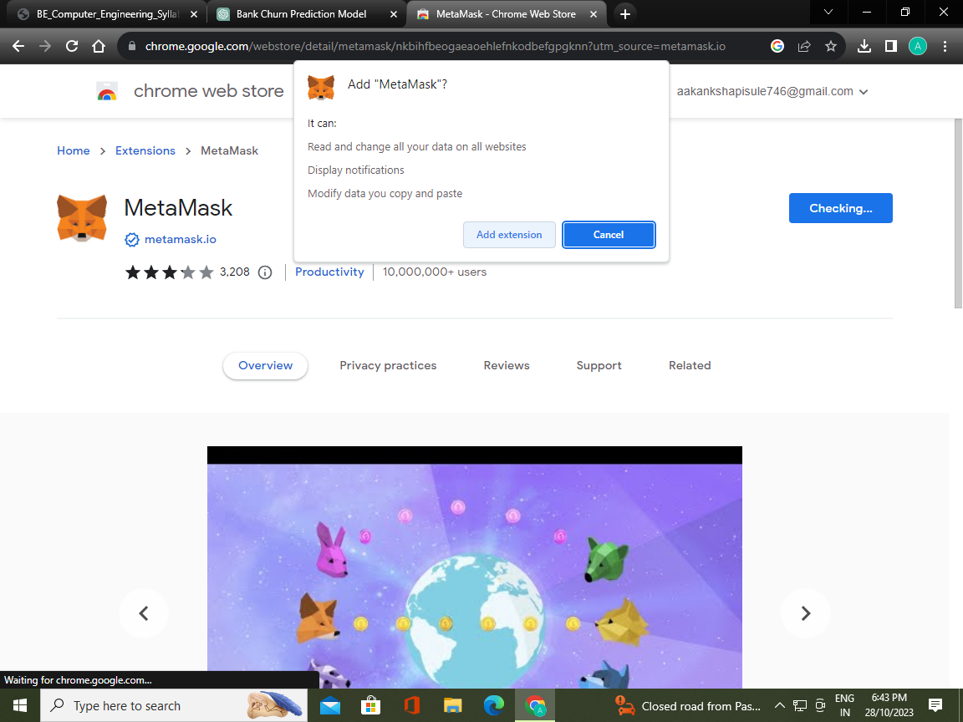

**Add Extension to the Chrome Bowser.**

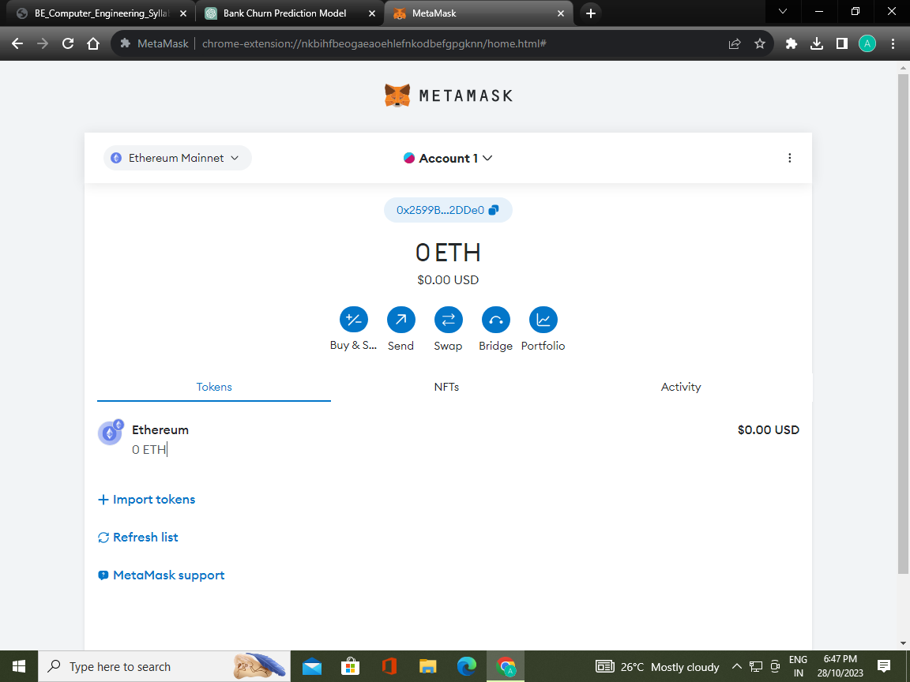

**After creating the Wallet**

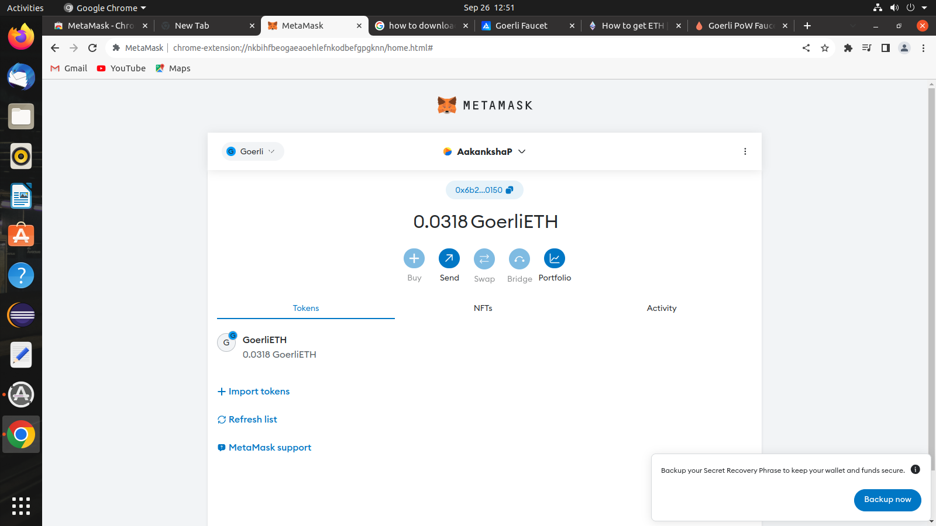

**After getting Ether in Digital Wallet.**

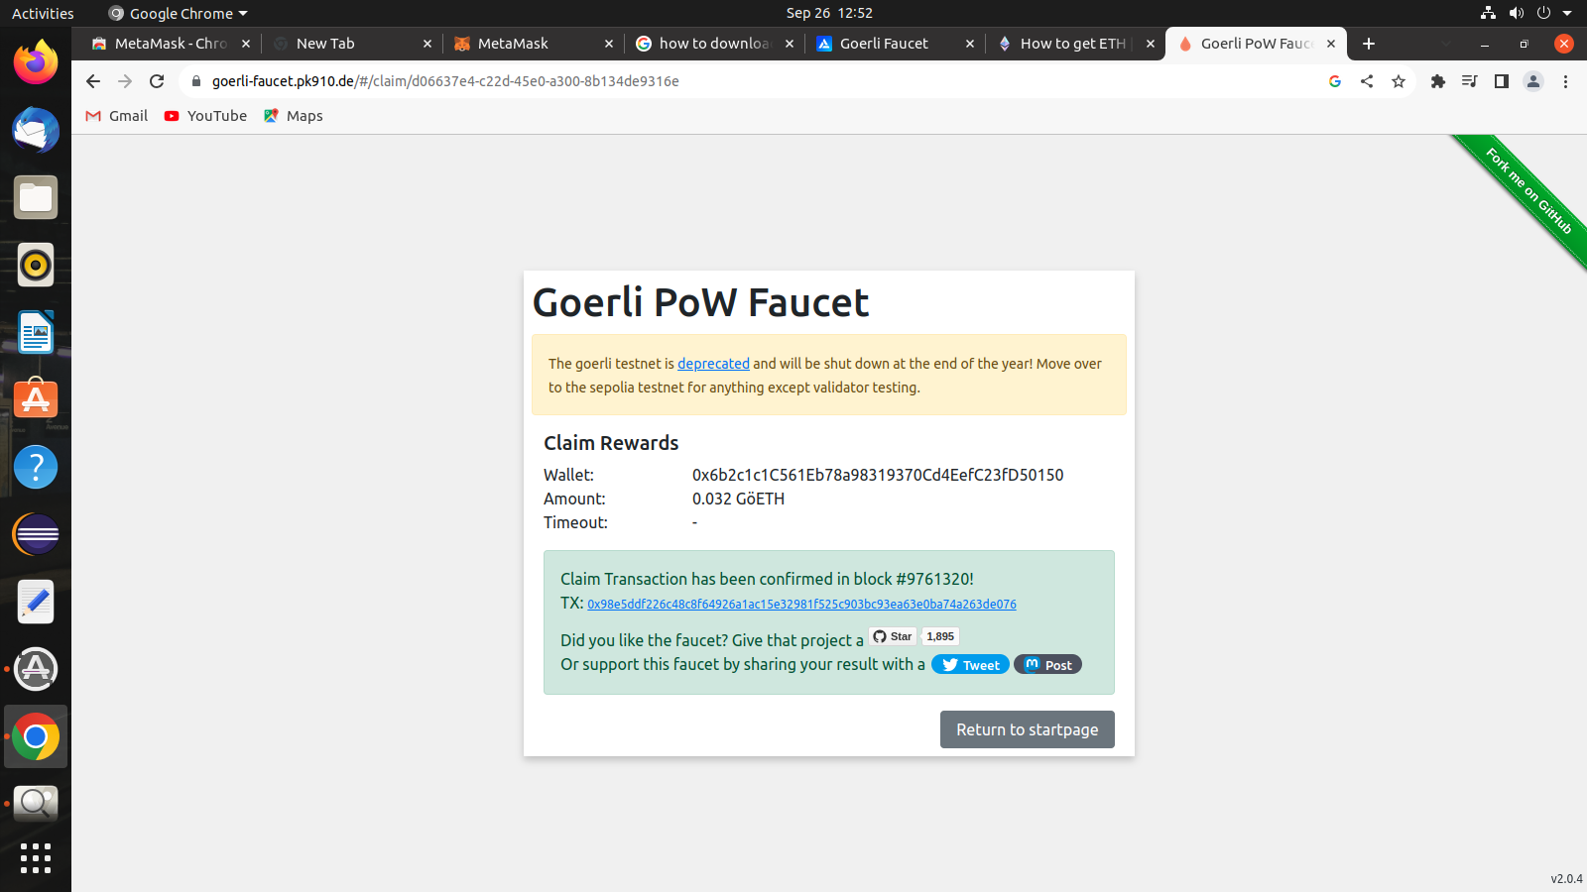

**Ether getting from faucet site.**