**Practical –02**

**Aim :**

Create your own wallet using Metamask for crypto transactions.

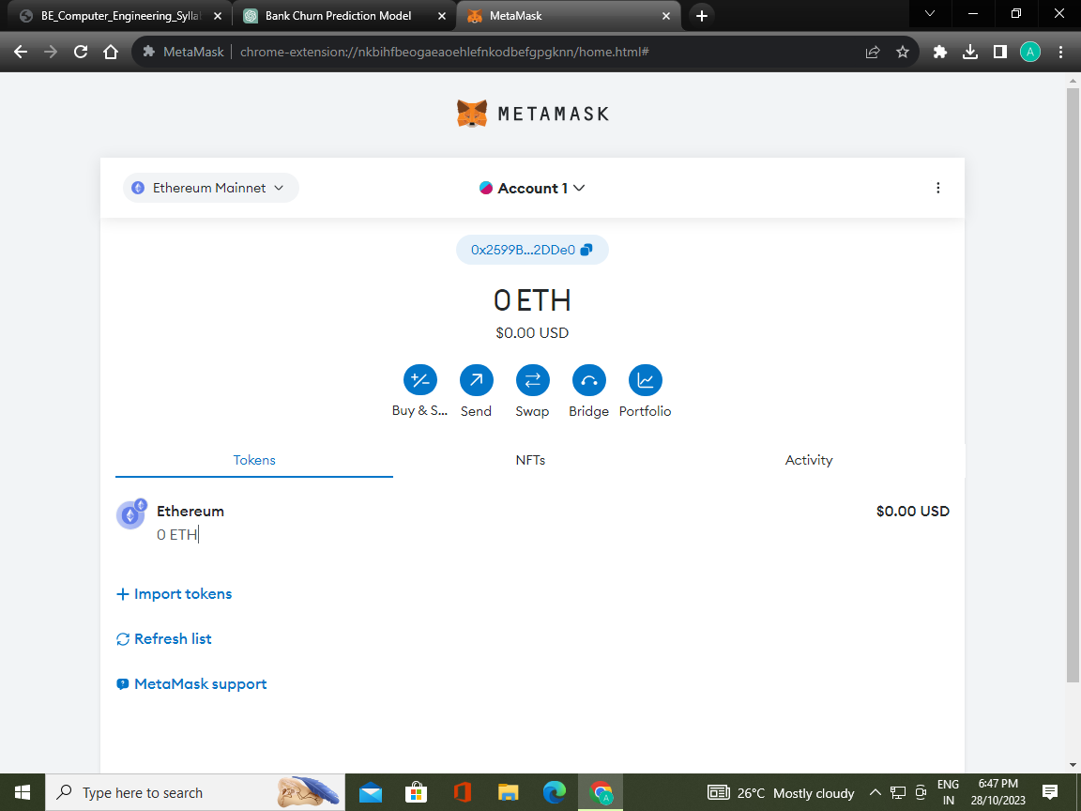

After creating the digital Wallets.

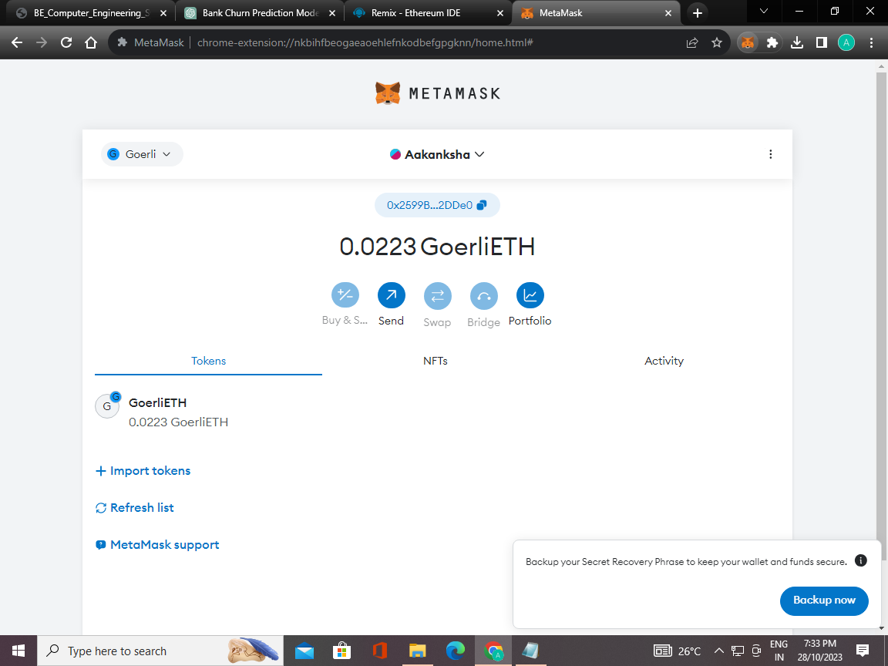

After getting the Eth To our account.

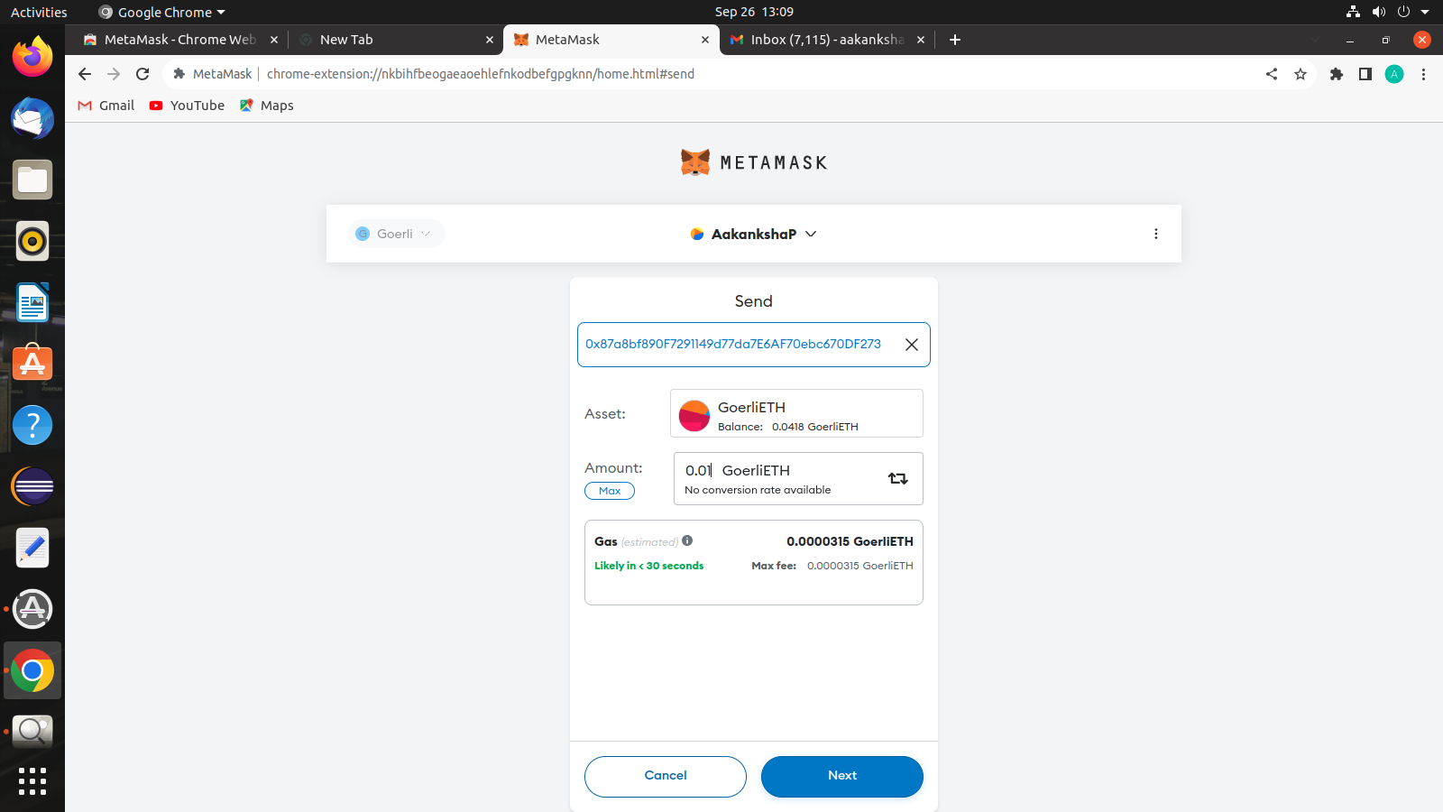

**Sending ETH to another account**.

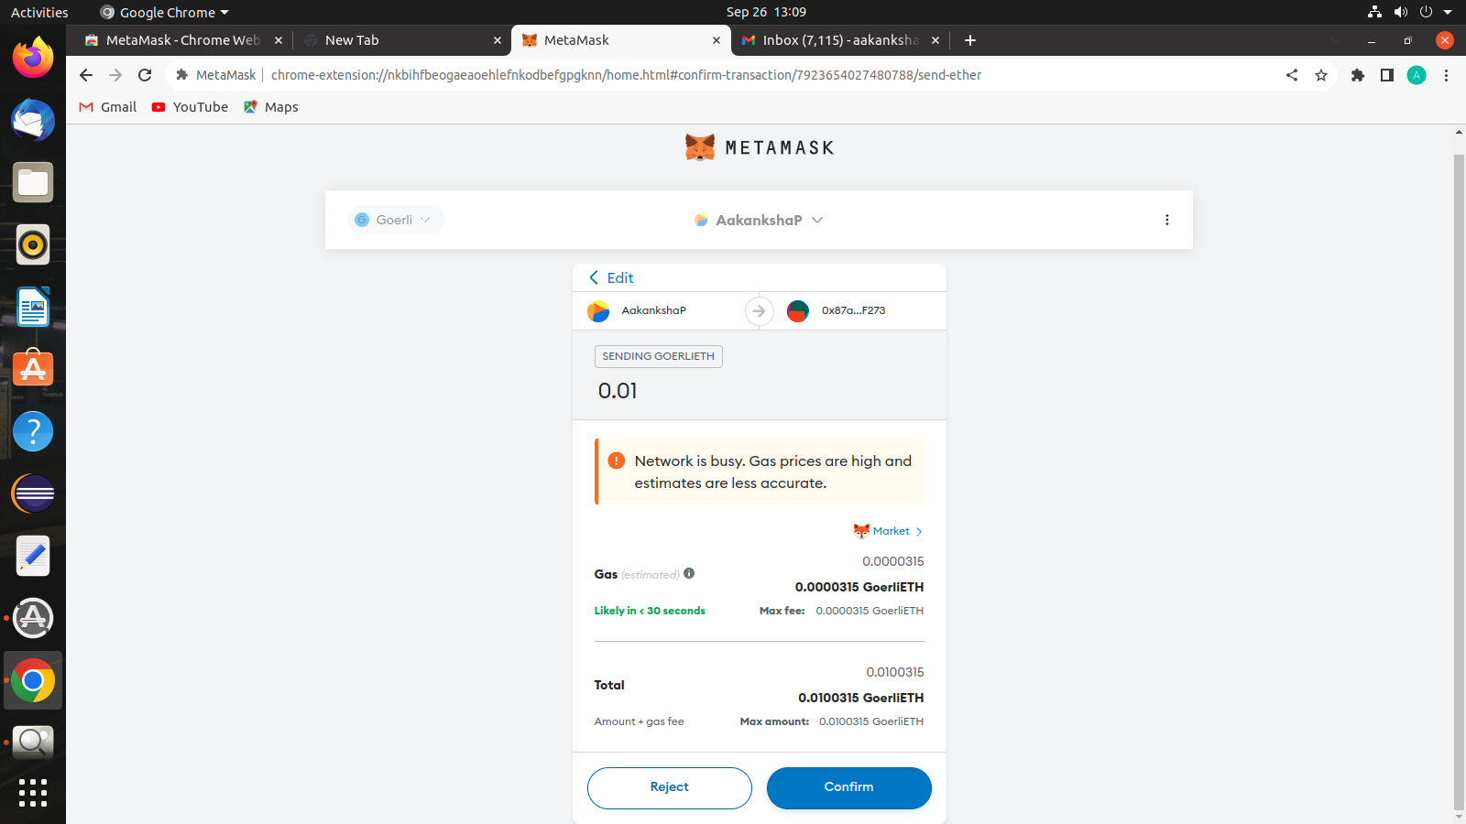

**Entering the account address to which we want to sent the ETH.**

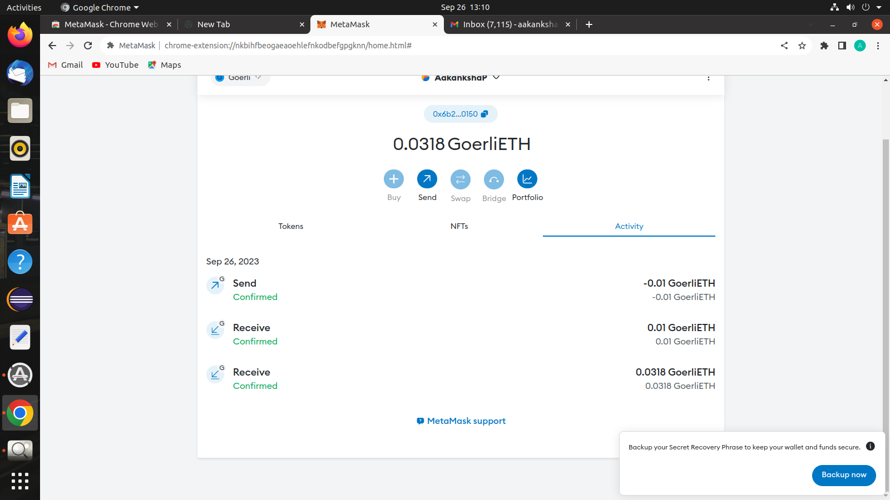

**Successfully Transferred ETH to another account.**

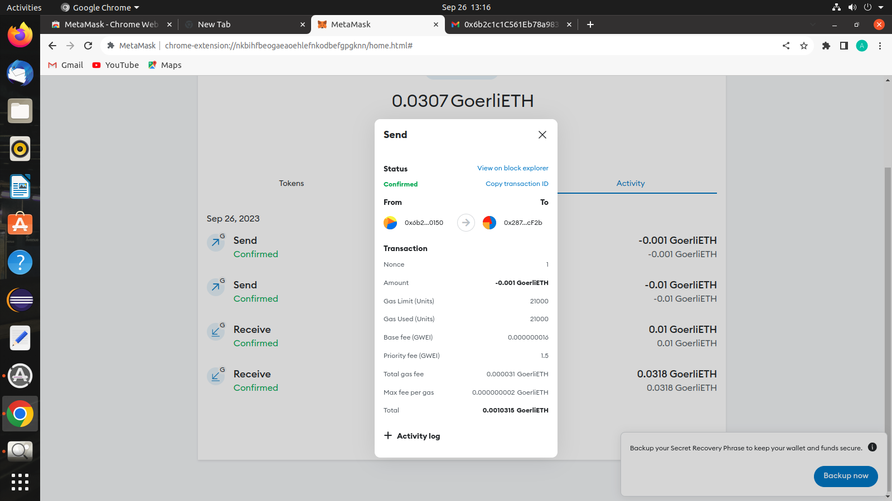

**Details of Transactions.**