**Practical – 03**

**Aim :**

Write a smart contract on a test network, for Bank account of a customer for following operations:

* Deposit money
* Withdraw Money
* Show balance

**Code:**

* //SPDX-License-Identifier: MIT
* pragma solidity ^0.6;
* contract banking
* {
* mapping(address=>uint) public user_account;
* mapping(address=>bool) public user_exists;
* function create_account() public payable returns(string memory)
* {
* require(user_exists[msg.sender]==false,'Account already created');
* if(msg.value==0)
* {
* user_account[msg.sender]=0;
* user_exists[msg.sender]=true;
* return "Account created";
* }
* require(user_exists[msg.sender]==false,"Account already created");
* user_account[msg.sender]=msg.value;
* user_exists[msg.sender]=true;
* return "Account created";
* }
* function deposit() public payable returns(string memory)
* {
* require(user_exists[msg.sender]==true,"Account not created");
* require(msg.value>0,"Value for deposit is Zero");
* user_account[msg.sender]=user_account[msg.sender]+msg.value;
* return "Deposited Successfully";
* }
* function withdraw(uint amount) public payable returns(string memory)
* {
* require(user_account[msg.sender]>amount,"Insufficient Balance");
* require(user_exists[msg.sender]==true,"Account not created");
* require(amount>0,"Amount should be more than zero");
* user_account[msg.sender]=user_account[msg.sender]-amount;
* msg.sender.transfer(amount);
* return "Withdrawl Successful";
* }
* function transfer(address payable userAddress, uint amount) public returns(string memory)
* {
* require(user_account[msg.sender]>amount,"Insufficient balance in Bank account");
* require(user_exists[msg.sender]==true,"Account is not created");
* require(user_exists[userAddress]==true,"Transfer account does not exist");
* require(amount>0,"Amount should be more than zero");
* user_account[msg.sender]=user_account[msg.sender]-amount;
* user_account[userAddress]=user_account[userAddress]+amount;
* return "Transfer Successful";
* }
* function send_amt(address payable toAddress, uint256 amount) public payable returns(string
* memory)
* {
* require(user_account[msg.sender]>amount,"Insufficeint balance in Bank account");
* require(user_exists[msg.sender]==true,"Account is not created");
* require(amount>0,"Amount should be more than zero");
* user_account[msg.sender]=user_account[msg.sender]-amount;
* toAddress.transfer(amount);
* return "Transfer Success";
* }
* function user_balance() public view returns(uint)
* {
* return user_account[msg.sender];
* }
* function account_exist() public view returns(bool)
* {
* return user_exists[msg.sender];
* }
* }

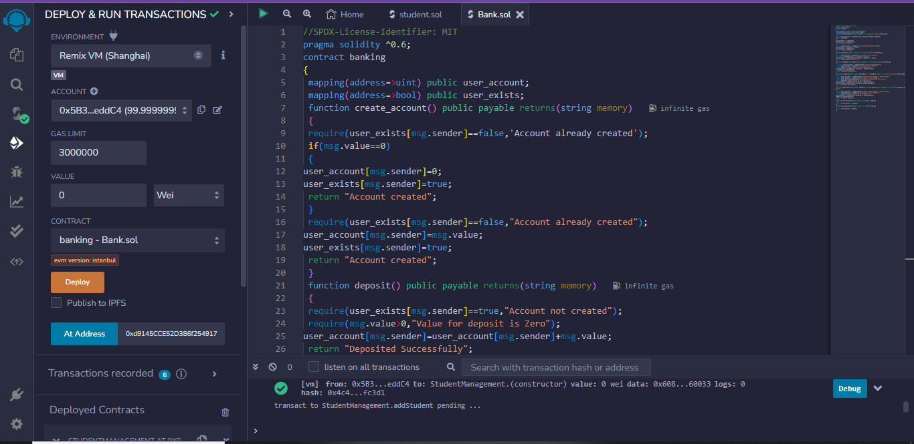

**After Compiling the solidity program in Remix IDE.**

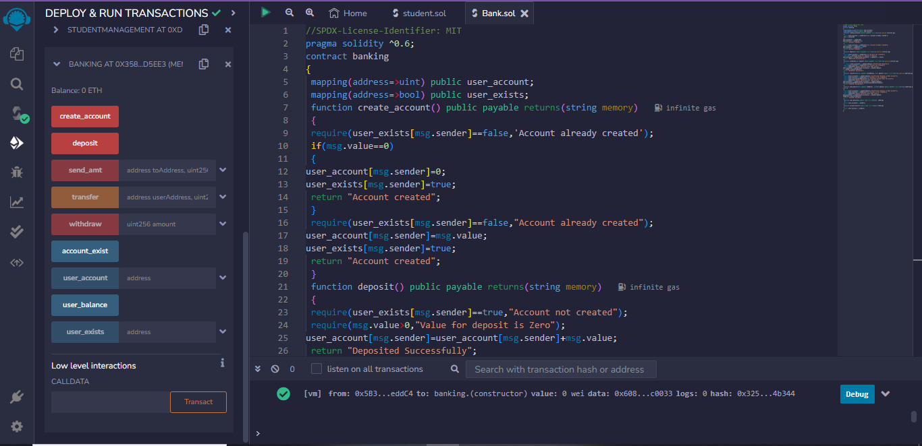

**After Deploying and Run transactions.**