**Practical – 04**

**Aim :**

Write a program in solidity to create Student data. Use the following constructs:

* Structures
* Arrays
* Fallback

Deploy this as smart contract on Ethereum and Observe the transaction fee and Gas values

**Code:**

// SPDX-License-Identifier: MIT

pragma solidity ^0.8.0;

contract StudentManagement {

    struct Student {

        int stud_id;

        string name;

        string department;

    }

    Student[] public students;

    function addStudent(int _stud_id, string memory _name, string memory _department) public {

        Student memory newStudent = Student(_stud_id, _name, _department);

        students.push(newStudent);

    }

    function getStudent(int _stud_id) public view returns (string memory, string memory) {

        for (uint i = 0; i < students.length; i++) {

            if (students[i].stud_id == _stud_id) {

                return (students[i].name, students[i].department);

            }

        }

        return ("Not Found", "Not Found");

    }

}

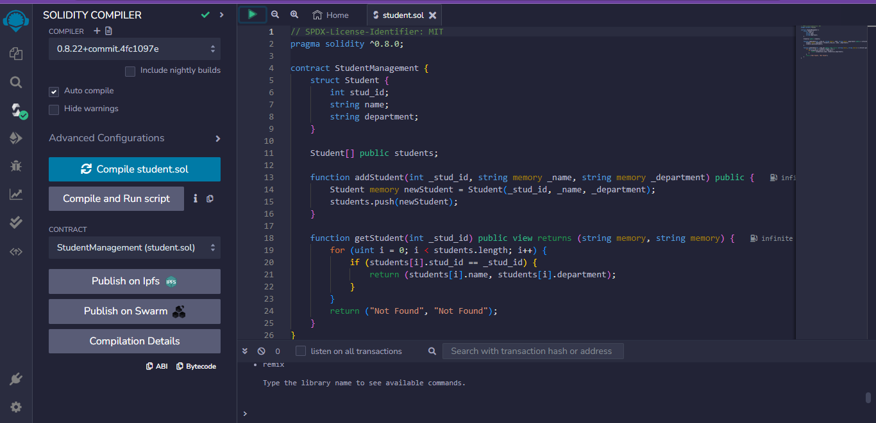

**Compiling the solidity program od student data.**

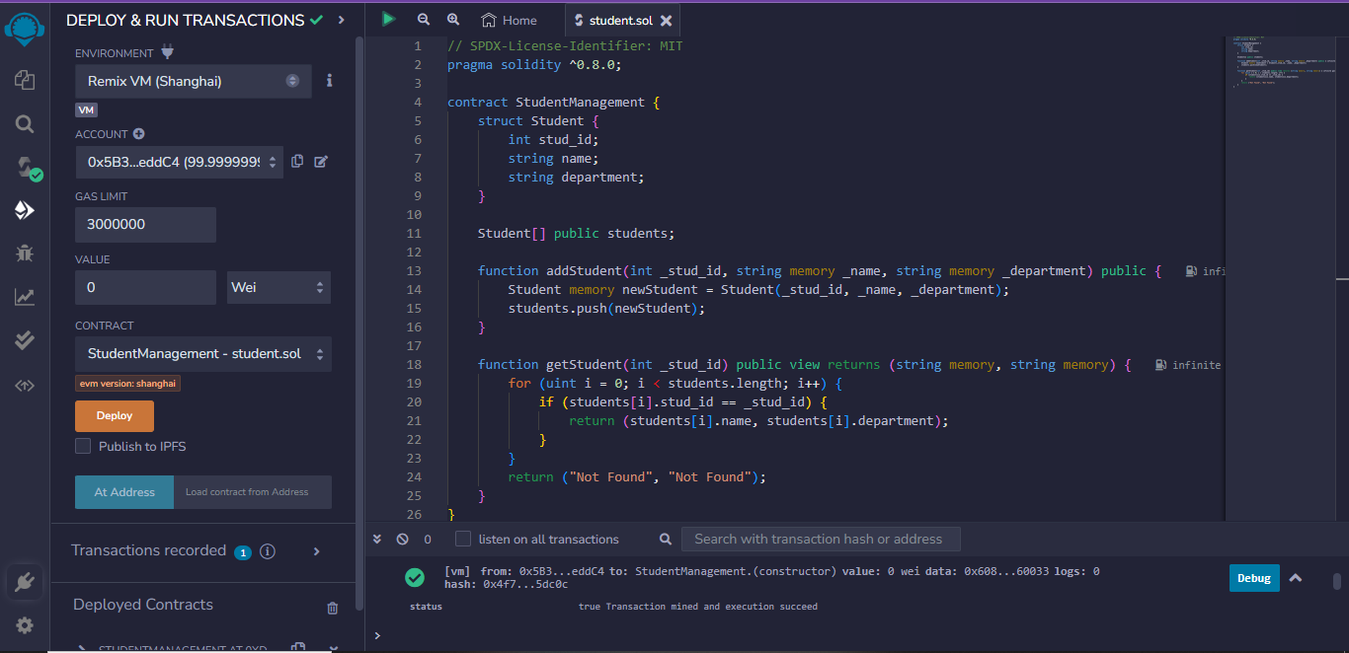

**After the Deploy and run Transaction executing.**

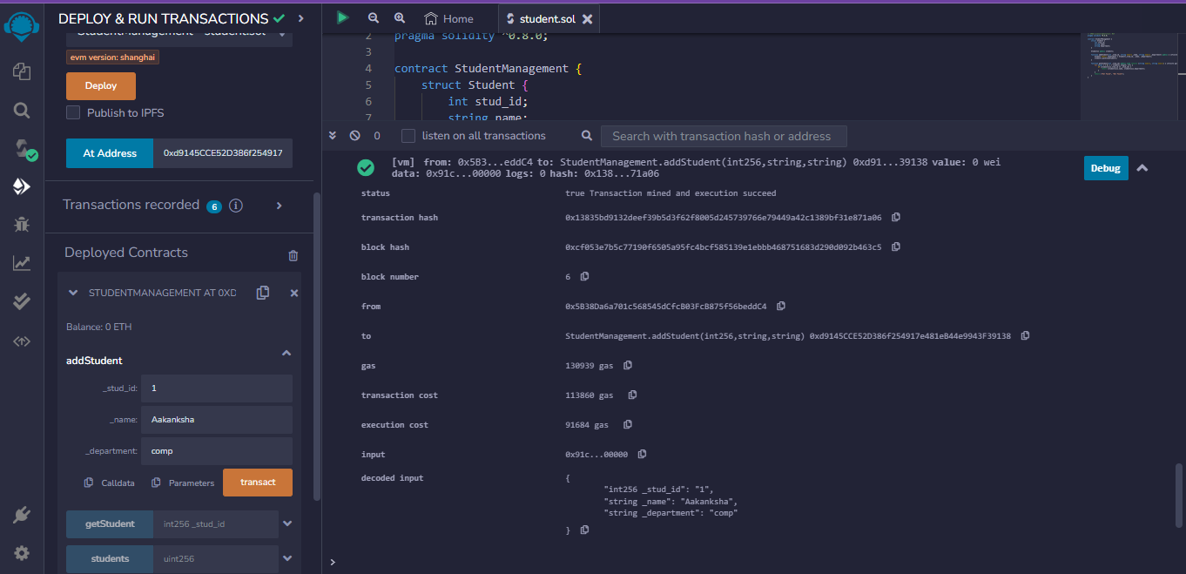

**After adding student information into the student database.**

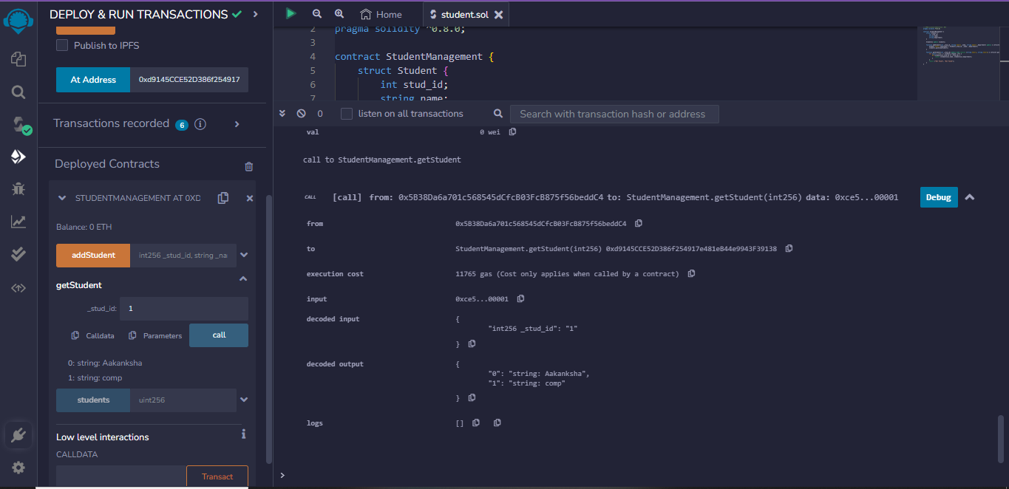

**After fetching the student information from the student database.**

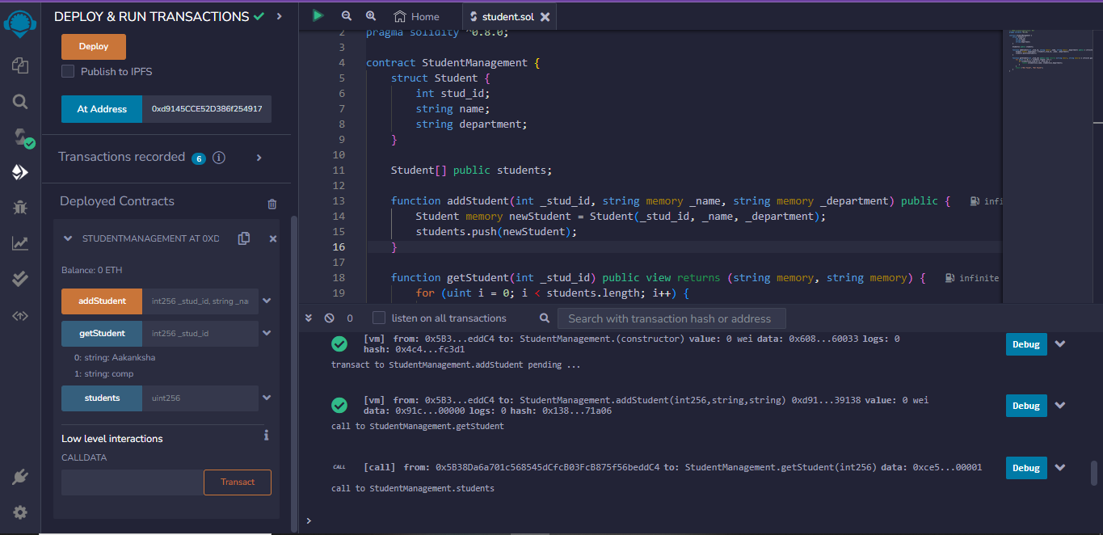

**The Final output.**