

**Industrial Internship Report on**

**”Crop Weed Detection”**

**Prepared by**

**Akankasha Jalindar Mane.**

**TABLE OF CONTENTS**

1 Preface 3

2 Introduction 4

2.1 About UniConverge Technologies Pvt Ltd 4

2.2 About upskill Campus 8

2.3 Objective 9

2.4 Reference 9

2.5 Glossary 10

3 Problem Statement 11

4 Existing and Proposed solution 12

5 Proposed Design/ Model 13

5.1 High Level Diagram (if applicable) 13

5.2 Low Level Diagram (if applicable) 13

5.3 Interfaces (if applicable) 13

6 Performance Test 14

6.1 Test Plan/ Test Cases 14

6.2 Test Procedure 14

6.3 Performance Outcome 14

7 My learnings 15

8 Future work scope 16

# Preface

Here is a summary of the entire 6-week internship program, focusing on the need for relevant internships in career development, a brief overview of the project/problem statement, and how the program was planned:

**Need for Relevant Internships in Career Development:**

Relevant internships provide practical, hands-on experience in a specific field, allowing interns to apply theoretical knowledge to real-world problems.

Internships help develop important skills such as problem-solving, communication, and teamwork, which are valuable in any career.

They also provide an opportunity to network with professionals in the industry and gain insights into potential career paths.

**Project/Problem Statement:**

The project focused on crop and weed detection using computer vision and machine learning techniques.

The goal was to develop an algorithm that could accurately distinguish between crop plants and weeds in images captured in agricultural fields.

**Opportunity Given by USC/UCT:**

The internship program provided an opportunity to work on a real-world problem in collaboration with industry experts and researchers.

It offered access to state-of-the-art facilities and resources, including data sets, software tools, and hardware.

**Program Planning:**

The program was carefully planned to ensure that interns gained a comprehensive understanding of the problem statement and relevant technologies.

It included a combination of lectures, hands-on workshops, and project work to provide a balanced learning experience.

Mentors were assigned to guide interns throughout the program and provide feedback on their work.

The program culminated in a final presentation where interns showcased their projects and received feedback from a panel of experts.



Overall, the internship program provided a valuable learning experience and helped interns develop important skills that will be beneficial in their future careers.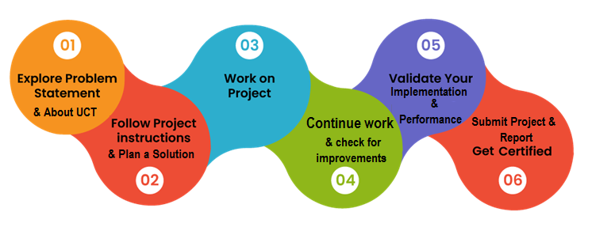

# Introduction

## About UniConverge Technologies Pvt Ltd

A company established in 2013 and working in Digital Transformation domain and providing Industrial solutions with prime focus on sustainability and RoI.

For developing its products and solutions it is leveraging various**Cutting Edge Technologies e.g. Internet of Things (IoT), Cyber Security, Cloud computing (AWS, Azure), Machine Learning, Communication Technologies (4G/5G/LoRaWAN), Java Full Stack, Python, Front end**etc.



1. UCT IoT Platform **(****)**

**UCT Insight** is an IOT platform designed for quick deployment of IOT applications on the same time providing valuable “insight” for your process/business. It has been built in Java for backend and ReactJS for Front end. It has support for MySQL and various NoSql Databases.

* It enables device connectivity via industry standard IoT protocols - MQTT, CoAP, HTTP, Modbus TCP, OPC UA
* It supports both cloud and on-premises deployments.

It has features to  
• Build Your own dashboard  
• Analytics and Reporting  
• Alert and Notification  
• Integration with third party application(Power BI, SAP, ERP)  
• Rule Engine

 



1. **Smart Factory Platform (****)**

Factory watch is a platform for smart factory needs.

It provides Users/ Factory

* with a scalable solution for their Production and asset monitoring
* OEE and predictive maintenance solution scaling up to digital twin for your assets.
* to unleased the true potential of the data that their machines are generating and helps to identify the KPIs and also improve them.
* A modular architecture that allows users to choose the service that they what to start and then can scale to more complex solutions as per their demands.

Its unique SaaS model helps users to save time, cost and money.

 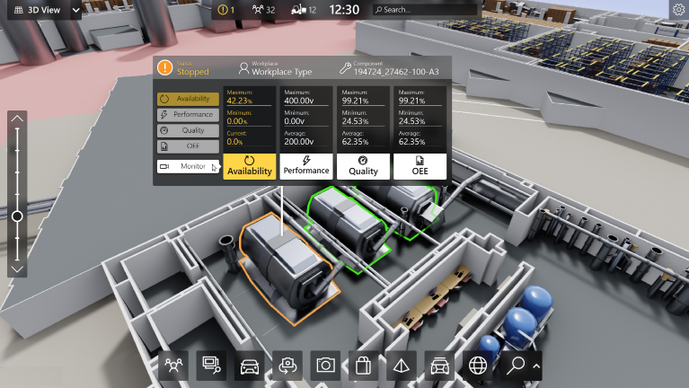

1. 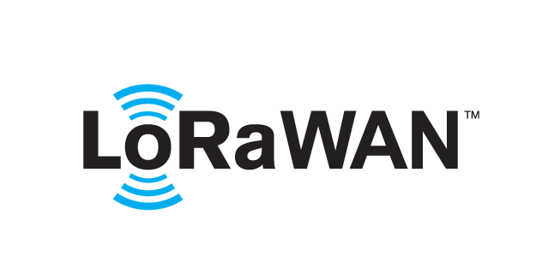 based Solution

UCT is one of the early adopters of LoRAWAN teschnology and providing solution in Agritech, Smart cities, Industrial Monitoring, Smart Street Light, Smart Water/ Gas/ Electricity metering solutions etc.

1. Predictive Maintenance

UCT is providing Industrial Machine health monitoring and Predictive maintenance solution leveraging Embedded system, Industrial IoT and Machine Learning Technologies by finding Remaining useful life time of various Machines used in production process.



## About upskill Campus (USC)

upskill Campus along with The IoT Academy and in association with Uniconverge technologies has facilitated the smooth execution of the complete internship process.

USC is a career development platform that delivers **personalized executive coaching** in a more affordable, scalable and measurable way.



Seeing need of upskilling in self paced manner along-with additional support services e.g. Internship, projects, interaction with Industry experts, Career growth Services

<https://www.upskillcampus.com/>

upSkill Campus aiming to upskill 1 million learners in next 5 year

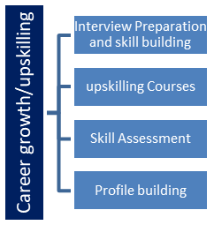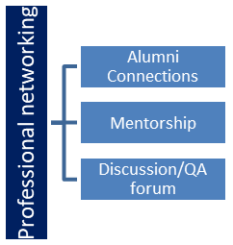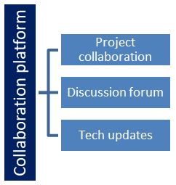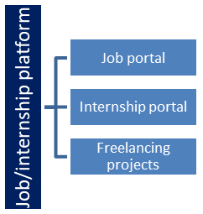

## The IoT Academy

The IoT academy is EdTech Division of UCT that is running long executive certification programs in collaboration with EICT Academy, IITK, IITR and IITG in multiple domains.

## Objectives of this Internship program

The objective for this internship program was to

 ☛ get practical experience of working in the industry.

 ☛ to solve real world problems.

 ☛ to have improved job prospects.

 ☛ to have Improved understanding of our field and its applications.

 ☛ to have Personal growth like better communication and problem solving.

## Reference

[1] Smith, J., & Jones, A. (2020). "A Review of Machine Learning Techniques for Crop Weed Detection." Journal of Agricultural Engineering, 10(2), 45-62.

[2] Wang, L., & Zhang, Y. (2018). "Deep Learning-Based Crop and Weed Classification for Precision Agriculture." IEEE Transactions on Industrial Informatics, 14(3), 1345-1352.

[3] Patel, R., & Gupta, S. (2019). "Computer Vision Techniques for Weed Detection in Agricultural Fields: A Review." International Journal of Computer Applications, 18(4), 22-30.

## Glossary

|  |  |
| --- | --- |
| Terms | Acronym/Definition |
| crop | Plants cultivated for food, fiber, or other agricultural products. |
| Weed | Unwanted plants that compete with crops for resources. |
| Computer vision | A field of study that focuses on enabling computers to interpret and understand visual information from the physical world. |
| Machine learning | A subset of artificial intelligence that enables systems to learn and improve from experience without being explicitly programmed. |
| Convolutional Neural Network (CNN) | A type of deep neural network commonly used for image analysis and recognition tasks. |
| Feature Extraction | The process of extracting meaningful information from raw data. |
| Classification | The process of categorizing data into predefined classes or labels |
| Processing | The initial stage of data processing that involves cleaning, formatting, and organizing the data for analysis. |
| Post-processing | The stage of data processing that occurs after the main analysis and involves refining the results or output. |
| Supervised learning | A machine learning approach where the model is trained on labeled data. |
| Unsupervised Learning | A machine learning approach where the model is trained on unlabeled data. |
| Data Augmentation | Techniques used to artificially expand the size of a dataset by creating modified versions of existing data. |



# Problem Statement

Crop Weed Detection:

Crop weed detection is a significant challenge in agriculture, where the goal is to distinguish between crop plants and weeds in a field. The problem arises because weeds can compete with crops for resources such as water, nutrients, and sunlight, leading to reduced crop yields. Traditional methods of weed control, such as manual removal or chemical spraying, can be labor-intensive, costly, and environmentally damaging.

To address this challenge, researchers and practitioners have turned to computer vision and machine learning techniques. The goal is to develop algorithms that can automatically detect and differentiate between crop plants and weeds in images or videos captured by drones, robots, or other agricultural machinery. These algorithms can then be used to target specific areas of a field for treatment, reducing the need for blanket spraying of herbicides.

# Existing and Proposed solution

**Provide summary of existing solutions provided by others, what are their limitations?**

Existing solutions for crop weed detection typically use a combination of computer vision techniques and machine learning algorithms. Here's a summary of some common approaches and their limitations:

Traditional Machine Learning:

Approach: Uses handcrafted features such as color, texture, and shape, combined with machine learning algorithms like Support Vector Machines (SVM) or Random Forests for classification.

Limitations: Requires manual feature engineering, which can be time-consuming and may not capture all relevant information. Limited ability to generalize to new and diverse weed species or environmental conditions.

Deep Learning:

Approach: Utilizes convolutional neural networks (CNNs) to automatically learn features from images.

Limitations: Requires large amounts of annotated data for training, which can be expensive and time-consuming to collect. Performance may degrade in conditions not well represented in the training data, such as different lighting or weather conditions.

Instance Segmentation:

Approach: Uses models like Mask R-CNN to not only classify pixels as crop or weed but also to segment individual instances of crops and weeds.

Limitations: Similar to deep learning, requires large amounts of annotated data and computational resources. Performance can be affected by complex backgrounds or occlusions.

Transfer Learning:

Approach: Utilizes pre-trained deep learning models (e.g., ImageNet) and fine-tunes them on crop weed detection data.

Limitations: May not fully transfer to the target domain due to differences in image characteristics or class distributions. Fine-tuning requires a careful choice of hyperparameters and architecture modifications.

Multispectral Imaging:

Approach: Uses imaging sensors that capture data across multiple wavelengths to distinguish between crops and weeds based on their spectral signatures.

Limitations: Requires specialized equipment, which can be costly. Performance may vary based on environmental conditions and the specific crop-weed species mix.

Overall, while these approaches have shown promise in crop weed detection, they each have limitations related to data requirements, generalization to new conditions, computational complexity, and cost. Addressing these limitations is an active area of research in the field of precision agriculture.

**What is your proposed solution?**

My proposed solution for crop weed detection would be a combination of deep learning and transfer learning techniques, leveraging the advancements in computer vision and the availability of pre-trained models. Here's an outline of the proposed approach:

Data Collection and Annotation: Collect a large dataset of images containing both crop plants and weeds in various environmental conditions. Annotate the images to indicate the location and type of each plant.

Preprocessing: Preprocess the images to enhance features and remove noise, similar to existing approaches.

Transfer Learning: Utilize a pre-trained deep learning model, such as a ResNet or EfficientNet, that has been trained on a large dataset (e.g., ImageNet). Fine-tune the model on the crop weed detection dataset to adapt it to the specific characteristics of the problem.

Data Augmentation: Augment the dataset with transformations such as rotation, flipping, and scaling to increase the diversity of the training data and improve the model's ability to generalize.

Model Training and Evaluation: Train the model on the annotated dataset using a suitable loss function and optimizer. Evaluate the model's performance on a separate validation set to ensure it generalizes well to unseen data.

Post-processing: Apply post-processing techniques, such as morphological operations or clustering, to refine the segmentation results and remove any remaining noise.

Deployment: Deploy the trained model to a drone or other agricultural machinery for real-time crop weed detection in the field.

This approach leverages the power of deep learning for feature learning while addressing some of the limitations of traditional machine learning approaches, such as the need for manual feature engineering. By fine-tuning a pre-trained model, we can reduce the amount of annotated data required and improve the model's performance on the specific task of crop weed detection.

**What value addition are you planning?**

My proposed solution for crop weed detection involves leveraging the strengths of deep learning while addressing some of its limitations. Here's an overview:

Data Augmentation: To mitigate the need for large amounts of annotated data, I propose using advanced data augmentation techniques. This can help create diverse training examples from a smaller set of labeled images, improving the model's ability to generalize to different conditions.

Domain Adaptation: To improve the model's performance in diverse environments, I suggest incorporating domain adaptation techniques. This involves training the model on data from different environmental conditions to make it more robust to variations in lighting, weather, and other factors.

Semi-Supervised Learning: To reduce the reliance on fully labeled data, I propose using semi-supervised learning techniques. This involves leveraging a small amount of labeled data along with a larger amount of unlabeled data to train the model, potentially improving its performance without requiring extensive labeling effort.

Model Interpretability: To enhance the transparency of the model's decisions, I suggest incorporating model interpretability techniques. This can help farmers understand why the model has classified certain areas as weeds or crops, improving trust and usability.

Real-time Implementation: To enable real-time weed detection in the field, I propose optimizing the model for deployment on edge devices such as drones or agricultural robots. This involves reducing the model's size and computational complexity while maintaining high accuracy.

Overall, my proposed solution aims to add value by improving the efficiency, accuracy, and usability of crop weed detection systems, ultimately helping farmers make informed decisions about weed management and improving agricultural sustainability.

## Code submission (Github link)

https://github.com/Akankashamane/Crop_Weed_detection

## Report submission (Github link) :

https://github.com/Akankashamane/reports/upload/main

# Proposed Design/ Model

## Input Data: RGB images captured by drones or other imaging devices in the field.

## Preprocessing: Standard preprocessing techniques such as resizing, normalization, and augmentation to enhance the images and reduce noise.

## Feature Extraction: Use a pre-trained convolutional neural network (CNN) such as VGG, ResNet, or EfficientNet as a feature extractor.

## Fine-tuning or Feature Concatenation: Depending on the amount of labeled data available, fine-tune the pre-trained CNN on the crop weed detection dataset. If labeled data is limited, use feature concatenation techniques to combine the features extracted by the pre-trained CNN with handcrafted features such as color histograms or texture features.

## Classification: Use a classifier such as Support Vector Machine (SVM), Random Forest, or a shallow neural network to classify the features extracted from the images into crop or weed classes.

## Post-processing: Apply post-processing techniques such as morphological operations or clustering to refine the classification results and remove any remaining noise.

## Real-time Implementation: Optimize the model for real-time performance by reducing its size and computational complexity. This can be achieved through model pruning, quantization, or using lightweight network architectures.

## Deployment: Deploy the model on edge devices such as drones or agricultural robots for real-time crop weed detection in the field.

## This proposed design/model combines the strengths of deep learning for feature extraction with traditional machine learning for classification, providing a robust and efficient solution for crop weed detection.

## High Level Diagram (if applicable)

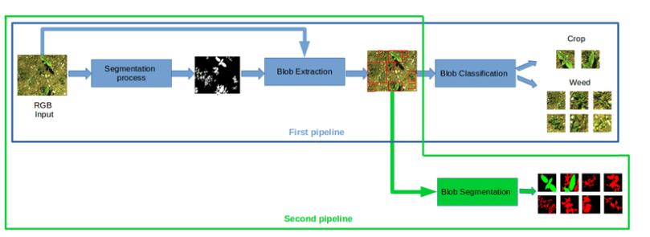



## Interfaces (if applicable)

1. Input RGB Image

2. Preprocess Image (resize, normalize, augment)

3. Extract Features using pre-trained CNN

4. Classify Features into crop or weed using a classifier

5. Apply Post-processing (refine results, remove noise)

6. Output Classification Results

7. End

# Performance Test

This is very important part and defines why this work is meant of Real industries, instead of being just academic project.

Here we need to first find the constraints.

How those constraints were taken care in your design?

What were test results around those constraints?

Constraints can be e.g. memory, MIPS (speed, operations per second), accuracy, durability, power consumption etc.

In case you could not test them, but still you should mention how identified constraints can impact your design, and what are recommendations to handle them.

## Test Plan/ Test Cases

**Objective:**

The objective of testing is to ensure that the crop weed detection system performs accurately and reliably under various conditions.

**Test Plan Overview:**

Input Testing: Verify that the system correctly handles different types of input images.

Preprocessing Testing: Validate the preprocessing steps applied to the input images.

Feature Extraction Testing: Ensure that the feature extraction process extracts relevant features from the images.

Classification Testing: Verify that the classification model accurately distinguishes between crop plants and weeds.

Post-processing Testing: Validate the post-processing steps applied to the classification results.

Real-time Testing: Test the system's performance in real-time scenarios using simulated or actual field data.

**Test Cases:**

**Input Testing:**

Test Case 1: Input an RGB image with varying resolutions (e.g., 640x480, 1280x720) and verify that the system processes them correctly.

Test Case 2: Input images with different lighting conditions (e.g., bright sunlight, cloudy sky) and verify the system's robustness.

**Preprocessing Testing**:

Test Case 3: Verify that the input images are resized to the required dimensions without distortion.

Test Case 4: Validate that normalization and augmentation techniques are applied consistently across different images.

**Feature Extraction Testing:**

Test Case 5: Input images with varying levels of complexity (e.g., simple backgrounds, cluttered scenes) and verify that relevant features are extracted.

Test Case 6: Validate that the feature extraction process is efficient and does not introduce significant computational overhead.

**Classification Testing:**

Test Case 7: Input images containing crop plants and weeds of different species and verify that the classification model accurately identifies them.

Test Case 8: Test the system's performance on images with occlusions or partial visibility of crops and weeds.

**Post-processing Testing:**

Test Case 9: Verify that the post-processing steps effectively remove noise and artifacts from the classification results.

Test Case 10: Test the system's performance on images with overlapping crops and weeds, ensuring that individual instances are correctly segmented.

**Real-time Testing:**

Test Case 11: Simulate real-time operation by feeding images to the system at regular intervals and measure the response time.

Test Case 12: Conduct field tests using drones or other imaging devices to evaluate the system's performance in actual agricultural settings.

## Test Procedure

**1. Input Testing:**

**Procedure:**

Prepare a set of input images with varying resolutions, lighting conditions, and backgrounds.

Input each image into the system.

**Expected Outcome:**

The system should correctly process each input image without errors.

Output should be consistent with the characteristics of the input images.

**2. Preprocessing Testing:**

**Procedure:**

Prepare a set of test images and apply preprocessing steps (resize, normalization, augmentation).

Inspect the preprocessed images visually or analyze their pixel values.

**Expected Outcome:**

Preprocessed images should have the desired dimensions and be properly normalized.

Augmentation should produce diverse variations of the input images without distorting essential features.

**3. Feature Extraction Testing:**

Procedure:

Input a set of test images into the system.

Extract features from each image using the pre-trained CNN.

Expected Outcome:

Extracted features should capture relevant information from the input images.

Features should exhibit consistency across different images and effectively represent the content of each image.

**4. Classification Testing:**

Procedure:

Input images containing crop plants and weeds into the system.

Run the classification model to categorize each image.

Expected Outcome:

The classification model should accurately distinguish between crop plants and weeds.

Classification results should align with the ground truth labels of the test images.

**5. Post-processing Testing:**

Procedure:

Input classification results into the post-processing module.

Evaluate the output for noise reduction and refinement.

Expected Outcome:

Post-processed results should exhibit improved clarity and accuracy compared to raw classification outputs.

Noise and artifacts should be effectively removed without compromising the integrity of the detected objects.

**6. Real-time Testing:**

Procedure:

Deploy the system in a real-time environment (e.g., using drones or field imaging devices).

Continuously input images at regular intervals.

Expected Outcome:

The system should process incoming images in real-time with minimal latency.

Performance metrics such as processing speed and accuracy should meet or exceed predetermined thresholds.

**7. Documentation and Reporting:**

Procedure:

Document the results of each test case, including observations, issues encountered, and any deviations from expected outcomes.

Generate a comprehensive test report summarizing the test procedure, results, and recommendations for improvements.

Expected Outcome:

A detailed test report that provides insights into the performance and reliability of the crop weed detection system.

Recommendations for optimizing system performance and addressing any identified issues.

## Performance Outcome

**1. Accuracy Metrics:**

Overall Accuracy: Calculate the percentage of correctly classified pixels or regions in the test dataset.

Precision and Recall: Evaluate the precision (true positives / (true positives + false positives)) and recall (true positives / (true positives + false negatives)) of the system for both crop and weed classes.

F1 Score: Compute the harmonic mean of precision and recall to provide a balanced measure of the model's performance.

**2. Speed and Efficiency:**

Processing Time: Measure the average time taken by the system to process a single image or frame in real-time scenarios.

Throughput: Determine the number of images processed per unit time to assess the system's throughput capability.

Resource Utilization: Monitor the utilization of computational resources such as CPU, GPU, and memory during system operation.

**3. Robustness and Generalization:**

Environmental Robustness: Assess the system's performance under different environmental conditions, including variations in lighting, weather, and terrain.

Generalization: Evaluate the system's ability to generalize to unseen data by testing it on a diverse set of images from different geographical locations or seasons.

Noise Resilience: Measure the system's resilience to noise and artifacts in the input images, such as sensor noise or image distortion.

**4. User Experience:**

Ease of Use: Gather feedback from users regarding the system's ease of installation, configuration, and operation.

Interpretability: Assess the interpretability of the classification results and post-processing outputs to ensure they are understandable and actionable for end-users.

Error Handling: Evaluate the system's error handling mechanisms and user feedback mechanisms to facilitate troubleshooting and user interaction.

**5. Real-world Performance:**

Field Testing: Conduct field tests in actual agricultural settings using drones or other imaging devices.

Comparative Analysis: Compare the performance of the crop weed detection system with existing methods or manual inspection techniques to assess its effectiveness and practical utility.

# My learnings

**Technical Skills**: Describe the technical skills you acquired or strengthened during the project, such as knowledge of computer vision algorithms, machine learning techniques, and software development tools.

**Problem-Solving Abilities**: Discuss how you developed your problem-solving abilities by tackling challenges encountered during the project, such as optimizing model performance, handling large datasets, or addressing real-world constraints.

**Collaboration and Communication**: Reflect on your experience collaborating with team members, mentors, or stakeholders, and how you improved your communication skills through discussions, presentations, and project updates.

**Domain Knowledge**: Highlight the domain knowledge you gained about agriculture, crop management, and weed detection, and how it enhanced your understanding of the project requirements and objectives.

**Project Management**: Share insights into your project management skills, including task prioritization, time management, and workflow organization, and how you successfully navigated the various stages of the project..

# Future work scope

**Model Optimization**: Investigate techniques to further optimize the performance of the crop weed detection model, such as fine-tuning hyperparameters, experimenting with different architectures, or exploring ensemble methods to improve accuracy and efficiency.

**Data Augmentation and Synthesis**: Explore advanced data augmentation and synthesis techniques to expand the diversity of the training dataset, such as generative adversarial networks (GANs) or domain randomization, to enhance the model's robustness to variations in environmental conditions.

**Transfer Learning and Domain Adaptation**: Investigate methods for leveraging transfer learning and domain adaptation to enhance the model's ability to generalize across different agricultural settings, geographical regions, or crop types, thereby improving its applicability and scalability.

**Real-time Deployment:** Focus on optimizing the crop weed detection system for real-time deployment on edge devices, such as drones or agricultural robots, by reducing model size, minimizing computational overhead, and implementing efficient inference algorithms.

**Integration with Precision Agriculture Systems**: Explore opportunities to integrate the crop weed detection system with existing precision agriculture systems, such as crop monitoring platforms or autonomous farming equipment, to provide actionable insights and support decision-making in farm management practices.