RV UNIVERSITY, BENGALURU-59

SCHOOL OF COMPUTER SCIENCE AND ENGINEERING


A Project Report On
IoT-Based Obstacle Detection and Radar Monitoring System
Submitted in partial Fulfillment for the award of degree of
B.Tech(Honors)
In
School of Computer Science and Engineering
Submitted By
Name1: Y S JEEVAN (1RUA25CSE0533)
Name2: AKANKSH B R (1RUA25CSE0037)
Name3: HEMANTH D (1RUA25CSE0189)
Name4: THEJAS GOWDA S (1RUA25CSE0490)

Under the Guidance of
Dr./Prof. NAGARAJA J
Designation
School of CSE
RV University, Bengaluru-560059
2025-2026

DECLARATION

We hereby declare that the project report entitled “IoT-Based Obstacle Detection and Radar Monitoring System” submitted by us to RV University, Bengaluru, is a record of bona fide work carried out by us under the supervision of Prof. NAGARAJA J, School of Computer Science and Engineering, RV University. We further declare that this work has not been submitted to any other institution for the award of any degree or diploma.

Place: Bengaluru
Date: 27 – 04 - 2026

Name(s):
Y S JEEVAN
AKANKSH B R
HEMANTH D
THEJAS GOWDA S

CERTIFICATE

This is to certify that the project report entitled “IoT-Based Obstacle Detection and Radar Monitoring System” submitted by Y S Jeevan , Akanksh B R , Hemanth D, Thejas Gowda S, USN:1RUS25CSE0533,1RUA25CSE0037,1RUA25CSE0189,1RUA25CSE0490 School of Computer Science and Engineering, RV University, Bengaluru, for the award of the degree of B.Tech (H) in Computer Science, is a record of bona fide work carried out under my supervision.

Signature of the Guide
Prof. NAGARAJA J
School of Computer Science and Engineering
RV University, Bengaluru

ACKNOWLEDGEMENT

We express our sincere gratitude to Prof. NAGARAJA J, our project guide, for their guidance, continuous support, and encouragement throughout this project. We extend our thanks to the Dean, Program Director, and all faculty members of the School of Computer Science and Engineering for their valuable inputs. We are also thankful to our peers, friends, and family for their constant support and motivation.

ABSTRACT

This project presents an IoT-Based Obstacle Detection and Radar Monitoring System developed using the ESP32 microcontroller, HC-SR04 ultrasonic sensor, servo motor, LEDs, buzzer, and the Blynk IoT platform. The system continuously scans its surroundings by rotating the ultrasonic sensor with a servo motor and measures the distance of nearby obstacles in real time. Based on the measured distance, the system provides visual indications using LEDs, activates a buzzer when obstacles are detected within a critical range, and sends instant mobile notifications through the Blynk IoT platform.
The project was implemented using Arduino IDE with the ESP32Servo and Blynk libraries. The developed system demonstrates an efficient, low-cost, and reliable solution for obstacle detection and monitoring. It can be applied in robotics, smart surveillance, autonomous navigation, and industrial safety. Future enhancements include integrating AI-based object recognition, cloud data storage, and camera modules for advanced monitoring capabilities.

TABLE OF CONTENTS

- Introduction
- Objectives
- Literature Survey and Research Gap
- Project Description and Design
- Methodology / Technical Implementation
- Results and Discussion
- Conclusion and Future Scope
- References

INTRODUCTION

Radar systems are widely used in modern applications such as defense systems, autonomous vehicles, robotics, obstacle detection, and smart surveillance. Traditional radar systems are expensive and complex. Therefore, low-cost embedded systems using ultrasonic sensors and microcontrollers provide an effective alternative for short-range obstacle detection.

This project focuses on designing an ESP32-based ultrasonic radar system capable of detecting obstacles in real time. The HC-SR04 ultrasonic sensor continuously measures the distance of nearby objects while rotating using a servo motor. The ESP32 microcontroller processes the sensor data and controls LEDs and buzzer alerts based on obstacle distance.

The project also integrates the Blynk IoT platform for mobile notifications, allowing users to monitor alerts remotely through smartphones. The system combines IoT, embedded systems, wireless communication, and sensor technologies into a single smart application.

OBJECTIVES

List clear, measurable goals of the project.

- To design a real-time obstacle detection system using ESP32.

- To rotate the ultrasonic sensor using a servo motor for radar scanning.

- To measure obstacle distance accurately using the HC-SR04 ultrasonic sensor.

- To provide visual indication using LEDs.

- To generate buzzer alerts for nearby obstacles.

- Integrate the Blynk IoT platform for mobile notifications.

- To create a low-cost and efficient smart radar system.

LITERATURE SURVEY AND RESEARCH GAP

SN | Paper title | DOI | Methodology/  Algorithms used | Datasets | Evaluation Metrics | Tools/  frameworks | Research gap | Results/ Findings | Remarks
 | IoT-Based Obstacle Detection and Radar Monitoring System

PROJECT DESCRIPTION

Explain system overview, architecture, tools, and dataset used.
The system consists of an ESP32 microcontroller connected to an HC-SR04 ultrasonic sensor mounted on a servo motor. The servo rotates between 15 degrees and 165 degrees to scan the surroundings.

The ultrasonic sensor measures the distance of nearby objects. Depending on the detected distance:
- Red LED glows for close objects.
- Yellow LED glows for medium distance.
- Green LED glows for far objects.
- Buzzer sounds when objects are too close.
- Blynk sends mobile notifications.

Hardware Components
1. ESP32 Development Board
2. HC-SR04 Ultrasonic Sensor
3. Servo Motor
4. Red LED
5. Yellow LED
6. Green LED
7. Buzzer
8. Breadboard and Jumper Wires
9. USB Cable

Software Tools
1. Arduino IDE
2. Blynk IoT Platform
3. ESP32Servo Library
4. Blynk Library

Working Principle

The ultrasonic sensor transmits ultrasonic waves and receives reflected signals from nearby obstacles. The ESP32 calculates the distance based on the echo time. According to the measured distance, LEDs and buzzer are controlled. If the distance becomes critically low, the ESP32 triggers a Blynk event to send a mobile notification.

METHODOLOGY / TECHNICAL IMPLEMENTATION

Describe the stepwise technical process, algorithms, and models used.
Step 1: Hardware Setup
The ultrasonic sensor, servo motor, LEDs, and buzzer are connected to the ESP32 GPIO pins.

## Pin Configuration
Component - ESP32 Pin
Trig Pin -- GPIO 12
Echo Pin -- GPIO 14
Servo Motor -- GPIO 13
Buzzer -- GPIO 27
Green LED -- GPIO 25
Yellow LED -- GPIO 26
Red LED -- GPIO 33

Step 2: Servo Rotation
The servo motor rotates continuously between 15° and 165° to scan nearby objects.

Step 3: Distance Measurement
The HC-SR04 sensor measures the obstacle distance using ultrasonic pulses.

Distance Formula:
Distance = (Duration × 0.034) / 2

Step 4: LED Indication
Distance Range - LED Status
- 0 – 20 cm - Red LED
- 20 – 40 cm - Yellow LED
- Above 40 cm - Green LED

Step 5: Buzzer Alert
The buzzer activates whenever the obstacle is detected within 20 cm.

Step 6: Blynk Notification
The ESP32 sends a notification to the user’s smartphone through the Blynk IoT platform using: Blynk.logEvent("obstacle_alert");

Algorithm
1. Initialize ESP32 and WiFi connection
2. Rotate servo motor.
3. Measure obstacle distance.
4. Display LED indication.
5. Activate buzzer if obstacle is close.
6. Send mobile notification.
7. Repeat scanning continuously.

Circuit Diagram

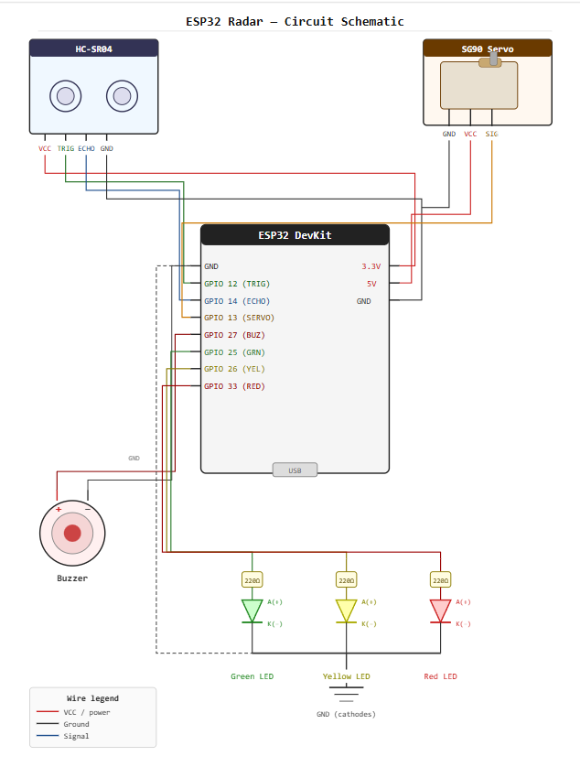

SCREEN SHOTS

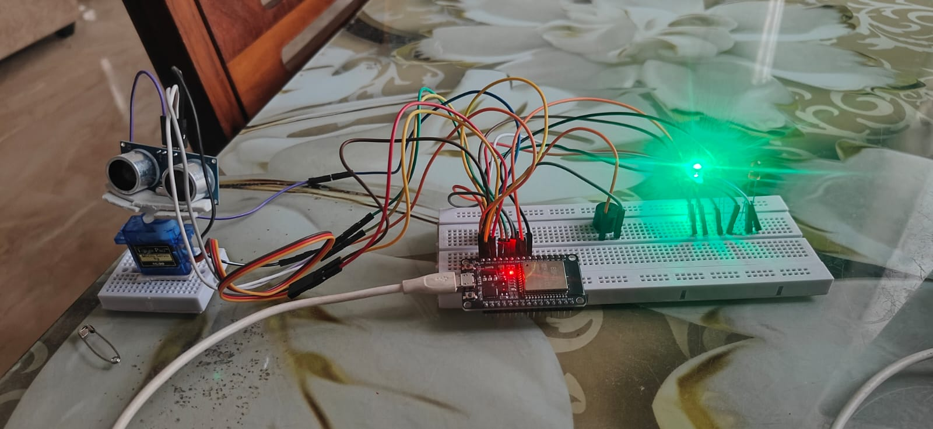
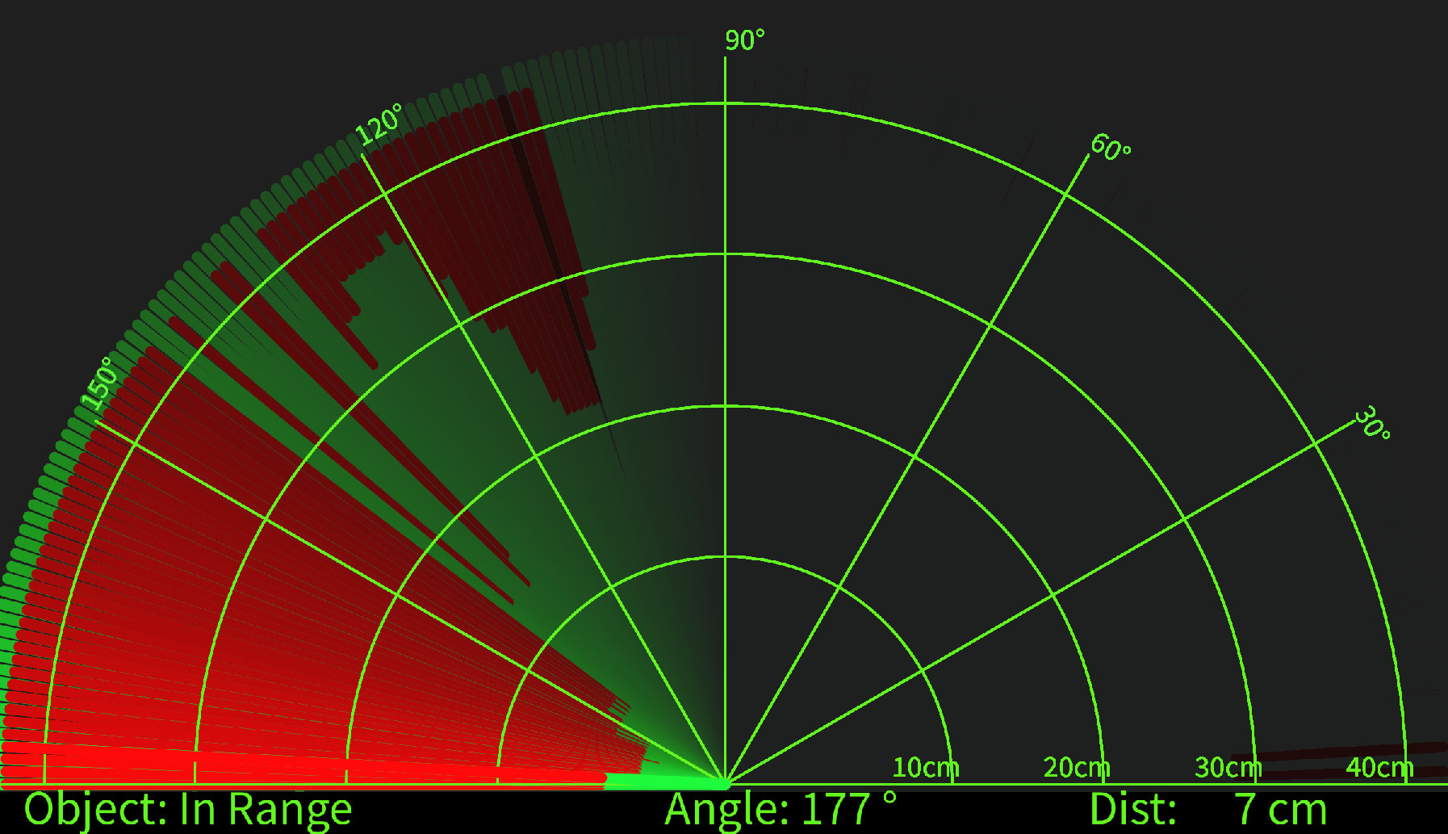

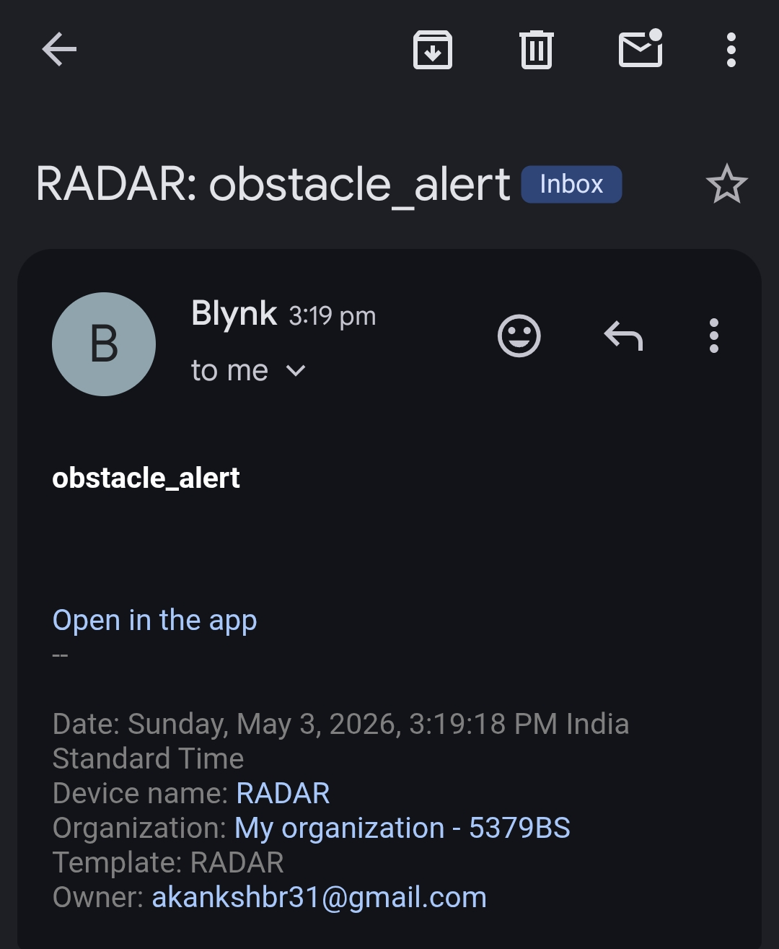

CONCLUSION AND FUTURE SCOPE

The project successfully developed a smart ultrasonic radar system using ESP32 and IoT technology. The system can detect nearby obstacles, generate alerts, and send real-time mobile notifications. The integration of sensors, servo motor, LEDs, buzzer, and Blynk platform provides an efficient and low-cost solution for obstacle monitoring applications.

##Future Scope
- Integration with camera modules for live monitoring.
- Addition of radar visualization using Processing software.
- Implementation of AI-based object classification.
- Integration with robotic navigation systems.
- Cloud-based data storage and analytics.
- Voice assistant integration.

REFERENCES

- ESP32 Official Documentation.
- Blynk IoT Platform Documentation.
- HC-SR04 Ultrasonic Sensor Datasheet.
- Arduino IDE Documentation.
- Servo Motor Technical Manual.
- Research papers related to obstacle detection systems and IoT radar systems.

APPENDICES

Appendix A: Work Diary
Include weekly progress logs, guide meetings, and reflections.
WEEKS | Tasks Completed | Task in Progress
Week 1 | Project topic selection | Literature survey
Week 2 | Hardware component collection | Circuit planning
Week 3 | ESP32 setup and testing | Sensor testing
Week 4 | Ultrasonic sensor integration | Servo motor control
Week 5 | LED and buzzer integration | Testing
Week 6 | Blynk setup and notifications | Debugging
Week 7 | Final integration | Documentation
Week 8 | Testing and result analysis | Report preparation

Appendix B: Plagiarism Report

Attach Turnitin plagiarism report (<20%).

Appendix C: Review Paper Draft

Attach draft or published version of the review paper with proof of submission.

