**Backend Admin for Learner’s Academy**

This document contains sections for:

* Sprint planning and Task completion
* Core concepts used in project
* Flow of the Application.
* Demonstrating the product capabilities, appearance, and user interactions.
* Conclusions

The code for this project is hosted at https://github.com/Akanksha-1312/Admin-Portal-Final.git

The project is developed by Akanksha Mishra.

Sprints planning and Task completion

The project is planned to be completed in 1 sprint. Tasks assumed to be completed in the sprint are:

* Creating the flow of the application
* Initializing git repository to track changes as development progresses.
* Writing the Java program to fulfill the requirements of the project.
* Testing the Java program with different kinds of User input
* Pushing code to GitHub.
* Creating this specification document highlighting application capabilities, appearance, and user interactions.

Core concepts used in project

Exceptions, collections, and sorting techniques for source code optimization and increased performance

Flow of the Application

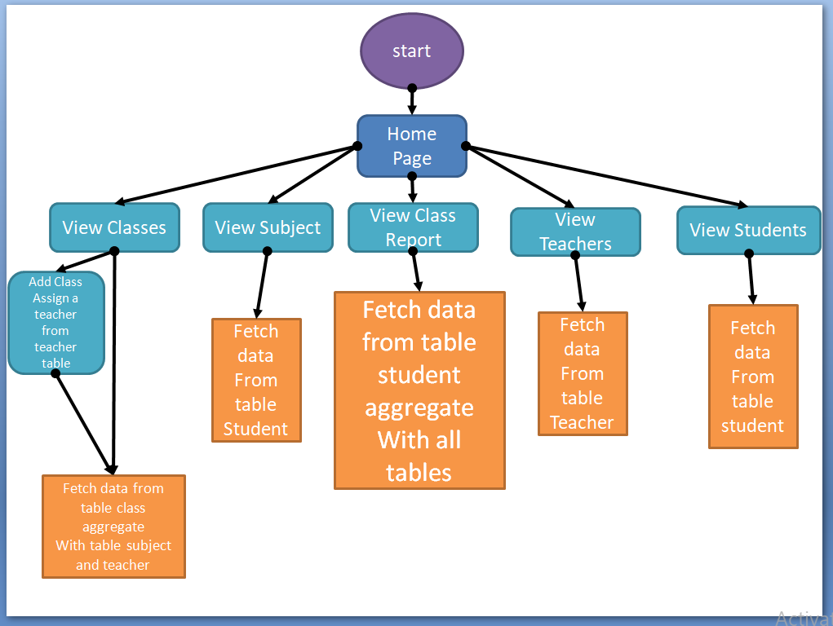



Demonstrating the product capabilities, appearance, and user interactions

demonstrate the product capabilities, below are the sub-sections configured to highlight appearance and user interactions for the project:

**Home Page**

**Able to view all feature** 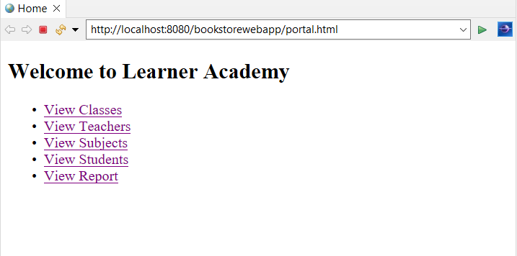

**Display Classes**

**Display classes with corresponding teacher and subject give option to add classes.**

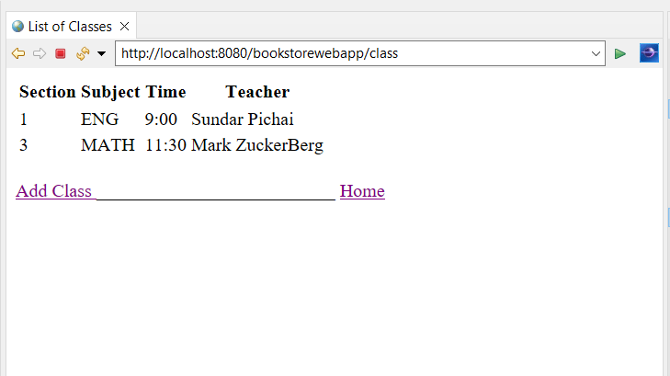

**Assign a Class**

**Assign a class with corresponding subject and teacher with their id.(used aggregation)**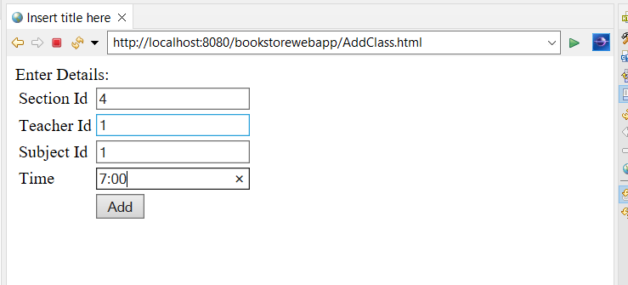

**Class added with corresponding Id and fetch value from corresponding table.**

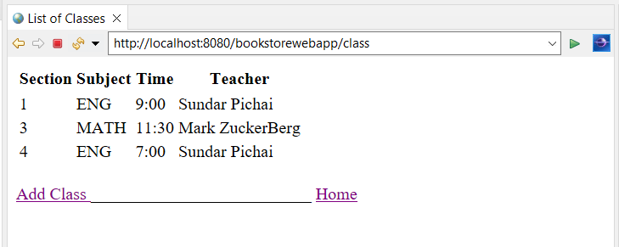

**View Teachers**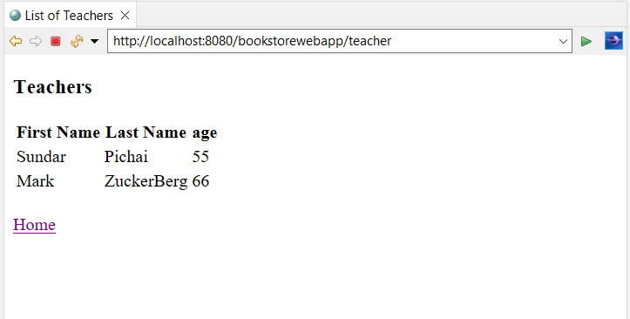

**View Subjects**

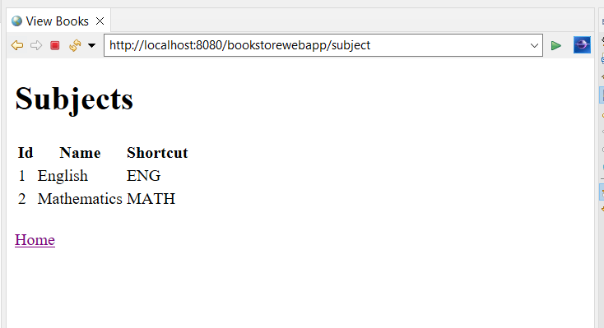

**View Students**

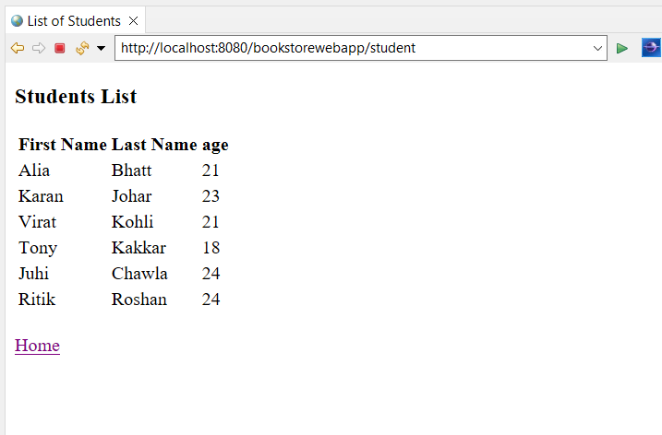

**View Class Report**

**Show the student with corresponding class ,teacher and subject.( aggregated all tables)**

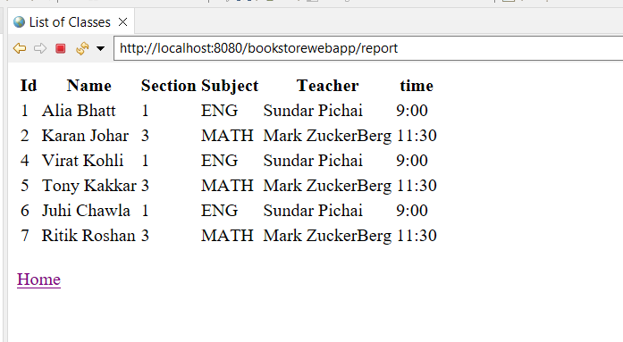

**Step 6:** Pushing the code to GitHub repository

* Open your command prompt and navigate to the folder where you have created your files.

**cd <folder path>**

* Initialize repository using the following command:

**git init**

* Add all the files to your git repository using the following command:

**git add .**

* Commit the changes using the following command:

**git commit . -m <commit message>**

* Push the files to the folder you initially created using the following command:

**git push -u origin master**

Conclusions

Able to do

● Set up a master list of all the subjects for all the classes

● Set up a master list of all the teachers

● Set up a master list of all the classes

● Assign classes for subjects from the master list

● Assign teachers to a class for a subject (A teacher can be assigned to different classes for different subjects)

● Get a master list of students (Each student must be assigned to a single class)