**LockedMe – Virtual Key for Repositories**

This document contains sections for:

* Sprint planning and Task completion
* Core concepts used in project
* Flow of the Application.
* Demonstrating the product capabilities, appearance, and user interactions.
* Unique Selling Points of the Application
* Conclusions

The code for this project is hosted at https://github.com/Akanksha-1312/LockedMeApp.git.

The project is developed by Akanksha Mishra.

Sprints planning and Task completion

The project is planned to be completed in 1 sprint. Tasks assumed to be completed in the sprint are:

* Creating the flow of the application
* Initializing git repository to track changes as development progresses.
* Writing the Java program to fulfill the requirements of the project.
* Testing the Java program with different kinds of User input
* Pushing code to GitHub.
* Creating this specification document highlighting application capabilities, appearance, and user interactions.

Core concepts used in project

Collections framework, File Handling, Sorting, Flow Control, Recursion, Exception Handling, Streams API

Flow of the Application



<flowchart.pptx>

Demonstrating the product capabilities, appearance, and user interactions

To demonstrate the product capabilities, below are the sub-sections configured to highlight appearance and user interactions for the project:

1. Creating the project in Eclipse
2. Writing a program in Java for the entry point of the application (RunFile.java)
3. Writing a program in Java to display Menu options available for the user (MenuLockMe.java)
4. Writing a program in Java to handle Menu options selected by user (MenuLockMe.java)
5. Writing a program in Java to perform the File operations as specified by user .
6. Pushing the code to GitHub repository

**Step 1:** Creating a new project in Eclipse

* Open Eclipse
* Go to File -> New -> Project -> Java Project -> Next.
* Type in any project name and click on “Finish.”
* Select your project and go to File -> New -> Class.
* Enter **RunFile.java** in any class name, check the checkbox “public static void main(String[] args)”, and click on “Finish.”

**Step 2:** Writing a program in Java for the entry point of the application (**RunFile.java**)

**package mainApp;**

**public class RunFile {**

**/*Please enter your desired path,by default path is given by me may not exist in your system*/**

**public static final String *path* = "P:\\javafsd\\JAVAdemo\\File Temp";**

**public static void main(String[] args) {**

**MenuLockMe menu = new MenuLockMe();**

**//for introduction**

**menu.firstScreen();**

**//for user interface**

**menu.mainMenu();**

**}**

**}**

**Step 3:** Writing a program in Java to display Menu options available for the user (**MenuLockMe.java**)

* Select your project and go to File -> New -> Class.
* Enter **MenLockMe** in class name and click on “Finish.”
* **MenuLockMe** consists methods for -:
  1. Displaying Welcome Screen
  2. Displaying Initial Menu
  3. Displaying Secondary Menu for File Operations available
  4. Display Exit Screen

**Step 3.1:** Writing method to display Welcome Screen

**public void firstScreen() {**

**System.out.println();**

**System.out.println("*************************************************");**

**System.out.println("* WELCOME USER TO *");**

**System.out.println("* LOCKEDME.COM *");**

**System.out.println("*===============================================*");**

**System.out.println("* DEVELOPED BY Akanksha Mishra *");**

**System.out.println("*************************************************");**

**System.out.println("* Directory: " + RunFile.path +" *");**

**System.out.println("*************************************************");**

**System.out.println("\n\n");**

**}**

Output:

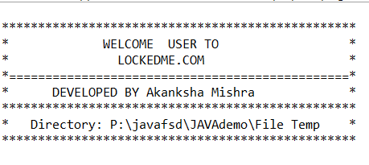

**Step 3.2:** Writing method to display Initial Menu

**public void mainMenuOptions() {**

**System.out.println("=================================================");**

**System.out.println("| MAIN MENU |");**

**System.out.println("-------------------------------------------------");**

**System.out.println("| Select any one of the following: |");**

**System.out.println("| 1 - List All Files |");**

**System.out.println("| 2 - File Options |");**

**System.out.println("| 3 - Exit |");**

**System.out.println("=================================================");**

**System.out.println("Enter your choice : ");**

**}**

**Output:**

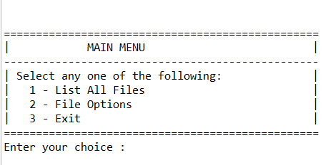

**Step 3.3:** Writing method to display Secondary Menu for File Operations

**public void subMenuOptions() {**

**System.out.println("=================================================");**

**System.out.println("| SUB MENU |");**

**System.out.println("-------------------------------------------------");**

**System.out.println("| Select any one of the following: |");**

**System.out.println("| 1 - Add a file |");**

**System.out.println("| 2 - Delete a file |");**

**System.out.println("| 3 - Search a file |");**

**System.out.println("| 4 - Go Back |");**

**System.out.println("=================================================");**

**System.out.println("Enter your choice : ");**

**}**

**Output:**

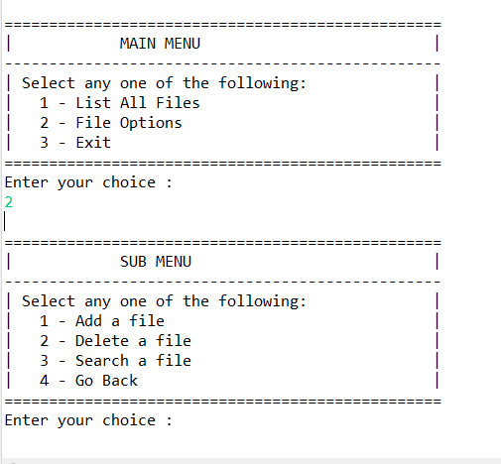

**Step 3.4: Writing method to display Exit Screen.**

**public void exitScreen() {**

**System.out.println("=============================================");**

**System.out.println(" _______________________________________________ ");**

**System.out.println("| |");**

**System.out.println("| THANK YOU FOR VISITING |");**

**System.out.println("| LOCKEDME.COM |");**

**System.out.println("|_______________________________________________|");**

**System.out.println("============================================= ");**

**System.out.println("\n\n");**

**}**

**Output:**

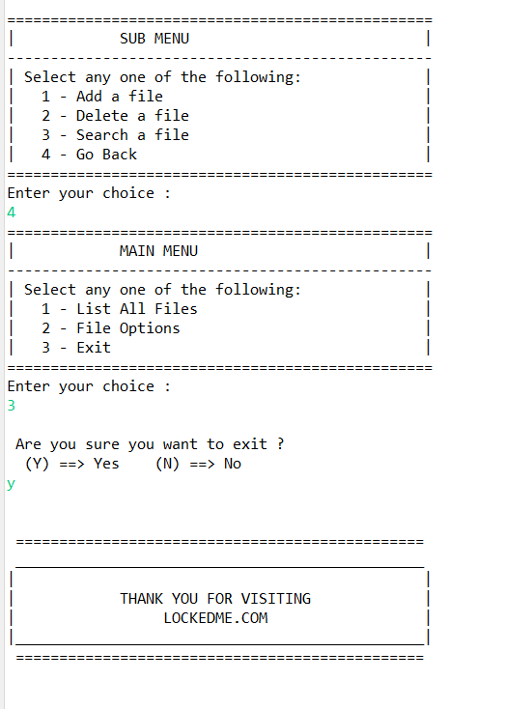

**Step 4:** Writing a program in Java to handle Menu options selected by user (**MenuLockMe.java**)

* 1. Handling input selected by user in initial Menu
  2. Handling input selected by user in secondary Menu for File Operations

**Step 4.1:** Writing method to handle user input in initial Menu

**public void mainMenu() {**

**int choice = 0;**

**char decision = 0;**

**do {**

**mainMenuOptions();**

**try {**

**choice = Integer.parseInt(scan.nextLine());**

**} catch (NumberFormatException e) {**

**System.out.println("\nInvalid Input \nValid Input Integers:(1-3)\n");**

**mainMenu();**

**}**

**switch (choice) {**

**case 1:**

**System.out.println();**

**try {**

**ListAllFiles obj1=new ListAllFiles();**

**obj1.listAllFiles(RunFile.path);**

**}catch(NullPointerException e) {**

**System.out.println(e.getMessage());**

**}catch(IllegalArgumentException e) {**

**System.out.println(e.getMessage());**

**}catch(Exception e) {**

**System.out.println(e.getMessage());**

**}**

**System.out.println("\n***********************************\n");**

**break;**

**case 2:**

**System.out.println();**

**subMenu();**

**break;**

**case 3:**

**System.out.println("\n Are you sure you want to exit ? ");**

**System.out.println(" (Y) ==> Yes (N) ==> No ");**

**decision = scan.nextLine().toUpperCase().charAt(0);**

**if(decision == 'Y') {**

**System.out.println("\n");**

**exitScreen();**

**System.exit(1);**

**}else if(decision == 'N') {**

**System.out.println("\n");**

**mainMenu();**

**}else {**

**System.out.println("\nInvalid Input \nValid Inputs :(Y/N)\n");**

**mainMenu();**

**}**

**default:**

**System.out.println("\nInvalid Input \nValid Input Integers:(1-3)\n");**

**mainMenu();**

**}**

**}while(true);**

**}**

**Step 4.2:** Writing method to handle user input in Secondary Menu for File Operations

**public void subMenu() {**

**String file = null;**

**String fileName = null;**

**int choice = 0;**

**do {**

**subMenuOptions();**

**try {**

**choice = Integer.parseInt(scan.nextLine());**

**} catch (NumberFormatException e) {**

**System.out.println("Invalid Input \nValid Input Integers:(1-4)");**

**subMenu();**

**}**

**switch (choice) {**

**case 1:**

**System.out.println("\n==> Adding a File...");**

**System.out.println("Please enter a file name : ");**

**file = scan.nextLine();**

**fileName = file.trim();**

**try {CreateFile obj2=new CreateFile();**

**obj2.createNewFile(RunFile.path, fileName);**

**}catch(NullPointerException e) {**

**System.out.println(e.getMessage());**

**}catch(IOException e) {**

**System.out.println("Error occurred while adding file..");**

**System.out.println("Please try again...");**

**}catch(Exception e) {**

**System.out.println("Error occurred while adding file..");**

**System.out.println("Please try again...");**

**}**

**System.out.println("\n**********************************\n");**

**break;**

**case 2:**

**System.out.println("\n==> Deleting a File...");**

**System.out.println("Please enter a file name to Delete : ");**

**file = scan.nextLine();**

**fileName = file.trim();**

**try {DeleteFiles obj3=new DeleteFiles();**

**obj3.deleteFile(RunFile.path, fileName);**

**}catch(NullPointerException e) {**

**System.out.println(e.getMessage());**

**}catch(IOException e) {**

**System.out.println("Error occurred while Deleting File..");**

**System.out.println("Please try again...");**

**}catch(Exception e) {**

**System.out.println("Error occurred while Deleting File..");**

**System.out.println("Please try again...");**

**}**

**System.out.println("\n***********************************\n");**

**break;**

**case 3:**

**System.out.println("\n==> Searching a File...");**

**System.out.println("Please enter a file name to Search : ");**

**file = scan.nextLine();**

**fileName = file.trim();**

**try {SearchFiles obj4=new SearchFiles();**

**obj4.searchFile(RunFile.path, fileName);**

**}catch(NullPointerException e) {**

**System.out.println(e.getMessage());**

**}catch(IllegalArgumentException e) {**

**System.out.println(e.getMessage());**

**}catch(Exception e) {**

**System.out.println(e.getMessage());**

**}**

**System.out.println("\n***********************************\n");**

**break;**

**case 4: mainMenu();**

**break;**

**default:**

**System.out.println("Invalid Input \nValid Input Integers:(1-4)");**

**subMenu();**

**}**

**file = null;**

**fileName = null;**

**}while(true);**

**}**

**Step 5:** Writing a program in Java to perform the File operations as specified by user .

* 1. Displaying all files in the directory.
  2. Creating a file/folder as specified by user input.
  3. Search files as specified by user input in the directory.
  4. Deleting a file/folder from the Directory.

**Step 5.1:** Writing class to display all files in the directory.

**package mainApp;**

**import java.io.File;**

**import java.util.Arrays;**

**import java.util.Set;**

**import java.util.TreeSet;**

**public class ListAllFiles {**

**public void listAllFiles(String path) {**

**if (path == null || path.isEmpty() || path.isBlank())**

**throw new NullPointerException("Path cannot be Empty or null");**

**File dir = new File(path);**

**if(!dir.exists())**

**throw new IllegalArgumentException("Path does not exist \n Note: !!Please change the path in the \n code(RunFile.java) to your desired path ");**

**if(dir.isFile())**

**throw new IllegalArgumentException("The given path is a file. A directory is expected.");**

**String [] files = dir.list();**

**System.out.println("\n***********************************");**

**if(files != null && files.length > 0) {**

**Set<String>filesList = new TreeSet<String>(Arrays.asList(files));**

**System.out.println("The Files in "+ dir.getAbsolutePath() + " are: \n");**

**for(String file1:filesList) {**

**System.out.println(file1);**

**}**

**System.out.println("\nTotal Number of files: "+ filesList.size());**

**}else {**

**System.out.println("Directory is Empty");**

**}**

**}**

**}**

Output:

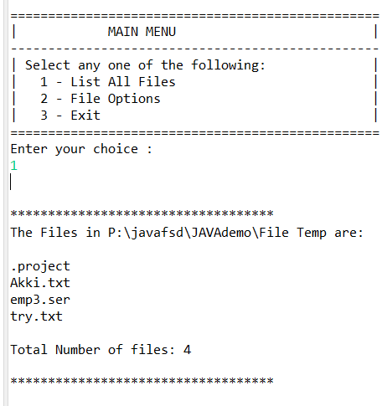

**Step 5.2:** Writing a class to create a file/folder as specified by user input.

**package mainApp;**

**import java.io.File;**

**import java.io.IOException;**

**public class CreateFile {**

**public void createNewFile(String path , String fileName) throws IOException {**

**if (path == null || path.isEmpty() || path.isBlank())**

**throw new NullPointerException("Path cannot be Empty or null");**

**if (fileName == null || fileName.isEmpty() || fileName.isBlank())**

**throw new NullPointerException("File Name cannot be Empty or null");**

**File newFile = new File(path + File.separator + fileName);**

**boolean createFile = newFile.createNewFile();**

**if (createFile) {**

**System.out.println("\nFile Successfully Created: " + newFile.getAbsolutePath());**

**}else if(!createFile) {**

**System.out.println("\nFile Already Exist.. Please try again." );**

**}**

**}**

**}**

**Output:**

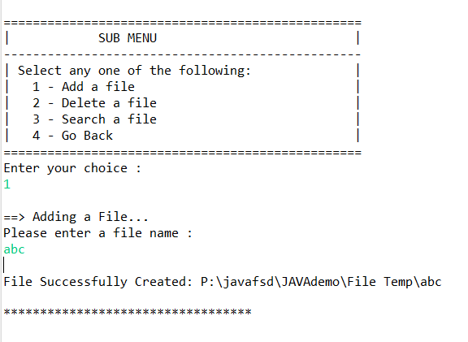

**Step 5.3:**  Writing class to search a file in the directory.

**import java.io.File;**

**import java.util.regex.Matcher;**

**import java.util.regex.Pattern;**

**public class SearchFiles {**

**public void searchFile(String path , String fileName){**

**if (path == null || path.isEmpty() || path.isBlank())**

**throw new NullPointerException("Path cannot be Empty or null");**

**if (fileName == null || fileName.isEmpty() || fileName.isBlank())**

**throw new NullPointerException("File Name cannot be Empty or null");**

**File dir = new File(path);**

**if(!dir.exists())**

**throw new IllegalArgumentException("Path does not exist");**

**if(dir.isFile())**

**throw new IllegalArgumentException("The given path is a file. A directory is expected.");**

**String [] fileList = dir.list();**

**boolean flag = false;**

**Pattern pat = Pattern.compile(fileName);**

**if(fileList != null && fileList.length > 0) {**

**for(String file:fileList) {**

**Matcher mat = pat.matcher(file);**

**if(mat.matches()) {**

**System.out.println("File Found at location: " + dir.getAbsolutePath());**

**flag = true;**

**break;**

**}**

**}**

**}**

**if(flag == false)**

**System.out.println("File Not Found.. Please try again.");**

**}**

**}**

**Output:**

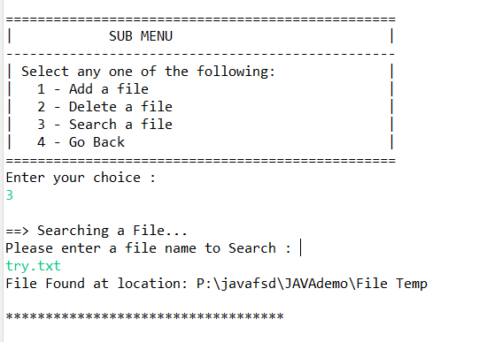

**Step 5.4:**  Writing class to delete file/folder in the directory.

**import java.io.File;**

**import java.io.IOException;**

**public class DeleteFiles {**

**public void deleteFile(String path , String fileName) throws IOException {**

**if (path == null || path.isEmpty() || path.isBlank())**

**throw new NullPointerException("Path cannot be Empty or null");**

**if (fileName == null || fileName.isEmpty() || fileName.isBlank())**

**throw new NullPointerException("File Name cannot be Empty or null");**

**File newFile = new File(path + File.separator + fileName);**

**boolean deleteFile = newFile.delete();**

**if (deleteFile) {**

**System.out.println("\nFile deleted Successfully");**

**}else {**

**System.out.println("\nFile Not Found.. Please try again." );**

**}**

**}**

**}**

Output:

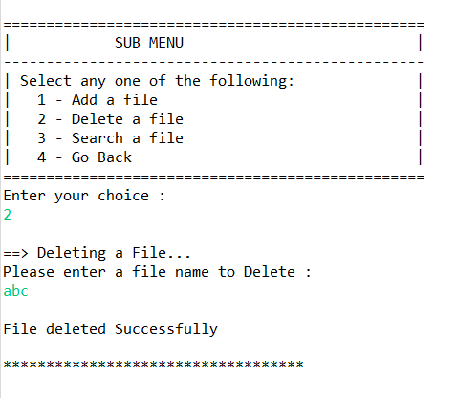

**Step 6:** Pushing the code to GitHub repository

* Open your command prompt and navigate to the folder where you have created your files.

**cd <folder path>**

* Initialize repository using the following command:

**git init**

* Add all the files to your git repository using the following command:

**git add .**

* Commit the changes using the following command:

**git commit . -m <commit message>**

* Push the files to the folder you initially created using the following command:

**git push -u origin master**

Unique Selling Points of the Application

1. The application is designed to keep on running and taking user inputs even after exceptions occur. To terminate the application, appropriate option needs to be selected.
2. The application can take any file/folder name as input. Even if the user wants to create nested folder structure, user can specify the relative path, and the application takes care of creating the required folder structure.
3. User is also provided the option to write content if they want into the newly created file.
4. The application doesn’t restrict user to specify the exact filename to search/delete file/folder. They can specify the starting input, and the program searches all files/folder starting with the value and displays it. The user is then provided the option to select all files or to select a specific index to delete.
5. The application also allows user to delete folders which are not empty.
6. The user is able to seamlessly switch between options or return to previous menu even after any required operation like adding, searching, deleting or retrieving of files is performed.
7. When the option to retrieve files in ascending order is selected, user is displayed with two options of viewing the files.
   1. Ascending order of folders first which have files sorted in them,
   2. Ascending order of all files and folders inside the “main” folder.
8. The application is designed with modularity in mind. Even if one wants to update the path, they can change it through the source code. Application has been developed keeping in mind that there should be very less “hardcoding” of data.

Conclusions

Further enhancements to the application can be made which may include:

* Conditions to check if user is allowed to delete the file or add the file at the specific locations.
* Asking user to verify if they really want to delete the selected directory if it’s not empty.
* Retrieving files/folders by different criteria like Last Modified, Type, etc.
* Allowing user to append data to the file.