**Online Quiz Portal**

This document contains sections for:

* Sprint planning and Task completion
* Core concepts used in project
* Flow of the Application.
* Demonstrating the product capabilities, appearance, and user interactions.
* Conclusions

The code for this project is hosted at <https://github.com/Akanksha-1312/OnlineQuiz>

The project is developed by Akanksha Mishra.

Sprints planning and Task completion

The project is planned to be completed in 1 sprint. Tasks assumed to be completed in the sprint are:

* Creating the flow of the application
* Initializing git repository to track changes as development progresses.
* Writing the Java program to fulfill the requirements of the project.
* Testing the Java program with different kinds of User input
* Pushing code to GitHub.
* Creating this specification document highlighting application capabilities, appearance, and user interactions.

Core concepts used in project

Exceptions, collections, and sorting techniques for source code optimization and increased performance

Flow of the Application

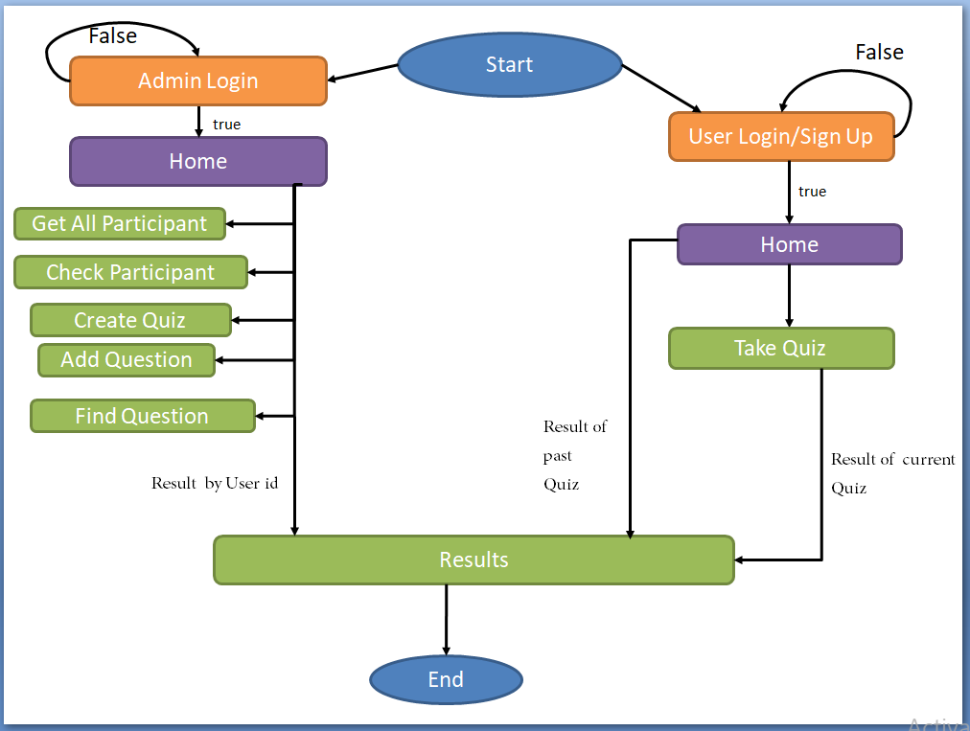



Demonstrating the product capabilities, appearance, and user interactions

demonstrate the product capabilities, below are the sub-sections configured to highlight appearance and user interactions for the project:

* Admin Login

With correct user id and password

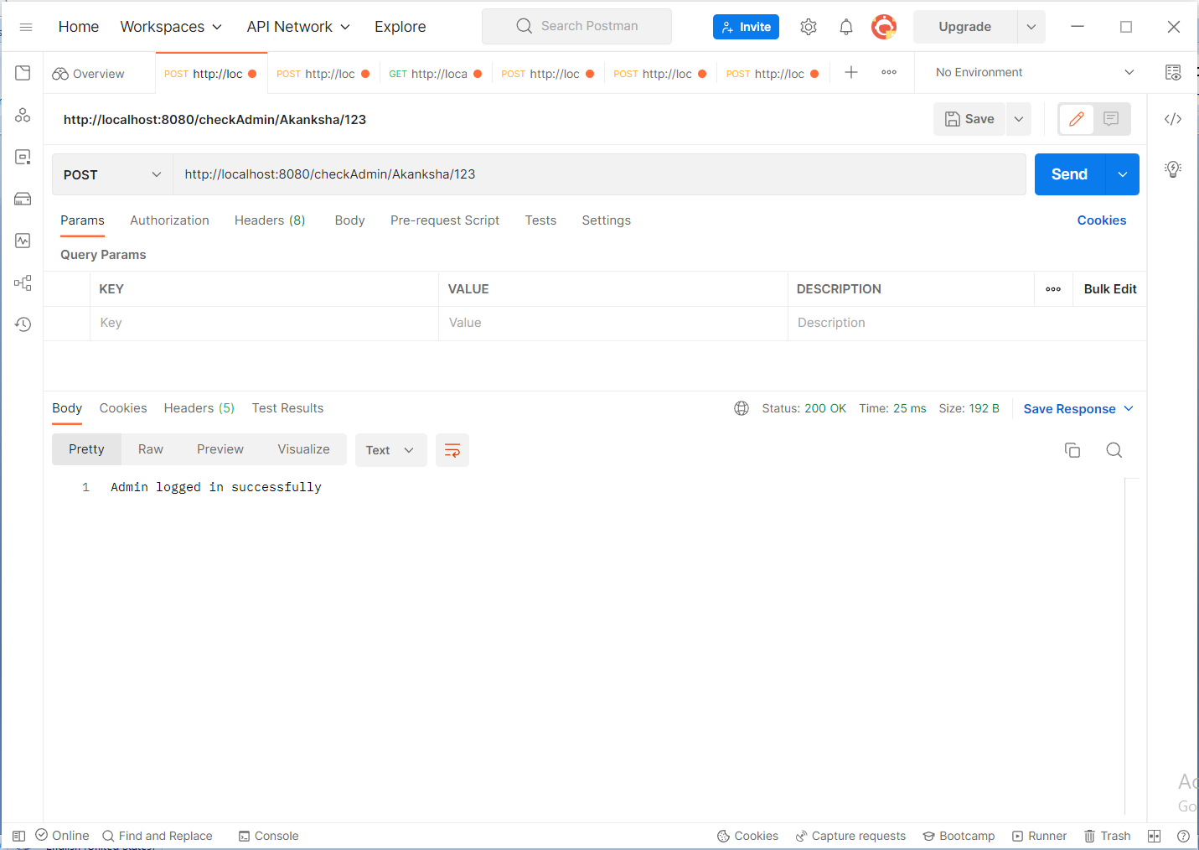

With incorrect user id and password

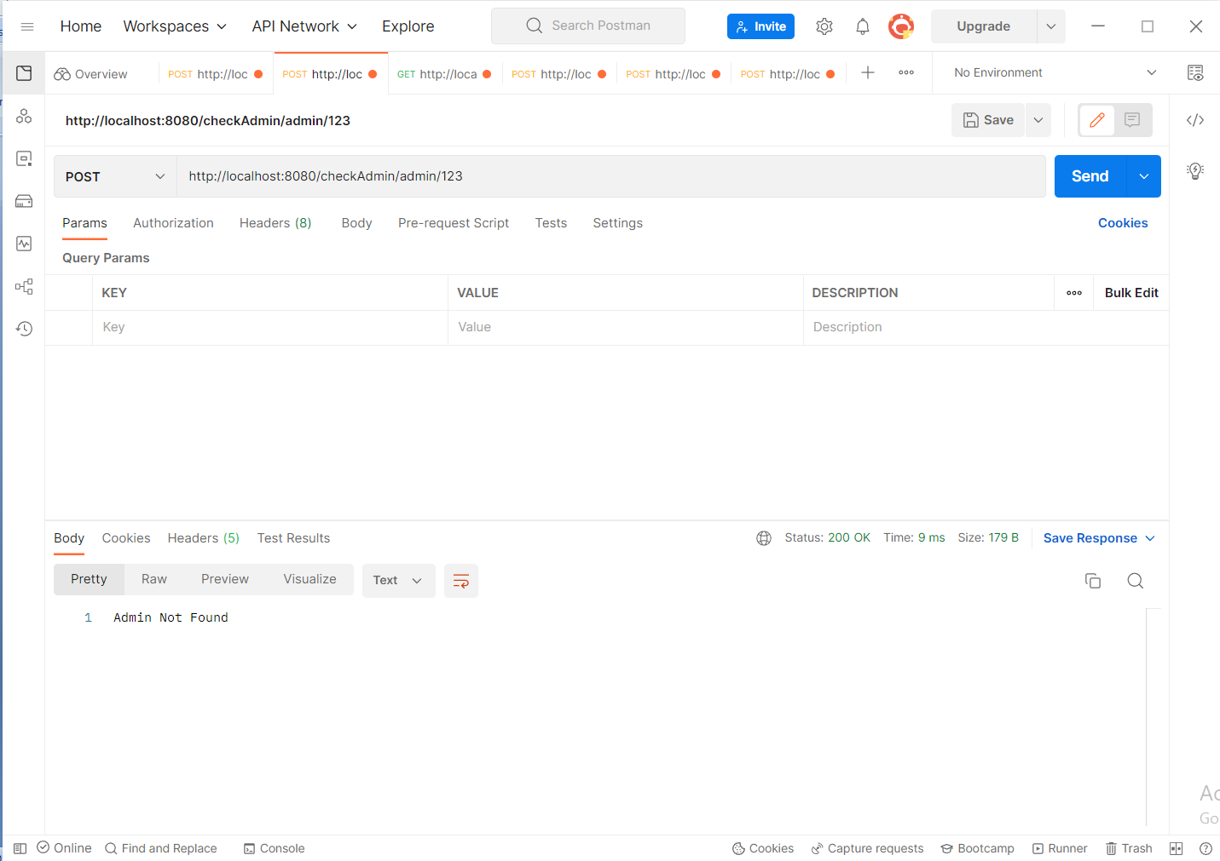

* User Sign Up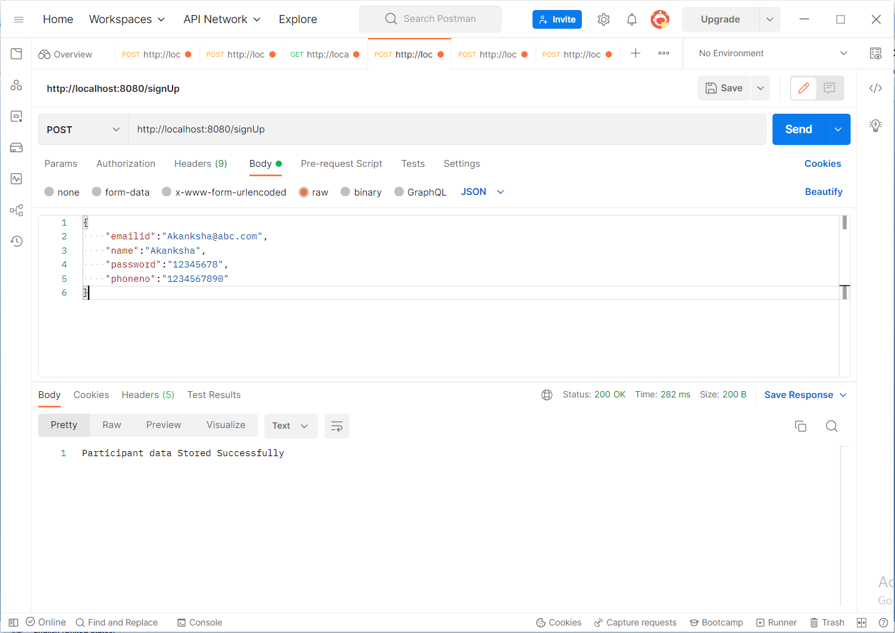

• User Sign In

With correct Id and password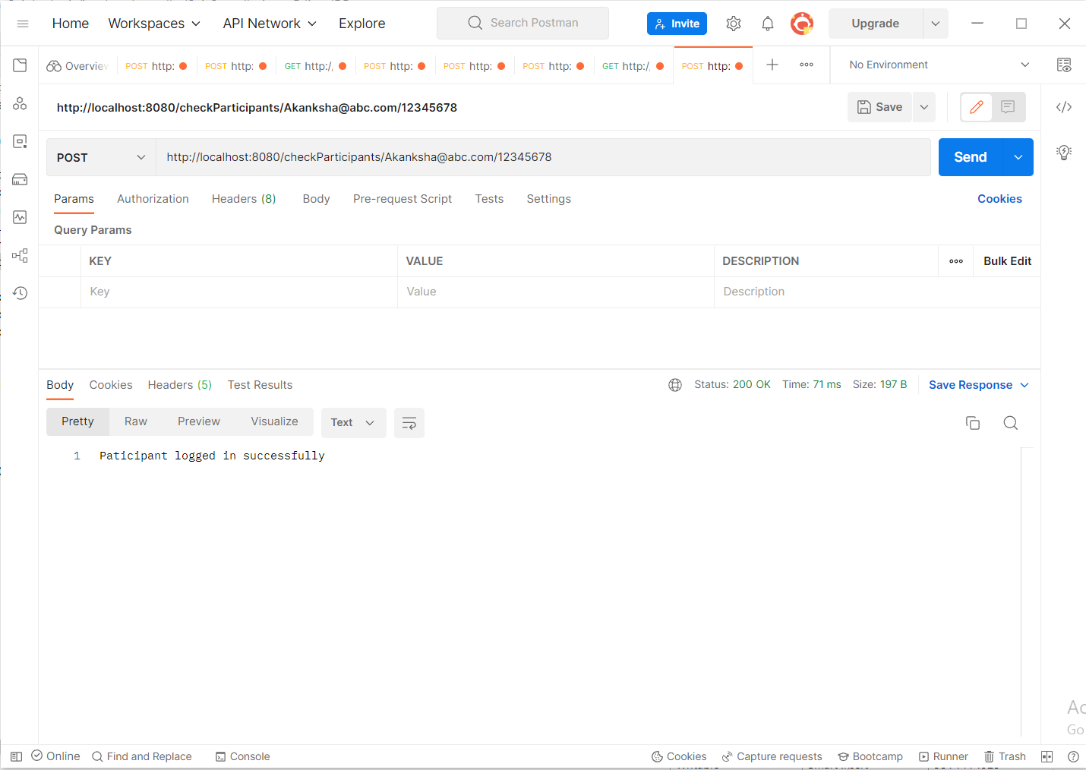

With incorrect Id and password 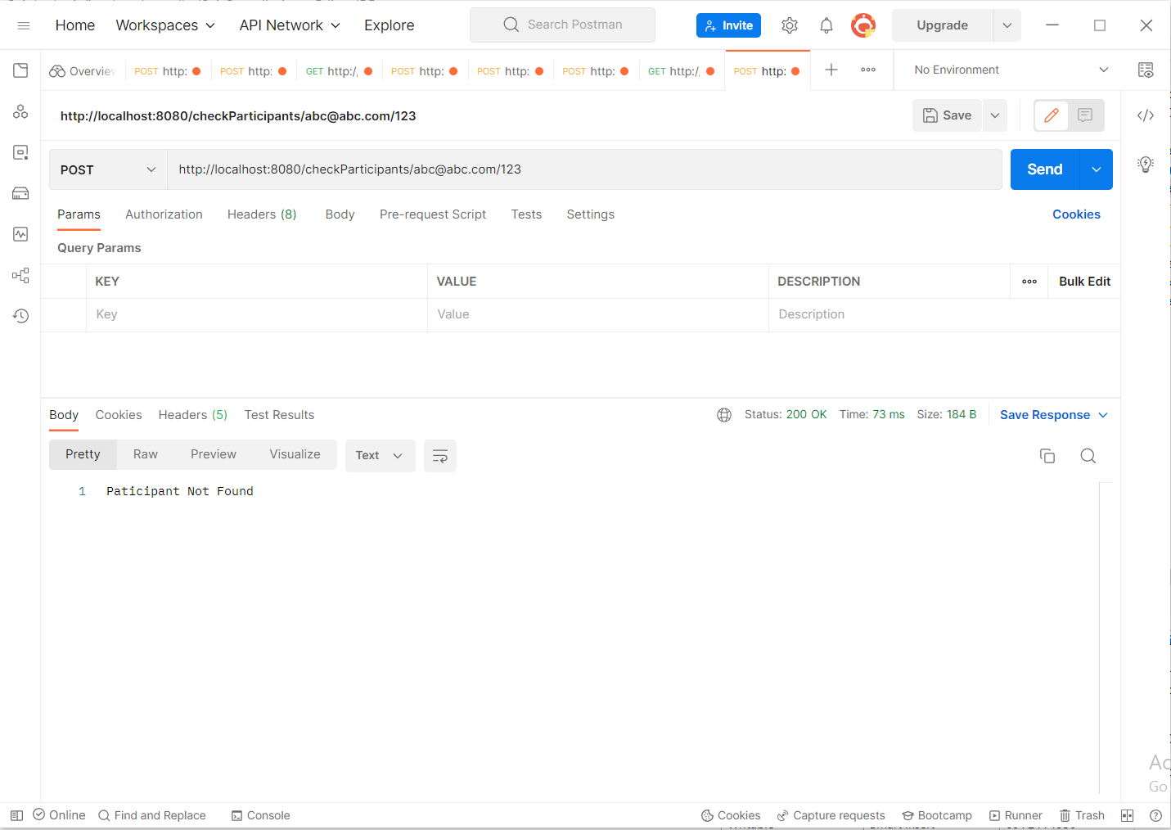

* Get Participant 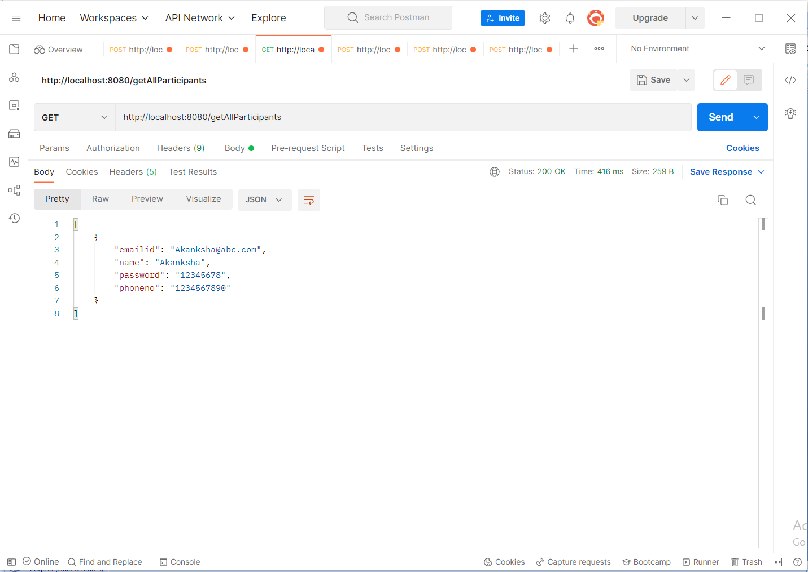
* Add Questions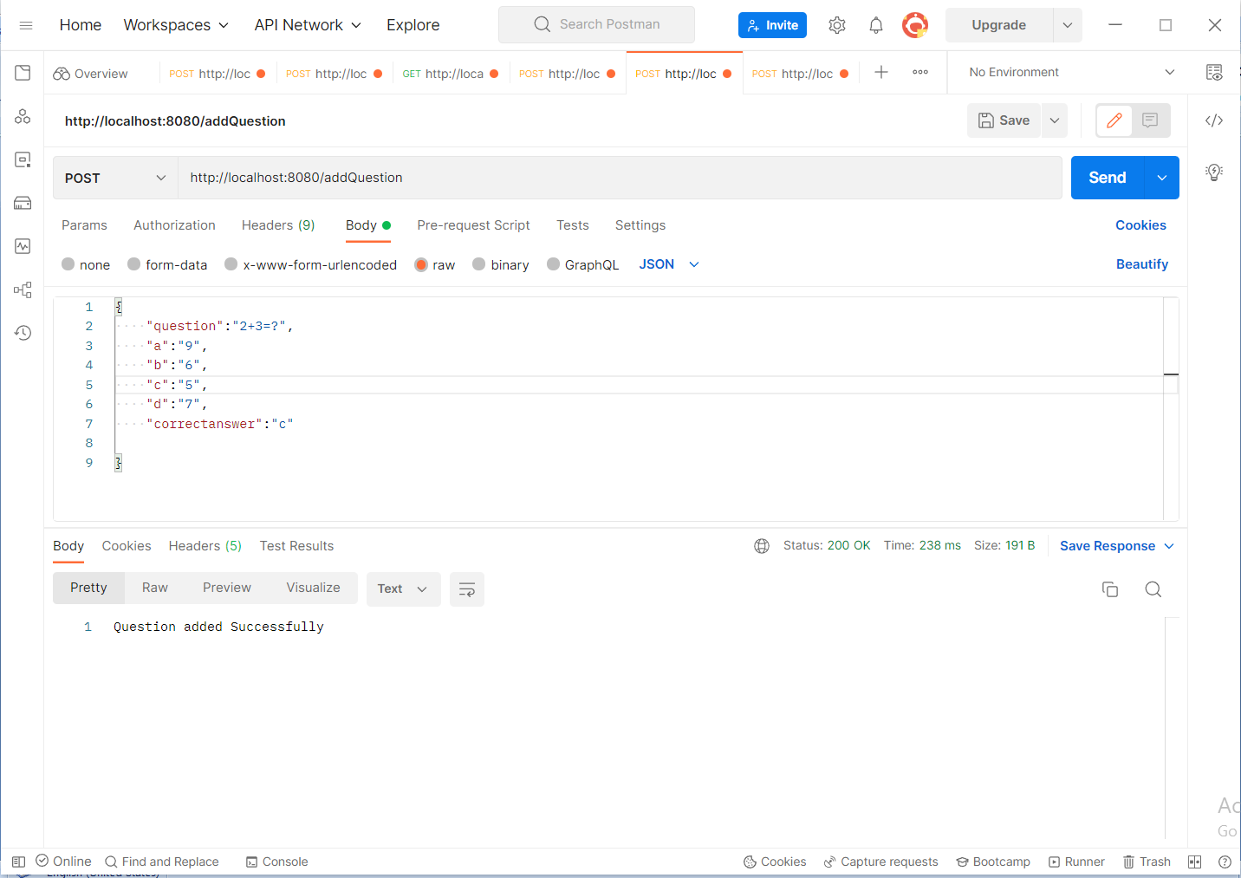

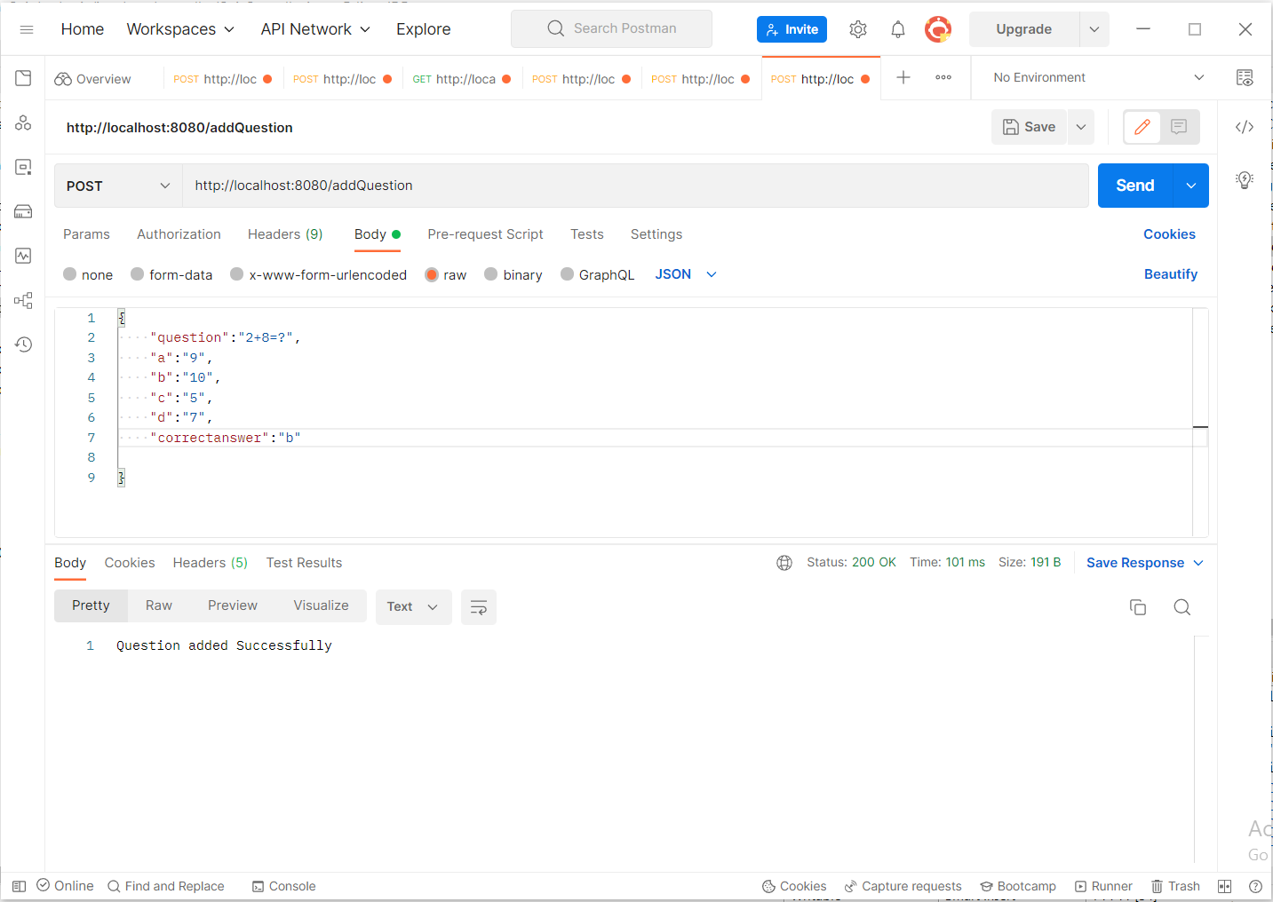

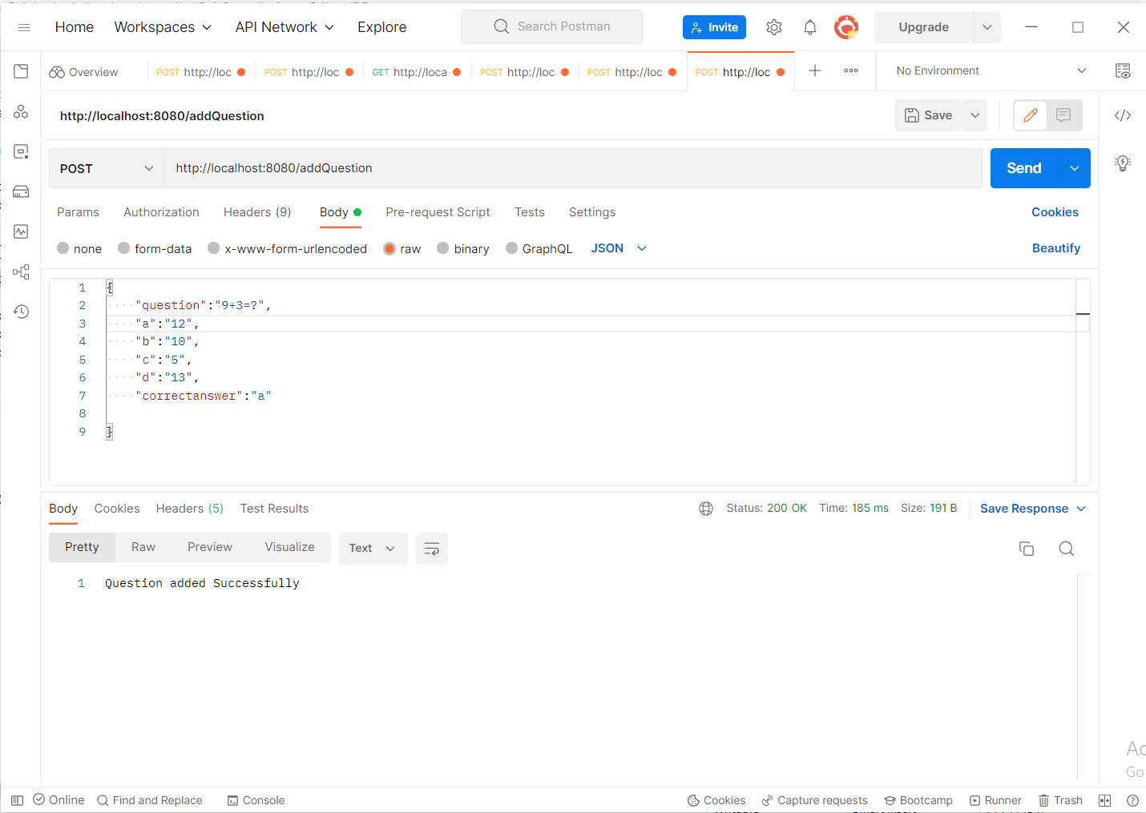

* Find Questions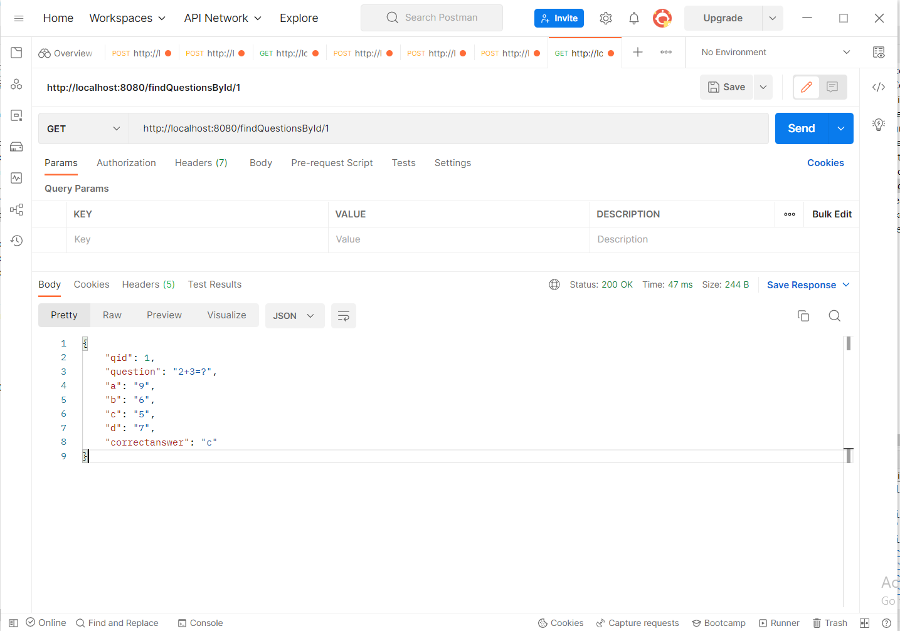

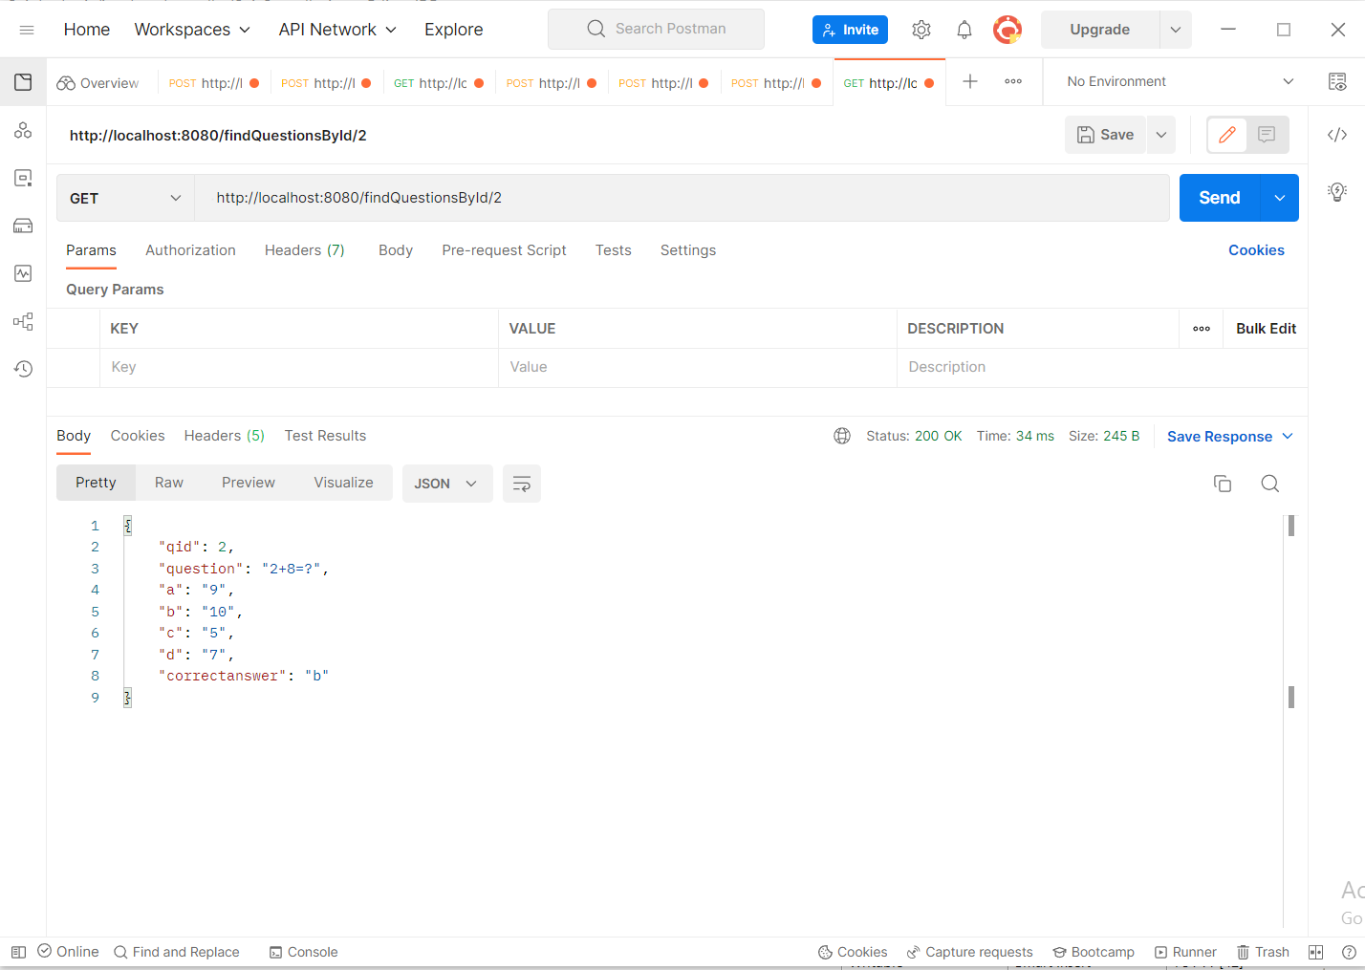

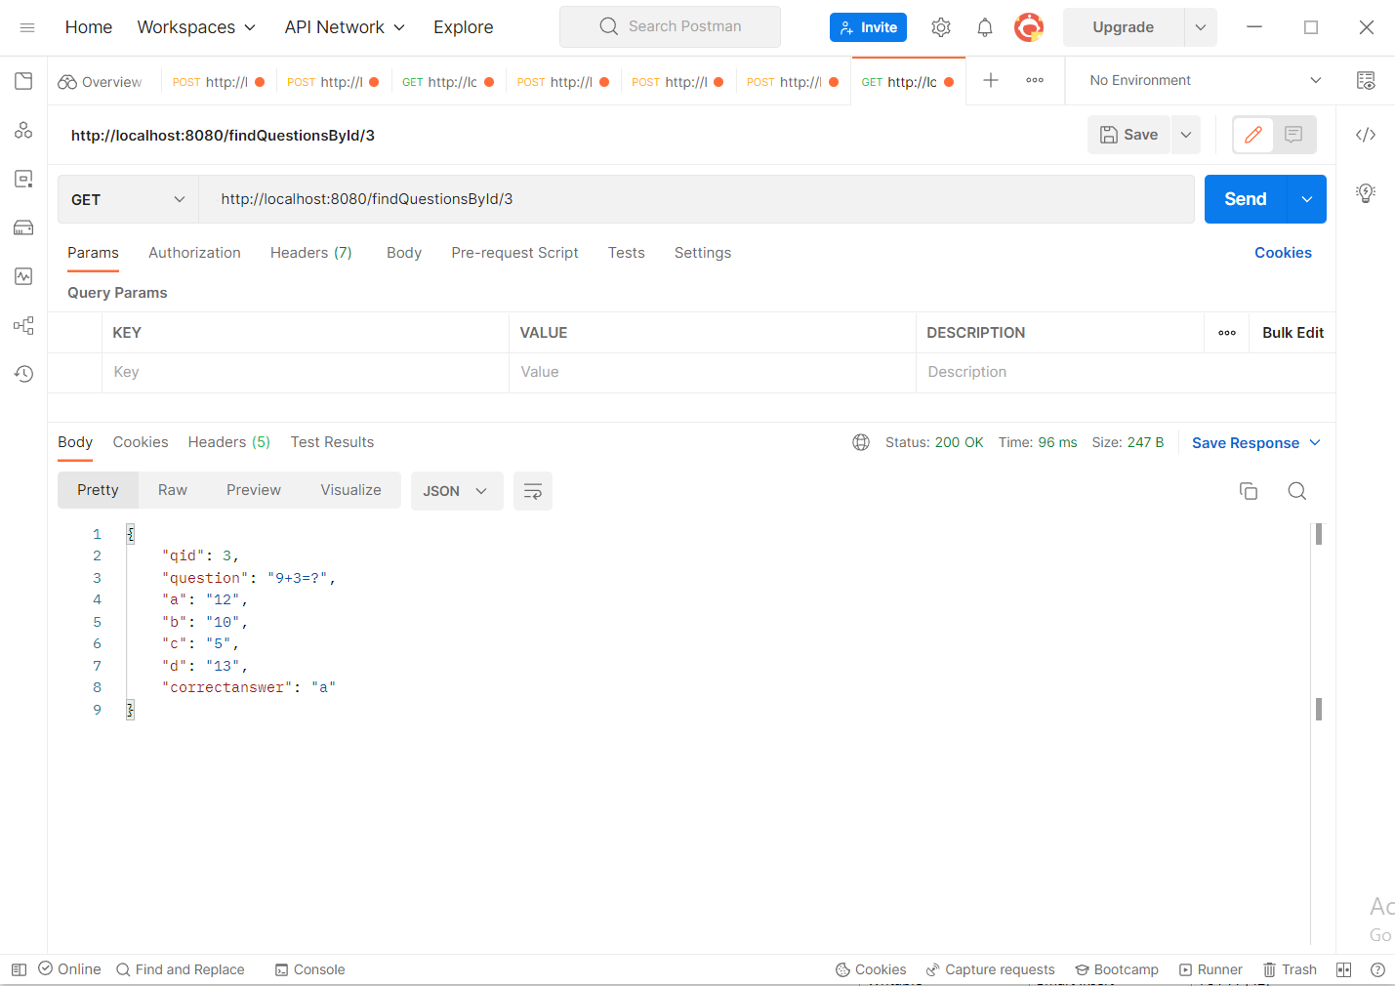

* Create Quiz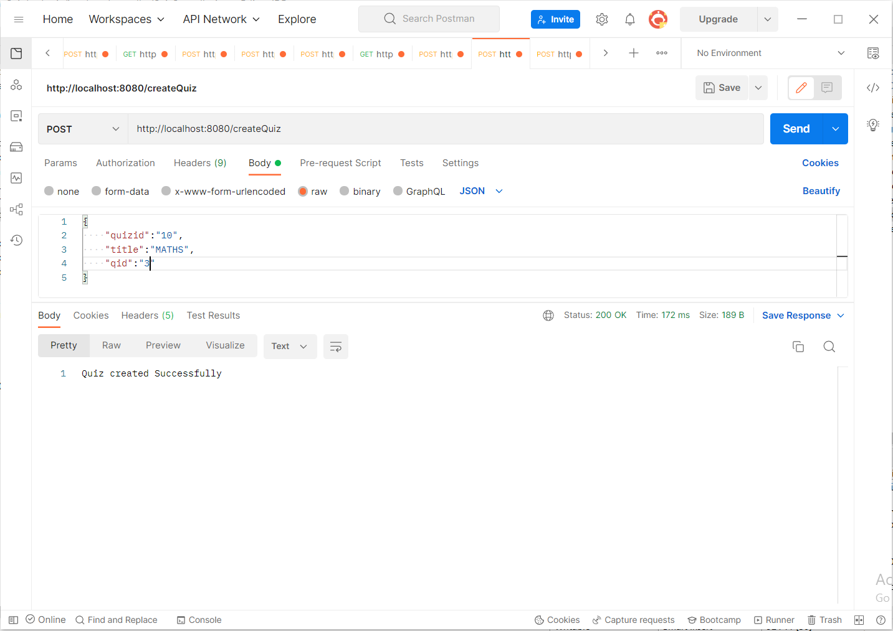
* Take Quiz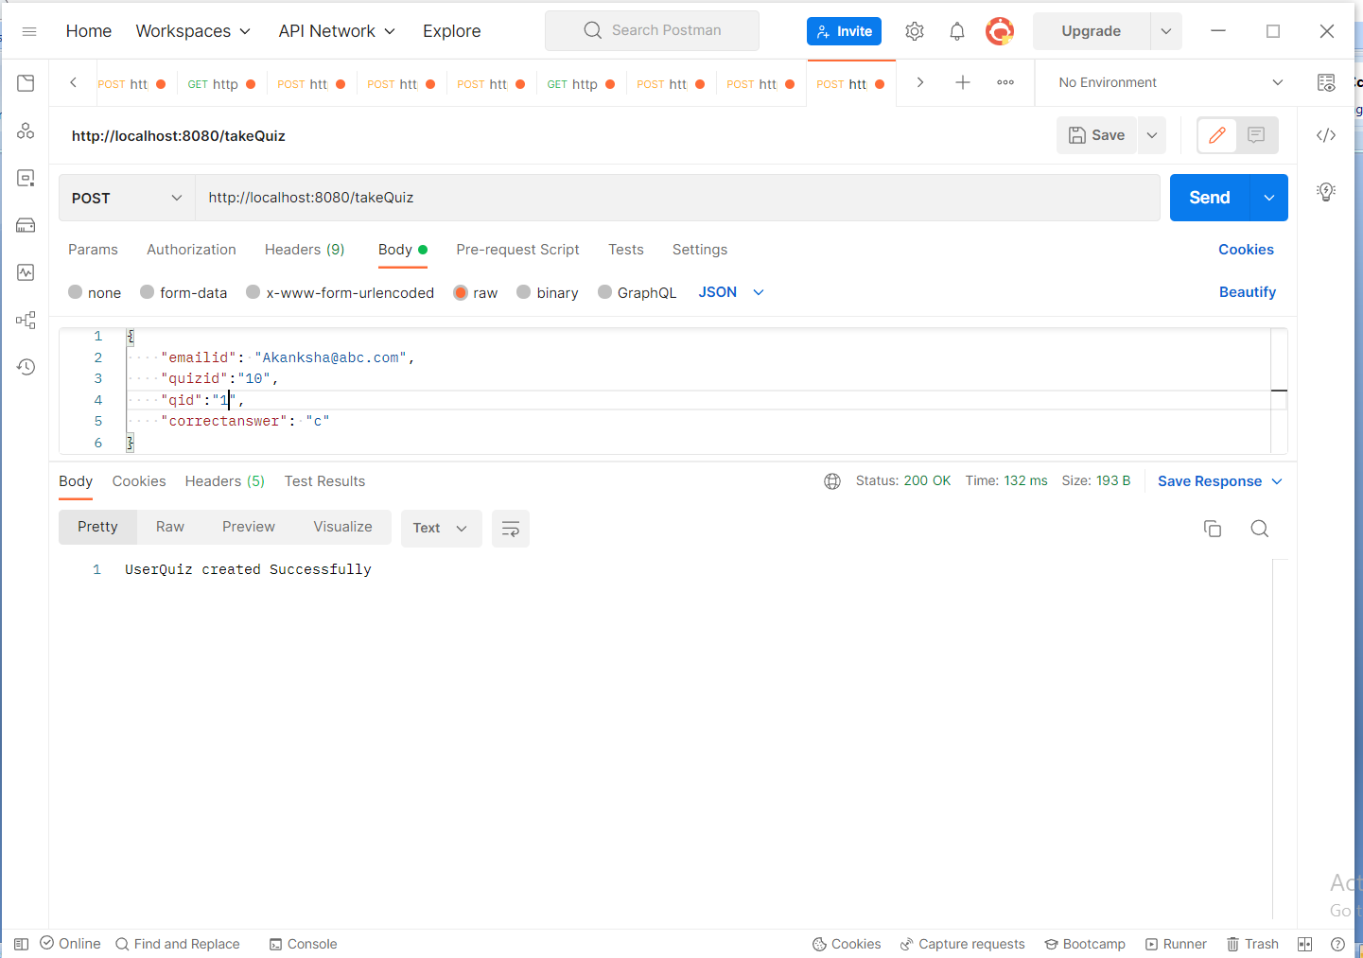

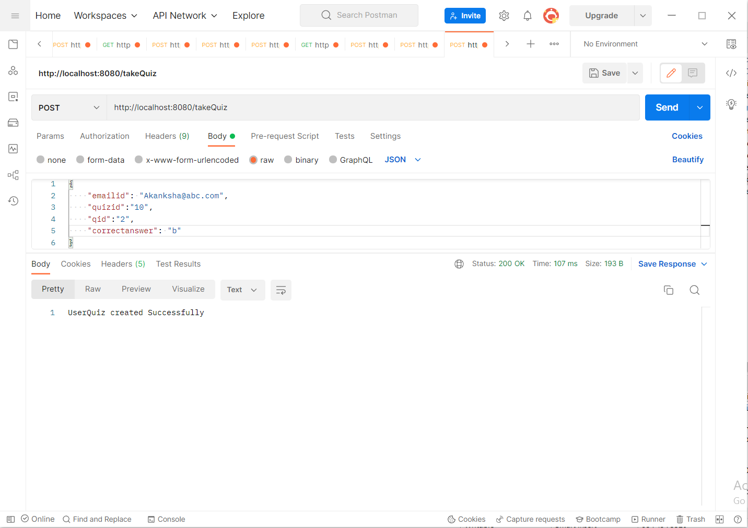

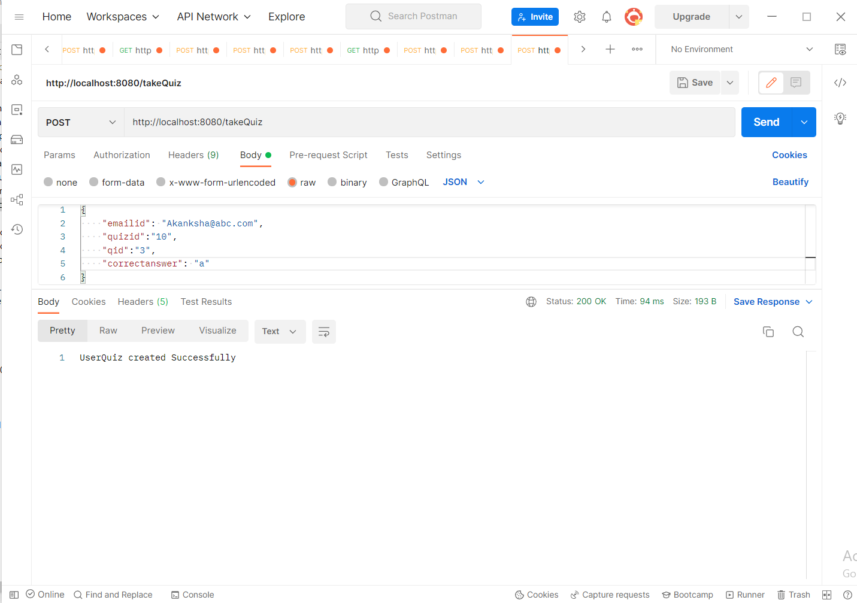

* Check Result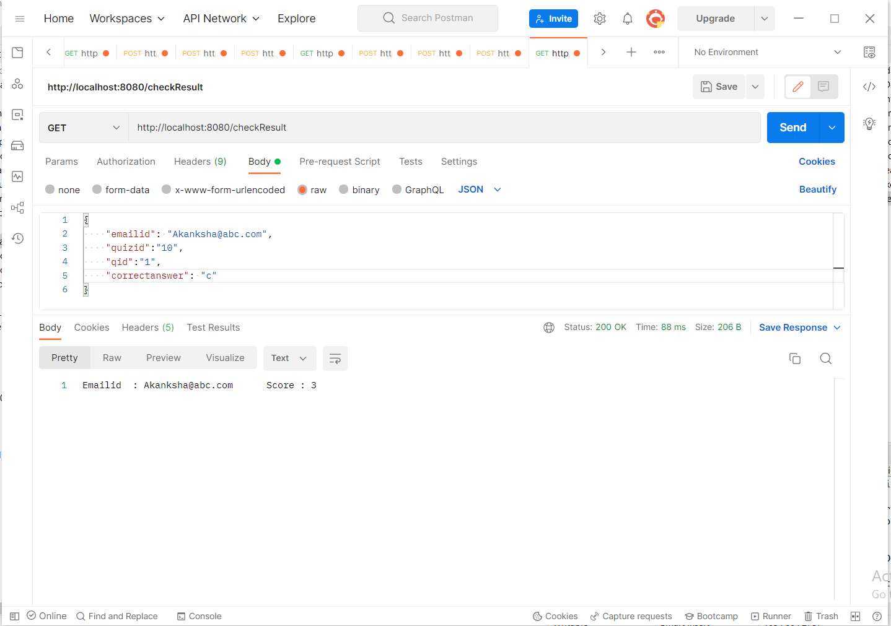
* Database

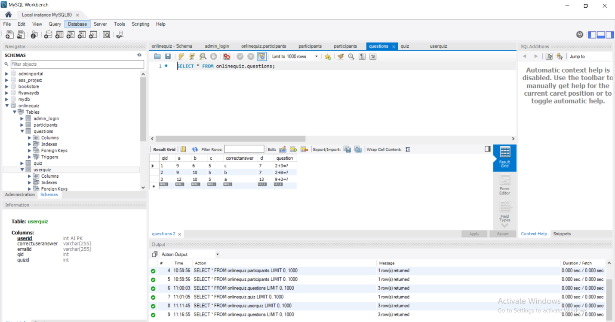

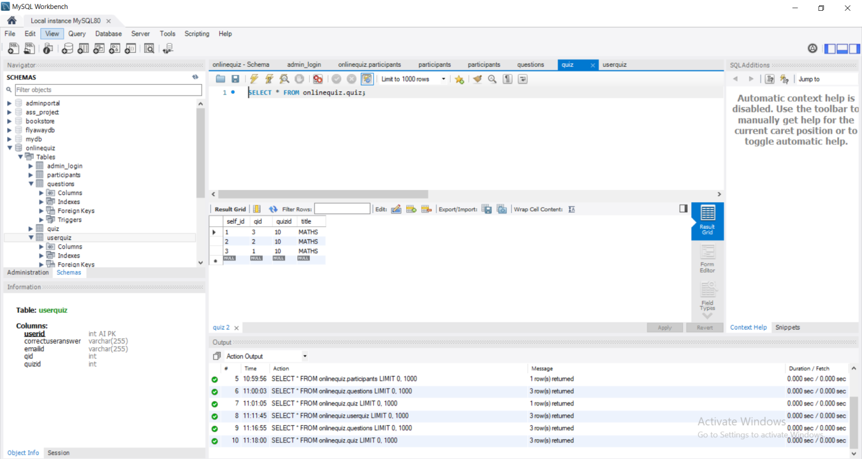

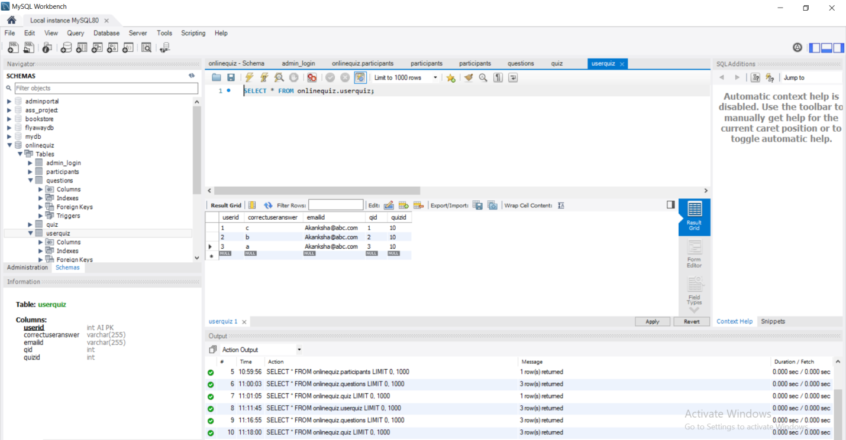

**Step 6:** Pushing the code to GitHub repository

* Open your command prompt and navigate to the folder where you have created your files.

**cd <folder path>**

* Initialize repository using the following command:

**git init**

* Add all the files to your git repository using the following command:

**git add .**

* Commit the changes using the following command:

**git commit . -m <commit message>**

* Push the files to the folder you initially created using the following command:

**git push -u origin master**

Conclusions

Able to do

Develop a RESTful Web API to perform CRUD operations on Domain objects as per requirement using Spring Boot and MySQL/Oracle database.

•The admin user has a separateAPIto access the admin portal, which requires authentication with the admin username and password.

•The admin user can update the profile details and change the password after using the access token generated by login.

•The admin user can add questions using the addQuestionsAPI.

•The admin user can create a quiz by entering quizidand selecting questions with questionid.

•The admin user can obtain statistics on total quizzes, questions, and users by using theirAPIs.

•The admin user can find the users who participated in the quiz along with scores and standings.

•Users can explore various quizzes created by the admin.

•Userscan create their profile using new user registration.

•Users can take the quiz and try to answer the questions.

•Users can also check if the given answers are correct, aswell astheir results and positions.