ParkEase – Smart Parking Spot Finder

Problem Statement
With the rapid increase in the number of vehicles in urban areas, parking management has become a major challenge. The demand for parking spaces is growing continuously, but the availability of organized parking facilities is still limited. This creates inconvenience for drivers and leads to inefficient use of existing parking resources.
Drivers often spend a significant amount of time searching for available parking spaces, which results in frustration and delays. This unnecessary searching also contributes to traffic congestion, as more vehicles remain on the road for longer periods. In addition, it leads to increased fuel consumption and higher levels of air pollution, negatively impacting both the environment and public health.
Another major issue is the lack of a centralized system that provides real-time information about parking availability. Due to this, users rely on guesswork, and parking owners are unable to manage their spaces efficiently. Unorganized and illegal parking further worsens the situation.
Therefore, there is a need for a smart and technology-driven solution that can provide real-time parking information, reduce search time, and improve the overall efficiency of parking management systems.

Objectives of the Project
- To develop a system that provides real-time information about parking slot availability.
- To reduce the time and effort required by users to find parking spaces.
- To help in minimizing traffic congestion caused by vehicles searching for parking.
- To enhance the overall user experience through a simple and efficient interface.
- To create a secure and reliable platform for booking and managing parking slots.

Technology Used
Frontend:
- HTML, CSS, JavaScript, React
Backend:
- Java, Spring Boot
Database:
- PostgreSQL
Tools:
- GitHub, Postman, VS Code

Proposed Solution / Approach
ParkEase provides a digital solution where parking slots are monitored and displayed to users.
Working:
- Parking slots are monitored
- Data is sent to the backend server
- Server processes the data
- Application shows available slots to users

Scope of the Project
Current Scope:
- Real-time parking slot display
- Booking system
- Admin dashboard
- Basic monitoring
Future Scope:
- Online reservation
- Digital payment integration
- AI-based prediction
- Smart city development

Project Approach
- Requirement Analysis – Understand system needs
- System Design – Design architecture
- Backend Development – APIs and database
- Frontend Development – UI development
- Integration – Connect frontend and backend
- Testing – Test system
- Deployment – Deploy project

Features of the Project
- User Authentication (Login & Registration): Secure login and registration system for users, admins, and owners.
- Real-Time Parking Availability: Users can view available parking slots instantly.
- Parking Booking System: Users can book parking spaces in advance, reducing uncertainty.
- Admin Dashboard: Admin can manage users, parking slots, and monitor system activity.
- Owner Dashboard: Parking owners can add, update, and manage their parking spaces.
- JWT-Based Security: Ensures secure communication and protects user data.
- Logging System: Tracks system activities and helps in debugging and monitoring.

Team Members & Roles
- Punith A – Frontend Developer:
Responsible for designing and developing the Admin and User dashboards. Implemented responsive UI components and ensured smooth user interaction across the platform.

- Ratna Shiva Singh – Backend Developer:
Handled database setup and schema design. Developed core backend functionalities, including the parking booking module and data management logic.
- Rajeswari Devi – Backend Developer:
Worked on exception handling mechanisms to ensure system stability. Developed and managed the user entity and related backend services.
- Nilakshi Kuldhar – Frontend Developer:
Designed and implemented the Owner dashboard and landing page UI. Focused on improving visual design and user experience.

- Akanksha Devi – Backend Developer & GitHub Owner:
Managed the project repository on GitHub, handled version control, and coordinated integration of all modules. Implemented JWT-based authentication, logging mechanisms, and ensured secure backend integration.

Milestone 1 – Project Development Contributions
During Milestone 1, the team collaboratively worked on designing the UI, building core dashboards, setting up backend infrastructure, and establishing database connectivity. Below are the individual contributions of each team member:

Punith A – Frontend Developer (Dashboards & UI Development)
- Designed and implemented the User Dashboard interface with booking-related features.
- Developed the Admin Dashboard structure and UI components.
- Integrated frontend components with routing and basic functionality.
- Improved user experience by enhancing responsiveness and layout design.

Nilakshi Kuldhar – Frontend Developer (Owner Dashboard & Landing Page)
- Designed and developed the Owner Dashboard for managing parking slots and bookings.
- Created the Landing Page UI for the application.
- Worked on UI consistency across multiple pages.
- Assisted in refining visual elements to make the application more user-friendly.

Ratna Shiva Singh – Backend Developer (Database Design & Setup)
- Designed the database schema for users, bookings, and parking slots.
- Set up the PostgreSQL database environment.
- Ensured proper table relationships and data flow.
- Supported backend integration by validating stored data.

Rajeswari Devi – Backend Developer (Backend Structure & Stability)
- Created user entity and backend base structure.
- Assisted in setting up backend architecture.
- Implemented basic exception handling structure.
- Contributed to improving backend stability and organization.

Akanksha Devi – Backend Developer & GitHub Owner (Backend & Integration)
- Set up the complete backend architecture of the project.
- Implemented APIs for registration and core backend functionality.
- Connected backend with database to store user data successfully.
- Managed GitHub repository, including code organization, commits, and collaboration.
- Coordinated with frontend and database teams for smooth integration.

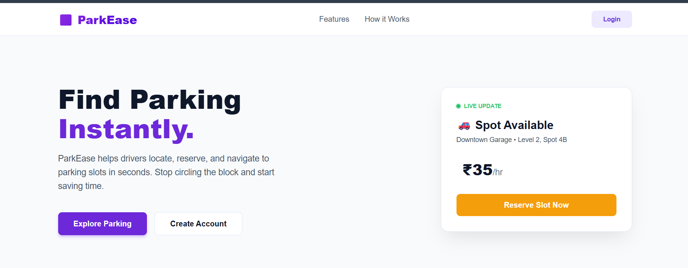
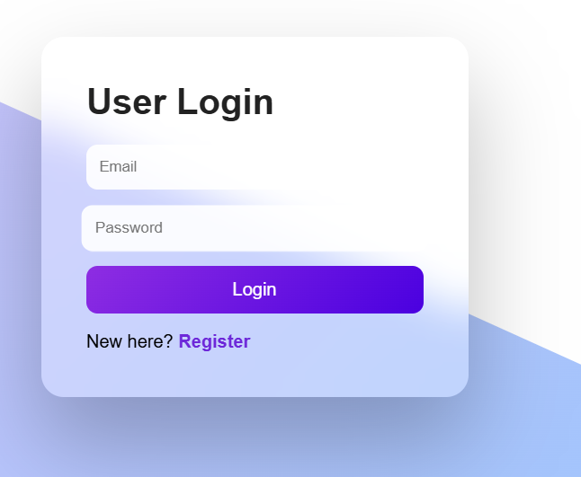

Milestone 2 – Security Module & Code Refinement
During Milestone 2, the team focused on implementing security features, improving backend logic, and refining UI and system performance.

Punith A – Frontend Developer
- Enhanced dashboard UI and improved responsiveness.
- Integrated frontend with authentication flow.
- Improved user interaction and navigation.

Nilakshi Kuldhar – Frontend Developer
- Refined UI design and improved consistency across pages.
- Enhanced Owner dashboard features and usability.
- Assisted in frontend validation and form improvements.

Ratna Shiva Singh – Backend Developer
- Developed backend logic for booking-related operations.
- Optimized database queries and performance.
- Improved data handling between backend and database.

Rajeswari Devi – Backend Developer
- Implemented exception handling mechanisms.
- Improved backend stability and error handling.
- Assisted in refining backend code structure.

Akanksha Devi – Backend Developer & GitHub Owner
- Implemented JWT Authentication for security.
- Developed logging module for tracking system activities.
- Refined backend APIs and improved system flow.
- Managed updates and collaboration through GitHub.

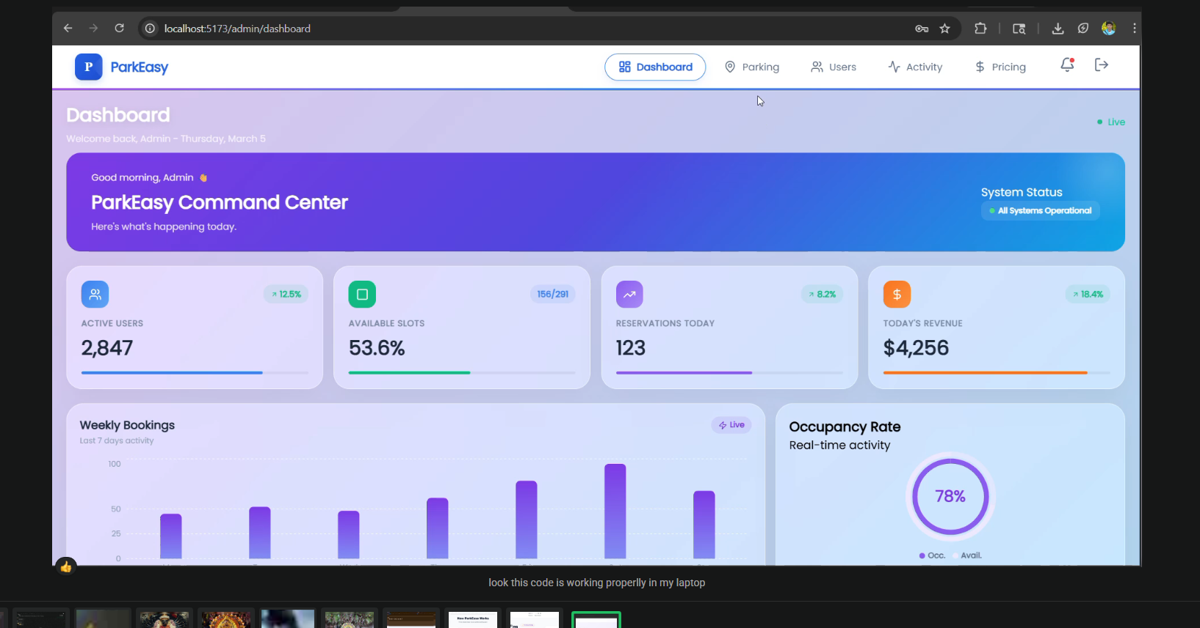

Milestone 3 – Core Module Development & Integration
During Milestone 3, the team worked on implementing core functionalities and integrating frontend with backend systems.

Punith A – Frontend Developer
- Integrated frontend dashboards with backend APIs.
- Displayed booking data dynamically in UI.
- Improved user dashboard functionality.

Nilakshi Kuldhar – Frontend Developer
- Enhanced Owner dashboard features (manage slots, view bookings).
- Improved UI interactions and usability.
- Assisted in frontend-backend integration.

Ratna Shiva Singh – Backend Developer
- Developed the Booking Module.
- Implemented backend logic for parking slot booking.
- Managed database operations related to bookings.

Rajeswari Devi – Backend Developer
- Strengthened backend error handling mechanisms.
- Assisted in API testing and debugging.
- Improved backend performance and reliability.

Akanksha Devi – Backend Developer & GitHub Owner
- Integrated frontend with backend APIs.
- Implemented Swagger for API documentation and testing.
- Managed overall system flow and coordination.
- Ensured smooth communication between all modules.

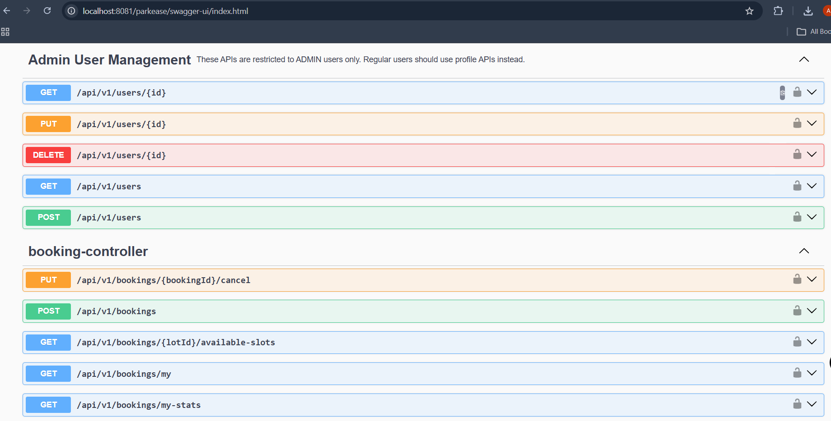

Milestone 4 – In Progress
During Milestone 4, the project focuses on completing the remaining modules, enhancing system functionality, and preparing the application for final deployment and real-world usage.
The remaining modules include advanced features such as improved booking management, real-time slot availability updates, user profile enhancements, and validation mechanisms to ensure accurate and secure data handling. Additional refinements are being made to both frontend and backend components to improve performance, responsiveness, and overall user experience.
A key addition in this phase is the integration of a chatbot system. The chatbot is designed to assist users by providing instant responses to queries related to parking availability, booking processes, and general navigation within the application. It enhances user interaction by offering guidance, reducing manual effort, and improving accessibility. The chatbot is integrated with the backend services to fetch real-time data and deliver accurate information to users.
Furthermore, this milestone includes thorough system testing using tools like Postman and Swagger, debugging of existing modules, and final optimization of the application. The goal is to ensure a stable, secure, and user-friendly system before deployment.

Conclusion
ParkEase offers a smart and efficient solution to modern parking challenges by integrating real-time data and user-friendly features. It significantly reduces the time spent searching for parking, minimizes traffic congestion, and enhances overall convenience for users. By combining secure backend systems with intuitive frontend design, the project demonstrates how technology can be used to solve real-world problems effectively and improve urban mobility.

