ParkEase

– Smart Parking Spot Finder System

Team Members and Roles

Rajeswari Devi Guthula – Backend Development, Spring Security, JWT, Chatbot implementation
Rantna Shiva Shingh – Backend Development , Database Management, Admin Module, Owner Module, Rest API’s.
Akanksha Devi – Backend Development, Integration, Booking Module, Logging.
Punith A – Frontend Development.
Nilakshi – Frontend Development.

Problem Statement:

In rapidly growing cities, finding parking has become a major challenge, causing traffic congestion, fuel wastage, pollution, and driver frustration. Traditional parking systems are mostly manual or semi-automated, lacking real-time visibility and efficient management of reservations and records. The proposed Smart Parking Spot Finder System, developed in Java, automates parking operations and provides real-time availability. Users can search, reserve, and release parking spots, while administrators can manage locations, slots, and activities efficiently. This system reduces search time, improves parking utilization, and enhances the overall user experience.
Scope Of Project:
The scope of the Smart Parking Spot Finder System includes the design and development of a Java-based application that automates parking space management. The system focuses on providing real-time parking availability, enabling users to search and reserve parking spots, and allowing administrators to manage parking locations and slots.
The project covers:
- User registration and secure login
- Viewing available parking spots in real time
- Reserving and releasing parking slots
- Maintaining parking and booking records
- Admin management of parking areas and slots
The system is limited to managing parking operations within defined parking locations and does not include hardware-level integrations such as sensors or IoT devices. The project is designed to serve as a scalable backend solution that can be extended with web or mobile interfaces in the future.

Scope of requirements:

1. User Scope
- Users can register and log in securely
- Users can search for available parking locations
- Users can view real-time parking slot availability
- Users can book and reserve parking slots
- Users can receive booking confirmation notifications
- Users can cancel or modify reservations

2. Admin Scope
- Admin can add, update, and delete parking locations
- Admin can manage parking slots (available/occupied)
- Admin can monitor real-time parking usage
- Admin can manage user accounts
- Admin can generate parking and revenue reports

3. Owner Scope
- Owner maintains real-time parking slot status
- Owner ensures secure authentication and authorization
- Owner handles concurrent user requests efficiently
- Owner stores parking and user data in a database
- Owner provides high availability and reliability

4. Technical Scope
- Backend developed using Java and Spring Boot
- Database managed using PostgreSQL
- REST APIs used for frontend–backend communication
- Security implemented using Spring Security & JWT
- Application deployed on Postman

MileStones

First MileStone:
Connected database to Java code and added validations to check user input, and used proper HTTP status codes to handle API responses.

Second MileStone:
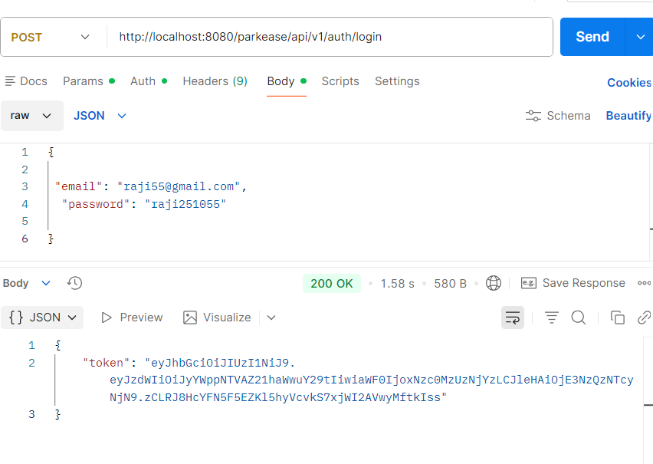
Worked On User Registration , User Login , Token Generation , Role Based Authentication.

Third Milestone:
Developed a chatbot that helps users find, book, and manage parking slots efficiently using predefined conditions, menus, and location-based prompts.

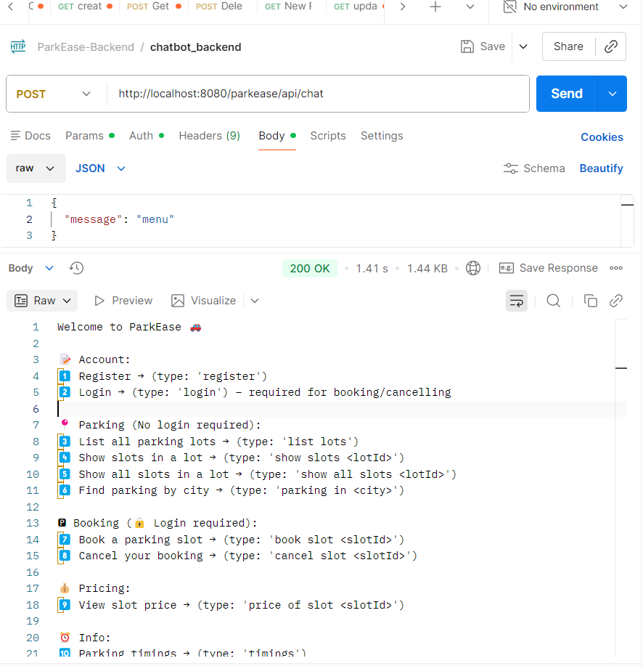

Fourth Milestone: Completed frontend integration with backend.

Applications of the Smart Parking Spot Finder System:
- Shopping Malls: Helps visitors quickly locate and reserve available parking spaces, reducing congestion.
- Corporate Offices: Manages employee and visitor parking efficiently with controlled access.
- Hospitals: Enables patients and visitors to find parking easily, saving critical time.
- Airports: Supports large-scale parking management with real-time slot availability.
- Residential Apartments: Organizes resident and guest parking spaces effectively.
- Educational Institutions: Manages parking for students, faculty, and staff.
- Public Parking Areas: Improves utilization and monitoring of municipal parking spaces.
- Commercial Complexes: Provides centralized control over multiple parking locations.

