Input file for dataset 1:

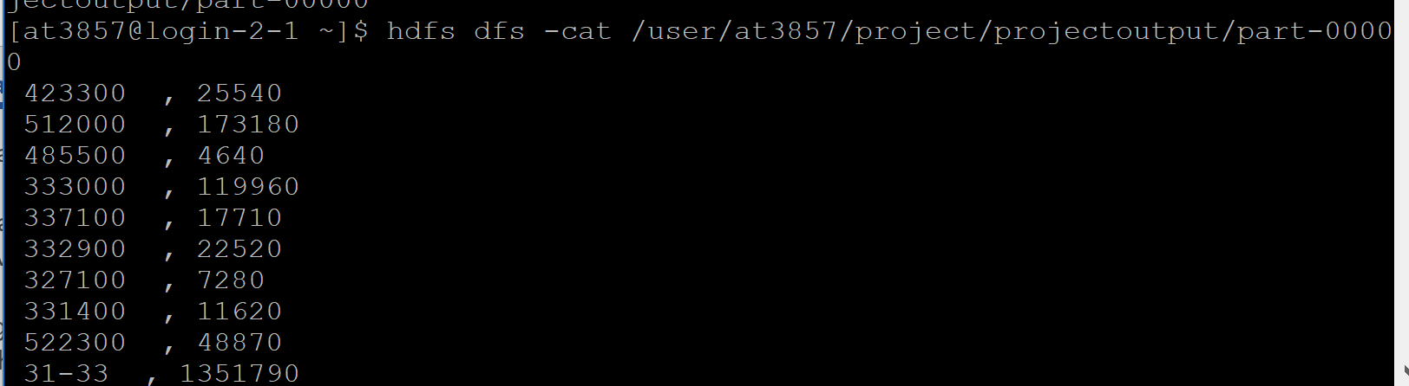

select * from at3857.dataset1; -- input from first dataset

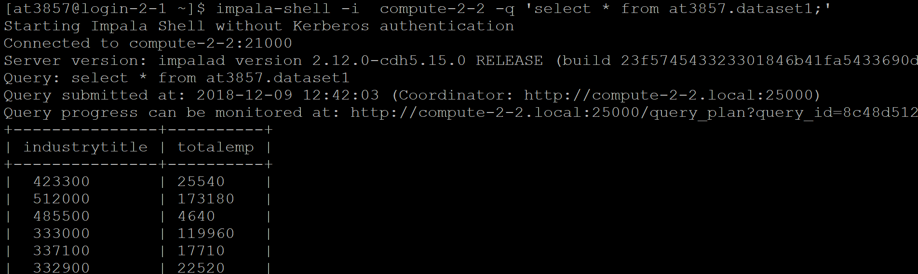



--create table akanksha_naics as (select substr(industrytitle,1,3) as industrycode,totalemp from dataset1 order by industrytitle ASC);

select * from akanksha_naics;

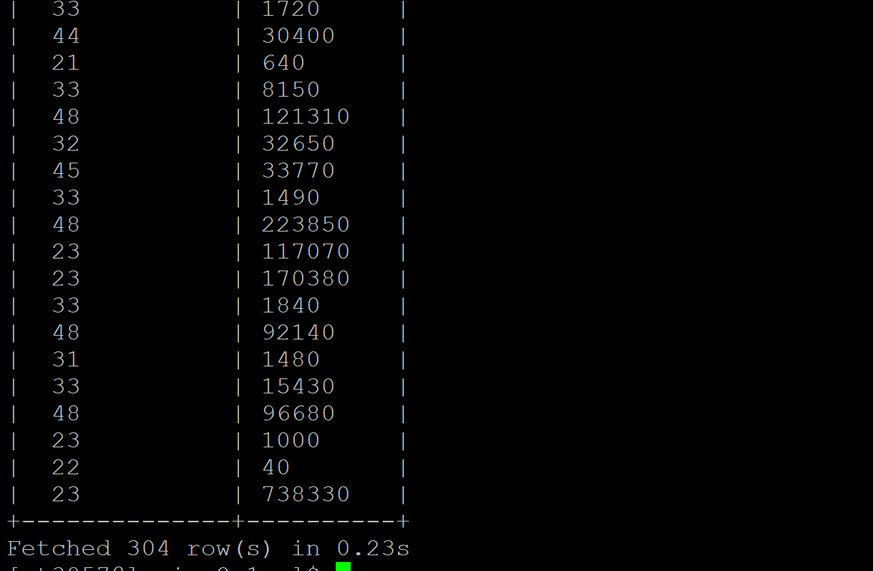

--create table sumit_naics as (select substr(trim(industrytitle),1,2) as industrytitle ,totalwages from sa4764.dataset2 order by industrytitle ASC);

select * from sumit_naics;



select * from sa4764.dataset2; -- input from dataset2

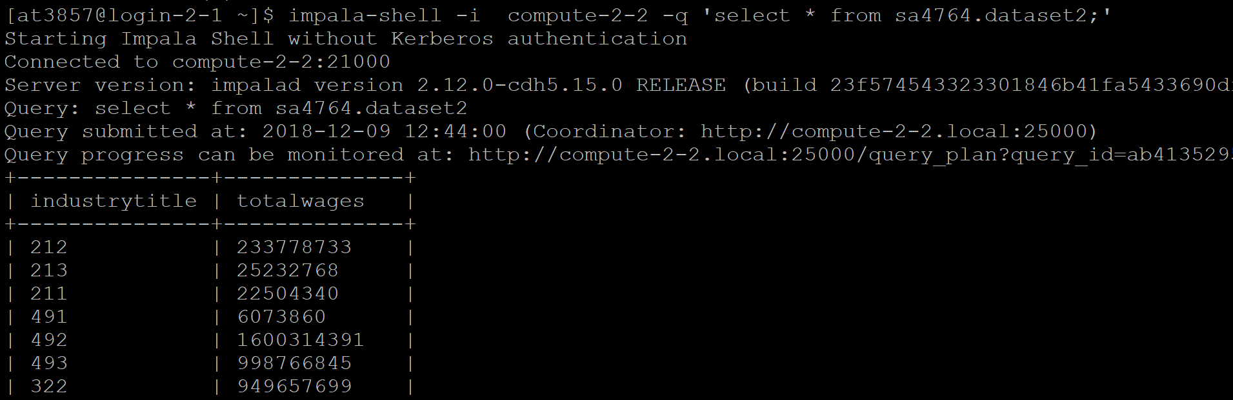



select * from at3857.dataset3new; -- input from dataset3 (revised )

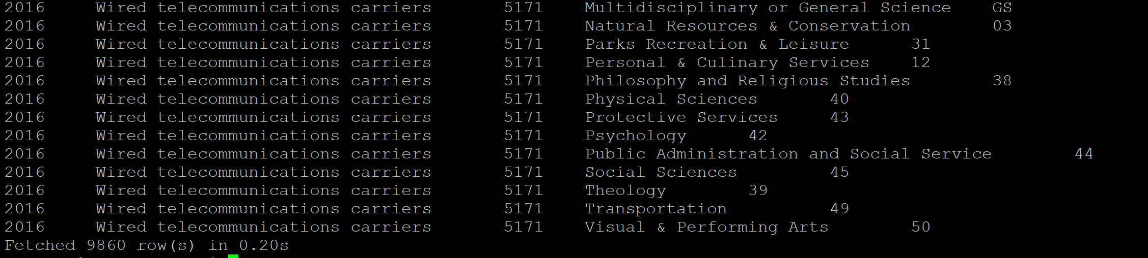

RAW join of dataset1 and dataset 2

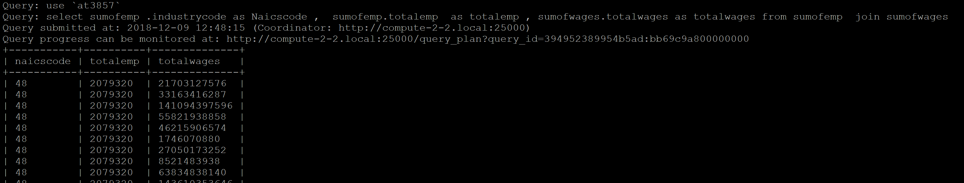



Select * from naicsemp; -- join of dataset1 and dataset 2 distinct selection

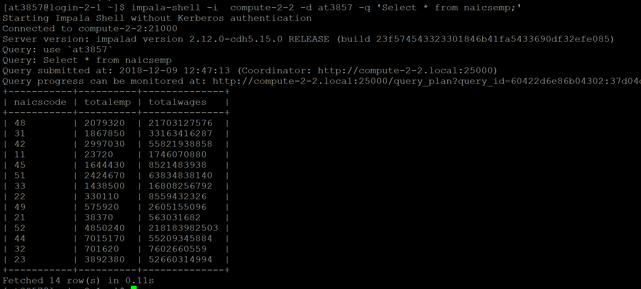

Raw joins on salary without major classification: -- select * from rankdegreebysal;

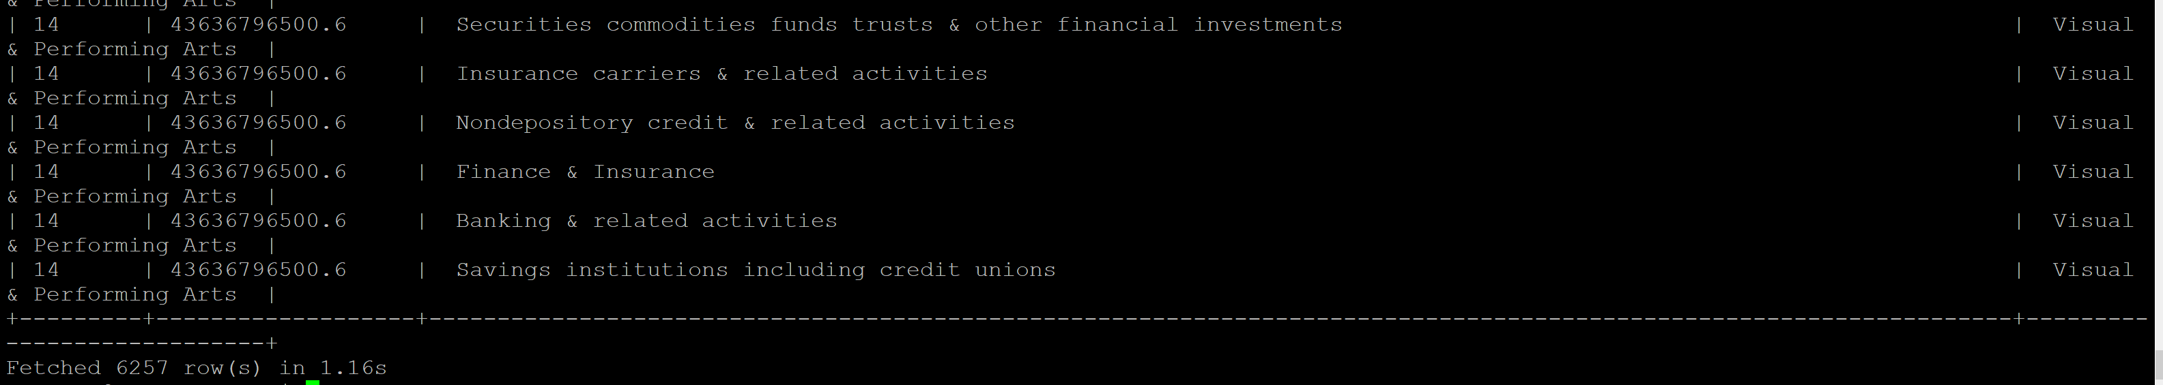

Raw joins on employment without major classification: -- select * from rankdegreebyemp;

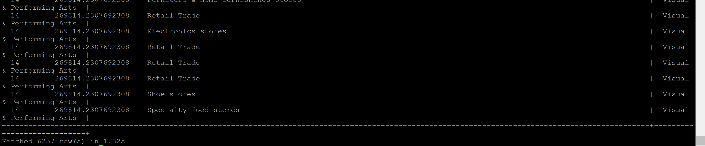

Final distinct and major industry joins of dataset1 and dataset2 and total employment and salary: -- NaicsJoin table

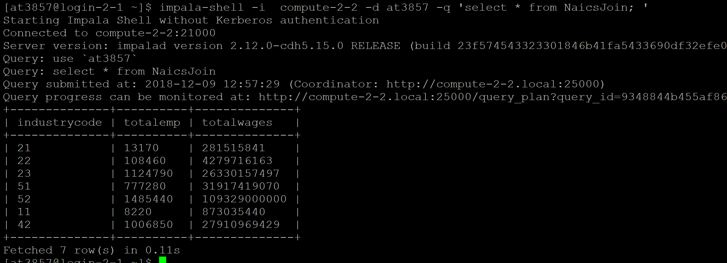

Join of NAicsJoin and revised dataset3 without ranking:

select distinct * from NaicsJoin join dataset3new on trim(industrycode) = trim(code);

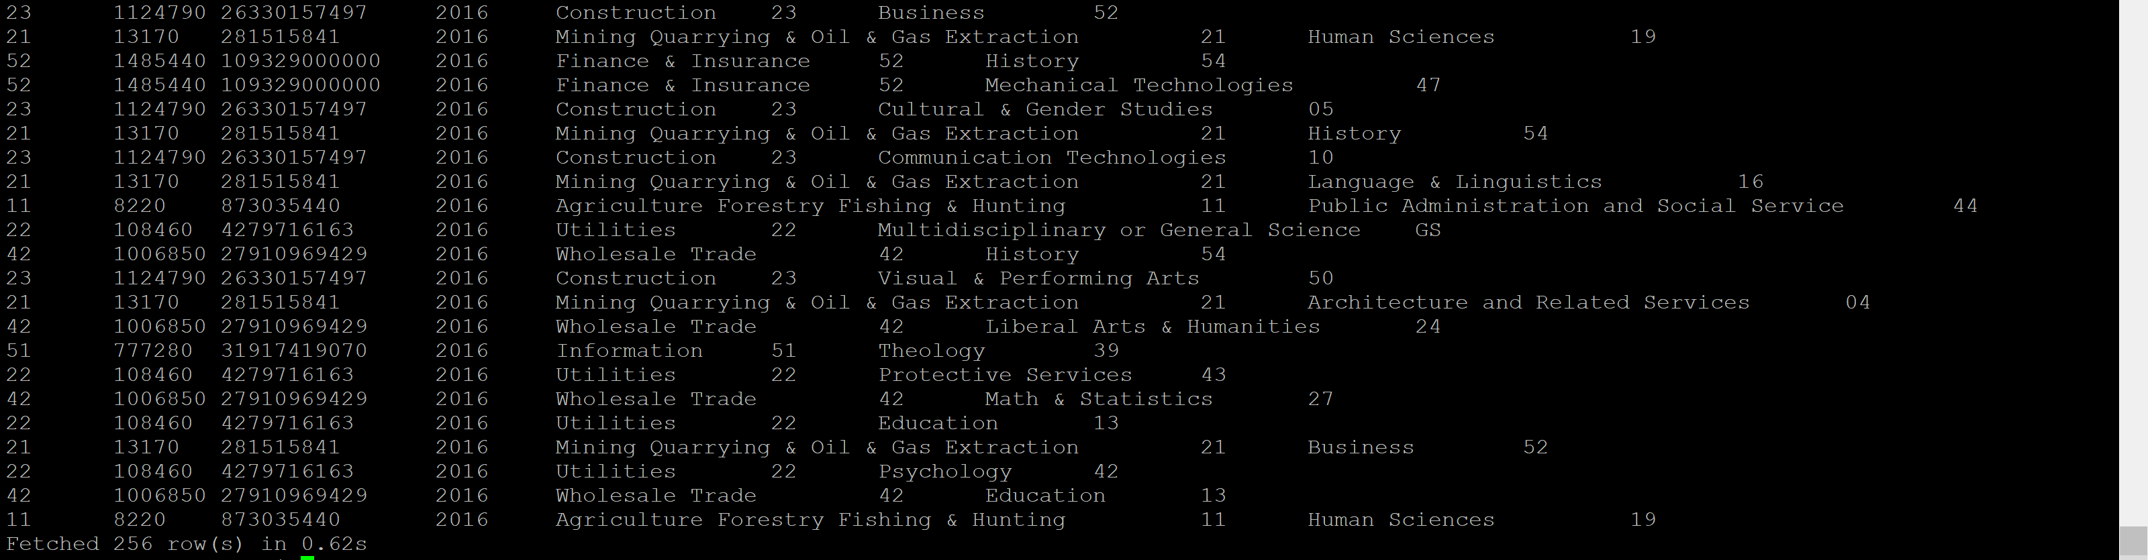

Entire dataset ranking on basis of industry wages --select * from NYwages ;

-- Create table NYwages as select dense_rank() over (partition by dataset3new.cipname order by naicsjoin.totalwages) as nyrank,totalwages as totalwages ,industry as industry, cipcode as cipcode, cipname as degree from naicsjoin join dataset3new on trim(dataset3new.code) = trim(industrycode) where trim(industrycode) in (select naicscode from naicsemp) and dataset3new.cipname in (select distinct cipname from dataset3new) order by dataset3new.cipname , naicsjoin.totalwages desc;

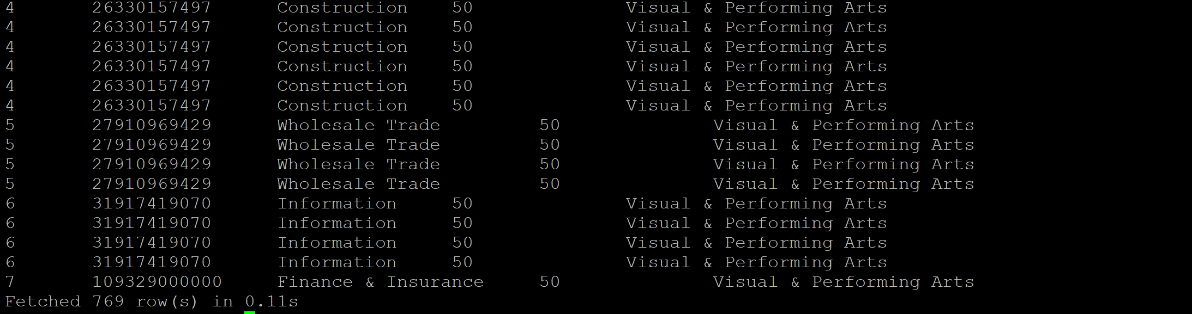

On basis of employment (Ranking of entire dataset)

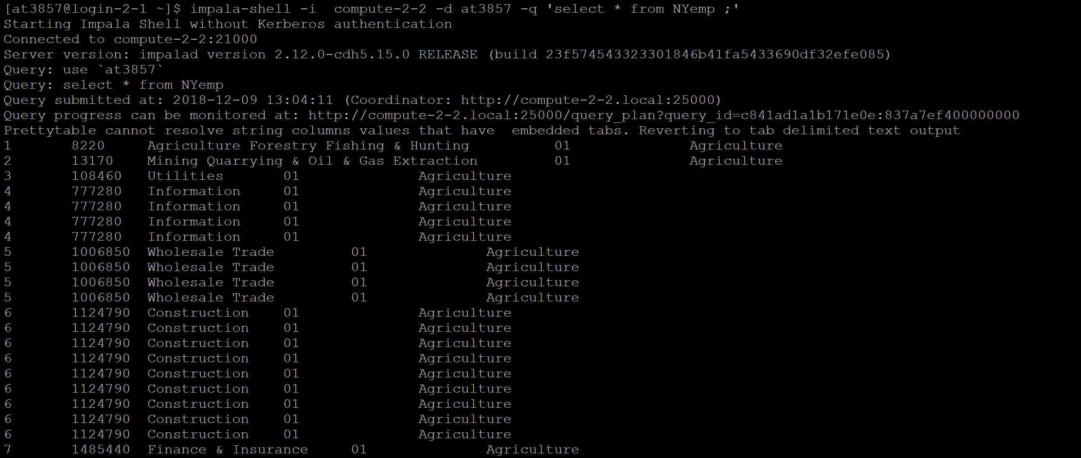

Highest rank in terms of employment of NY state:

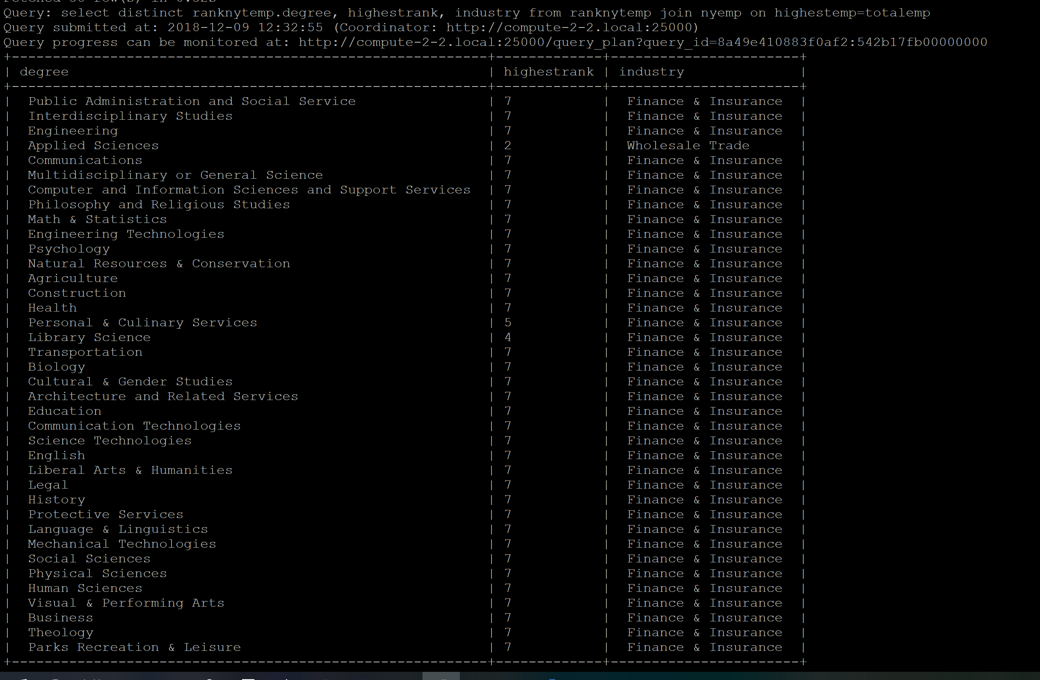

Highest ranked industry on basis of wages:

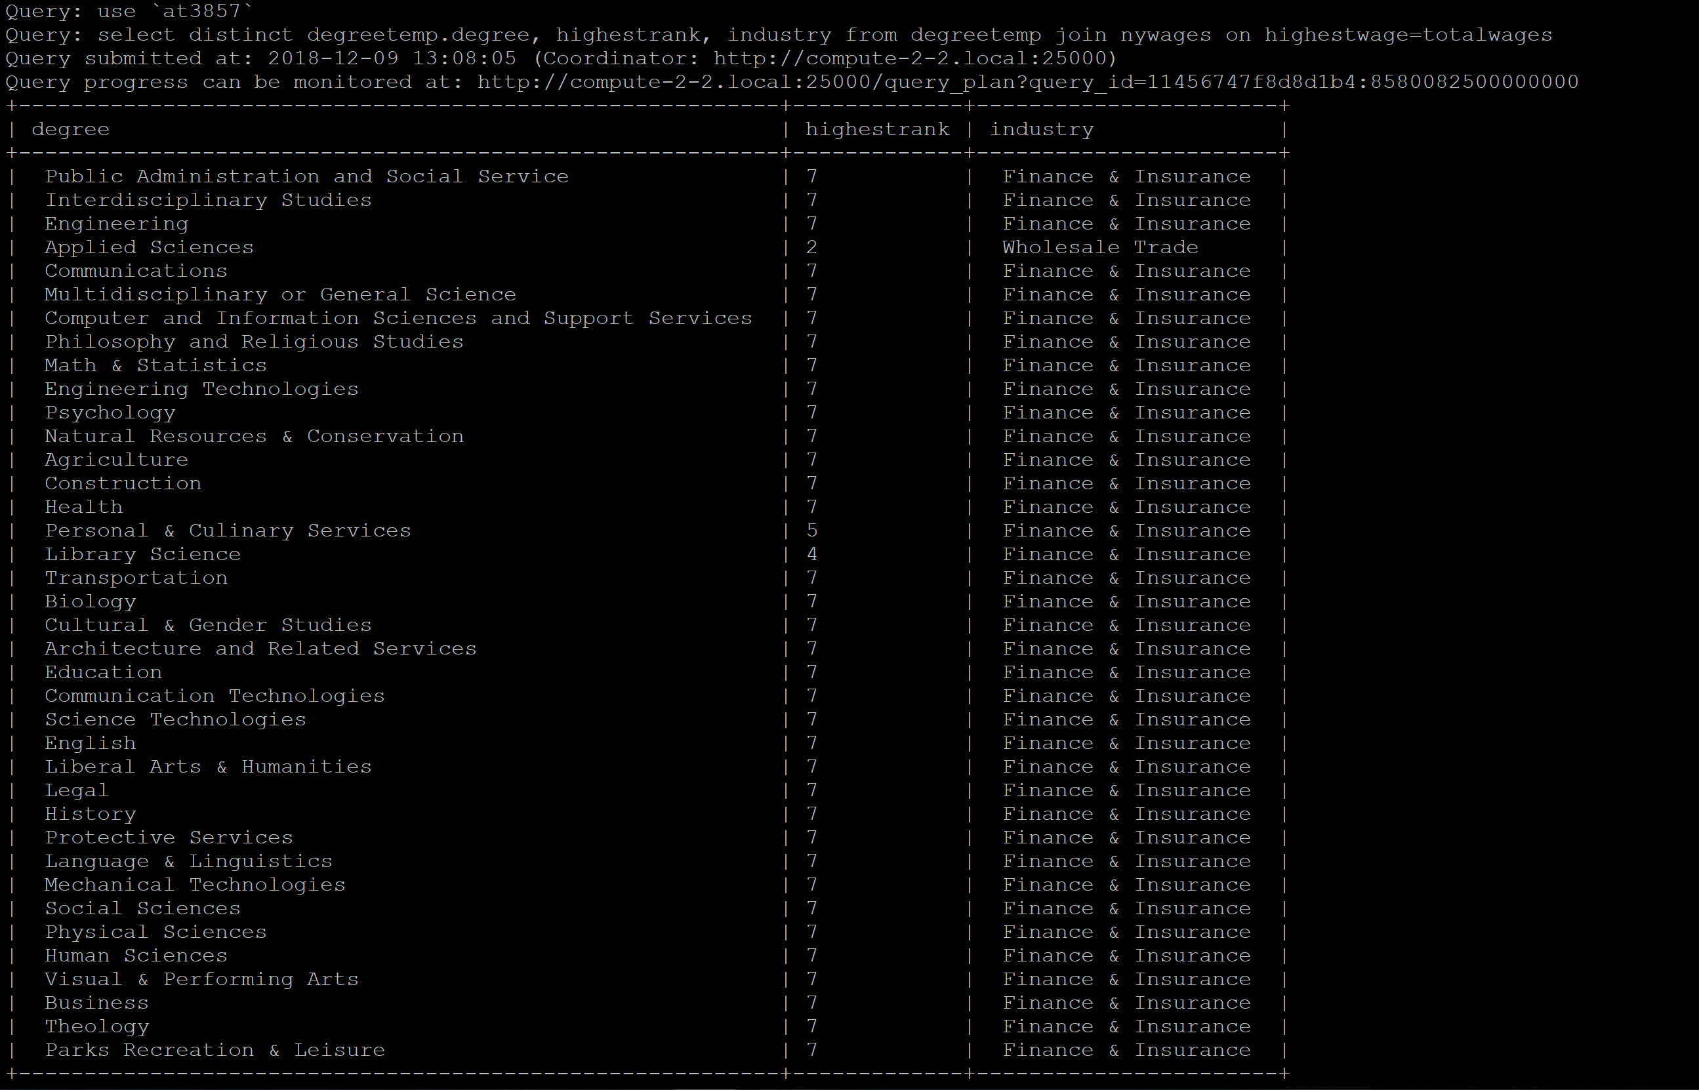

Ranking of Florida dataset

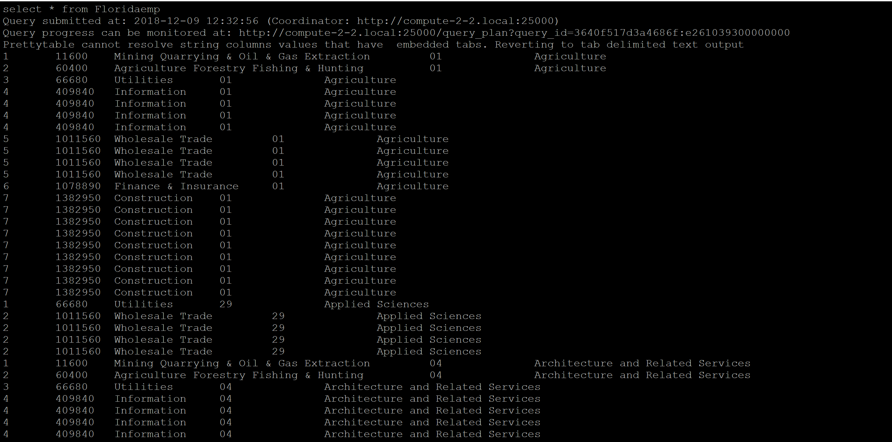

Final Florida analysis

